
This topic is all about celebrating each child’s uniqueness, being able to describe oneself in positive terms and talk about abilities.

AUTUMN 1
Core Texts: A range of topic related poetry, stories and non fiction to include:

The Colour Monster
Who are You?
Superworm
Supertato
10 Little Superheroes
People who help us!

This topic is about animals of all shapes and sizes, including minibeasts, pets, farm, zoo and safari animals.

Big questions I will be thinking about:

Who am I?
How do we keep happy and safe?
What makes a good friend?
Who can help me?

Personal, Social and Emotional Development

Rules and routines in school.
Making relationships with new friends and adults.
School rules and values.
Getting to know friends.
Be safe in school.
Listening games.

Communication & Language:

To understand 2 part questions.
Nursery rhymes and songs
Longer sentences
Rhyming and repetitive phrases.
Read Write Inc.

Physical Development:

Participates in finger and action rhymes, songs and games.
Cutting skills, pencil grip.
Funky Fingers
Engage in physical play, running , jumping ,dancing

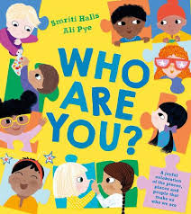

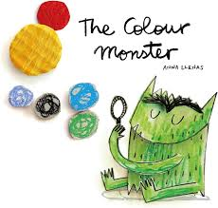
Maths

Counting songs and rhymes.
Numicon patterns and shapes
Repeating patterns
Comparing
How old am i?
Counting with 1:1 correspondence.

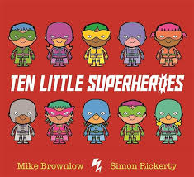

Expressive Arts and Design

Joins in with singing and singing songs
Experiment with colour and colour mixing
Engage in role play activities
Artist - Matisse.
Funky Fingers Activities.

Understanding the World

Understand our own family
Begin to learn about similarities and differences between ourselves and others
Learn about different occupations of people in our community
Remember where objects belong in class - help to tidy and show respect.

The places I might go and people I might meet:

Fire Fighters
Police
Dentist
Vet
Woodgate Estate & shop

Literacy

Name writing and recognising lettes.
Handles books with interest
Listens to story with increased interest and recall
Joins in with repeated refrains and actions

