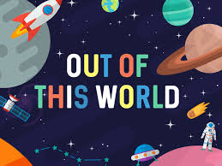
This topic is a science topic with links to the solar system, history of the moon landing and light and dark shadows.

AUTUMN 2
This topic is about animals of all shapes and sizes, including minibeasts, pets, farm, zoo and safari animals.

Big questions I will be thinking about:

Where is Earth?
How many planets are there?
How do we see light and dark?
What is a shadow?

Personal, Social and Emotional Development

Who is there to keep me safe?
Being a good friend.
My happy mind - learning about my brain.
Safety around fireworks.

Core Texts: A range of topic related poetry, stories and non fiction to include:

Room on the broom.
Whatever next.
How to catch a star.
Non-fiction: Planets.
Non-fiction: Shadows.

Communication & Language:

Listening to my friend
Taking turns
Word blending (cvc)
Following instructions with 2 parts.
Nativity lines and songs

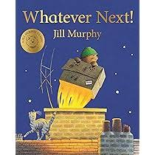
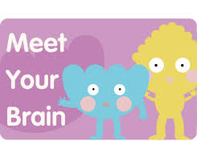
Physical Development:

Cutting skills, pencil grip.
Funky Fingers
Engage in physical play, running , jumping ,dancing with nativity links.
Throwing and catching a ball.

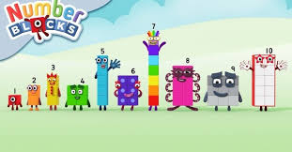
Understanding the World

Remember where objects belong in class - help to tidy and show respect.
Keeping ourselves safe and others.
Naming the planets.
Understanding the moon landing.
How to make a shadow.
How do we get light and dark? Day and night?

Maths

Counting songs and rhymes.
Number formation.
Numicon patterns.
Numbers 5-8 in depth.
Counting with 1:1 correspondence.
Features of triangles and circles.

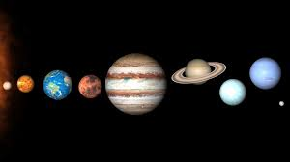
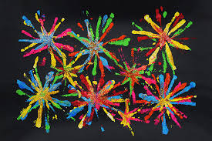
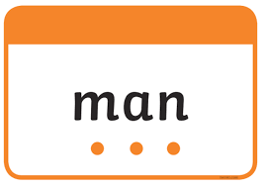
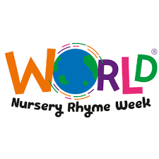
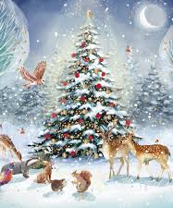
Key events this term:

Nursery rhyme week.
Nativity
Now press play - space
Christmas
Art day
Firework night
Diwali

Literacy

Name writing and recognising letters.
Word blending (CVC words).
Recognising initial sounds.
Drawing Club
Rhyming words.

Expressive Arts and Design

Joins in with singing and singing songs with nativity link.
Experiment with colour and colour mixing.
Designing and making rockets.
Space station role play.
Fireworks.

