Version: March 24

Woodgate
Nursery
“Working together to be our best”


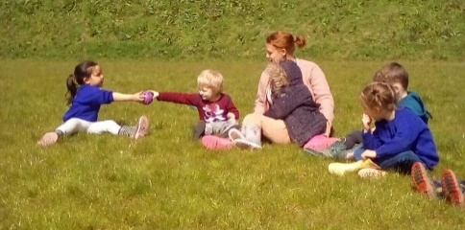
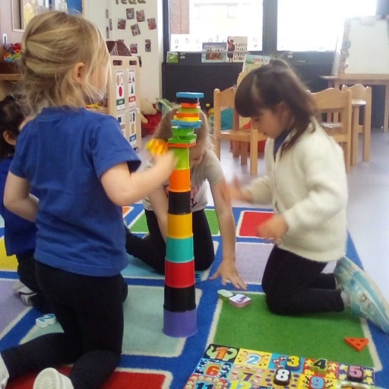
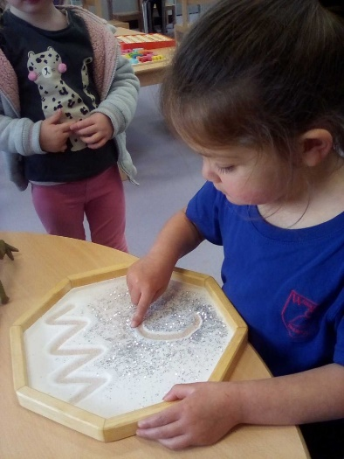

Vision

Our vision at Woodgate Nursery is to provide the very best start to each child’s education.

At Woodgate Nursery, we get to know every child (and family) really well. We celebrate character, promote independence and challenge capabilities. We strive to facilitate a love of learning, encouraging children to become lifelong learners.
Aims
At Woodgate Nursery, we aim to…
- Work closely in partnership with parents/carers, families, staff, children, fostering open communication.
- Provide a welcoming and safe educational environment
- develop children’s personal interests and celebrate their strengths
- Support children to become effective communicators.
- Provide a broad, stimulating and interest-led curriculum through a variety of play and sensory activities.
- Ensure the nursery class is an integral part of the EYFS unit and school as a whole
- Facilitate a smooth successful transition into school by ensuring secure personal social and emotional development.
- Provide excellent teaching to ensure the best possible start to each child’s education, allowing them to achieve their full potential

Version: March ‘26

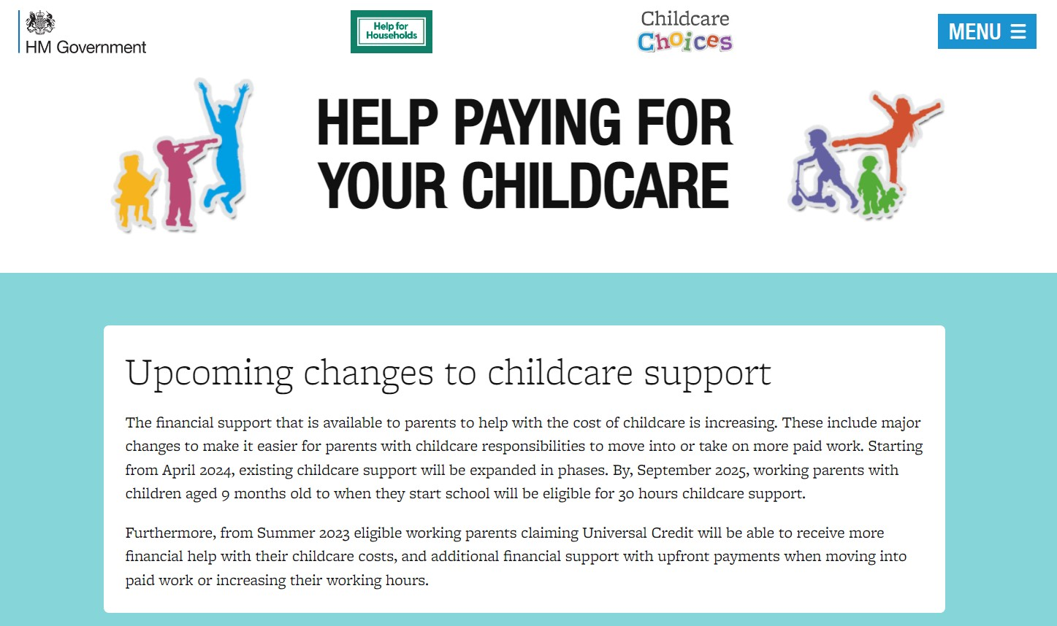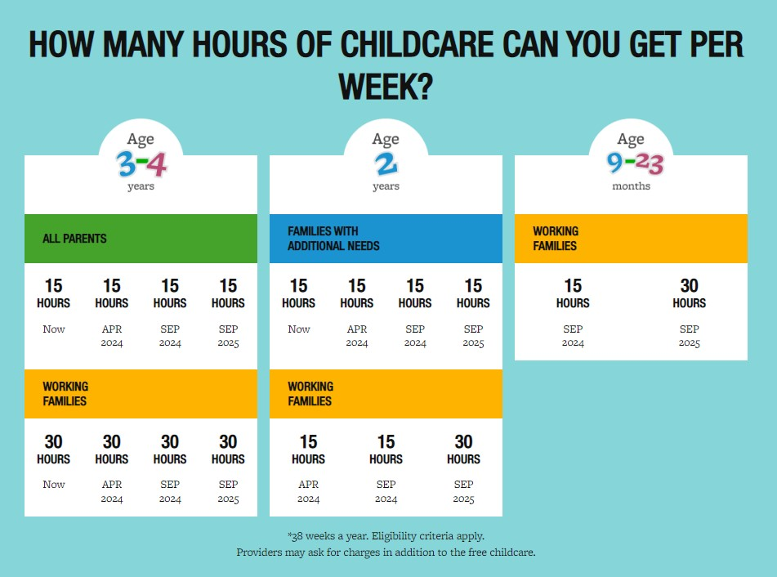
Woodgate Nursery Registration Form

Personal Details
Child’s first name(s)
Child’s surname
Date of birth: |  | Male / Female:

Parent 1: Mother/Father/Legal Guardian | Parent 2: Mother/Father/Legal Guardian
First name: | First name:
Surname: | Surname:
Address: | Address:
Postcode: | Postcode:
Contact Number: | Contact Number:
Email: | Email:

Does your child have special educational needs and/or health needs? YES___ NO ___ (if yes please see below)
Is this child registered as being in the care of a Local Authority or previously been looked after? YES___ NO ___
Is their sibling at Woodgate Primary Academy or will be at your preferred time of starting? YES____ NO____
Are you eligible for Free Funding? | Yes | No
Early Learning Funding - 2yr (15 hours) (LA Issued EYFE)
2 Years (30 hours) (for working families)
3 & 4 Years Universal Funding (15 hours) (all families)
9mths – 4 year old (30 hours) (for working families inc Universal Funding)
When would you like your child to start nursery? Our main intakes are September and January

Month ______________________ Year ________________
Limited spaces in April as priority to existing children to review & increase sessions pattern

Please indicate which sessions you would like your child to attend (✔)
We suggest that children attend at least 5 sessions per week - mornings/afternoons or 5 sessions over 2.5 days (subject to review). We do our best to meet your request, subject to availability.
Attendance | Monday | Tuesday | Wednesday | Thursday | Friday
Session 1 9:00- 12:00
Session 2 12.00- 15:00
Full day 9:00- 15:00

If your child has any special educational needs or health needs, please give brief details below:

Any general concerns/further comments:

Signature: Date:

