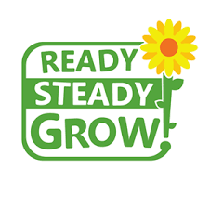
This topic is a geography and DT topic. We will be learning about food and where it comes from. We will also learn about healthy lifestyles.

SUMMER 1
This topic is about animals of all shapes and sizes, including minibeasts, pets, farm, zoo and safari animals.

Big questions I will be thinking about:
Where does food come from?
How do we get our food?
What are the features of a plant?
What do plants need to grow?

Personal, Social and Emotional Development

Friendships
Being resilient
Giving things a go
Problem solving
Summer safety
Core Texts: A range of topic related poetry, stories and non fiction to include:

Handa Surprise
Jack and the Beanstalk
Little Red Hen
Jasper’s Beanstalk
The giant Turnip

Communication & Language:

Read write Inc.
Circle time
Discussions about healthy eating and lifestyle

Physical Development:

Ball skills - throwing, catching, rolling and kicking.
Aiming at a target.
Circus skills
Sitting and writing comfortably and correctly.
Pincer grip

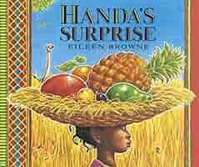

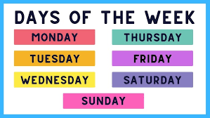
Maths

Subtraction and patterns in number
measuring/capacity
Number Bonds to 10
Odds and evens.
Manipulate, compose and decompose.

Understanding the World

Eating a rainbow
Healthy foods
Types of food
Where food comes from?
Food from the UK
Seasonal changes - Winter to Spring

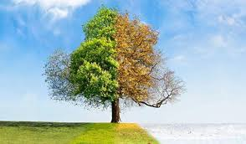
Key events this term:

Phunky Food lessons
PIzza Express Trip
Children’s mental health week
Tea Party

Expressive Arts and Design

DT topic this term:
Food preparation
Healthy food
Growing seeds
Tea party

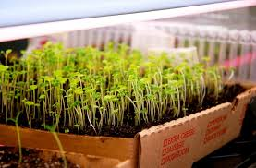

Literacy

Writing full sentences.
Capital letters, fingers spaces, full stops.
Adding adjectives to our writing.
Tickets / role play

