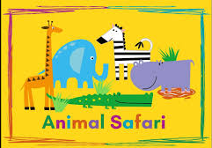
This topic is a science and geography topic with links to animals from all over the World.

SPRING 2
This topic is about animals of all shapes and sizes, including minibeasts, pets, farm, zoo and safari animals.

Big questions I will be thinking about:
Where do animals live?
What is a lifecycle?
What are groups of animals called?
Who has the most legs?

Personal, Social and Emotional Development

Appreciate me - My happy mind
Problem solving
Sharing and taking turns
Understand my own needs.
Core Texts: A range of topic related poetry, stories and non fiction to include:

The hungry caterpillar
Dear Zoo
The butterfly bouquet
Snail trail
Commotion in the ocean

Communication & Language:

Following instructions
Retelling traditional tales
Circle time
Expressing opinions

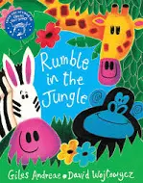
Physical Development:

Copy and repeating
Shape and direction
Using prop
Expressing through movement
Moving with music
Begin to use counts.

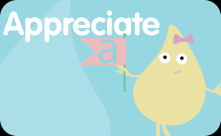

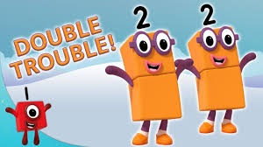
Understanding the World

Easter
Life cycles of insects and animals
Special places for people
Observations of the environment
Seasonal changes - spring

Maths

Ordering numbers
Numbers to 8
Less than
More than
Focus on 7
Doubling
2 equal parts
Sorting numbers

Key events this term:

Animal visits
World Book Day
Comic Relief
Easter Disco

Expressive Arts and Design

Animals masks
Clay models
Role play
Sorting and collecting
Planting

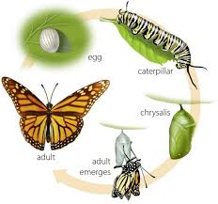
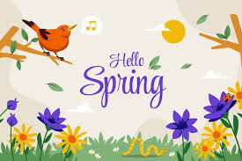

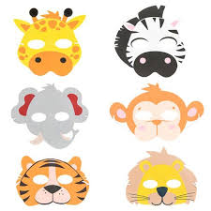

Literacy

CVC words
Caption writing
Beginning to form sentence verbally
Capital letters and full stops
Writing our first and last name

