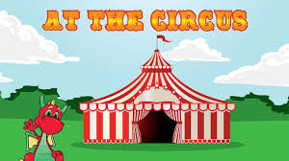
This topic is a expressive arts and design and physical development topic!

SPRING 1
This topic is about animals of all shapes and sizes, including minibeasts, pets, farm, zoo and safari animals.

Big questions I will be thinking about:
What is team work?
How can I show my feelings?
How do I keep my body healthy?
How do I keep safe?

Personal, Social and Emotional Development

Rule and routines
Being a good friend
Celebrating my happy mind
Circle time
Dream big! Future Me

Core Texts: A range of topic related poetry, stories and non fiction to include:

Albert doubles the fun
You see a circus
Paddington at the circus
Eric the lion tamer
Clown
The singing mermaid

Communication & Language:

Feelings
Retelling stories
Listening to others ideas
Listening skills

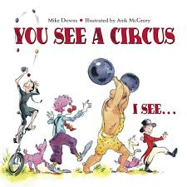
Physical Development:

Balancing
Following routines
Jumping and landing
Travelling in directions
Tripod grip when holding a pencil.

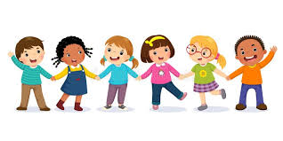

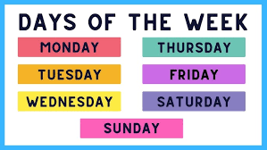
Maths

Days of the week
Months of the year
Numbers 5-8
Counting - staircase method
Comparing
More and less

Understanding the World

Seasonal changes
Circus life
Past and present
Science experiments (magic)
Religious places.
Similarities and differences of lifestyles.
New Year celebrations
Key events this term:

Circus workshop
Topic day

Expressive Arts and Design

Listening to beat
Circus music
Circus role play
Circus workshop
Junk modelling
Making tents
Making props

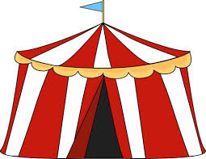

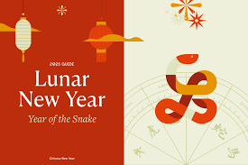

Literacy

CVC words
Caption writing
Recipe writing
Writing a list
Writing our first and last name

