**Transition – Problem of the Fortnight**

At Whickham School, one lesson every fortnight is dedicated to solving one big problem-solving question. This is to develop important skills that will help you in maths from year 7.

It takes the whole lesson because you need to look at it very carefully, think about it logically and from lots of different perspectives. To ensure success with problem solving, in the Maths faculty we use our problem-solving pencil and exam question toolkit to help you.

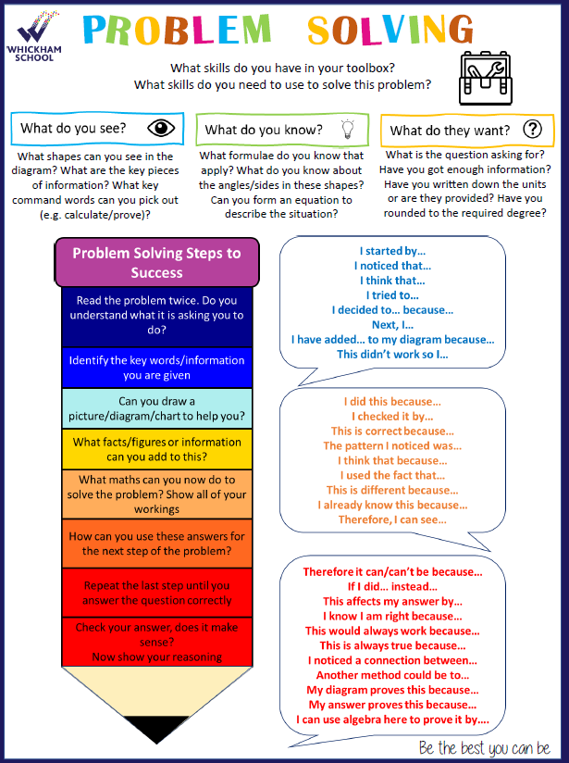

**Your Task – The Number Daisy**

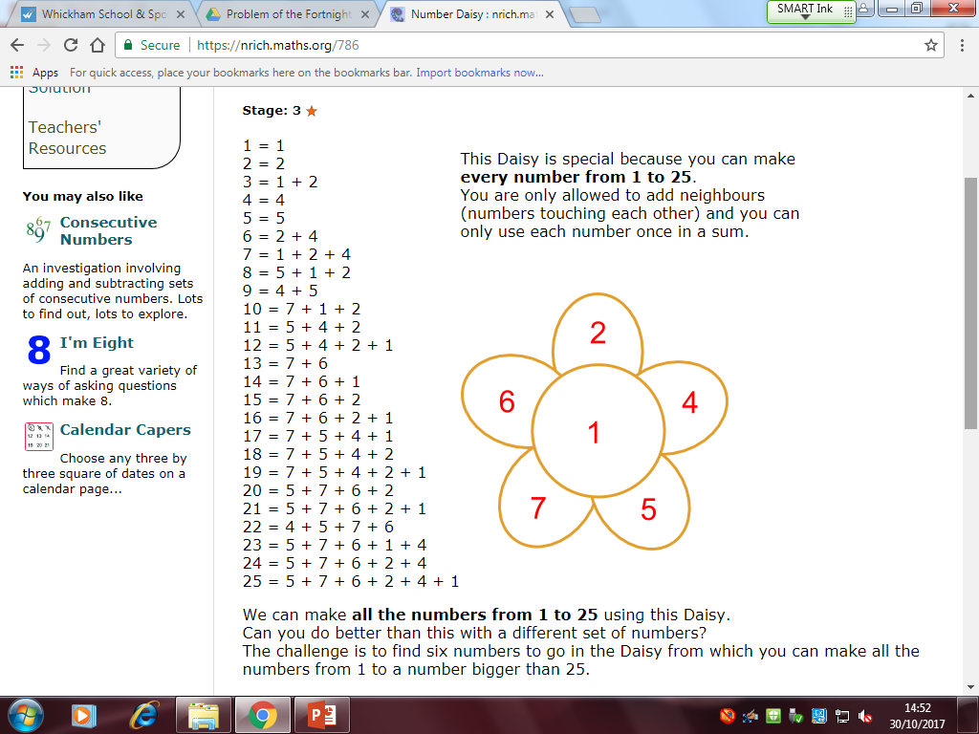

Hints:

* Use the problem-solving pencil and the tips in there to help you.
* Use the toolkit and think about what you see, what you know and what they want.
* Experiment! Draw lots of daisies and put lots of different numbers in there. Can you see any patterns? Are there any numbers that are essential? Any orders of numbers that are essential?

#FastFinisher:

* Can you explain your reasoning and thinking? What was your thought process? How many experimental daisies did you have to draw and what did you discover? Use the ‘steps to success’ to help you with this.
* Can you create a daisy that gets you higher than 25 but doesn’t have 1 in the middle?