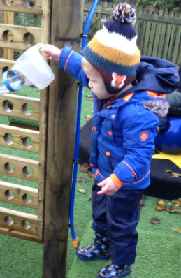
Welcome to Nursery
At Whittonstall we take pride in the early year’s provision that we provide. The importance of a happy and positive start to your child’s school life is the key to everything we strive to do in our early years setting.
Our Early Years Vision
At Whittonstall we understand that every child is unique, with their own interests, strengths and experiences. We believe that getting to know your child and understanding their interests and individual strengths and development needs is the key to them settling well, engaging actively in their own learning and reaching those important developmental milestones.
Contact Details
Whittonstall First School
Whittonstall
Consett
Northumberland
DH8 9JN
Tel: 01207 560325
Email: admin@whittonstall.northumberland.sch.uk
Headteacher: Mrs Leanne Barker
Deputy Head Teacher: Mrs Kelly Howe
Staff
EYFS Lead/Class Teacher/SENCo : Mrs Samantha Drysdale
Teaching Assistant: Miss Monica Wilson
School Day
The school day starts at 8.55am. Children enter through yard gate and will be supervised by staff until bell is rang.
The school day finishes for Nursery children at 12.00pm and parents can collect their child from the yard gate.
Timetable of Morning
8.55 Registration
9.05 Carpet time together
9.20 Free flow, child-initiated and directed activities
10.20 Snack time
10.30 Play Time
11.00 Phonics
11.25 Story Time
11.30 Lunch Time
12.00 Home Time
Lunches
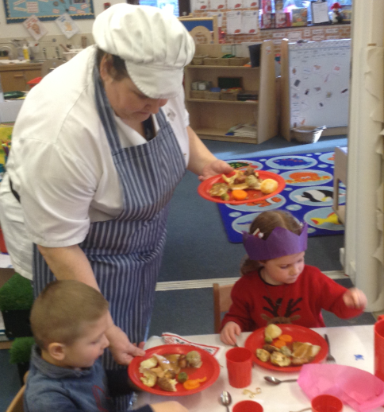
Mrs Robinson provides delicious well-balanced meals daily. Lunchtime is an important part of your child’s day in school. We encourage the children to try a variety of foods, develop accurate use of cutlery and further develop table manners. Children in reception, year 1 and year 2 are entitled to a Universal Free School Meal which is a government initiative, so will not be charged for school lunches but Nursery children have to pay for their lunches.

Snack
Milk and fruit are provided daily for your child as their morning snack. If your child is under 5 they are entitled to free milk, once they are 5 you will need to order and pay each term if they require milk. Under the “Fruit for Schools Scheme” children up to year 2 receive free fruit every day. Please inform school if your child does not drink milk and we can give them water.
Water Bottle 
Fresh water will be available throughout the day for your child but it is also recommended that your child brings their own water bottle daily which is clearly labelled with their name.
Attendance
If you are late dropping off your child, please enter through the school’s main entrance, where you will be asked to sign in by a member of staff. If your child is unwell or will not be attending school on a particular day, please inform the school office by 9.00 am on the day of absence. If you cannot get through to reception you can leave a message on the school answerphone or enter details of the absence on parent mail.
Curriculum 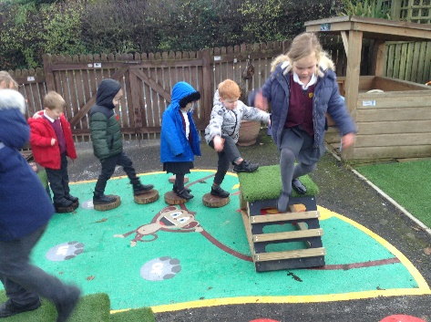
We follow the Early Years Foundation Stage Curriculum, planning carefully to ensure that within that curriculum we provide a relevant, stimulating and rich variety of experiences for your child. The emphasis in reception is on the acquisition of skills and knowledge in a play-based setting with a careful balance of play and focused tasks that are both child initiated and adult led.
Areas of Learning
The seven areas of learning covered in the Early Years are separated into Prime and Specific Areas of Learning. The Prime Areas begin to develop quickly in response to relationships and experiences. The
Prime areas are as follows:
- Personal, Social and Emotional Development
- Physical Development
- Communication, Language and Literacy

Specific Areas include essential skills and knowledge for children to participate successfully in society. The Specific areas of the curriculum are:
- Literacy
- Mathematics
- Understanding the World
- Expressive Arts and Design

Characteristics of Learning 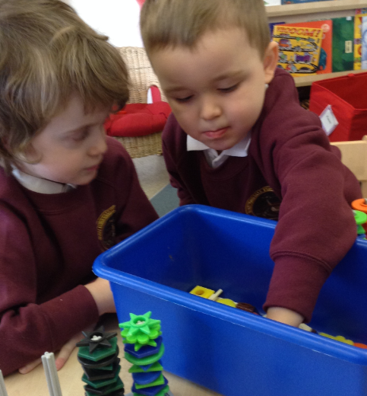
Integral to all we do within the prime and specific areas are the characteristics of learning. Developing these characteristics ensure that children develop the skills and knowledge needed to be lifelong learners who are resilient and have a positive attitude to their learning. These characteristics are something that parents and teachers should endeavour to foster every day in their interactions. Children develop the ability to become independent and capable learners for life when we focus on the following skills and attitudes:
- being willing to have a go and try something new
- bouncing back after difficulties and persisting in the face of challenge
- being encouraged and supported to have their own ideas
- finding more than one way of doing something
- being proud of how they achieve something, not just the achievement itself
- making links and connections between their learning

School Readiness 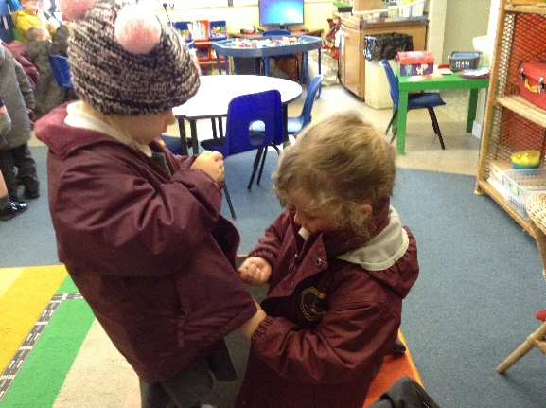
We strive to ensure that transition into Reception is as smooth and enjoyable for your child as possible. There are certain skills that your child can practise at home prior to starting Reception to help that transition. Do not be concerned if your child cannot do all the things listed below, children develop skills at different rate!
For example:
- Able to attend to own toileting, including handwashing
- Independent eating using cutlery
- Able to run, jump, balance in a variety of physical activities
- Able to take turns by readily sharing toys of interest with others, sit, listen and play independently for short periods of time.
- Shares ideas through talk. Talk about what they observe in their immediate environment, answer simple ‘what’, ‘when’, ‘why’ questions.
- Dress and undress independently, including identifying own name in labelled clothing.
- Recognise their own name.
- Use a pencil using correct ‘nip, nip, Mr Crab’ grip
- Use scissors and simple tools
- Sing some familiar songs and nursery rhymes
Learning Journals
Your child will be given a journal when they start Reception. This is a very important link between home and school. It will build up a picture of your child’s interests, strengths and areas to develop. Your contributions to this journal will help inform planning and effective next steps for their learning.
Uniform 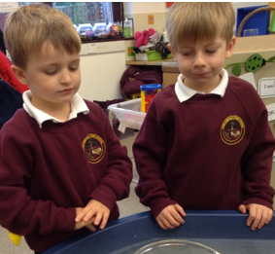
An order form will be sent to you prior to your child starting in Reception with a list of uniform requirements, including P.E. kit requirements. We currently use a local company Salto for our school uniform, as we do not keep a stock in school, any orders need to be made direct to them online, by telephone or in person at their shop in Prudhoe. We do keep a stock of donated second-hand uniform in school for which we request a small donation to school funds. Please ensure that every piece of your child’s clothing is labelled and they are aware of where that label is on their clothing. Black school shoes, not boots, are requested and your child should be able to put them on and off independently so ideally not laced.

Toilet Training
It is important that your child is toilet trained in time to start Nursery. However, we do understand that children develop at different rates and we will work closely with parents to quickly develop those important self-help skills around toileting. If your child is not toilet trained prior to the start of Nursery, please talk to Mrs Drysdale about routines at home and ensure your child has a change of clothes, clearly labelled, in their school bag every day.
Medicines
Designated staff will administer medication to children only when it has been prescribed by a doctor. Medication should have a prescription label with the child’s name and dosage clearly visible, this includes medicines such a Calpol. You will be required to complete a consent form at the office when handing over the medication.
Asthma
For children with asthma, please provide the school with a clearly labelled inhaler stating your child’s name and dosage. If a spacer is required it is the parents’ responsibility to provide this.

Home Visits 
We offer a home visit prior to your child starting in Nursery, usually in the Summer term prior to your child starting in the September. The home visit gives the staff, child and parent an opportunity to get to know one another in a personal, familiar and relaxed setting. Visits may be longer if your child has a particular individual need.

Two-Year Check
It is important to share any issues that may have been raised at your child’s two-year check with Mrs Drysdale prior to your child starting in Nursery. It is particularly important to share any prior issues around hearing and early speech. This will ensure that provision is closely planned to tailor for your child’s developmental needs.

School Bag 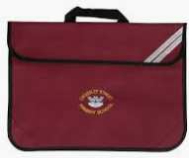
We request that you purchase our standard school bag with the school logo. This aids storage in school and helps to ensure correspondence between home and school get to you. The children like to put a personal keyring on their bags for easy recognition! Please ensure they bring their school bag to school every day.
Wellies 
We access the outdoors daily and in all weathers! We are also a Forest School with regular outdoor learning sessions. Please could your child have a pair of labelled wellies to keep in school.
Forest School and Outdoor Learning 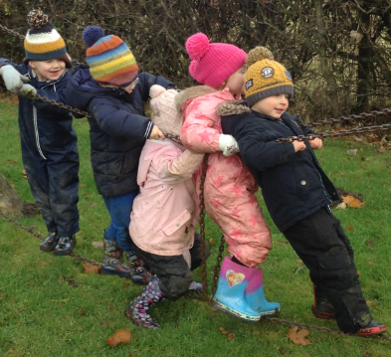
Your child will enjoy outdoor learning sessions and Forest School activities regularly in school. Please could you provide, on these days, waterproof outdoor clothing that, ideally, your child can put on and take off independently. Please always include a pair of labelled gloves and a hat as even in the warmer seasons these are often required!

Working with Parents
Your child’s journal is an important link between home and school. Regular contact between parents and staff is important to us. We very much promote an ‘open door policy’ and staff are readily available, with notice, to meet for a chat after school or at a mutual convenient time. There will be termly ‘Stay and Play’ sessions and a formal parents meeting early in the Spring term.
Parentmail 
We use Parentmail to share important information, dates and weekly newsletters with parents. You will be sent an email and text inviting you to register with parentmail. Please ensure you register for this prior to the start of term so you can receive any emails or text messages. If you have any problems registering, contact the school office for advice and support.

Marvellous Me
You will be asked to register with ‘Marvellous Me’ when your child starts in Nursery. This app is a great way of sharing class information, celebrating the children’s work in class and rewarding ‘badges’ for super work in class.
Wrap Around Care
Our ‘Kid’s First’ Breakfast and afterschool provision is available daily. The provision is available from 7.30am on a morning and afterschool care is available until 5.30pm. If you are interested in this for your child, please contact Mrs Joanne Ridley through the school office who will send you a Kids First brochure and registration/booking form.
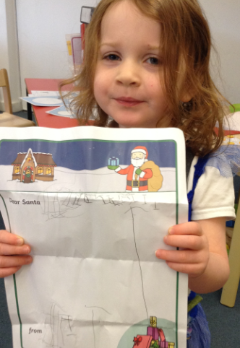 Early Reading and Writing 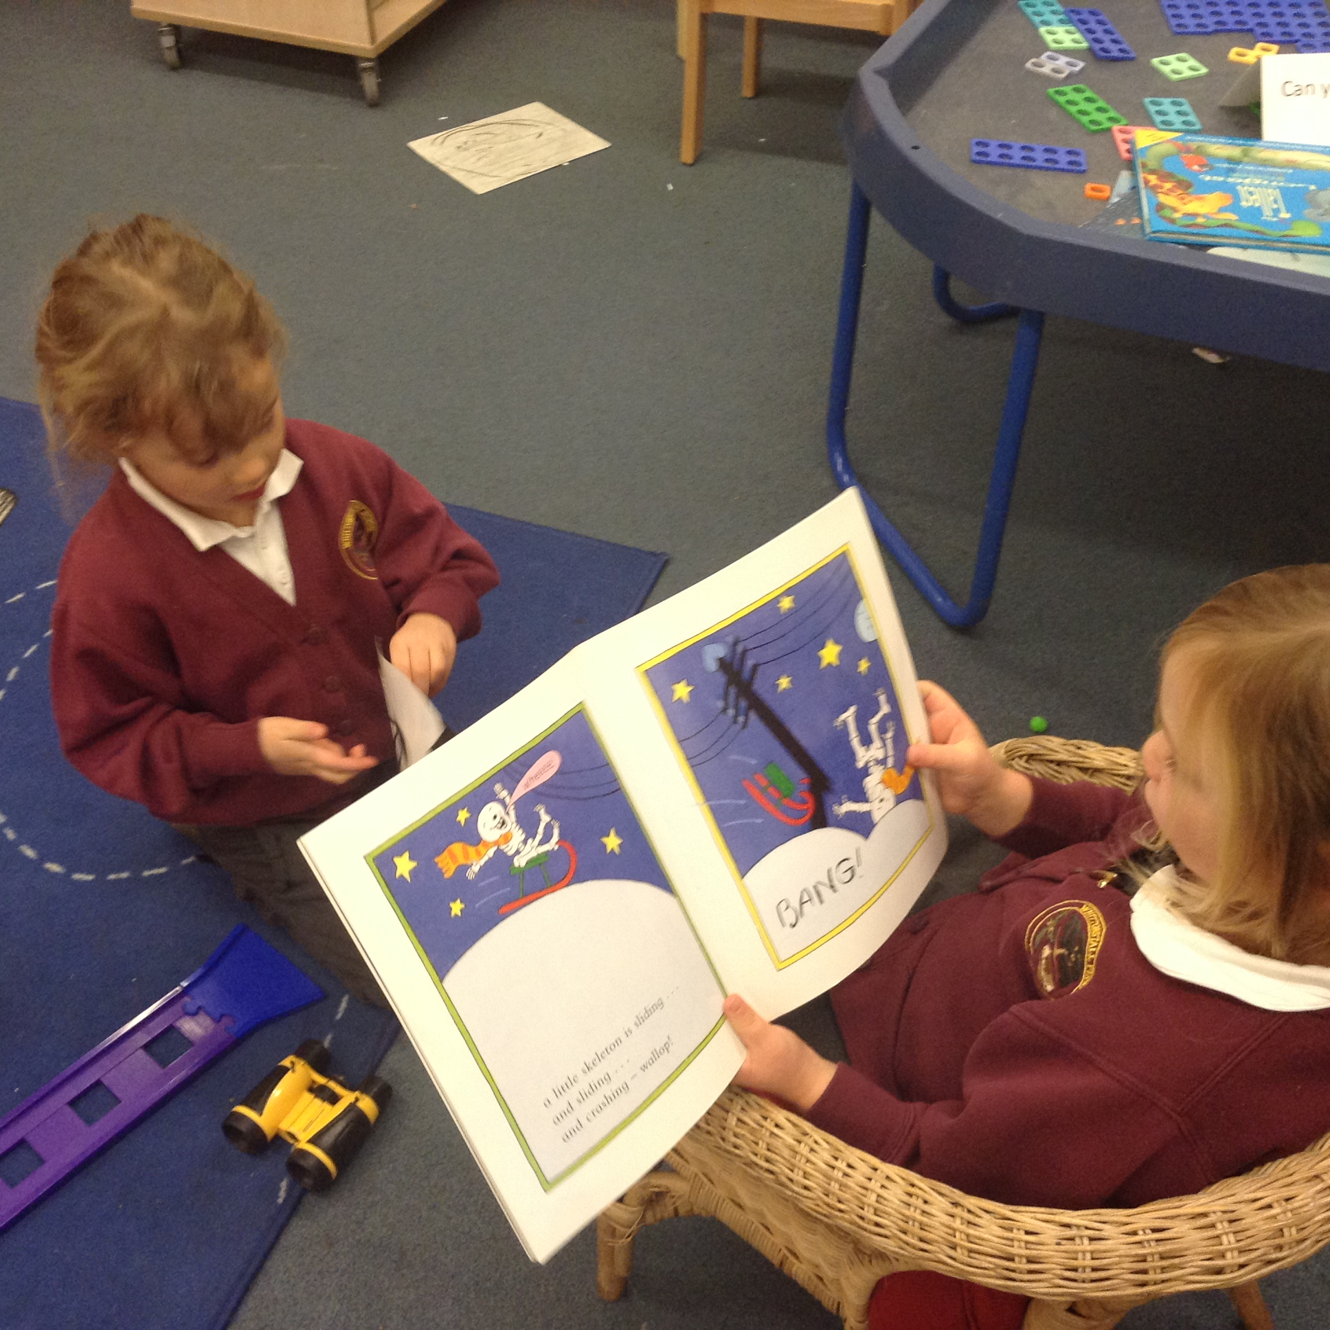
At Whittonstall we follow the phased ‘Letters and Sounds’ phonics programme and the Nelson Handwriting programme. We also use ‘Jolly Phonics’ to support early letter and sound recognition. In the Nursery year the focus is on developing sound listening skills and developing the children’s ability to tune into sounds and hear sounds in the world around them in words. They will also explore rhyme and rhythm through songs and stories and adult led games and activities.
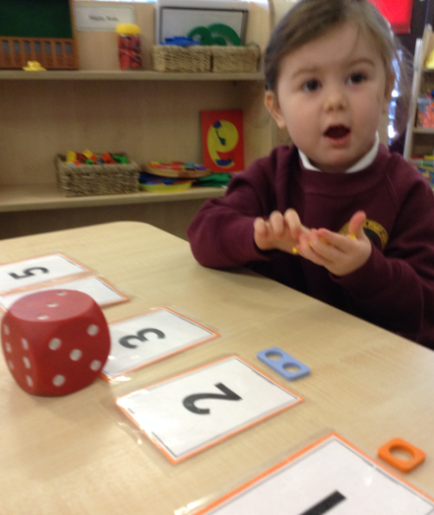 Early Maths Skills 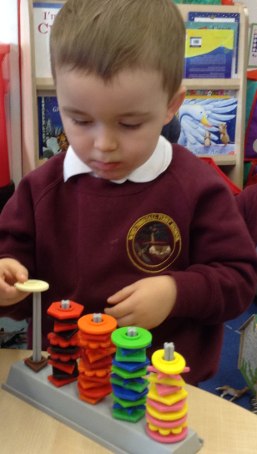
Play and child-initiated exploration of number is the focus of the early year curriculum. The children are encouraged to explore number, shape, space and measure through meaningful practical play using a balance of child-initiated and adult-led play and interactions. Key principles that are enbedded and how you can best support your child at home will be outlined in detail at the meeting for parents in the Autumn Term.

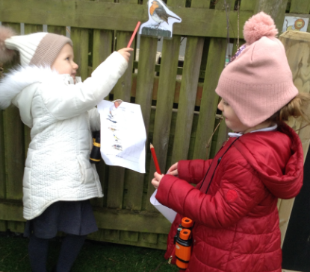 Communication and Language 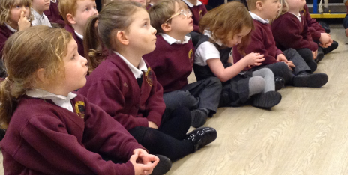
This is a very important focus in Nursery and is integral in all aspects of their learning and play. It is important that they develop sound listening skills and attention, can demonstrate understanding and speak effectively as they share their ideas, thoughts, needs and wants. These are all things you will be nurturing in your daily interactions with your child.

