Special Educational Needs


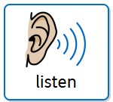
Information Report 2026-2027
Learning, creating and growing together.

Meet the SEND team
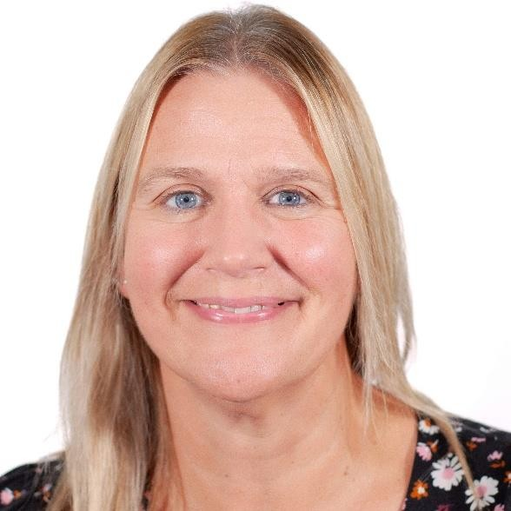
- Mrs Gordon  Mrs Woodward
- Headteacher  Special Education and
Disabilities Coordinator (SENDCo)

- Miss Green
- SEND Support KS2

Webheath School Vision and Values for SEND
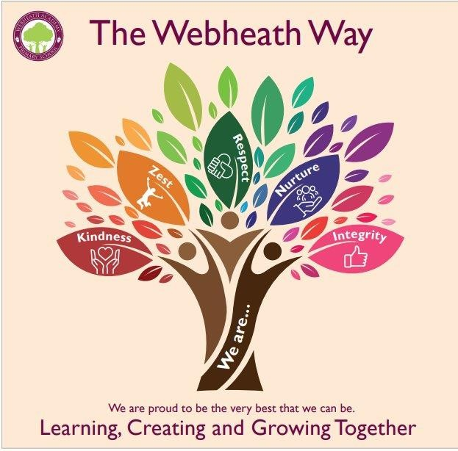
  - Inclusion is a key part of our values here at Webheath and we aim to interweave inclusion at every level and in every sense through our whole school offer.
  - We are passionate about helping all children to develop to their full potential and grow as confident individuals who are ready for their journey into adulthood.
  - At Webheath Academy Primary School, we recognise that all children are individuals, each with their own strengths and difficulties. We aim to teach children in the way that best supports their learning and this means that all children, from the most able to those with additional difficulties and needs, can achieve their full potential in our school.
  - Our values promote the nurture and inclusion of all children, particularly those with SEND, and encourage everyone to feel welcomed, supported and able to thrive.

Areas of Special Educational needs
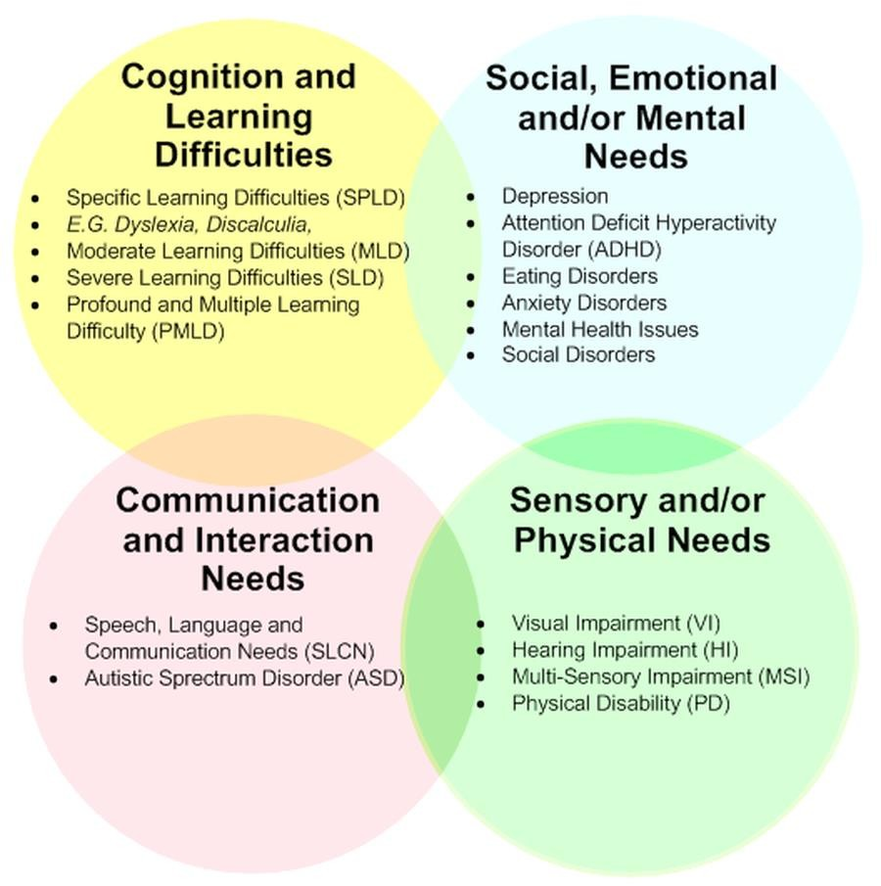
- Children are identified as having SEND, when they have a significantly greater difficulty in learning than most children the same age or have a disability which prevents or hinders them from making use of education facilities of a kind provided for children of the same age in schools within the area of the Local Authority (SEND Regulations 2015).
- The 4 Areas of Need are:
- Cognition and Learning
- Social, Emotional and Mental Health (SEMH) ➢ Communication and Interaction ➢ Sensory and Physical.
- Often, children and young people’s needs overlap and are rarely confined to one area, which is why it is important to gain a holistic view of your child.


Acronyms
Acronym | Meaning
SEND | Special Education Needs + Disabilities
IPM | Individual Provision Map
EHCP/EHC Plan | Educational Health Care Plan
SENDCo | Special Educational Needs + Disabilities Co-ordinator
LA | Local Authority
CAMHS | Children and Adult Mental Health Service
SALT | Speech and Language Therapist
SENDIASS | Special Educational Needs and Disabilities Information, Advice and Support Service
ASC | Autism Spectrum Condition
ADHD/ADD | Attention Deficit Hyperactivity Disorder
SEMH | Social, Emotional and Mental Health
SLCN | Speech, Language and Communication Needs

Page 1 Quick links:
- What should I do if I think my child has Special Educational needs?
- How does the school know if a child needs extra help?
- How will both school and I know how my child is doing?
- How will school help me support my child’s learning?
- How will the curriculum be matched to my child’s needs?
- How are the school’s resources allocated and matched to chi...
- How will the school decide the type of support my child wi...
- How does the school judge whether the support has had an ...
- How will my child be included in activities outside the c...
- What support will there be for my child’s overall well be...
This SEN Information report can be looked through page by page or you can use these ‘quick links’ to find answers to a specific question.
Page 2 Quick links:
- What training have the staff supporting SEND had or what ...
- How accessible is the school both indoors and outdoors?
- How are parents involved in the school? How can I get inv...
- How do children contribute their views about their suppor...
- What specialist services are available or can be accessed...
- How will the school prepare and support my child when tra...
- Who can I contact for further information or to complain ...
- The Local Offer
- School Contact details:
- What other support services can help me?
This SEN Information report can be looked through page by page or you can use these ‘quick links’ to find answers to a specific question.

What should I do if I think my child has Special
Educational needs?
- Parents/carers who are worried about their child’s learning, or who have concerns about additional needs are encouraged to discuss their concerns with their child’s class teacher.
- Class teachers will liaise with the SENDCo, and meetings will be arranged to discuss concerns and build a picture of your child’s individual strengths and needs.
- The school may carry out some diagnostic assessments, with your consent, to aid in targeting the right support for your child.


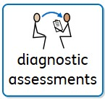
➢ Should parents/carers want to contact the SENDCo directly, they should do this via email or by calling the school office.
SENDCo; Mrs J Woodward
email; jwoodward@waps.shiresmat.org.uk
Tel; 01527 544820
- All teachers are teacher of SEND and are vigilant at raising concerns with parents/carers and the SENDCo. Class teachers meet with the SENDCo and Assessment Leader regularly to monitor progress, identify needs and celebrate achievement
How does the school know if a
child needs extra help?
- The identification of a child needing extra help can come from staff members, parents/carers, outside agencies or the child themselves.
- Class teachers and those supporting your children in their learning, work closely together to monitor progress over time and identify where extra help is needed.
- Extra help can be in the form of adaptive, quality first teaching, group or individual 'on the day' intervention, a specific intervention programme or if required individual targets written in an Individual Provision Map (IPM) or Passport.
- For specific issues, we may choose to draw upon the advice of key consultants to further explore the SEND needs of individuals.
- Parents/carers will be involved at all stages of the process.
How will both school and I know how my child is doing?
- In school we have a robust Monitoring and Evaluation cycle where teachers, teaching assistants, phase leaders and the senior leadership team, including the SENDCo, regularly monitor and report on progress. This is done formally through termly learning walks and pupil progress meetings as well as informally.
- Children received feedback as part of the teaching and learning cycle on their learning tasks. This can be to celebrate achievement or to provide guidance and support on how to improve.
- Parents/carers were invited to a range of opportunities to find out how their child was progressing such as;
- open classroom events
- two formal parents' evenings during the year
- a written report with the opportunity to discuss this with their child's class teacher.
- Student’s work uploaded to Showbie to view at home
- The families of children on the SEND register were invited to termly Structured Conversations to discuss their child's individual targets. At these meetings we were able to review the IPM together to decide collaboratively on the child's targets using the Assess, Plan, Do, Review cycle.
- Those children with an Education, Health & Care plan (EHCP) had structured conversation meetings as well as their annual review. Key workers for children who have an EHCP gave daily feedback to Parents/Carers.

How will school help me support my child’s learning? | - The individual structured conversation meetings have been an ideal opportunity for teachers and the SENDCo to share ways that parents/carers can support their child's learning. All targets were created collaboratively, and through discussion parents/carers know how they can support their child's learning both in school and at home.  - Individual Provision Maps ensure we have tailored and personalised targets for those children on the SEND register and our adaptive, high
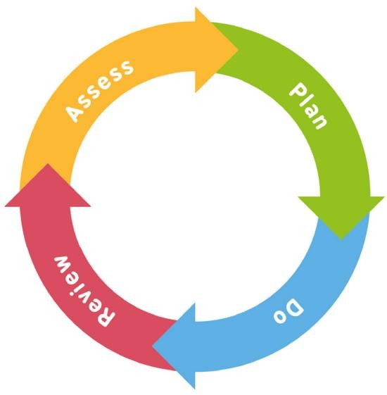
quality teaching methods ensure the curriculum is accessible to all.
- Homework tasks for children in KS2 were adapted for children on the SEND register and parents/carers were aware of expectations of their child.

How will the curriculum be  matched to my child’s needs? | ➢  ➢  ➢  ➢ | High quality, adaptive teaching is embedded in our curriculum with all teaching staff involved in continuous professional development during the year.  All our teachers and teaching assistants have a clear understanding of the expectations of high-quality universal provision, and this is monitored as part of the monitoring and evaluation cycle.  Our curriculum was structured to support meta-cognition and research on learning. We used;  - Lessons starting with a recall task/retrieval practice  - Regular practice of key concepts  - Spacing/interleaving of new information  IPMs outline the specific adaptive teaching strategies that support
individuals to access the curriculum.

- All children are supported to access the full, broad and balanced curriculum.
- Where a pupil has an Education, Health and Care Plan, a more individualised curriculum may be designed based on the recommendations of supporting specialists.
- As part of high quality, adaptive teaching, teachers provide resources to match the needs of the children in their class.
How are the schools' resources allocated and matched to  children’s special educational needs? | department which is closely monitored and aligned to the School Improvement Plan. Specialist equipment, facilities and professionals from outside agencies are financed through the SEND budget and these are arranged as part of the Assess, Plan, Do and Review Cycle, through discussion with the SENDCo.  - This is a context driven area and we use our finances to respond to the needs of each cohort.  - The Head Teacher, governors and school business manager oversee all matters of finance and we use our budget to respond to the needs of the children.
- In addition, the school provides a budget for the SEND

How will the school decide the type of support my child will receive?
- High quality adaptive teaching is at the heart of our provision and specific on-the-day, intervention supports learners to address their specific challenges and misconceptions.
- Teachers decide on additional support within each lesson which has been provided by them or a teaching assistant and have taken place within the classroom, outside the classroom, as 1:1 provision or in a small group.
- Where high quality adaptive teaching methods and in class intervention did not lead to the expected progress for an individual, additional support was sought, in consultation with the SENDCo and parents/carers.
- All additional interventions were short term and monitored for impact. It was the role of the SENDCo to oversee additional interventions, and regular updates were shared with the rest of SLT and with the SEND Governor.
- Additional interventions are;
- Rapid phonics, rapid reding, precision teaching, SNIP and Nessy
- 1stclass@number
- Speech and language
- Social and emotional support and mentoring
- Sensory circuits

How does the school judge whether the  support has had an impact? | - Our governors play an active role in monitoring the quality of our special educational needs provision, as does the Head Teacher, Senior Leadership Team and SENDCo. We have high expectations of all our teachers in meeting a range of needs. All interventions we put in place are research informed, evidence based and measured to monitor impact.  - Impact is discussed with parents at termly meetings to discuss children’s progress towards targets.  - Where we feel something is not working, we are quick to respond and find alternatives through dialogue with the class, children and
parents/carers. Our additional support programs are overseen by the SENDCo and all our teachers are teachers of inclusion and Special Educational Needs.

How will my child be included in
activities outside the classroom
including school trips?
- All children are involved in all aspects of our curriculum, including learning outside the classroom.
- Risk assessments are always carried out prior to activities outside the classroom, including educational visits and school trips, minimising the risk and ensuring the safety and inclusion of all.
- During the last academic year learning outside the classroom including educational visits:-
- The Botanical Gardens​

- Hartlebury Castle
- Tudor World
- Hatton Country World
- Kenilworth Castle​
- Thinktank
- Bishops Wood​
- Robinwood Activity Centre
- Morton Stanley Park
- Vue Cinema
- Swimming
- Local area studies
- Dudley Castle and Zoo
What support will there be for my child’s overall wellbeing?
- Our school provides a nurturing and caring environment for all, and our staff provide a high standard of support for the positive wellbeing of all children.
- We have a Supporting pupils with medical conditions policy and medical needs have been shared on a 'need-to-know' basis, ensuring high quality care and provision as well as appropriate levels of confidentiality.
- Our Positive Behaviour Policy, has been implemented by all staff, who are committed to creating an environment where exemplary behaviour is at the heart of productive learning and everyone is expected to maintain the highest standards of personal conduct, to accept responsibility for their behaviour and encourage others to do the same.
- We value the child voice and seek their contributions through evaluating their achievements and progress in lessons.
- Many of our Lunchtime and After School clubs focus on wellbeing and all children are encouraged to attend these.
- We have a specialist Pastoral Support lead who took children for additional social and emotional support in groups or for individual support
Supporting pupils with medical conditions (Shires MAT) Aut23.pdf - Google Drive
Positive Behaviour Policy 2022-2023.pdf - Google Drive
- We regularly monitored attendance and took the necessary actions to prevent prolonged unauthorised absences
What training have the staff
supporting SEND had or what are they having?
- All staff receive regular training, at Trust level, as part of the school training offer and to meet their personal training requirements.
- We regularly invest time and money in training our staff to improve delivery of high-quality adaptive teaching and targeted interventions as well as developing individual knowledge and skills.
- We have established relationships with professionals who support the school and all external partners we work with are vetted in terms of safeguarding. All additional services, are monitored to ensure a value for money.
- Teaching assistants who work with children with SEND have received specific training to support their role.
- Our SENDCo is a qualified teacher and holds the mandatory National SENDCo Award. All teachers have Qualified Teacher Status and support staff have the relevant qualifications for their role. One member of staff is completing the NPQ SENDCo qualification to further support the needs of children with SEND in school.
- Weekly staff meetings update on matters pertaining to special education needs and disability. Staff have had specific training on:
- Adaptive teaching strategies
- Supporting children with SEND
- ACES
- Dyslexia
- IPM reviews

How accessible is the school both indoors and outdoors? | - https://drive.google.com/file/d/1HLg6_UH186lJ7q7tH8lDRK5MsW7 xOmfQ/view?usp=drivesdk  - We are vigilant about making reasonable adjustments, where possible. Our policy and practice adhere to The Equality Act 2010. (https://www.gov.uk/guidance/equality-act-2010-guidance)  - We value and respect diversity in our setting and do our very best
- We have a full Accessibility Plan/Policy in place and as such, we consider our environment to be fully accessible to meet the needs of our children and their families. to meet the needs of all children.


How are parents involved in the
school? How can I get involved?
- Parents/carers are encouraged to be involved in their child's education and are a valuable part of our school community.
- Structured conversations for all parents/carers of children on the SEND register 3 times a year.
- Parent/carer consultations twice a year
- Open classrooms
- Friends Association
- Coffee mornings for parents/carers of children on the SEND register
- Parent/carer questionnaires
- Viewing children’s work online though ‘Showbie’
- Taking part in the school summer and Christmas Fairs
- Become a parent/carer ambassador
- Viewing their IMP Passports through Edukey

How do children contribute their  views about their support and who can help them? | - All children are encouraged to take part in 'Child Voice' activities, which include;  - Evaluating their achievements and progress in lessons.  - Being part of IPM review meetings and contributing to target setting.  - Each class has a School Council representative who can share children’s views at regular school council meetings.  - Children who are 'Looked after' regularly meet with the SENDCo
- Pupils’ views are at the heart of our support planning and their opinions will be gathered in a way that is appropriate for their developmental stage and individual needs.
/Designated Teacher to share their views.

What specialist services are
available or can be accessed by the school?
- We have links with outside agencies whose expertise we have called upon in individual cases when necessary.
- The expertise of outside agencies is called upon as part of the Assess, Plan, Do, Review and is collaborative decision between the SENDCo, Class Teacher and Parents/Carers.
- Outside agencies used are;
- Educational Psychologist – Dr D. Rouse
- Learning Support Team – Chadsgrove Support Services
- Complex Communication Needs Team – Chadsgrove Support Services
- Mentor Link
- Family Support Worker – Lisa Sinclair
- SALT services
How will the school prepare
and support my child when
transferring
classes or schools?
- When transferring classes within our school, all children have a transition day in July when they spend the day with their new class teacher and those who will support them in the following year.
- Children who are on the SEND register and other individuals who need additional support, spend extra time in their new classes, and have photographs of their new teacher, support staff and learning environment to take home over the summer holidays.
- Those childrenthat have an EHC plan or have some 1:1 support, will keep the same support for the following academic year if at all possible.
- All teachers have a robust handover from the previous class teacher, they can also access SEND information on the schools online systems.
- For children who are transferring to secondary school, we have particularly strong relationships with the secondary schools and offer a robust transition. We begin preparing children for transition in Year 5 by helping them to gradually develop their independence. During Year 6 at Webheath, all children are offered experience days at the receiving schools as well as transition days in July. Those children on the SEND register are offered additional transition experiences. We have a robust handover with staff at secondary schools and all paperwork is transferred in line with GDPR guidelines.
school, to hand over all information and paperwork, we also support transition days for these children.
- For those children who transfer 'in year' the SENDCo will meet with the child's new
Who can I contact for further
information or to complain about SEN issues?
- We operate an open-door policy, so please talk to your child's class teacher in the first instance.
- Further support can be gained from the Phase Leader, SENDCo, Assistant Head Teacher, Deputy Head Teacher or Head teacher.
- Complaints should be made using the school complaint form which can be found on the school website.
- Complaints Policy and Procedure (Shires MAT) May 23.pdf - Google Drive
- Complaints Form (Shires MAT) May 23.docx - Google Docs
Phase Leaders  Miss Z Pettit – EYFS Miss F Tyler– KS1  Mr M Mellor– LKS2 Mrs C Biddle- UKS2 | Senior Leadership Team  Mrs J Woodward – SENDCo  Miss E Clifton – Assistant Head Teacher  Mrs H Heffernan – Deputy Head Teacher Mrs R Gordon – Head Teacher

- In addition to the information on the school's website, parents/carers can access services through the Local Authority’s Local Offer which can be found on the Worcestershire Children First Website:
- What is SEND? | Worcestershire County Council
The Local Offer 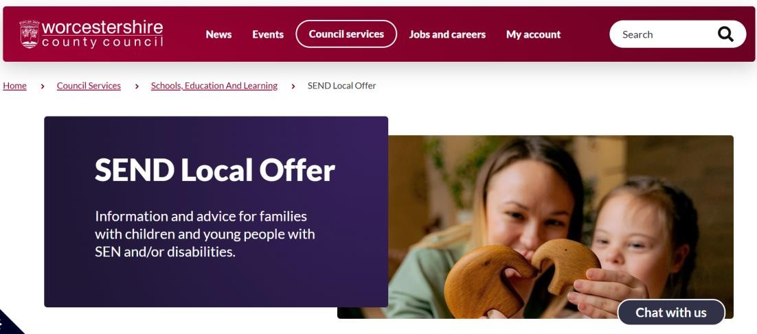
SENDCo

Mrs. J Woodward
Email - jwoodward@waps.shiresmat.org.uk
School Contact Tel- 01527 544820
details:Website - Webheath Academy | Learning, Creating and Growing
Together
SENDIASS
What other support services can help me? | The Dyscalculia Information Centre  The British Dyslexia Association  PDA Society
Young Minds
National Autistic Society
ASD Friendly
NSPCC

