

KIRFS Autumn 2 – Year 3

Target:  By the end of the term, you child should be able to ….  Know multiplication and division facts for the 3 times tables. | Activities to try at home  Interactive counting stick Times tables games  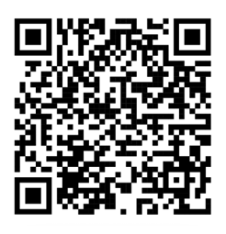  3 Times table song Number blocks Times tables games  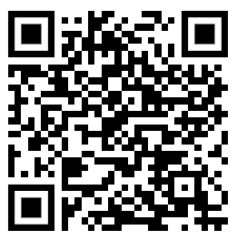  - 3 Times Table Snap - make cards with numbers from 1–12 and another set with their answers (3, 6, 9, 12, etc.). Take turns turning over cards. Players try to match the multiplication question with its answer, such as 3 × 5 and 15. The player with the most pairs wins.  - Times Table Treasure Hunt - Write 3-times-table questions on pieces of paper and hide them around the house. Children find a question, solve it, and then look for the next one.
Key Vocabulary
Multiply , Multiple , Four , Times, Calculation, Total, Lots of, Groups of, Equals, Divide, Share, Group.
Questions to ask
- What are 5 lots of 3?
- What is 3 x 7?
- How many 3s in 24?
- 3 x ? = 18,
- What is the cost of 5 cinema tickets at £3 each?
- What is 3 x 3?
- What is 78 ÷ 3?
- Complete the fact: 3 x __ = 12
- What is 10 x 3?
- If 3 x 9 = 27, what is 27 ÷ 3?

