Target:  By the end of this half term, you child should be able to:  - To say one more than a given number, up to ten | Activities to try at home  How old will you be on your next birthday?  Count fruit in the fruit bowl What would one more be?  Count the stairs as you come down. What number would the next step be?  Sing songs such as ‘One, Two, Three, Four, Five or Five Little Peas in a Pea Pod Press
Key Vocabulary

- Add
- More
- One
- Bigger

Questions to ask

Can you tell me one more?
What do you need to add?
How many did you have?
How many have you now?
Can you show me one more?

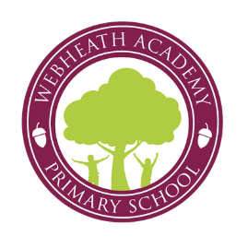
Key Instant Recall Facts
Reception Summer 1

