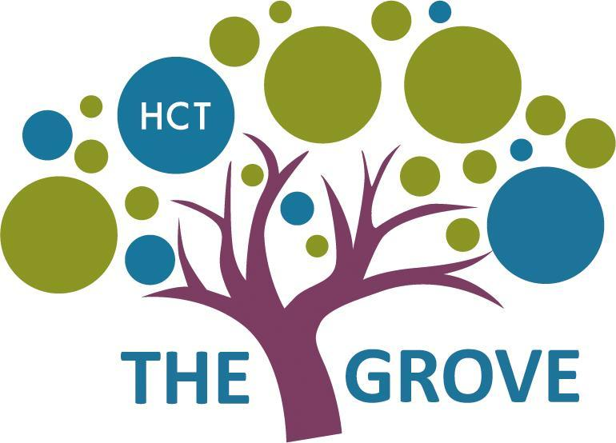

Careers Overview
The Grove School
2021-2022

The Grove Careers Overview |  | 2020-2021
School Context
Intent |  | At The Grove, we see learning about the World of Work as an important part of realising The Grove’s vision for its learners to “Inspire Excellence, Challenge Potential and Empower Learning”. It is through this vision that we aspire to ensure that every student is given every opportunity to experience the necessary skills in readiness for work. Furthermore, we aim to provide a range of experiences which enable them to make informed choices about life beyond school; preparing them for the next stage of their education or training.  Learning about work skills starts from the primary age at key stage 1 and 2, where students learn key functional skills through our life skills curriculum. These are built upon in key stage 3 so that students are ready to tackle the World of Work modules when they reach key stage 4. Our aim is that all students within key stage 4 experience a short block of work experience in the final term of year 11. Once students enter the Post 16 department, there is a heavy focus on work experience and work related learning.
Implementation |  | The Grove’s careers’ plan outlines how the school Careers Programme is designed to equip young people with the confidence and skills needed to prepare them for their future, which may include further/higher education, internships and apprenticeships and employment. This takes place through bespoke support starting in our primary department through to our post 16 department and through our life skills and PSHE curriculum. Our curriculum provides young people with opportunities to learn essential skills and enhance personal characteristics such as social skills, communication, independence and self-help. Our children will achieve personalised positive career outcomes such as identifying and choosing appropriate steps to take after post 16 and compulsory education as well as developing independent living skills, supported internships and work placements.
Impact |  | All young people from years 9-14 should receive careers support that is impartial, includes information on  a range of pathways, including apprenticeships or internships and is adapted to the needs of the child. All children from year 1 - year 9 will receive an introduction to careers skills and information embedded within their curriculum - mainly through PSHE and Life Skills.  Pupils will transition from The Grove into clear pathways for adulthood such as supported internships, apprenticeships or relevant college courses
Roles and  Responsibilities |  | This strategy is led and managed by Bronja Elton: Associate Assistant Head and Head of Post 16  Telephone: 020 3876 6555 Email: bronja.elton@thegroveschool.co.uk
Gatsby Benchmarks |  | The Grove School Careers Programme follows the recommendations outlined in the Gatsby Benchmarks.We aim to meet these in full by 2021 and use the SEND toolkit to ensure provision for our young people aligns with the high standards of personal provision outlined in our curriculum.
BENCHMARK 1 - A STABLE CAREERS PROGRAM
Every school and college should have an embedded programme of career education and guidance that is known and understood by Young people, parents, teachers and employers.
CRITERIA |  | HOW THE GROVE SCHOOL MEETS THESE
Every school should have a stable, structured careers programme that has the explicit backing of the senior management team and has an identified and appropriately trained person Responsible for it.  The careers programme should be published on the school’s website in a way that enables young people, parents, teachers and employers to access and understand it.  The programme should be regularly evaluated with feedback from young people, parents, teachers and employers as part of the evaluation process |  | - The Grove is committed to starting career development early and continuing throughout the school and the life of the pupil.  - A Careers lead is in place and direct input and support from the senior leadership team is given  - 1:1 careers sessions for pupils in year 10 and above through SCOPE with a level 6 careers advisor.  - Published careers strategy and programme on the website.  - Information is regularly shared to stakeholders via newsletters and website  - A robust career’s curriculum and career’s skills progression guide embedded across the school
BENCHMARK 2: LEARNING FROM CAREER AND LABOUR MARKET INFORMATION
Every pupil, and their parents, should have access to good quality information about future study options and labour market opportunities. They will need the support of an informed adviser to make the best use of available information.
CRITERIA |  | HOW THE GROVE SCHOOL MEETS THESE
By the age of 14, all young people should have accessed and used information about career paths and the labour market to inform their own decisions on study options. Parents should be encouraged to access and use information  about labour markets and future study options to inform their support to their children. |  | - Database of employers, both local and across London.  - Commitment to building strong relationships with local employers, providing opportunities for them to learn more about disability through visits and training.  - Use of NOMIS LAbour market information to disseminate where relevant to pupils and families attending the school.  - Cordinate with internship providers and pathways such as: Steps into Work, Mencap, The Autism Project and Project Search to provide students with both clear career pathways and first hand workplace information.
BENCHMARK 3: ADDRESSING THE NEEDS OF EACH PUPIL
Young people have different career guidance needs at different stages. Opportunities for advice and support need to be tailored to the needs of each pupil. A school’s careers programme should embed equality and diversity considerations throughout.
CRITERIA |  | HOW THE GROVE SCHOOL MEETS THESE
A school’s careers programme should actively seek to challenge stereotypical thinking and raise aspirations.  Schools should keep systematic records of the individual advice given to each pupil, and subsequent agreed decisions. All Young people should have access to these records to support their career development.  Schools should collect and maintain accurate data for each pupil on their education, training or employment destinations for at least three years after they leave the school. |  | - Careers strategy in line with our Policy on Equal Opportunities, which are also posted on our website.  - Triangulation of EHCP, Vocational profiles and Transition to Adulthood plans.  - Training delivered to staff on careers.  - Differentiated resources provided for all career related activities.  - EARWIG Tag and Track system to keep a record of achievement for pupils throughout the whole of their school journey - creating a report and record of achievement with photos and teacher narrative.  - Robust PSHE curriculum working alongside Careers.  - Life skills passport linked to careers skills where relevant to support progress.  - Personalised pathways and outcomes for pupils supported by OT, SALT, EHCP targets, Pastoral Lead and families.
BENCHMARK 4: LINKING CURRICULUM LEARNING TO CAREERS
All teachers should link curriculum learning with careers. For example, STEM subject teachers should highlight the relevance of STEM subjects for a wide range of career pathways.
CRITERIA |  | HOW THE GROVE SCHOOL MEETS THESE
By the age of 14, every pupil should have had the opportunity to learn how the different STEM subjects help people to gain entry to, and be more effective workers within, a wide range of careers. |  | - Teaching staff that deliver the curriculum recognise where this takes place and factor careers development into their planning.  - Where Science, Maths and Technology are taught as individual subjects, students are encouraged to investigate the roles and different career pathways within this sector.  - External visitors are brought in to deliver workshops and enrichment opportunities are there to highlight the pathways that could be taken and the skills required for a career in any of these subjects.  - A positive culture of shared knowledge and applied learning.  - Work based learning is an integral aspect of the school curriculum. Students in KS3, KS4 and KS5 participate in a variety of Worked based learning activities.  - Comprehensive travel-training programmes for specific students as well as incorporating travel training into life skills and other lessons across the curriculum.  - Life Skills Curriculum to develop greater independence and builds this into a life skills curriculum throughout the school at all ages.
BENCHMARK 5: ENCOUNTERS WITH EMPLOYERS AND EMPLOYEES
Every student should have multiple opportunities to learn from employers about work, employment and the skills that are valued in the workplace.

CRITERIA |  | HOW THE GROVE SCHOOL MEETS THESE
Young people should participate in at least one meaningful encounter with an employer every year between years 7-14.  Work with your regional LEP to make sure you are aligning to the strategic economic plan of the region. |  | - Dallaglio charity - Rugby Works: weekly sports sessions  - Dallaglio charity - Rugby Works: two employability workshops per year  - Dallaglio charity - Rugby Works: Sports Leadership  - Organiclea (Hawkswood Nursery)  - Forest Schools  - Enrichment and after school clubs  - Off site work experience: Morrisons/Heartlands/Timpsons etc  - Onsite work experience in different department  - Careers week activities - different external experience across all departments
BENCHMARK 6: EXPERIENCES OF WORKPLACES
Every pupil should have first-hand experiences of the workplace through work visits, work shadowing and/or work experience to help their exploration of career opportunities, and expand their networks.
CRITERIA |  | HOW THE GROVE SCHOOL MEETS THESE
By the age of 16, every student should have had at least one experience of a workplace, additional to any part-time jobs they may have. |  | - Engagement with employers for students from KS3 - KS5.  - Opportunities to work in different departments across both schools in the Trust, The Grove and Heartlands. Opportunities for pupils to shadow staff in roles that link to the pupils individualised targets towards adulthood on their EHCPs and Transition to Adulthood plans.  - Opportunities to meet both employers and employees,ask questions and gain experience of the workplace.  - KS4 and KS5 students have a wider range of work experience placements.
BENCHMARK 7: ENCOUNTERS WITH FURTHER AND HIGHER EDUCATION
All young people should understand the full range of learning opportunities that are available to them. This includes academic and vocational routes and learning in schools, colleges, universities and the workplace.

By the age of 16, every pupil should have had a meaningful encounter with a provider of the full range of learning opportunities. |  | - Information on colleges and opendays shared with parents  - Next steps information evening for prospective Post 16 parents  - 1:1 meetings with parents of Secondary East year 11 pupils who will transition outside of the Grove  - Updated website with pathways and options.  - PArtnership with Bsix college in Hackney to provide additional capacity for college experiences.  - Post 16 Open Evening  - Careers/Next Step events with access for all secondary pupils/families
BENCHMARK 8: PERSONAL GUIDANCE
Every student should have opportunities for guidance interviews with a Careers Adviser, who could be internal (a member of school staff) or external, provided they are trained to an appropriate level. These should be available whenever significant study or career choices are being made. They should be expected for all young people but should be timed to meet their individual needs.
CRITERIA |  | HOW THE GROVE SCHOOL MEETS THESE
Every student should have at least one such interview by the age of 16, and the opportunity for a further interview by the age of 18. |  | - 3 x 1:1 sessions with a SCOPE level 6 careers advisor  - Careers sessions delivered by the careers team

