The Dales Newsletter
22nd December 2023

Happy Christmas!

It has been a busy and fun-filled half term at The Dales, we even had a special visit from Santa himself! The children have enjoyed inviting their families into school for a Christmas event and have taken part in many Christmas activities.

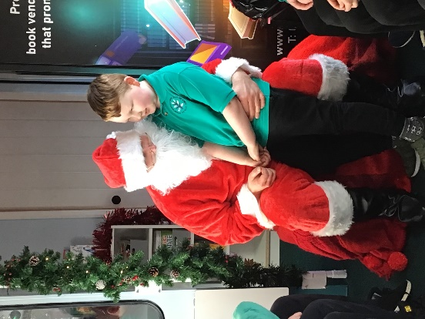
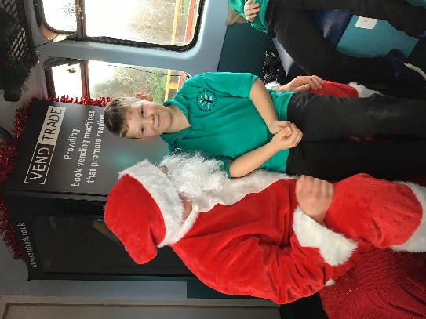

A big shout out to our Kitchen staff!
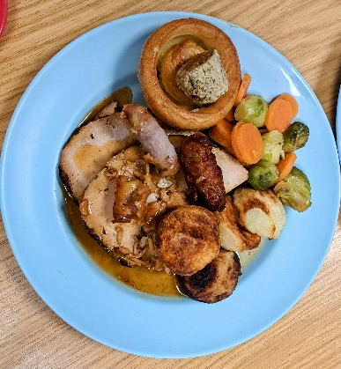
Thank you to Jo, Margaret and Jo’s Mum (our special visitor) for cooking and serving us all a delicious Christmas dinner. What a treat it was!
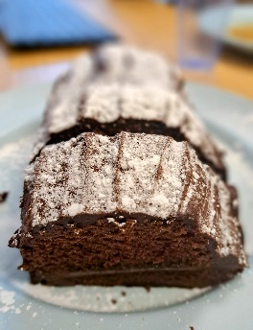

A farewell to our lovely Jackie Herron
Jackie has been with The Dales many years and has supported hundreds of children and staff over these years. Jackie is leaving us on the 19th January to work with adults who have experienced brain injury. We will miss her very much and we wish her all the best in her next adventure!

Thank you Jackie from The Dales Family!

Northumberland C.A.R.E project

Thank you for completing the questionnaire and for those families who joined our focus group around relationships and behaviour. We will keep you updated with the outcomes and our next steps in the New Year. Look out for upcoming workshops in the New Year!

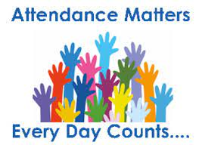

“Being in school is important to your child’s achievement, wellbeing, and wider development.” Department of Education

Safeguarding

The Dales School is committed to keeping all children safe. Our staff regularly participate in safeguarding training and are fully aware of how to keep our pupils safe and what signs to look out for. Our pupils know they can share any concerns and we have robust policies and procedures in place which underpin safeguarding all up to date policies can be found on our website. It is our paramount priority to keep all children healthy and safe. Our Designated Safeguarding Leads are:

Online Safeguarding this Christmas

#Wake up Wednesday is a really useful site and gives top tips to help you keep your children safe online. Below is an example of what you will find if you type #wakeupwednesday into google.

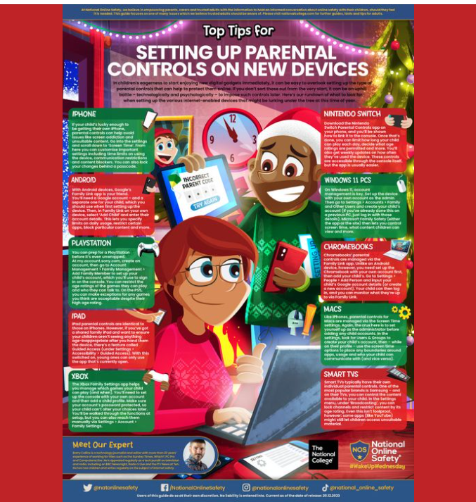

Talking Cameras

This term we welcomed photographers Madeleine Waller and Vickie Doyle to work with children in B11, B14, A3 and A5. The children found out about how light is used in photography and took photos using DSLR and Polaroid cameras and ipads. They had lots of fun learning new skills and were even able to share their learning with some of their parents.
The project has allowed us to purchase 20 iPad and 14 DSLR cameras to use in school. Next term Vicki and Lindsay Duncanson will be working with us to continue and develop the project.

Kids Clothing Café

To remind all parents/carers that we have a lovely selection of Children’s pre-loved clothing (free), in our Clothing Café at Blythdale

We also have a selection of pre-loved School Uniform.
If you would like to pop in for a coffee and browse, please contact us. Alternatively, please let us know sizes etc and we can send home some items (Don’t forget siblings as well !!
Contact Glynis or Tracy on 01670 352556Or Suzanne on 01670 336906

The Christmas Shop

We held our annual Christmas shop at Blythdale and it was once again very successful. Thank you to all who came and for the very generous donations and support.
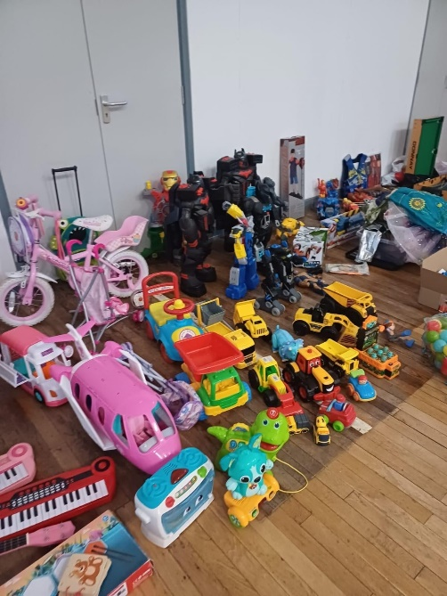
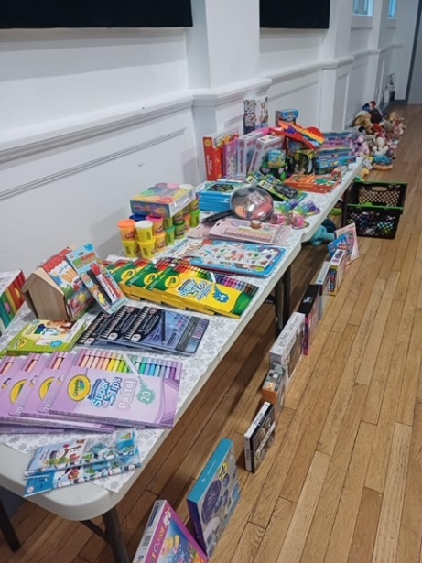

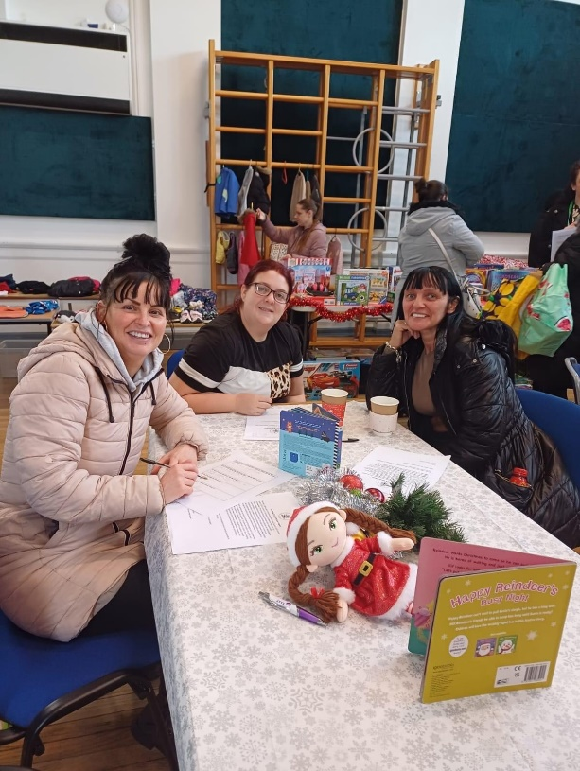

Dates for your diary

Monday 8th January | Return to school

We wish you all a very happy Christmas and we look forward to welcoming you back in the New Year.
Thank you for all of your support

