Energy Changes Mastery Booklet
In all chemical reactions, energy is either taken in from the surroundings or released to the surroundings.
If energy is released to the surroundings, the temperature of the surroundings will increase. We call these reactions exothermic.
If energy is taken in from the surroundings, the temperature of the surroundings will decrease. We call these reactions endothermic.
Remember that the thermometer counts as the surroundings. So if the temperature on the thermometer decreases, the reaction is endothermic. If the temperature on the thermometer increases, the reaction is exothermic.
 | Exothermic | Endothermic
Energy | Released to surroundings | Taken in from surroundings
Temperature of surroundings | Increases | Decreases
Examples | Combustion, respiration, self-heating cans, hand warmers | Thermal decomposition, citric acid and sodium hydrogen carbonate, sports related cold-packs

- The following experiment was used to compare how much heat energy three different fuels gave out when they were burnt.
Thermometer
Metal can

Fuel burner
100g water

Here are the results when 1.0 g of each fuel was burnt.
fuel | temperature of water at start | temperature of water at end
ethanol | 19ºC | 36ºC
paraffin | 20ºC | 47ºC
white spirit | 18ºC | 41ºC

Are the reactions exothermic or endothermic?
- Explain how you know your answer to Q1.
- What was the temperature change when 1.0 g of ethanol was burnt?
- Which fuel released the most energy when it was burnt?
- Why it is important to burn 1.0 g of each fuel in each experiment?
- The temperatures of reactions of zinc, magnesium and nickel with hydrochloric acid were measured.
The results are shown in the table.
metal | Temp at start ºC | Highest temp reached ºC | Temp change  ºC
nickel | 19 | 24 | 5
calcium | 19 | 57
zinc | 19 | 30 | 11
  - Calculate the temperature change for the calcium reaction.
  - Magnesium is more reactive than zinc but less reactive than calcium. Predict the temperature change for a reaction between magnesium and hydrochloric acid.
  - What name is given to reactions which give out heat?
- What temperature change will be observed for an endothermic reaction?
- Suggest another reaction which would give out heat.
- Write a word equation for the reaction between calcium and hydrochloric acid. If you cannot remember the products, go back in your notes to where we studied acids.
- Write a symbol equation for that reaction, including state symbols.
- Write an ionic equation for the reaction.
- Write half equations for the reaction and identify which substance has been oxidised and which has been reduced.
- In a different reaction, magnesium oxide is reacted with hydrochloric acid to make magnesium chloride and water.
  - Explain why the formula for magnesium chloride is MgCl₂ and not MgCl
  - What is the Mr of magnesium chloride and magnesium oxide?
  - If 30g of magnesium oxide are reacted with an excess of hydrochloric acid, what mass of magnesium chloride will be produced?
  - In two moles of magnesium chloride, how many chloride ions are there?
  - Hydrochloric acid is a strong acid. Explain what is meant by a strong acid.
  - Challenge: a student makes hydrochloric acid by dissolving 40g in 200cm³. Establish the concentration of this solution. The student takes 50cm³ of that solution. What mass of magnesium oxide would need to be added to neutralise that solution?
Measuring the temperature change
In order to measure the temperature change of a reaction, we can use a range of different apparatus. The most common will be either to mix a solid with a solution, or to use the reaction to heat up water. You could use a fuel burner for this (like the diagram on the first page) or any other substance, including food. The change in temperature allows you to work out if the reaction was endo or exothermic.
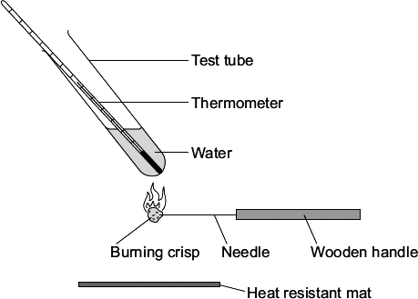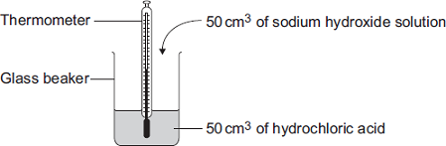
In each of the reactions energy is transferred from the reaction to the thermometer (or the reverse). To improve these you must make sure that no heat can escape to the environment so use a better insulator than a glass beaker or tube and put a lid on it.
- A student investigated the reaction of magnesium with hydrochloric acid. A piece of magnesium was dropped into the hydrochloric acid. Use your notes from when we studied acids to write a word equation for this reaction.
  - Extension: write a symbol equation for this reaction. Remember that you need to look at the charges of the ions to work out the formula of magnesium chloride
- In your answer to question 9, indicate which substances are reactants and which are products.
- In your answer to question 9, indicate which substances are elements and which are compounds
- Why does the mass of the substances decrease as the reaction goes on?
- The reaction is exothermic. Which two measurements would the student make to show that the reaction is exothermic? (hint – look at the table in question 6. Which two measurements have been taken?)
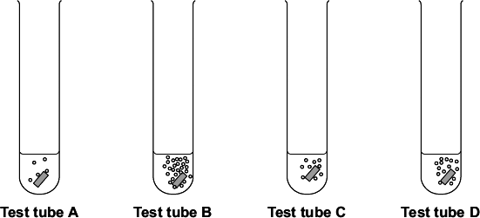
- How would the measurements from Q13 show that the reaction is exothermic?
- The student investigated how changing the concentration of the hydrochloric acid affects this reaction. Each test tube contained a different concentration of hydrochloric acid. The diagrams show the results of this experiment. Suggest one control variable in this investigation.
- Which test tube, A, B, C or D, contained the greatest concentration of hydrochloric acid?
- Explain your answer.
- Which test tube would show the smallest temperature change?
- How could the student improve the experiment’s design?
- Some students did an experiment to find the temperature change when hydrochloric acid reacts with sodium hydrogencarbonate. The results are in the table.
  - Describe, as fully as you can, the trends shown in the students’ results.
  - State the type of energy transfer for this reaction.
- Sodium hydrogencarbonate is used as baking powder for making cakes. When the cake mixture is baked the sodium hydrogencarbonate decomposes. The equation for the reaction is:
NaHCO₃(s) Na₂CO₃(s) + H₂O(g) + CO₂(g)
- Balance the equation.
- Write a word equation for this reaction.
- The cake mixture rises when baked. Use the equation to suggest why
- Sodium hydrogen carbonate is an ionic compound. Give two properties of sodium hydrogen carbonate.
- Explain why carbon dioxide is a gas at room temperature by making reference to its bonding and structure.
Reaction profiles
A reaction profile shows you the relative energy difference between the reactants and the products in a chemical reaction.
- For each of the reactions below, draw a reaction profile and state whether the reaction is exo or endothermic:
Reaction | Temp. at start (°C) | Temp. at end (°C)
zinc + sulfuric acid → zinc (II) sulfate + hydrogen | 21 | 51
nitric acid + sodium hydroxide → sodium nitrate + water | 22 | 28
potassium hydrogencarbonate + hydrochloric acid → potassium chloride + water + carbon dioxide | 21 | 9
silver (I) nitrate + copper → silver + copper (II) nitrate | 20 | 25
Challenge: write balanced symbol equations for the above
- The reaction between iron and oxygen is exothermic and produces iron (III) oxide. Construct a word equation for this reaction
- Construct a balanced symbol equation for this reaction.
- Iron oxide is an ionic substance. What state do you predict it will be at room temperature? Explain your answer.
- Oxygen is a simple molecular substance. Explain why it does not conduct electricity.
- Explain why oxygen has a low boiling point.
- Iron conducts electricity. Making full reference to its structure and bonding explain why.
- Draw a reaction profile for this reaction.
- In this reaction, iron has been oxidised. Explain what is meant by this term.
- How could someone produce pure iron from the iron oxide?
- Challenge: use half equations to show that iron has been oxidised and oxygen has been reduced in the reaction which forms iron oxide from iron and oxygen.

Bonds and energy changes
Whenever a chemical bond is broken, energy must be supplied. Different bonds require different amounts of energy.
When a chemical bond is formed, energy is released. Different bonds release different amounts of energy.
In a reaction, the bonds in the reactants are broken, and bonds in the products are formed. The first process requires energy, the second process releases it. If more energy is released than is required, the reaction will be exothermic. If more energy is required than released, the reaction will be endothermic.
We can therefore work out if a chemical reaction will be endothermic or exothermic by looking at the energy required to break the bonds in the reactants and the energy required to form the bonds in the products.
We can use a table like the below to work this out (don’t worry about the kJ/mol unit as we will deal with this later).

Bond | Bond Energy (kJ/mol) | Bond | Bond Energy (kJ/mol)
C-C | 347 | H-Cl | 432
C-O | 358 | H-O | 464
C-H | 413 | H-N | 391
C-N | 286 | H-H | 436
C-Cl | 346 | O=O | 498
Cl-Cl | 243 | NΞN | 945
C=O | 799 | C=C | 614
Worked example 1
A substance has a C-Cl bond and a C-N bond. How much energy is required to break these bonds?
The C-Cl bond in the table has 346kJ/mol. The C-N bond has 286kJ/mol. This means that overall 346+286 which is 632kJ/mol. This amount of energy is required to break the bonds.
Worked example 2
A substance is formed with an O-H bond and a C-O bond. How much energy is released when these bonds are formed?
The O-H bond has 464kJ/mol and the C-O bond has 358kJ/mol. This means that when they are formed we release 822kJ/mol.
Questions
- A substance has a C-H bond. How much energy is required to break its bond?
- A substance has four C-H bonds. How much energy is required to break its bonds?
- A substance has three C-H bonds and one C-Cl bond. How much energy is required to break all its bonds?
- A substance has one C-H bond and three C-Cl bonds. How much energy is released when it is formed.
- Hydrogen chloride is an atom of hydrogen bonded to an atom of chlorine. How much energy is required to break its bond?
- How much energy is released when the bond is formed?
- Draw a molecule of hydrogen chloride.
- HCl(g) is hydrogen chloride. What is HCl(aq)?
- Give the products for the reaction between HCl(aq) and Mg
- Explain why the mass of the reaction above appears to decrease.
- Give the symbol for a magnesium ion
- Give a half equation to show the formation of a magnesium ion
- Give a half equation to show the formation of H₂(g) from hydrogen ions
- A collection of four carbon atoms are all separate. When they all bond together is energy required or released?
- Nitrogen molecules consist of two nitrogen atoms with a triple bond between them. How much energy is required to break that bond?
- What is the Mr of a nitrogen molecule?
- How many moles are in 45g of nitrogen?
- What is the mass of 80 moles of nitrogen?
- Which has a greater mass, 80 moles of nitrogen or 80 moles of oxygen?
- How many atoms of nitrogen are there in 80 moles of nitrogen gas?
- 20g of a compound is dissolved in water. What information would you need to work out its concentration?
- How could you increase the concentration of the solution?

The energy required to break molecules
In the final section of this booklet we will look at how much energy is involved in a whole reaction. We will be using the molecules below.
- Complete the table to show how much energy is required to break all the bonds in the molecule and how much energy is released when all the bonds in the molecule are made. The first one has been done for you.
Formula | Structure | Energy required to break all the bonds | Energy released when all the bonds are made
H₂ | H-H | One H-H bond so 436 | Also 436
O₂ | O=O
H₂O | H-O-H
Cl₂ | Cl-Cl
HCl | H-Cl
CH₄ | 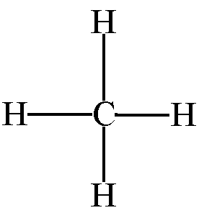 | There are four C-H bonds, so the total energy is:  413+413+413+413= 1652
CO₂ | O=C=O
C₃H₈ | 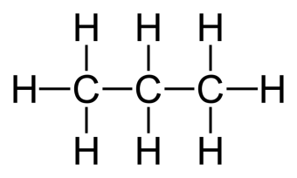
CH₂=CH₂ | 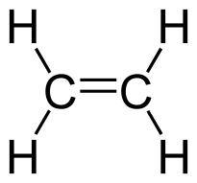
C₂H₆ | 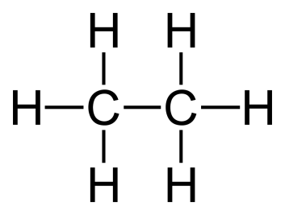
CH₃CH₂OH | 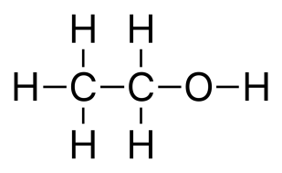

Working out the overall energy change in a whole reaction
The diagram below shows what occurs in terms of bonds breaking and being formed in the reaction:
2H₂ + O₂ 2H₂O
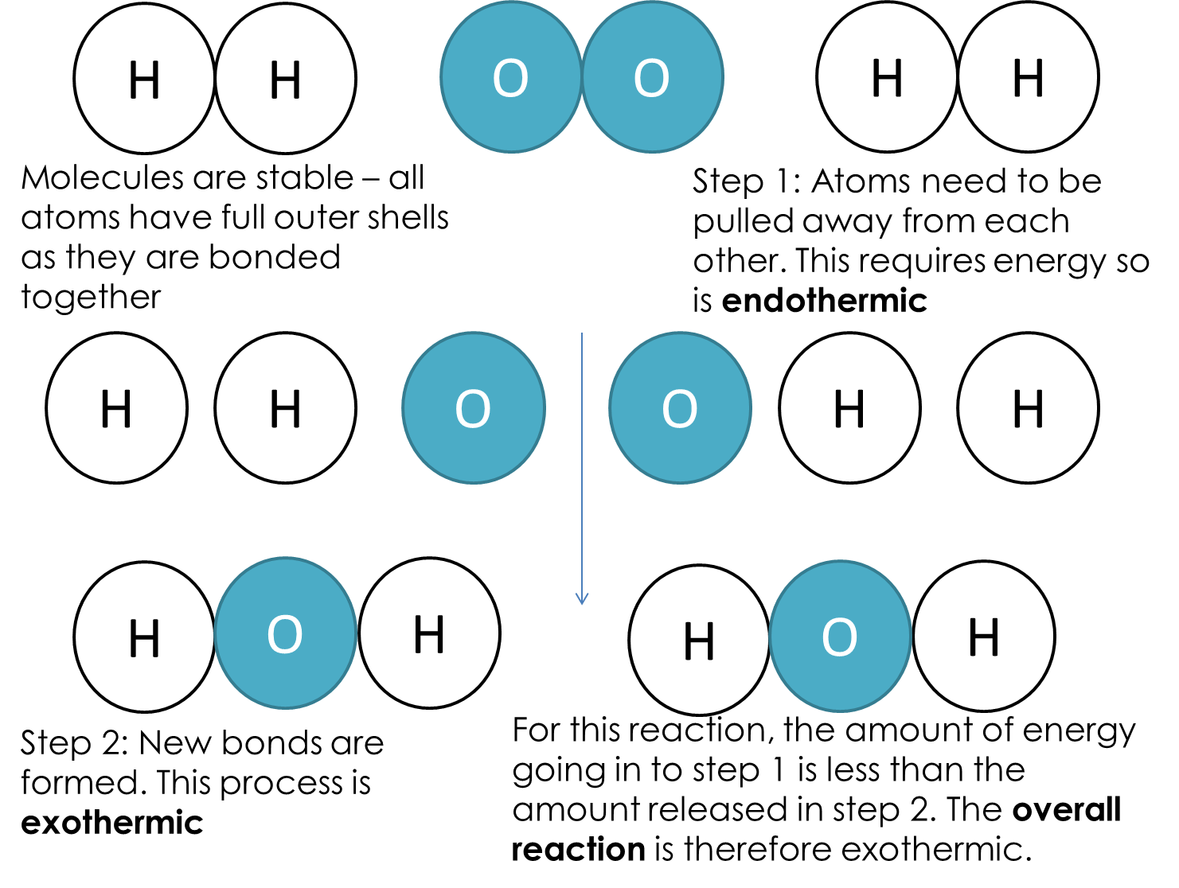
We can use the above to work out the overall energy change in a reaction. We will do two worked examples together on the board. The step by step guide is:
- Write out the full balanced equation
- Draw out all the molecules in the reactants and in the products
- Label each bond in each molecule with its energy
- Work out how much energy is required to break all the bonds in the reactants
- Work out how much energy is released when all the bonds in the products are formed
- Do 4-5
- If the answer is negative, the reaction is exothermic. If the answer is positive, the reaction is endothermic.
Questions
For each of the below, follow the steps to calculate the overall energy change. Each of the molecules can be found on page 6. The answers have been given to you as a guide but you must show how those answers are found.
- H₂(g) + Cl₂(g) → 2HCl(g) -185kJ/mol
- CH₄(g) + 2O₂(g) → CO₂(g) + 2H₂O(g) -806kJ/mol
- C₃H₈(g) + 5O₂(g) → 3CO₂(g) + 4H₂O(g) -2018kJ/mol
- CH₂=CH₂(g) + H₂(g) → C₂H₆(g) -123kJ/mol
- CH₃CH₂OH(g) → CH₂=CH₂(g) + H₂O(g) +40kJ/mol
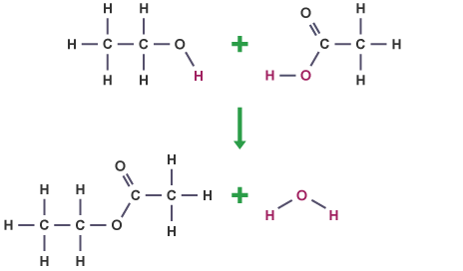
- Challenge: establish the overall energy change for the reaction on the right.
- Super challenge: calculate the mass of methane required to release 600kJ of energy

