Chemical Changes Mastery Booklet
This booklet covers:
- Formulae of ionic compounds
- Reactivity of metals
- Extraction of metals
- Acids
- Ionic equations
- Half equations
- Electrolysis

Part 1: Formulae of ionic compounds
Recap questions:
- Draw an atom of beryllium showing all its electrons
- Draw an atom of oxygen showing all its electrons
- In words, explain what occurs in terms of electrons when beryllium reacts with oxygen
- Draw out the two ions formed in this reaction
- Repeat the process, but for lithium reacting with oxygen
- Use the above to explain why the formula for lithium oxide is Li₂O but the formula for beryllium oxide is BeO
- Challenge: Predict the formulae of:

  - Lithium fluoride
  - Lithium nitride
  - Aluminium nitride
  - Aluminium chloride
  - Aluminium oxide
  - Magnesium nitride

There are many different ways to predict the formulae of ionic compounds, and your teacher will do a number of examples. In terms of working out which charge the ion has:
- Group 1: 1+
- Group 2: 2+
- Group 3: 3+
- Group 5: 3-
- Group 6: 2-
- Group 7: 1-
- Transition metals have their charge given by a Roman numeral, e.g. copper (II) is Cu²⁺
- Some ions can be compounds:
Name | Formula | Example
Ammonium ion | NH₄⁺ | Ammonium chloride, NH₄Cl
Hydroxide ion | OH⁻ | Calcium hydroxide. Ca(OH)₂
Sulphate ion | SO₄²⁻ | Sodium sulphate, Na₂SO₄
Carbonate ion | CO₃²⁻ | Calcium carbonate, CaCO₃
Nitrate ion | NO₃⁻ | Magnesium nitrate, Mg(NO₃)₂
Note that you use brackets to multiply the compound ion.
Practice – your teacher will do a number of the below as worked examples:
- Calcium chloride
- Calcium sulphate
- Lithium sulphate
- Lithium nitrate
- Aluminium bromide
- Aluminium oxide
- Aluminium nitrate
- Aluminium sulphate
- Ammonium iodide
- Ammonium sulphate
- Iron (II) sulphate
- Iron (III) sulphate
- Sodium nitrate
- Barium sulphate (think about what group it is in!)
- Copper (I) hydroxide
- Copper (I) sulphate
- Ammonium oxide
- Ammonium carbonate
- Aluminium hydroxide
- Copper (II) carbonate
- Beryllium fluoride
- Beryllium sulphate
- Vanadium (V) carbonate
- Manganese (VII) iodide
- Manganese (VII) sulphate

Part 2: Reactivity of Metals
Recap questions:
- Describe the structure and bonding in metals. You may use a diagram to help.
- Magnesium is a metal. Give three likely properties of magnesium.
- Explain why magnesium conducts electricity.
- Francium is a metal. It reacts with bromine (Br₂) to form francium bromide (FrBr). Write a word and symbol equation for this reaction.
Potassium
Sodium
Lithium
Calcium
Magnesium
(Carbon)
Zinc
Iron
(Hydrogen)
Copper
Gold
- 100g of Fr is used with 50g of bromine. Which is excess and which is limiting?
- 75g of Fr is reacted with an excess of bromine. How much FrBr is formed?
- FrBr is an ionic substance. Explain why it only conducts electricity when molten or dissolved in water.
- Fr is more reactive than Li. Explain why by making reference to its electrons.
- There are two isotopes of Francium, Fr-223 and Fr-221. Making reference to their numbers of protons, neutrons and electrons, discuss the similarities and differences between these two isotopes
- A sample of Francium is found to have an abundance of 81% Fr-223 and 19% Fr-221. Calculate the average mass of the atoms in this sample.
- Challenge: A similar sample is found to have a mass of 222.32. It contains 70% Fr-223, 22% Fr-221 and one other isotope. Calculate the mass of the other isotope.
A student heats up a piece of magnesium in air. It reacts with oxygen to make magnesium oxide. The student then heats up a piece of copper, but no reaction takes place. This is because different metals can have different reactivities: how easy it is for them to react.
- Which is more reactive, magnesium or copper? Explain your answer
- Write a word equation for the reaction of magnesium with oxygen.
- The formula for magnesium oxide is MgO. Write and balance a symbol equation for the reaction in Q2
- Label all reactants and products in the equations above.
A reaction where oxygen is added is called an oxidation reaction. If oxygen is removed, it is called a reduction reaction.
- Draw an atom of magnesium and an atom of oxygen.
- Use arrows to show what occurs when they react with each other.
- Draw the ions that are formed as a result of this reaction.
- Explain why this reaction is called an oxidation reaction
- In this reaction, the student started with 5g of magnesium. At the end of the reaction, they had 6.2g of magnesium oxide. Why did the mass increase?
- Magnesium oxide can also be turned into magnesium and oxygen. Write an equation for this reaction.
- What name is given to this type of reaction?
- Explain why oxygen has a low melting point.
- Explain why magnesium has a high melting point.
- Under what conditions will magnesium oxide conduct electricity?
- Challenge: which is more reactive: magnesium or calcium? Explain your answer.
The student takes the magnesium and puts it in a test tube with some acid in. The student notices that the acid starts to fizz quiet vigorously. The student takes the copper in and notices that it does not fizz at all. The student decides to try it again but with iron, and sees that it fizzes, but only a little bit.
- Put the three metals tested in order of their reactivity
- When iron atoms react, they form iron ions with a 3+ charge. What has happened to the iron atoms in terms of electrons?
- Why is it important that the student uses the same acid for each reaction?
- What else should the student try to keep the same?
- In the iron reaction, iron sulphate is formed. Iron sulphate has a formula of Fe₂(SO₄)₃. How many atoms are present in iron sulphate and what atoms are they?
- Challenge: what is it about some metals that make them more reactive than other metals?
Scientists use experiments like the one above to put metals into order by their reactivity. We call this the reactivity series. Most elements in the series are metals, but carbon and hydrogen are often included as well. In the series to the right, potassium is the most reactive and copper the least.
More reactive metals can displace less reactive ones, taking their place in a compound. For example, potassium reacts with sodium chloride to make potassium chloride and sodium. It has taken the place of the sodium in the chlorine.
Potassium + sodium chloride sodium + potassium chloride
However, this would not occur in reverse:
Potassium chloride + sodium no reaction
This is because sodium is less reactive than potassium so cannot displace it.
- For the element pairs below, state which is more reactive and which is less reactive
  - Calcium and lithium
  - Gold and copper
  - Sodium and iron
  - Zinc and copper
  - Copper and zinc
  - Iron and zinc
  - Iron and calcium
  - Sodium and lithium
- For each reaction below, state whether or not it would occur.
  - Magnesium oxide + calcium
  - Iron chloride + zinc
  - Copper bromide + gold
  - Zinc chloride + potassium
  - Iron sulphate + copper
  - Iron + lithium sulphate
  - Magnesium + iron oxide
- Write a word equation for the reaction of potassium with sodium chloride
- Explain why this is a displacement reaction
- When zinc reacts with iron bromide it forms zinc bromide and iron. Write a word equation for this reaction
- Identify any elements and compounds in the reaction
- How does this prove that zinc is more reactive than iron?
- When copper is added to lithium chloride no reaction takes place. Explain why this is the case.
- The reaction between calcium chloride and lithium is shown below. Copy the equation into your book and balance it.
CaCl₂ + Li LiCl + Ca
- In the reaction above, calcium chloride contains calcium ions. What charge do calcium ions have?
- Use your periodic tables to calculate the number of protons, neutrons and electrons in calcium, chlorine and lithium.
- Give the charges and relative masses of protons, neutrons and electrons.
- A student wishes to know how much gas will be produced when metal X, metal Y and metal Z react with water. The student collects and measures the amount of gas produced in one minute. Why is it important to always use one minute?
- The student notices that Y produces the most gas and X the least amount of gas. Write a reactivity series for the three metals.
- Which metal would react easiest with oxygen?
Metal | Extraction method
Potassium | Electrolysis: using electricity to split up the compound
Sodium
Lithium
Calcium
Magnesium
(carbon)
Zinc | Reduction with carbon: where carbon can remove the oxygen from a metal oxide
Iron
Copper
Gold | Mined from the Earth’s crust
- Metal X has three electrons in its outer shell. What charge will it form when it becomes an alloy?

Part 3: Extracting metals
We need metals for all sorts of uses, from electrical wiring to construction. Most metals are found as ores. An ore is a rock that contains enough of a metal compound in it to be worth extracting. Some metals are so unreactive that they can be found as elements in the Earth’s crust.
The way we extract the metal depends on its reactivity
Metals more reactive than carbon need electrolysis. Metals less reactive than carbon can be reduced by it.

An example of a reduction with carbon is:
Iron oxide + carbon iron + carbon dioxide
- Why is the reaction above an example of a reduction? Go back to the second paragraph on page 1 if you cannot remember.
- A scientist finds a rock with a very small amount of aluminium oxide in it. Explain why this rock cannot be called an Ore
- Francium is more reactive than lithium. How can francium be extracted from francium oxide?
- Aluminium is more reactive than zinc, but less reactive than magnesium. What more information would you need before you could say how aluminium should be extracted from aluminium oxide?
- Lithium. Iron and zinc are all placed in acid. Which one would react the most? Explain your answer.
- Zinc can be produced from zinc oxide by reduction with carbon. Write a word equation for this reaction
- Explain why gold is found naturally in the Earth’s crust.
- Silver is also found naturally in the Earth’s crust, but is more reactive than gold. Where would it go in the reactivity series.
- Lithium reacts with copper oxide to form lithium oxide and copper. Write a word equation for this reaction.
- The symbol equation is:
Li + CuO Li₂O + Cu
Copy the equation into your book and balance it.
- Explain why lithium has been oxidised and copper oxide has been reduced.
- Iron oxide reacts with sodium to form sodium oxide and iron.
- Write a word equation for this reaction.
- The symbol equation for this reaction is:
Fe₂O₃ + Na Na₂O + Fe
Copy the equation into your book and balance it.
- Identify what has been oxidised and what has been reduced.
- Potassium and zinc oxide are reacted together. Suggest the products of this reaction.
- What has been oxidised and what has been reduced? Explain your answer.

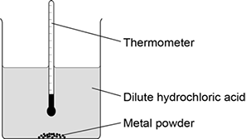
GCSE Practice Questions
Question 1: A student investigated the reactivity of different metals. The student used the apparatus shown in the figure to the right.
The student used four different metals. The student measured the temperature rise for each metal three times. The student’s results are shown in the table below.
Metal | Temperature rise in °C |  |  | Mean  temperature  rise in °C
 | Test 1 | Test 2 | Test 3
Calcium | 17.8 | 16.9 | 17.5
Iron | 6.2 | 6.0 | 6.1 | 6.1
Magnesium | 12.5 | 4.2 | 12.3 | 12.4
Zinc | 7.8 | 8.0 | 7.6 | 7.8
(a) Give two variables the student should control so that the investigation is a fair test.
(b) One of the results for magnesium is anomalous. Which result is anomalous? Suggest one reason why this anomalous result was obtained.
(c) Calculate the mean temperature rise for calcium.
(e) Aluminium is more reactive than iron and zinc but less reactive than calcium and magnesium. Predict the temperature rise when aluminium is reacted with dilute hydrochloric acid.

Question 2: A student investigated the reactivity of three different metals. This is the method used.
1. Place 1 g of metal powder in a test tube.
2. Add 10 cm³ of metal sulfate.
3. Wait 1 minute and observe.
4. Repeat using the other metals and metal sulfates.
The student placed a tick in the table below if there was a reaction and a cross if there was no reaction.

 | Zinc | Copper | Magnesium
Copper sulfate
Magnesium sulfate
Zinc sulfate
(a) What is the dependent variable in the investigation?
(c) The student used measuring instruments to measure some of the variables. Draw one line from each variable to the measuring instrument used to measure the variable.

Variable |  | Measuring instrument
 |  | Balance
 |  | Measuring cylinder
Mass of metal powder
 |  | Ruler
 |  | Burette
Volume of metal sulfate
 |  | Thermometer
 |  | Test tube
(d) Use the results shown in table above to place zinc, copper and magnesium in order of reactivity.
(e) Suggest one reason why the student should not use sodium in this investigation.
(f) Out of calcium, gold, lithium and potassium, which metal is found in the Earth as the metal itself?
(g) Iron is found in the Earth as iron oxide (Fe₂O₃). Iron oxide is reduced to produce iron. Balance the equation for the reaction.
___Fe₂O₃ + ___C → ___Fe + ___CO₂
(h) Name the element used to reduce iron oxide.
(i) What is meant by reduction?
Question 3: Metals are used in the manufacture of pylons and overhead power cables.
Suggest one reason why iron (steel) is used to make pylons.
(b) The table shows some of the properties of two metals.

Metal | Density in g per cm³ | Melting point in°C | Percentage(%) relative electrical conductivity | Percentage(%) abundance in Earth’s crust
copper | 8.92 | 1083 | 100 | 0.007
aluminium | 2.70 | 660 | 60 | 8.1
Use the information in the table to suggest why aluminium and not copper is used to conduct electricity in overhead power cables.

Part 4: Acids
Acids are substances that have a pH of less than 7. Alkalis have a pH of more than 7. A pH of 7 exactly is called a neutral solution.
The three main acids are:
- Hydrochloric acid: HCl(aq)
- Nitric acid: HNO₃(aq)
- Sulphuric acid: H₂SO₄(aq)
Each of these splits up into ions when dissolved in water:
- HCl splits into H⁺ and Cl⁻
- HNO₃ splits into H⁺ and NO₃⁻
- H₂SO₄ splits into 2H⁺ and SO₄²⁻
It is the H⁺ which makes them acidic, and the pH scale is based on how much H⁺ there is present. The more H⁺, the lower the pH.

1. Reactions of acids with metals
When a metal is added to acid, it will react to form a salt and hydrogen gas. A salt is a compound where the hydrogen from an acid has been replaced with a metal. For example:
Calcium + sulphuric acid calcium suphate + hydrogen
Ca(s) + H₂SO₄(aq) CaSO₄(aq) + H₂(g)
Here, the hydrogens from the sulphuric acid have been replaced by calcium.
- Hydrochloric acid makes metal chlorides
- Nitric acid makes metal nitrates
- Sulphuric acid makes metal sulphates

- Complete the table below. The first one has been done for you
Formula of salt | Name of salt | Original metal | Original acid
NaCl | Sodium chloride | Sodium | Hydrochloric acid
LiCl
CaSO₄
MgSO₄
KNO₃
- Write a word equation for the reactions between:
  - Aluminium and hydrochloric acid
  - Magnesium and hydrochloric acid
  - Calcium and nitric acid
  - Beryllium and sulphuric acid
  - Iron and sulphuric acid
- Write a word equation for a reaction which forms:
  - Aluminium sulphate
  - Calcium chloride
  - Barium nitrate
  - Rubidium chloride
Challenge: write symbol equations for every reaction in Q1 and Q2

Part 5: Ionic equations
We will return to acids shortly. Earlier, we looked at how different metals formed different ions. If they are in group 1, they form 1+, if they are in group 2 they form 2+ and in group 3 they form 3+. If they are in the central block, there will be a roman numeral to tell you the charge. For example, Iron (III) is the Fe³⁺ ion.
- Complete the table below. Some have been done for you.
Atom | Ion | Atom | Ion | Atom | Ion
Li | Li⁺ | Be |  |  | Al³⁺
Na |  | Mg | Mg²⁺ |  | Fe²⁺
K |  |  | Ca | Iron (III) | Fe³⁺

Remember that the ions from acids are: Cl⁻, NO₃⁻ and SO₄²⁻. When the metal ion combines with the ion from an acid to make a salt, the charges must balance. For example:
When magnesium reacts with hydrochloric acid, it forms magnesium chloride.
Magnesium forms Mg²⁺
Hydrochloric acid forms Cl⁻
I need two chlorine ions for each magnesium ion so the formula for magnesium chloride is MgCl₂.
Worked example 1
What is the formula for magnesium nitrate?
Magnesium forms Mg²⁺
Nitric acid forms NO₃⁻
I need two nitrate ions for every magnesium ion so the formula for magnesium nitrate is Mg(NO₃)₂.
Worked example 2
What is the formula for lithium sulphate?
Lithium forms Li⁺
Sulphuric acid forms SO₄²⁻
I need two lithium ions for every sulphate ion so the formula for lithium sulphate is Li₂SO₄
- For each of the salts formed in question 2 and question 3 write out the symbol formula.
- Complete the equations:
  - Mg + H₂SO₄ _____________ + H₂
  - 2Li + 2HNO₃ 2_____________ + H₂
  - 2Al + 6HNO₃2 ____________ + 3H₂
  - 2Fe(III) + 6HCl 2____________ + 3H₂
- For the equations below, you will need to balance and complete:
  - Mg + HNO₃ _______________ + H₂
  - Fe(III) + HNO₃ _______________ + H₂
  - K + H₂SO₄ _______________ + H₂
  - Li + H₂SO₄ _______________ + H₂
- Write out full word and symbol equations for each of the below:
  - A reaction between iron (II) and nitric acid
  - A reaction between barium and sulphuric acid
  - A reaction between strontium and hydrochloric acid
  - A reaction between aluminium and sulphuric acid
  - A reaction between gallium and nitric acid

Part 5: Ionic equations
In each of the reactions above, ions are involved and change charges. We can use an ionic equation to illustrate this.
Worked example 3:
For the reaction between magnesium and hydrochloric acid construct a balanced equation and an ionic equation.
We can use the above to write a word equation:
Magnesium + hydrochloric acid magnesium chloride + hydrogen
Mg(s) + HCl(aq) MgCl₂(aq) + H₂(g)
First the equation must be balanced:
Mg(s) + 2HCl(aq) MgCl₂(aq) + H₂(g)
Next, we need to split the ionic substances into ions. Remember that in order to have free ions it must:
- Have an (aq) or (l) symbol
- Be ionic, so either:
  - An acid
  - Or an ionic compound (has a metal and a non-metal)
In our case, HCl and MgCl₂ are the only ionic substances which can split up.
Mg(s) + 2H⁺(aq) + 2Cl⁻(aq) Mg²⁺(aq) + 2Cl⁻(aq) + H₂(g)
We can remove the spectator ions (the ions which are unchanged by the reaction):
Mg(s) + 2H⁺(aq) + 2Cl⁻(aq) Mg²⁺(aq) + 2Cl⁻(aq) + H₂(g)
Mg(s) + 2H⁺(aq) Mg²⁺(aq) + H₂(g)
Worked example 4
For the reaction between magnesium and nitric acid construct a balanced equation and an ionic equation. Below is a summarised version of what we did above.
Word equation | Magnesium + nitric acid magnesium nitrate + hydrogen
Symbol equation | Mg(s) + HNO₃(aq) Mg(NO₃)₂(aq)+ H₂(g)
Balanced symbol equation | Mg(s) + 2HNO₃(aq) Mg(NO₃)₂(aq)+ H₂(g)
Ionic equation | Mg(s) + 2H⁺(aq) + 2NO₃⁻(aq) Mg²⁺(aq) + 2NO₃¹⁻(aq) + H₂(g)
Ionic equation without spectator ions | Mg(s) + 2H⁺(aq) Mg²⁺(aq) + H₂(g)

- For each of the reactions in question 103105 construct an ionic equation

Part 6: Half equations
In each of the reactions above, the metal loses electrons and the H⁺ ions from the acid gain them. We can see this from constructing half equations from ionic equations. This means that the metal is oxidised and the hydrogen ions are reduced.
Worked example 5:
Using the half equation from worked example 3, construct a pair of half equations to show which substance is losing electrons and which is gaining.
Mg(s) + 2H⁺(aq) Mg²⁺(aq) + H₂(g)
In this case, magnesium has gone from no charge to a charge of 2+. This means it must have lost two electrons:
Mg(s) Mg²⁺(aq) + 2e⁻
This reaction is oxidation
The hydrogen ions have gained two electrons:
2H⁺(aq) +2e⁻ H₂(g)
This reaction is reduction
- For each of the ionic equations in question 106 construct half equations.

Acids continued: 5. Metal Hydroxides
An alkali is a metal hydroxide which is soluble (dissolves in water). The hydroxide ion is OH⁻.
Worked example 6:
State the formula for sodium hydroxide and for calcium hydroxide:
Sodium forms Na⁺ ions
The hydroxide ion is OH⁻
These two balance out sot the formula is NaOH
Calcium forms Ca²⁺ ions
The hydroxide ion is OH⁻
Two hydroxide ions are needed for each calcium ion so the formula is Ca(OH)₂
- State the formulae for the hydroxides of: lithium, potassium, calcium, aluminium, magnesium, iron (II), iron (III), zinc (II) and beryllium

6. Alkali + acid salt + water
Whenever an acid reacts with an alkali, a salt and water are formed. This is called a neutralisation reaction because you start with an acid but end up with a neutral solution: a solution with a pH of 7. For example, when sodium hydroxide reacts with hydrochloric acid, the reaction below takes place:
Sodium hydroxide + hydrochloric acid sodium chloride + water
The symbol equation for this is:
NaOH(aq) + HCl(aq) NaCl(aq) + H₂O(l)
The ionic equation is:
Na⁺(aq) + OH⁻(aq) + H⁺(aq) + Cl⁻(aq) Na⁺(aq) + Cl⁻(aq) + H₂O(l)
Once you remove the spectator ions you are left with:
OH⁻(aq) + H⁺(aq) H₂O(l)
Which is the ionic equation for all acid + alkali reactions.
For each of the reactions below, write:
  - A word equation
  - A balanced symbol equation (assume that all hydroxides are dissolved in water)
  - An ionic equation

- Potassium hydroxide and hydrochloric acid
- Magnesium hydroxide and hydrochloric acid
- Sodium hydroxide and nitric acid
- Sodium hydroxide and sulphuric acid
- Iron (III) hydroxide and sulphuric acid

7. Acid and base
Bases are any metal hydroxide or oxide which is insoluble in water. Remember that the oxide ion is O²⁻.
- Write the formula for the oxides of lithium, potassium, calcium, aluminium, magnesium, iron (II), iron (III), zinc (II) and beryllium

8. Metal oxide + acid salt + water
The products are exactly the same as for acid + alkali but because the metal oxides are insoluble we do not need to write ionic equations for them.
For each of the reactions below, write a word equation and balanced symbol equation:
- Potassium oxide and hydrochloric acid
- Magnesium oxide and hydrochloric acid
- Sodium oxide and nitric acid
- Sodium oxide and sulphuric acid
- Iron (III) oxide and sulphuric acid

9. Metal carbonate + acid salt + water + carbon dioxide
When a metal carbonate reacts with an acid it forms a salt, water and carbon dioxide. The carbonate ion is CO₃²⁻. Because carbonates are also insoluble, we do not need to write ionic equations.
State the formula for calcium carbonate and for sodium carbonate:
Calcium forms Ca²⁺ ions
The carbonate ion is CO₃²⁻
These are balanced out so the formula is CaCO₃
Sodium forms Na⁺ ions
The carbonate ion is CO₃²⁻
Two sodium ions are needed for each carbonate ions so the formula is Na₂CO₃
- State the formulae for the carbonates of: lithium, potassium, calcium, aluminium, magnesium, iron (II), iron (III), zinc (II) and beryllium
Example of writing the equations for a metal carbonate + acid:
Word equation:
Lithium carbonate + hydrochloric acid Lithium chloride + water + carbon dioxide
Symbol equation:
Li₂CO₃(s) + 2HCl(aq) 2LiCl(aq) + H₂O(l) + CO₂(g)
For each of the reactions below, write a word equation and balanced symbol equation:
- Potassium carbonate and hydrochloric acid
- Magnesium carbonate and hydrochloric acid
- Sodium carbonate and nitric acid
- Sodium carbonate and sulphuric acid
- Iron (III) carbonate and sulphuric acid

pH
The pH of a solution tells us how acidic or alkaline it is. Low pH means it is very acidic. pH measures how many H⁺ ions there are in solution so more H⁺ means more acidic and a lower pH.
The pH scale does not work like normal quantities. If we take length for example, a 2m plank is twice the length of a 1m plank, and half the length of a 4m plank. The distance between 1m and 2m is the same as between 2m and 3m.
With pH, the distances are not the same, but increase by 10. If something has a pH of 1, it is not twice as acidic as something with a pH of 2, but ten times as acidic.
Example: a solution has a pH of 1, and 1000g of acid in it. What mass of acid would be needed for a pH 2?
We know that there will need less acid for a higher pH, and that pH 1 is ten times more acidic than pH 2. Therefore, 1000/10 = 100, so 100g would need to be added.
Example 2: a solution has a pH of 5, and 70g of acid in it. What mass of acid would be required for pH 2?
We know that to go from pH 5 to pH 4 we need to multiply by 10, so we would have 7g acid. To get from pH 4 to 3 multiply by 10 again to 70g, then from pH 3 to pH 2 by 10 again to 700g.
Questions:
- A substance has 40g of acid in it and is pH 2.
  - What mass of acid would be required for pH 1?
  - What mass of acid would be required for pH 3?
  - What mass of acid would be required for pH 4?
- A certain solution has 12050 H⁺ ions in it and has a pH of 3.
  - How many H⁺ ions would need to be added for a pH of 1?
  - How many H⁺ ions would need to be taken away for a pH of 5?

Strong, weak, dilute, concentrated
All acids have molecules ionise (turn into ions) when they are in water, and all of them release H⁺. However, for some acids, not all their molecules ionise when in water. These are called weak acids, as they do not release as much H⁺ as they could. In strong acids all the molecules ionise when in water, releasing a lot more H⁺.
Concentrated or dilute relates simply to how much acid there is in the water. If I add only a little acid to the water, it is a dilute acid. If I add a lot of acid, it is concentrated.
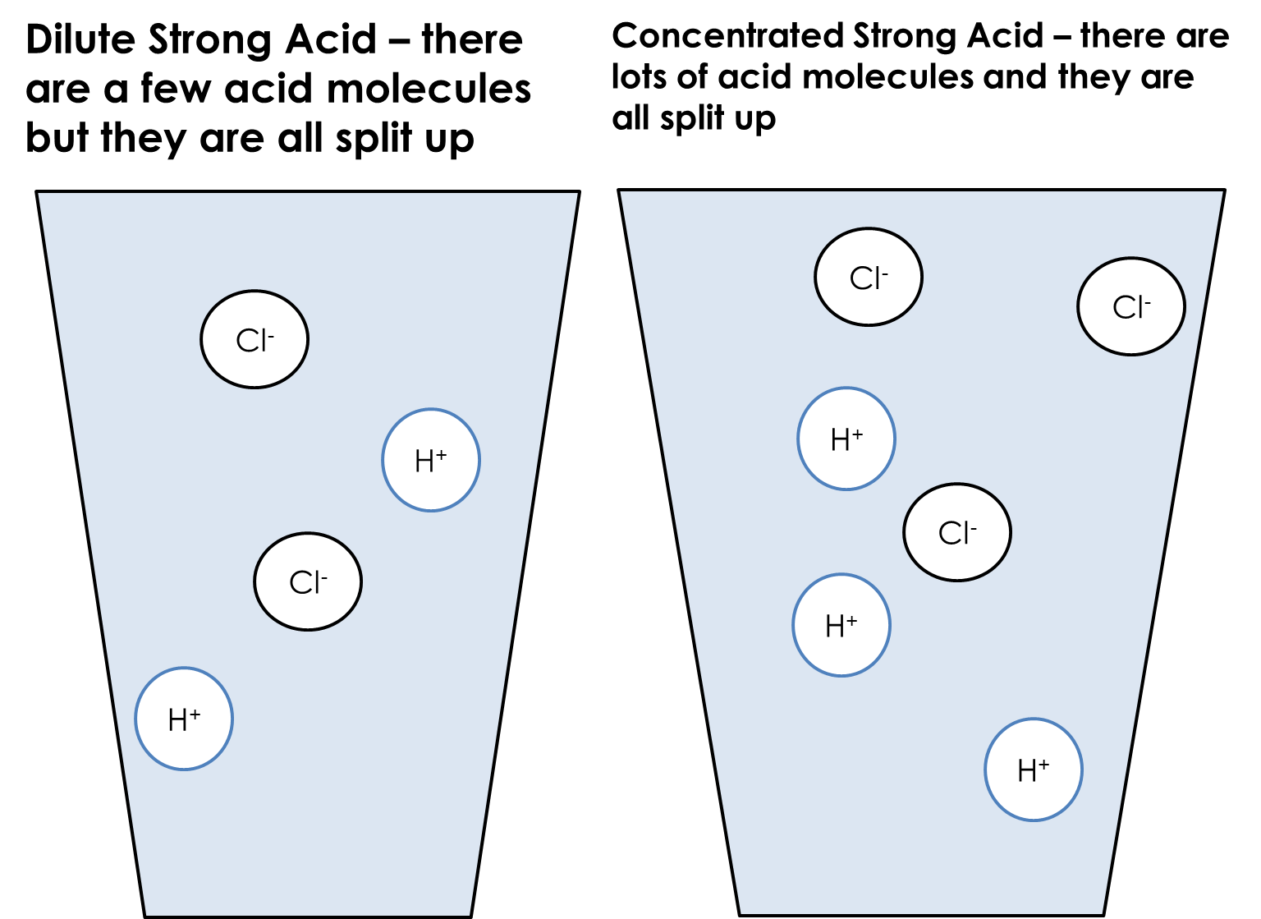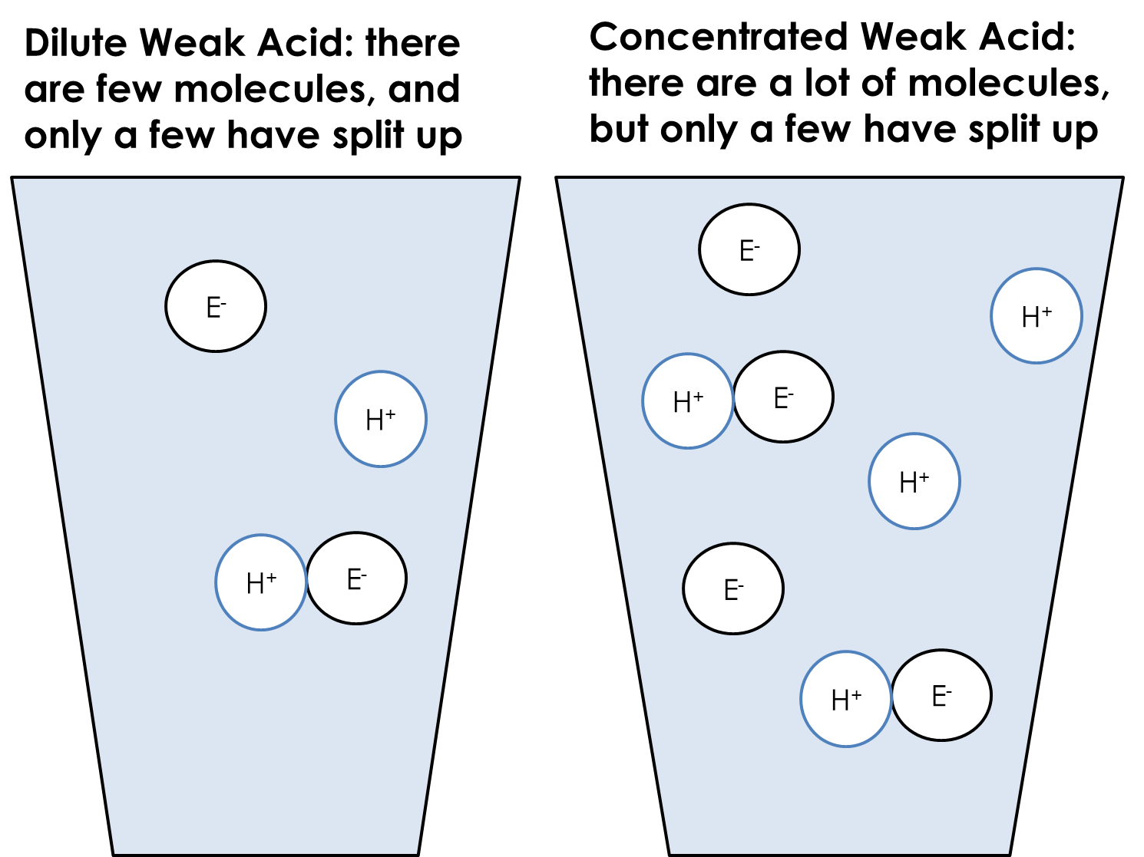

- Sulphuric acid is a strong acid. Explain what this means
- Which ions does sulphuric acid split up into?
- 2g of sulphuric acid is dissolved in water, and the pH is found to be 2. What mass of acid would be required for a pH of 1?
- Complete the table below, using the words “high,” “medium” or “low” to represent pH. The first one has been done for you.
 | Concentrated | Dilute
Strong acid | Low
Weak acid
- Write a word equation for the reaction between sulphuric acid and sodium hydroxide
- Write a symbol equation for this reaction
- Write an ionic equation for this reaction
- 10g of acid is dissolved in water, followed by another 10g. What happens to the pH?
- In terms of the number of H⁺ ions in solution, explain why a strong acid has a lower pH than a weak acid.
Back to metal extraction
We saw that a displacement reaction is one where a more reactive element takes the place of a less reactive one in a compound, for example:
Fe(s) + CuSO₄(aq) FeSO₄(aq) + Cu(s)
We can write an ionic equation for this:
Fe(s) + Cu²⁺(aq) + SO₄²¹(aq) Fe²⁺(aq) + SO₄²⁻(aq) + Cu(s)
Cancel the spectator ions:
Fe(s) + Cu²⁺(aq) Fe²⁺(aq) + Cu(s)
We can then write half equations for this too:
Fe(s) Fe²⁺(aq) + 2e⁻
Cu²⁺(aq) + 2e⁻ Cu(s)
This shows that iron has been oxidised and copper has been reduced.
- In a reaction, solid sodium displaces iron from iron (II) sulphate solution:
Na + FeSO₄ Na₂SO₄ + Fe
  - Balance the equation
  - Add state symbols to the equation
  - Write an ionic equation for this reaction
  - Use half equations to show that sodium has been oxidised and copper ions have been reduced
- Repeat the above process for reactions between:
  - Na(s) + LiOH(aq) NaOH(aq) + Li(s)
  - Ca(s) + MgCl₂(aq) CaCl₂(aq) + Mg(s)
  - Ca(s) + Fe₂SO₄(aq) CaSO₄(aq) + Fe(s) (the charge on the iron ion in iron sulphate is 3+)
- Sodium is more reactive than lithium. Explain why.
We can also do the same process with the displacement reactions of the halogens. In a reaction between lithium bromide and chlorine, the chlorine displaces the bromine because it is more reactive:
LiBr(aq) + Cl₂(aq) LiCl(aq) + Br₂
First, we balance the equation:
2LiBr(aq) + Cl₂(aq) 2LiCl(aq) + Br₂
Then, we write an ionic equation (Cl₂ is covalent so does not split into ions)
2Li⁺(aq) + 2Br⁻(aq) + Cl₂(aq) 2Li⁺(aq) + 2Cl⁻(aq) + Br₂(aq)
Cancel spectator ions:
2Br⁻(aq) + Cl₂(aq) 2Cl⁻(aq) + Br₂(aq)
And we can also now write half equations:
Cl₂(aq) + 2e⁻ 2Cl⁻(aq)
2Br⁻(aq) Br₂(aq) + 2e⁻
Showing that chlorine has been reduced and bromide ions have been oxidised
- Repeat the process above for the reaction:
LiCl(aq) + F₂(aq) LiF(aq) + Cl₂
- Repeat the process above for the reaction:
MgI₂(aq) + Br₂(aq) MgBr₂(aq) + I₂(aq)
- Explain why there is no reaction between sodium chloride and bromine
- In the reaction above between lithium bromide and chlorine, 10g of lithium bromide is used.
  - How much chlorine will be needed for a complete reaction?
  - What mass of lithium chloride will be produced?
- Lithium chloride solution conducts electricity. Explain why.
- A solution of lithium chloride is made with 20g of lithium chloride in 100cm³ of water. Calculate its concentration in g/dm³ (triple only – calculate also in mol/dm³).
- Explain why fluorine is more reactive than iodine.
Summary problem
This question is about the extraction of copper, an important metal in a number of settings.
- Copper is a metal. Describe the structure and bonding of copper.
- Copper can be alloyed with other elements to make it harder. Explain why an alloy of copper is harder than pure copper
- Copper conducts electricity. Explain why.
- Copper is a very good thermal conductor. Explain why.
- Copper exists in a number of isotopes. What is an isotope?
- Copper can react with oxygen to form copper oxide (CuO)
  - Write a word equation for this reaction
  - Write and balance a symbol equation for this reaction
  - Identify all elements, compounds, reactants and products in your equation
  - If 50g of copper is reacted in an excess of oxygen, what mass of copper oxide will be formed?
  - What is meant by an “excess” of oxygen?
- Copper be extracted from copper oxide by reacting it with carbon. This is called reduction.
  - What is meant by reduction?
  - Write a word equation for this reaction
  - Construct and balance a symbol equation for this reaction
  - What mass of carbon will be needed to react with 75g of copper?
- Copper can react with some acids to form salts.
  - Copper cannot react with some acids because they are weak acids. What is meant by weak acid?
  - Copper reacts well with concentrated hydrochloric acid. What is meant by concentrated acid?
  - Write a word equation for the reaction between copper and hydrochloric acid which forms copper (II) chloride and hydrogen
  - Explain why the mass of this reaction appears to decrease over time
  - Write a symbol equation for this reaction (including state symbols)
  - Construct an ionic equation for this reaction
  - Construct half equations for this reaction
  - Identify which substance has been oxidised and which has been reduced

Part 7: Electrolysis
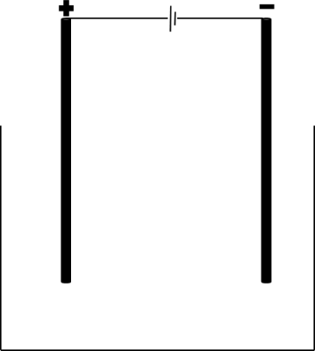
Electrolysis is the process of using electricity to split apart ionic compounds. The compounds can either be molten (liquid) or in a solution. The basic apparatus for electrolysis is always very similar:
Power source
Negative electrode: cathode
Positive electrode: anode
Container
The compound to be split up goes in the container. It is called the electrolyte.

A useful mnemonic to remember the names of the electrodes is PANIC: positive anode, negative is cathode.
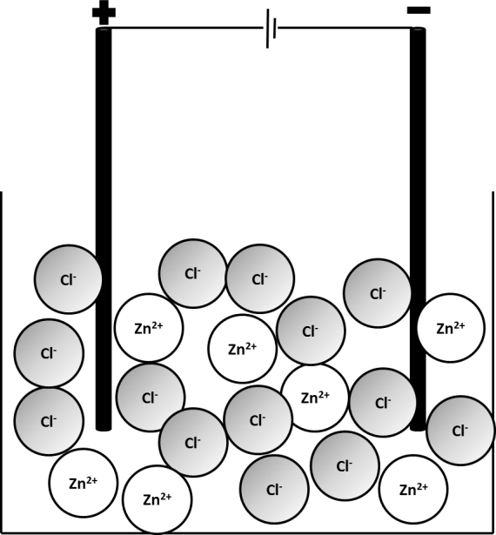
- A student is to electrolyse sodium chloride. If the sodium chloride is a solid, what must be done to it before it can be electrolysed?
- What is the electrolyte in this case?
- List the apparatus required to electrolyse sodium chloride

Electrolysis of liquids
Ionic compounds need to be molten or in solution for electrolysis to work. This is because the charged particles that make them up (ions) need to be free to move to the electrodes.
The positive ion (always a metal) will travel to the cathode, where it will gain electrons to become an element,
The negative ion (the non-metal) will travel to the anode, where it will lose electrons to become an element.
The example below involves electrolysis of molten zinc chloride, ZnCl₂(l). When zinc chloride is melted, the ions which make it up become free to move. The Zn²⁺(l) will travel to the cathode and the Cl⁻(l) will travel to the anode.
Pure zinc metal will be produced at the cathode and chlorine will be produced at the anode.
- In the electrolysis of zinc chloride, what is the electrolyte?
- In the electrolysis of each of the molten compounds below, state which elements will be produced:

  - Zinc iodide
  - Lithium bromide
  - Iron fluoride
  - Sodium oxide
  - Potassium chloride

- For each of the compounds in question 5, state at which electrode each element will be produced.
- Deduce the formulae of each of the compounds in question 5
- Why can electrolysis not be performed on covalent substances?
- Why can electrolysis not be performed on metals?

Redox and half equations recap
In previous units, we have learnt that:
- Oxidation is Loss of Electrons
- Reduction is Gain of Electrons
In the electrolysis of zinc chloride, Zn²⁺(l) gains two electrons to form Zn(s). This can be represented by a half equation:
Zn²⁺(l) + 2e⁻ Zn(s)
This occurs at the cathode. At the anode, Cl⁻(l) turns into Cl₂(g). This can also be represented by a half equation:
Cl⁻(l) Cl₂(g) + e⁻
This is not balanced as we need two Cl⁻ ions in order to form Cl₂. Each of those ions will lose one electron so two electrons are lost overall:
2Cl⁻(l) Cl₂(g) + 2e⁻
Example 2: electrolysis of NaCl(l)
NaCl(l) will split up into Na⁺(l) and Cl⁻(l). Na⁺(l) will travel to the cathode where it will be reduced to form Na(s). Cl⁻(l) will travel to the anode where it will be oxidised to form Cl₂(g).
Na⁺(l) + e⁻ Na(s)
2Cl⁻(l) Cl₂(g) + 2e⁻
Ideally, there should be the same number of electrons in each half equation so we multiply the first equation by 2:
2Na⁺(l) + 2e⁻ 2Na(s)
2Cl⁻(l) Cl₂(g) + 2e⁻
- Copy the table below into your exercise book. Add 7 empty rows.
Formula | Positive ion | Negative ion | Element formed at cathode | Element formed at anode | Half equation at cathode | Half equation at anode
ZnCl₂ | Zn²⁺(l) | Cl⁻(l) | Zn(s) | Cl₂(g) | Zn²⁺(l) + 2e⁻ Zn(s) | 2Cl⁻(l) Cl₂(g) + 2e⁻
- Complete the table for the electrolysis of the compounds:

  - NaCl
  - NaBr
  - KI
  - CaCl₂
  - AlBr₃
  - Na₂O (to form oxygen gas)
  - Al₂O₃

- Define an ore
- Why is gold found naturally in the Earth’s crust?
- Why is electrolysis not necessary to extract iron from iron oxide?
- What properties would you expect iron oxide to have?
- When iron (III) oxide is reacted with carbon, iron and carbon dioxide are produced. Write a word equation for this reaction
- A student has a sample of calcium chloride from which they want to extract pure calcium. Why is electrolysis of calcium oxide required to extract pure metal calcium?
- Challenge: write a balanced symbol equation for the reaction in 16. Remember that you will have to deduce the formula of iron oxide (it isn’t FeO!)
- Challenge: deduce the formula of vanadium (V) oxide and give half equations for its electrolysis

Electrolysis of aluminium oxide
Because aluminium is more reactive than carbon, it must be extracted using electrolysis. Electrolysis requires a lot of energy so scientists have to find ways to minimise the energy use
Aluminium oxide’s melting point is very high so we mix it with a substance called cryolite which brings down the melting point.

At the cathode, Al³⁺(l) is reduced to Al(s):
Al³⁺(l) + 3e⁻ Al(l)
Al is formed as a liquid as the temperatures used are so hot.
At the anode, O²⁻(l) is oxidised to O₂(g):
2O²⁻(l) O₂(g) + 4e⁻
The electrodes are made of carbon. When the oxygen gas is produced, it reacts with the carbon to make carbon dioxide:
C(s) + O₂(g) CO₂(g)
This means that gradually the anode wears away over time and needs to be replaced. This is another cost to consider in the production of aluminium.
- Explain why the formula of aluminium oxide is Al₂O₃ and not AlO₃
- Balance the equation:
Al + O₂ Al₂O₃
- In terms of electrons, explain how aluminium reacts with oxygen to form aluminium oxide.
- In terms of its bonding and structure, explain why aluminium oxide has a high melting point.
- Explain why aluminium oxide needs to be molten before it can be electrolysed.
- In the electrolysis of aluminium oxide, the electrodes are made of graphite. Explain how graphite can conduct electricity.
- Why must the anodes be regularly replaced?
- Sometimes, the anodes react with oxygen to form carbon monoxide (CO). Write a balanced symbol equation for this reaction.
- Is electrolysis an exothermic or endothermic change?
- Explain your answer.

Electrolysis of solutions
If an ionic compound is soluble, then we can electrolyse its solution as the ions become free to travel through the water. If we take NaCl as an example, when it is dissolved in water we obtain Na⁺(aq) and Cl⁻(aq).
We would expect to therefore obtain pure Na at the cathode. However, the element produced actually depends on the reactivity of the elements involved.
- If the metal is more reactive than hydrogen, hydrogen gas will be produced at the cathode
- Unless the non-metal is a halogen, oxygen gas will be produced
This is because water can also be electrolysed, breaking down to form hydrogen and oxygen. The process by which water is electrolysed works as follows:
First, water breaks apart into ions: H₂O(l) H⁺(aq) + OH⁻(aq)
The hydrogen ions are attracted to the cathode where they gain electrons and form hydrogen gas:
2H⁺(aq) + 2e⁻ H₂(g)
The OH⁻ ions are attracted to the anode where they lose electrons and form oxygen:
4OH⁻(aq) O₂(g) + 2H₂O(l) + 4e⁻
- For each of the below, state which elements are formed at the anode and at the cathode

  - Copper sulphate
  - Silver nitrate
  - Tin chloride
  - Zinc fluoride
  - Zinc sulphate
  - Calcium nitrate
  - Potassium chloride

- Explain why potassium can only be extracted from potassium nitrate if it is molten, not if it is dissolved.
- Sodium chloride is dissolved in water.
  - Which ions are present when the compound is dissolved? (hint – there are 2)
  - As soon as the electrolysis starts, which ions are present? (hint – there are 4)
  - Which element will be formed at the anode?
  - Which element will be formed at the cathode?
  - Give a half equation for the reaction at the anode and at the cathode
  - The process is repeated but with copper (II) sulphate. Give half equations for the reactions at the anode and the cathode
GCSE Questions
Q1.This question is about halogens and their compounds.
The table below shows the boiling points and properties of some of the elements in Group 7 of the periodic table.
 | Element | Boiling point in °C | Colour in aqueous solution
 | Fluorine | −188 | colourless
 | Chlorine | −35 | pale green
 | Bromine | X | orange
 | Iodine | 184 | brown
(a) Why does iodine have a higher boiling point than chlorine?
(b) Predict the boiling point of bromine.
(d) A redox reaction takes place when aqueous chlorine is added to potassium iodide solution. What is the ionic equation for the reaction of chlorine with potassium iodide?
(e) Why does potassium iodide solution conduct electricity?
(f) What are the products of electrolysing potassium iodide solution?
Q2.This question is about zinc.
Figure 1 shows the electrolysis of molten zinc chloride.
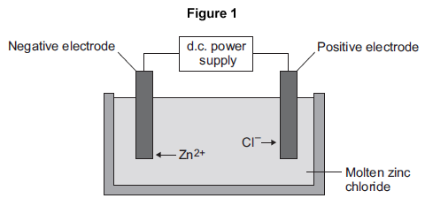
(a) Zinc chloride is an ionic substance.
Complete the sentence.
When zinc chloride is molten, it will conduct .................................................. .(1)
(b) Zinc ions move towards the negative electrode where they gain electrons to produce zinc.
(i) Name the product formed at the positive electrode. ....................................................................... (1)
(ii) Explain why zinc ions move towards the negative electrode. (2)
(iii) What type of reaction occurs when the zinc ions gain electrons? (1)
(c) Zinc is mixed with copper to make an alloy.
(i) Figure 2 shows the particles in the alloy and in pure zinc.
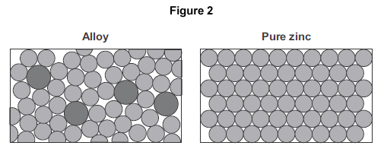
Use Figure 2 to explain why the alloy is harder than pure zinc. (2)
Q3.This question is about magnesium and magnesium chloride.
(a) Magnesium chloride contains magnesium ions (Mg²⁺) and chloride ions (Cl⁻). Describe, in terms of electrons, what happens when a magnesium atom reacts with chlorine atoms to produce magnesium chloride. (4)
(b) Magnesium chloride can be electrolysed.
The diagram below shows two experiments for electrolysing magnesium chloride.
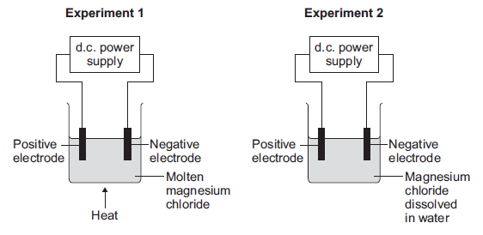
(i) Explain why magnesium chloride must be molten or dissolved in water to be electrolysed. (2)
(ii) Explain how magnesium is produced at the negative electrode in Experiment 1. (3)
(iii) In Experiment 2 a gas is produced at the negative electrode. Name the gas produced at the negative electrode. (1)
(iv) Suggest why magnesium is not produced at the negative electrode in Experiment 2. (1)
(v) Complete and balance the half equation for the reaction at the positive electrode.
.......... Cl⁻ → Cl₂ + .......... (1)
(c) Magnesium is a metal. Explain why metals can be bent and shaped. (2)

