Bonding booklet answers
- +1, 0, -1
- Atom, protons, electrons, charge
- 2 on first shell, 7 on second
- 9
- 0
- The number of protons and electrons are equal so the charges balance out
- 9
- Atoms have equal numbers of protons and electrons
- It no longer has equal numbers of protons as electrons
- +1
- +2
- -1
- -5
- As they have a negative charge
- 14
- 15
- 9
- 54
- Elements are made of one type of atom, compounds more than one type chemically bonded
- Plum pudding is sphere or positive charge with negative charges (electrons) studded in, nuclear has positive charge concentrated in nucleus and electrons orbiting
- 2Li(s) + Cl₂(g) 2LiCl(s)
- Solid, gas, solid
- Molecular is billions of molecules with no chemical bonds between them. Giant is billions of atoms with chemical bonds between them
- Atoms: equal numbers of protons and electrons
Isotopes: different atoms with equal numbers of protons, different numbers of neutrons
Ions: unequal numbers of protons and electrons

Element name and symbol | Group | Number of electrons in outer shell | Will it lose or gain electrons? How many? | Charge on ion
Lithium, Li | 1 | 1 | Will lose one | Li⁺
Beryllium, Be | 2 | 2 | Lose two | Be²⁺
Oxygen, O | 6 | 6 | Gain two | O²⁻
Nitrogen, N | 5 | 5 | Gain three | N³⁻
Boron, B | 3 | 3 | Lose three | B³⁺
Fluorine, F | 7 | 7 | Gain one | F⁻
Phosphorous, P | 5 | 5 | Gain three | P³⁻
Rubidium | 1 | 1 | Lose one | Rb⁺

  - 2; 1+ charge
  - 2, 8, 8 1- charge
  - 2; 2+ charge
  - 2,8,8; 2- charge
  - 2,8; 3+ charge
  - 2,8; 3- charge
  - 2,8; 2+ charge
  - 2,8,8; 1+ charge
- Chlorine
- Calcium

  - Lithium gives one to fluorine
  - Two potassium atoms each give one to oxygen
  - Three chlorine atoms each give one to aluminium
  - Two sodium atoms give one to an oxygen
  - Aluminium gives three to a nitrogen
  - Two aluminiums between them give six electrons to three oxygens (which each take two)
- –
- They both need to gain electrons
- They both need to lose electrons
- Because they are both positive
- One electron from sodium is transferred to chlorine forming a positive sodium ion and a negative chlorine ion that can be attracted electrostatically
- Aluminium transfers one electron to three different chlorine atoms forming a 3+ aluminium ion and three 1- chlorine ions that can be attracted electrostatically
- Giant ionic lattice made of alternating Al³⁺ and Cl⁻ ions held together by the electrostatic force of attraction

  - One electron from magnesium to two different chlorine atoms forming the ions referenced in the question which are attracted to each other electrostatically and can form a giant ionic lattice
  - Two potassium atoms each transfer one electron to a sulphur atom forming a giant ionic lattice of alternating K⁺ and S²⁻ ions held together by the electrostatic force of attraction
- –
- (s) is a solid where the ions are held in a giant ionic lattice. (aq) is dissolved in water where the ions from the lattice have separated and are free to move
- Giant ionic lattice made of strong electrostatic force between alternating ions of positive and negative charge which requires a large amount of energy to break
- One electron from sodium transferred to chlorine
- 19
- 8
- 8 protons, 10 electrons
- Two potassium atoms each transfer one electron to an oxygen, forms 2K⁺ and O²⁻
- K₂O
- They have opposite charges
- Giant ionic lattice
- High melting and boiling point, does not conduct electricity as solid, does conduct as (aq) or (l)
- Giant ionic lattice; Its ions are not free to move and it does not have delocalised electrons
- Giant ionic lattice; strong ionic bonds formed from electrostatic force of attraction between oppositely charged ions, requires lots of energy to break
- 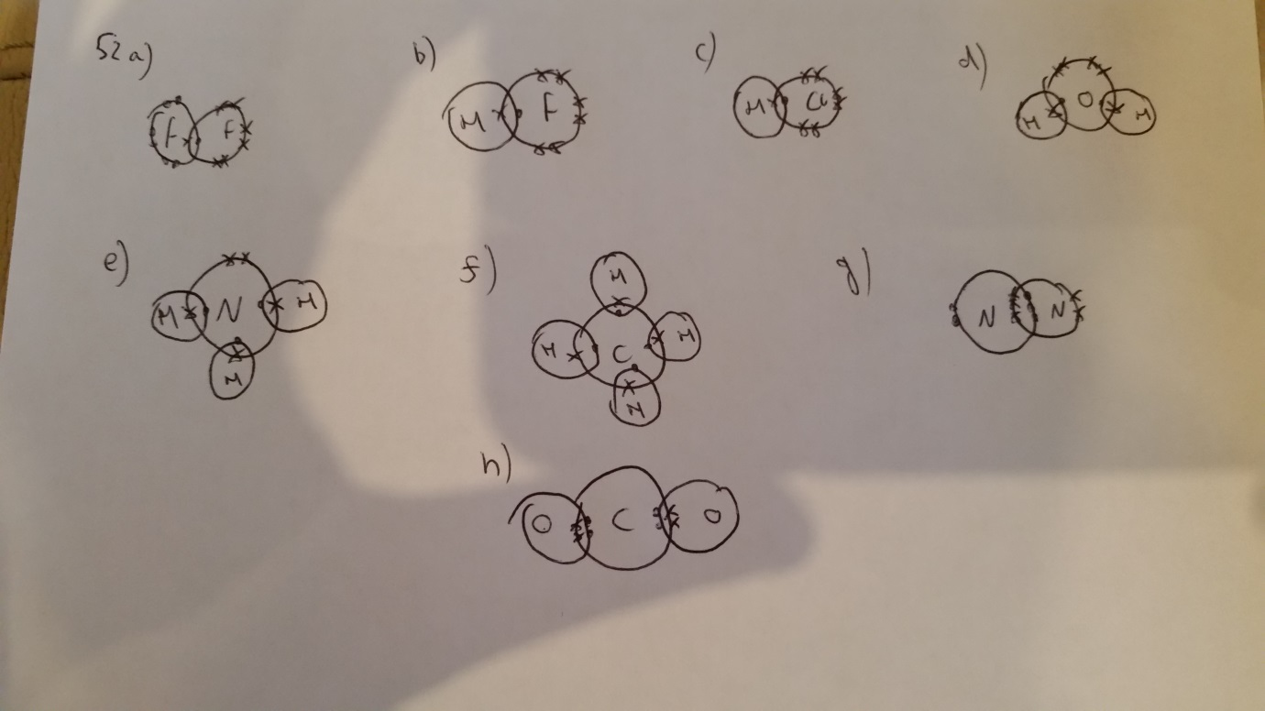
- Li with 2 electrons on outer shell and 1+ charge, fluorine with 2,8 and 1- charge
- Metal and non-metal, metal loses electron, non-metal gains
- High melting and boiling point, only conducts electricity when (l) or (aq)
- No
- Fluorine, chlorine, carbon, oxygen, any non-metal
- 18.94

  - Hydrogen + fluorine hydrogen fluoride
  - H₂ + F₂ 2HF
- –
- Hard, high melting and boiling point, not conduct electricity
- High melting point
- Strong covalent bonds between the atoms require lots of energy to break
- Ionic
- Aluminium loses electrons, iodine gains
- Aqueous or molten
- 4
- 14
- 0, -1
- The Rutherford scattering experiment

  - They would both be high
  - Melt them/dissolve and see which conducts electricity
  - One is made of ions, the other of atoms
- Made of carbon atoms, giant covalent structures
- Graphite is in layers, is soft and conducts electricity
- Delocalised electrons are free to move through the graphite
- Element is only one type of atoms chemically bonded, compound is two or more

  - See which conducts electricity when solid
  - Ionic substance conducts by the movement of ions, graphite by the movement of electrons
  - Sodium is a metal and chlorine is a non-metal
  - Sodium is 2,8 with a 1+ charge, chlorine is 2,8,8 with a 1- charge
  - Giant ionic lattice; strong ionic bonds formed from electrostatic force of attraction between oppositely charged ions, requires lots of energy to break
- As in 52
- They have a covalent bond between them which is strong
- Low melting and boiling point, not to conduct electricity

  - See previous definitions on Quizlet
  - N, O₂ CO₂ H₂O Ar
  - –
  - Nitrogen, oxygen or argon
  - Water or carbon dioxide
  - Argon
  - All of them
- It is a larger molecule so the intermolecular force is stronger
- Weak intermolecular forces between molecules do not reauire a lot of energy to break
- It has no free ions or delocalised electrons
- Giant covalent has billions of atoms chemically bonded not just a few into molecules
- They have no free ions or delocalised electrons

  - As the chain increases in length, the melting and boiling point increases
  - The larger the molecule, the stronger the intermolecular force, the more energy required to break, the greater the melting and boiling point
- –
  - –
    - Covalent
    - Carbon
    - 3
  - It is soft as the layers can slide over each other and off the material onto the paper
- It has delocalised electrons that are free to move through the graphite and carry charge
- –
  - –
    - Covalent
    - Covalent
  - It is very small
  - It has delocalised electrons that are free to move through the nanotube
- -
Sodium | Sodium | Metallic
Carbon | Silicon | Covalent
Carbon | Carbon | Covalent
Oxygen | Lithium | Ionic
Silver | Fluorine | Ionic
Magnesium | Chlorine | ionic
Magnesium | Calcium | Metallic
Beryllium | Nitrogen | Ionic
Phosphorous | Oxygen | Covalent
- ^
- Layers of positive metal ions with a sea of delocalised electrons held together by electrostatic interaction between positive ions and negative electrons
- the electrostatic force between the delocalised electrons and metal ions is strong
- It is malleable and conducts electricity
- Delocalised electrons are free to move through the graphite
- They do not have free ions or delocalised electrons to carry charge
- (l) or (aq)
- Easy to bend into shape
- They both need to lose electrons
- Magnesium, more electrons in the sea of delocalised and greater positive charge on the ion means greater strength of electrostatic attraction and more energy required to break
- Layers of positive metal ions with a sea of delocalised electrons held together by electrostatic interaction between positive ions and negative electrons. Delocalised electrons can move through the metal and carry charge
- It has different sized atoms which disturb the layers
- They would be too soft/would corrode too easily
- –
  - Delocalised electrons free to move through the metal
  - Malleable as layers can slide over each other
  - Strong force of electrostatic attraction between metal ions and delocalised electrons
- –
  - Metal
  - Simple molecular
  - Giant covalent
  - Giant ionic lattice
  - Simple molecular
- –
    - C
    - A
    - D
    - B
- More electrons in aluminium to be donated to the sea of delocalised electrons and can carry more charge/current

Bonding summary questions
- Metal or graphite
- Both conduct electricity and have high melting points
- One will be harder than the other
- Try to dissolve in water or melt and see if it conducts electricity
- Simple molecular (only metal possibility is Hg)
- No, has no delocalised electrons
- –
- –
- Because they have layers which can slide over each other
- Giant ionic
- Only have weak intermolecular forces between the molecules so they are easy to separate
- Metal is only one type of atom, alloy has others mixed in
- They have atoms of different sizes which disturb the layers and prevent them from travelling
- Giant covalent substance, high melting point
- Graphite has delocalised electrons, diamond does not
- None
- Delocalised electrons
- The bonds do not need to be broken to turn methane into a gas; only the forces between the molecules need to be broken and they are weak
- Similarities: contain sodium, sodium contained as ions in both, both arranged in neat rows and layers, both conduct electricity when molten. Differences: ionic has negative charge, often soluble, metals conduct when solid, metals soft, ionic brittle, metals have delocalised electrons, ionic does not
- Graphite conducts as it has delocalised electrons. Sodium chloride conducts as it has ions that are free to move.

- Because it only has the names of the elements on it
- Group: electrons in outer shell, period: number of shells
- 2,1
- 1+
- Compound
- Discovery of electrons – specifically those in the outer shell relevant for reactivity
- Ionic
- Potassium transfers one electron to chlorine
- High melting and boiling point, malleable, conductor of thermal energy and electricity
- Low melting and boiling point, does not conduct electricity
- Yes, same group

potassium + oxygen potassium oxide
4K(s) + O₂(g) 2K₂O(s)
potassium + chlorine potassium chloride
2K(s) + Cl₂(g) 2KCl(s)
potassium + water potassium hydroxide + hydrogen
2K(s) + 2H₂O(l) 2KOH(aq) + H₂(g)
- Solid, liquid, gas, aqueous
- Because gas has been formed which escapes

  - Metallic, covalent, ionic
  - Simple molecular substance, weak intermolecular force, easy to break
  - (l) or (aq)
  - Delocalised electrons free to flow through the metal
- Easier to lose outer electron due to more shells, more shielding, greater nucleus-electron distance
- Harder to lose outer electrons due to fewer shells, less shielding, shorter nucleus-electron difference
- They react with oxygen from the air
- It is too reactive
- Depends on how easy it is to lose the electron
- lithium + water lithium hydroxide + hydrogen
2Li(s) + 2H₂O(l) 2LiOH(aq) + H₂(g)
- As above
- As in 123
- Strength of attraction from positive potassium nucleuses to delocalised electrons is weaker
- 7
- Covalent
- As above
- Same as 134
- Simple molecular substance, weak intermolecular force requires little energy to break
- Bigger atoms, more electrons, stronger intermolecular attraction
- Easier to gain an electron due to fewer shells, less shielding, shorter nucleus- electron distance
- Harder to gain an electron due to more shells, more shielding, greater nucleus- electron distance
- Easier to lose outer electron due to more shells, more shielding, greater nucleus-electron distance
- 2Li + Cl₂ 2LiCl
- Br₂ +2 LiI 2LiBr + I₂
- Iodine and bromine are elements, lithium iodide and bromide are compounds
- Ionic
- Giant ionic lattice, strong electrostatic force of attraction between oppositely charged ions, requires lots of energy to break. Fluorine is simple molecular with weak intermolecular force which does not require a lot of energy to break
- Harder to gain an electron due to more shells, more shielding, greater nucleus- electron distance
- Simple molecular substance, no free ions or delocalised electrons
- –
  - B
  - D
  - E
  - C
  - 6.08
- For group 1 increases down the group as Easier to lose outer electron due to more shells, more shielding, greater nucleus-electron distance. Group 7 decreases down the group as Harder to gain an electron due to more shells, more shielding, greater nucleus- electron distance
- Very reactive, small distance from nucleus to outer shell, very little shielding
- Argon is unreactive as it has a full outer shell and does not need to gain or lose electrons

