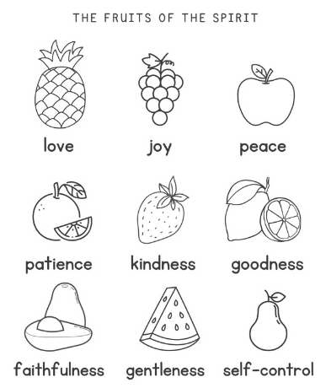 | Colour the fruits that you need to work hardest on sharing with others.  ******************  How are you going to use the fruits of The Holy Spirit to be a better person today?
Colour the fruits that you need to work hardest on sharing with others.
******************
How are you going to use the fruits of The Holy Spirit to be a better person today?

