Suggested prayer session: EYFS/KS1 and LKS2 follow script with appropriate pupil leadership (this could just be setting up a focal point through to reading/leading, etc.)

**Gather: -**

1. create atmosphere - in the initial sessions, agree what this should be like (dark/ seating in a circle/ tables moved back/ focal point with relevant items such as a prayer stone/candle to pass for private intentions); calm music to begin - <https://www.youtube.com/watch?v=dfpOvM5OcuY&list=RDQMTvQjZDgX6yY&start_radio=1>
2. Sign of the cross

(Keep music playing quietly across the whole of the session)

**Listen -**

Relevant scripture -

A reading from the Gospel according to Matthew

**RESPONSE – Glory to you O Lord**

Blessed are those who are persecuted because of righteousness,  
for theirs is the kingdom of heaven.

Blessed are you when people insult you, persecute you and falsely say all kinds of evil against you because of me. Rejoice and be glad, because great is your reward in heaven, for in the same way they persecuted the prophets who were before you.

The Gospel of the lord

**RESPONSE: Praise to you Lord Jesus Christ**

**The word of the Lord, Response: thanks be to God**

Age appropriate - give time to reflect on what the words of the scripture mean. Allow some time to think and then tell them 'There have been many people who have been persecuted for their religious beliefs. This has always happened and is still happening today. Christians in other countries, including parts of Africa and Asia, are at risk of harm from others. Some have to say Mass in secret.’

(reflect) Let us take time to reflect on those who are brave enough to join together in the name of God, even when others treat them badly because of this.’

Quiet reflection time with music…

**Respond –**

Look at the picture of this saint. They were a martyr. Who knows wo this is and why they were killed?

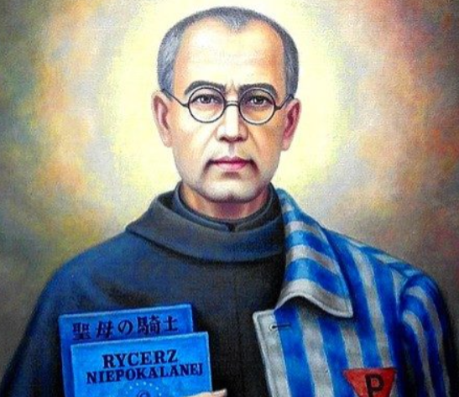

Share the story of St Maximilian Kolbe: <https://www.youtube.com/watch?v=KsHiBTLo3aw> (KS2 version)

<https://www.youtube.com/watch?v=SWUpfYHR1_Y> (KS1 version – play from 3:48+)

Spend some time to think about people who are so brave that they risk their lives to be able to share the word of God.

Say: St Maximilian Kolbe – Pray for Us

Pray the eternal rest to finish.

**Go Forth: (As per last week)**

1. Share with your parents that the month of November is a time when we remember loved ones who have died. Bring in any photos or names of people to be remembered for the prayer table/class book (teacher could invite via MM)
2. Share with parents that November is a time for remembrance and prayer together at home for the lost loved one
3. Remind pupils that they can write a remembrance plaque to be placed in the prayer garden (see MB or TD)

Prayer sessions...Either / OR

Fortnightly sessions in KS2 where week 1) class* discussion to plan, 2) week 2 = prayer session

UKS2 might be able to assign a group to plan and the rest of the class can do private reading, as long as group of pupils swaps each time.

Other ideas - consider what heaven looks like - how is this depicted in art work? This could be the stimulus for listen and respond.