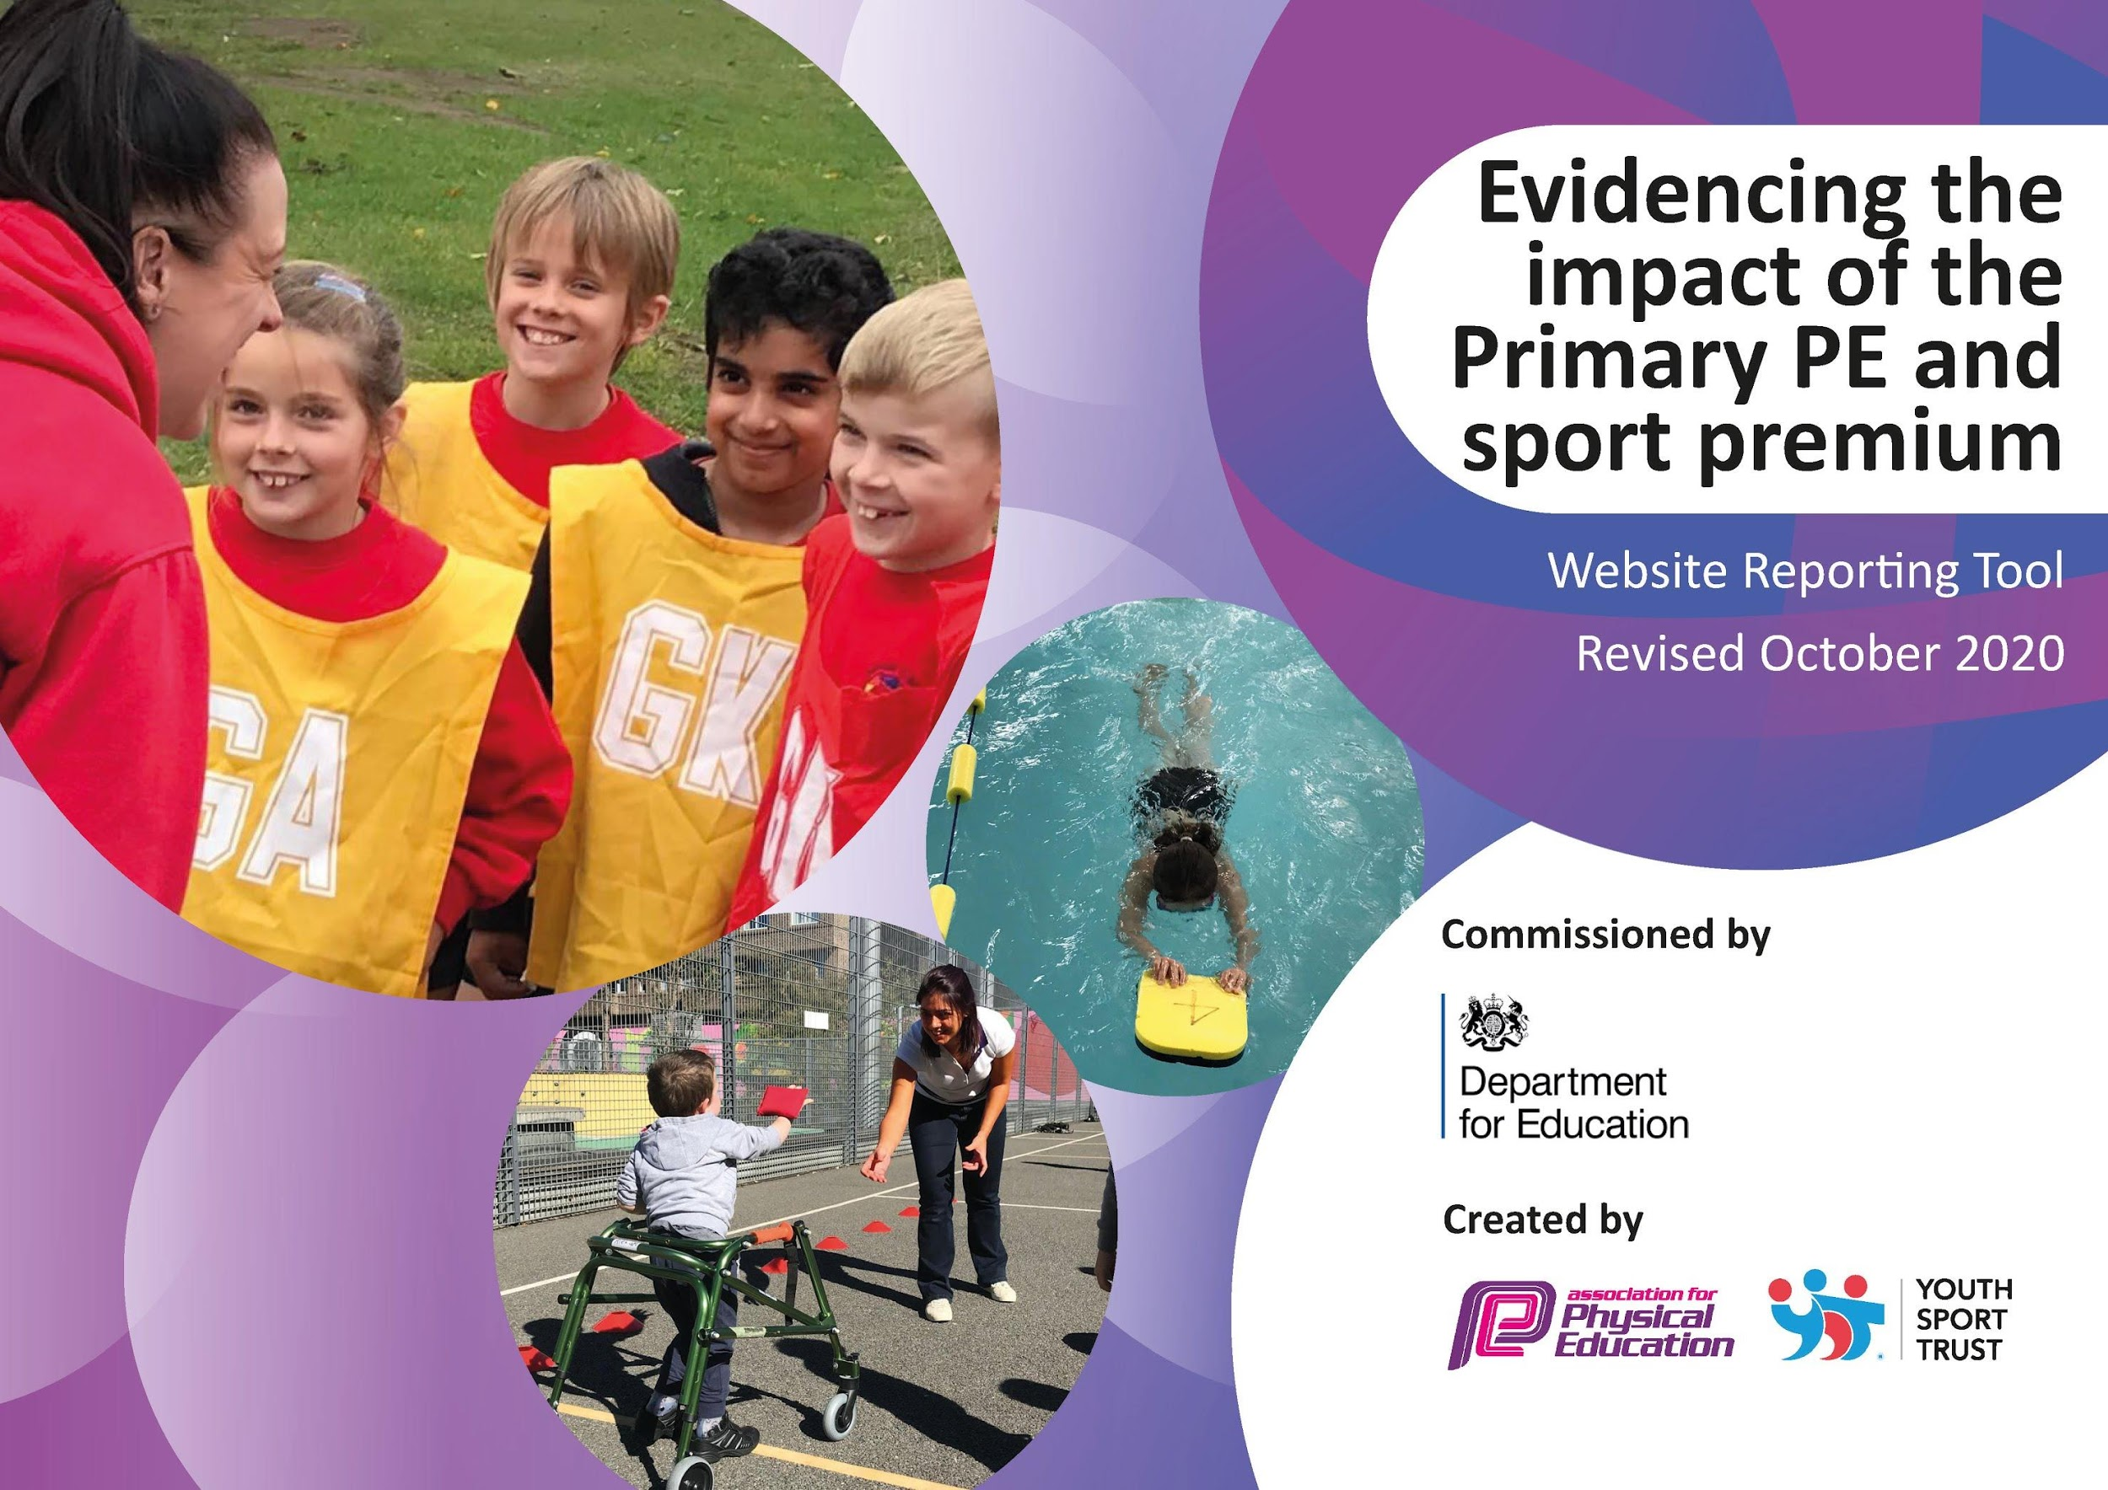

It is important that your grant is used effectively and based on school need. The Education Inspection Framework (Ofsted 2019 p64) makes clear there will be a focus on ‘whether leaders and those responsible for governors all understand their respective roles and perform these in a way that enhances the effectiveness of the school’.

Under the Quality of Education criteria (p41) inspectors consider the extent to which schools can articulate their curriculum (INTENT), construct their curriculum (IMPLEMENTATION) and demonstrate the outcomes which result (IMPACT).

To assist schools with common transferable language this template has been developed to utilise the same three headings which should make your plans easily transferable between working documents.

Schools must use the funding to make additional and sustainable improvements to the quality of Physical Education, School Sport and Physical Activity (PESSPA) they offer. This means that you should use
the Primary PE and sport premium to:

- Develop or add to the PESSPA activities that your school already offer
- Build capacity and capability within the school to ensure that improvements made now will benefit pupils joining the school in future years

Please visit gov.uk for the revised DfE guidance including the 5 key indicators across which schools should demonstrate an improvement. This document will help you to review your
provision and to report your spend. DfE encourages schools to use this template as an effective way of meeting the reporting requirements of the Primary PE and sport premium.

We recommend you start by reflecting on the impact of current provision and reviewing the previous spend.

Schools are required to publish details of how they spend this funding as well as on the impact it has on pupils’ PE and sport participation and attainment by the end of the summer term or by 31st July 2021 at the latest.

** In the case of any under-spend from 2019/20 which has been carried over this must be used and published by 31st March 2021.

We recommend regularly updating the table and publishing it on your website throughout the year. This evidences your ongoing self-evaluation of how you are using the funding to secure maximum, sustainable impact. Final copy must
be posted on your website by the end of the academic year and no later than the 31st July 2021. To see an example of how to complete the table please click HERE.
Created by: Supported by:

Please note: Although there has been considerable disruption in 2020 it is important that you publish details on your website of how you spend the funding - this is a legal requirement.

Support for review and reflection - considering the 5 key indicators from DfE, what development needs are a priority for your setting and your pupils now and why? Use the space below to reflect on previous spend and key achievements and areas for development.

N.B. In this section you should refer to any adjustments you might have made due to Covid-19 and how these will influence further improvement.
Key achievements to date until July 2020: | Areas for further improvement and baseline evidence of need:
-95% of pupils taking part in extracurricular provision.  -Further new clubs explored and introduced with our growing school with high take up.  -Continued membership with the Hertford and Ware schools partnership.  -School games gold award achieved.  -All children taking part in 2 hours of high quality PE per week, even when in bubbles all children had this opportunity through PE lessons and active playtime and lunchtimes.  -Swimming for key stage 2 this year completed and although planned for key stage 1 and not able to go ahead now planned for Year 1 - 5 for one or two terms of the next academic year.  -Lunchtime sports, using the astro and trim-trail for fitness every lunchtime has ensured there are always active playtimes and lunchtimes.  -Extra-curricular opportunities growing each year with the growing school.  -KS1 sports opportunities as well as KS2 through our explorers club.  -Inclusive curriculum planned and supported through external guidance.  -Curriculum is broad and balanced: including dance, gymnastics, orienteering and a wide range of games (staff CPD across these). | -Development of the all-through Physical Education curriculum mapping Reception all the way to Year 13 ensuring breadth and depth.  -Facilities development with our growing school.  -CPD of new staff that join us each year including NQTS and those training.  -SEND support and guidance in order to meet the needs of all of our pupils and deliver a highly effective PE curriculum.  -Maintain PE and sport resources- especially more needed for different bubble use.

Did you carry forward an underspend from 2019-20 academic year into the current academic year? YES Delete as applicable

If YES you must complete the following section
If NO, the following section is not applicable to you
If any funding from the academic year 2019/20 has been carried over you MUST complete the following section. Any carried over funding MUST be spent by 31 March 2021.
Academic Year: September 2020 to March 2021 | Total fund carried over: £ 3,781 | Date Updated: November 2020
What Key indicator(s) are you going to focus on? Indicator 4- Increased participation in competitive sport as well as key indicator 1- The engagement of all pupils in regular physical activity. |  |  |  | Total Carry Over Funding:
 |  |  |  | £ 3,718
Intent | Implementation |  | Impact
Your school focus should be clear how you want to impact on your pupils.  Active lessons across the curriculum to replace previously sedentary lessons. This will result in engaging children in curriculum time.  Hertford and Ware sports partnership subscription.  Children have a range of opportunities to engage in new extra-curricular provision, PE lessons and as well active playtimes and lunchtimes continuing in bubbles. | Make sure your actions to achieve are linked to your intentions:  Active English/maths resources to support cross-curricular PE for all children.  The Hertford and Ware partnership subscription offers us level 2 competition for all of our children.  Replenish depleting equipment.  Ensure new equipment is purchased for new sports clubs that have not been taught before in a brand new school.  Ensure there is enough equipment in the school to ensure all bubbles have enough equipment to remain active. | Carry over funding allocated:  £975  £1430  £1,313 | Evidence of impact: How can you measure the impact on your pupils; you may have focussed on the difference that PE, SS & PA have made to pupils re-engagement with school. What has changed?:  The impact will be on children being more active in all their lessons after a substantial amount of time indoors and not exercising in lockdown.  The impact on having the partnership is to ensure that competitions can still take place and can be virtual against other schools through the partnership. As well as this the partnership are able to come into school to deliver balanceability and sports leaders to our pupils vital life skills on the back of covid.  This will support in the re-engagement of children’s active journeys as well as offering them new opportunities to try sports they have not had a go at before. | Sustainability and suggested next steps and how does this link with the key indicators on which you are focussing this academic year?:  This will result in a more active cross curricular curriculum.  This will result in preparing the children for competitions as soon as these are able to commence post covid and ensuring children are provided with Level 2 competitions.  This will result in children having the opportunity to take part in more level 2 competitions in the partnership as well as ensuring they continue to be physically active.

Meeting national curriculum requirements for swimming and water safety.  N.B Complete this section to your best ability. For example you might have practised safe self-rescue techniques on dry land. | N/A as only up to Year 5. We are currently providing swimming for Year 1,2,3, 4 and 5.
What percentage of your current Year 6 cohort swim competently, confidently and proficiently over a distance of at least 25 metres?  N.B. Even though your pupils may swim in another year please report on their attainment on leaving primary school at the end of the summer term 2020. | N/A but all children in Year 1 and 2 are having experience of front crawl and backstroke; breastroke introduced at Year 3.
What percentage of your current Year 6 cohort use a range of strokes effectively [for example, front crawl, backstroke and breaststroke]? | N/A as we are currently only up to Year 5.
What percentage of your current Year 6 cohort perform safe self-rescue in different water-based situations? | N/A as we are only up to year 5 but our curriculum is designed for self-rescue and water skills for Year 5 children and Year 6 the following year.
Schools can choose to use the Primary PE and sport premium to provide additional provision for swimming but this must be for activity over and above the national curriculum requirements. Have you used it in this way? | Yes/No  The main school budget and contributions from parents also support our swimming curriculum (which is over and above the national curriculum requirements). We provide swimming to all children in Year 1 to Year 5 and not solely in one Key stage.

Action Plan and Budget Tracking
Capture your intended annual spend against the 5 key indicators. Clarify the success criteria and evidence of impact that you intend to measure to evaluate for pupils today and for the future.

Academic Year: 2020/21 | Total fund allocated: £18,400 | Date Updated: November 2020
Key indicator 1: The engagement of all pupils in regular physical activity – Chief Medical Officers guidelines recommend that primary school pupils undertake at least 30 minutes of physical activity a day in school |  |  |  | Percentage of total allocation:
 |  |  |  | £11,085 60%
Intent | Implementation |  | Impact
Your school focus should be clear what you want the pupils to know and be able to do and about  what they need to learn and to  consolidate through practice: | Make sure your actions to achieve are linked to your intentions: | Funding allocated: | Evidence of impact: what do pupils now know and what can they now do? What has changed?: | Sustainability and suggested next steps:
Targeted groups of children with identified needs and SEND being engaged in all areas of the curriculum.  All children from Reception to Year 5 accessing physical activity opportunities as well as extra curricular provisions.  Engage least active groups within our primary phase.  Targeted group of children identified with gross and fine motor needs to take part in interventions. | Specific equipment purchased to ensure that all children with identified needs are able to access all areas of their sporting journeys and the Physical Education curriculum.  All children in Reception to Year 5 will have the opportunity to take part in lunchtime sporting activities as well as extra-curricular provision and equipment will be purchased to ensure this can take place.  A proportion of the salary for JL and JG our sports apprentices to ensure that children are able to get these opportunities that they wouldn’t usually be offered.  Change4life clubs to support children to have a sport that they enjoy and will carry on as well as when partnership events can take part again to attend the partnership every 1 in festival.  Smart Moves – motor skills development programme (Reception to KS2) purchased to ensure interventions can take place. This will ensure whole school improvement as will support with their writing needs in the classroom. | £300  £500  £10,000  £ 200 ( for equipment for the club, entry and transport to the festival)  £85
Key indicator 2: The profile of PESSPA being raised across the school as a tool for whole school improvement |  |  |  | Percentage of total allocation:
 |  |  |  | £2328 13%
Intent | Implementation |  | Impact
Your school focus should be clear what you want the pupils to know and be able to do and about  what they need to learn and to  consolidate through practice: | Make sure your actions to achieve are linked to your intentions: | Funding allocated: | Evidence of impact: what do pupils now know and what can they now do? What has changed?: | Sustainability and suggested next steps:
Mental health and well-being in the primary phase.  Raise the profile of representing school at sporting competitions, festivals, events.  Athlete visit by Mike Mullen with the focus of the session on mindfulness, resilience and behaviour to support with whole school improvement.  Sports leadership  Technology to support with raising the profile of sport and linking to other curriculum areas. | Purchase Keys to Happier Living Toolkit. This is an engaging, accessible and evidence-based programme to promote the emotional wellbeing and resilience of our children.  Although this could be hard to achieve this year we are hopeful that by the summer term we will be able to raise the profile by attending sporting fixtures and events.  Primary teachers kit - profile of sports, modelling standards.  Children’s kits - for football(Years 4 +) Netball kits were purchased last year. These will be our first matches in the primary phase.  Mike Mullen to spend a day with identified children working on mindfulness, resilience and behaviour. These link with our values and on our whole school priorities post covid.  All children in Year 5 to be trained as sports leaders to support leadership across the whole primary phase and leadership in all areas of the curriculum and their school life.  Camera to be purchased for all sporting activities to ensure that children can use this to then write match reports and for analysis to link with whole school improvement.  Heart rate monitors purchased to link Science and Physical Education to raise the profile and link to other curriculum areas thus leading to more lessons being active. | £160  £168  £200  £700 (Exact price to be confirmed)  £400  £300  £400

Key indicator 3: Increased confidence, knowledge and skills of all staff in teaching PE and sport |  |  |  | Percentage of total allocation:
 |  |  |  | £2,900 16%
Intent | Implementation |  | Impact
Your school focus should be clear | Make sure your actions to | Funding | Evidence of impact: what do | Sustainability and suggested
what you want the pupils to know | achieve are linked to your | allocated: | pupils now know and what | next steps:
and be able to do and about | intentions: |  | can they now do? What has
what they need to learn and to |  |  | changed?:
consolidate through practice:
Identified staff to have CPD in areas of Physical Education that they have addressed as well as the PE lead to keep up to date with new guidance from the Hertford and Ware Sport partnership.(The intention is to carry this on post covid and may be back by the Summer term).  Get set for PE resources  Upskill staff with their swimming knowledge and ensure all children take part in swimming across both key stages in the primary phase. | Primary PE conference - M-C to attend with secondary PE teacher teaching in primary.  Primary staff training including JL. These will have to be virtual currently but hopefully in the Summer term courses can be attended by staff that have identified areas of development.  These support staff with CPD in PE and support them with the delivery of PE.  Little fishes to support swimming in Year 1 and 2. As we are offering swimming provision in both Key stage 1 and Key stage 2 this is above and beyond the national curriculum requirements as well as this Year 1 and Year 2 teachers are partaking in swimming CPD and upskilling opportunities. | £300  £500  (This is renewed currently until  24.10.2021)  £2,100
Key indicator 4: Broader experience of a range of sports and activities offered to all pupils |  |  |  | Percentage of total allocation:
 |  |  |  | £1,849 10%
Intent | Implementation |  | Impact
Your school focus should be clear | Make sure your actions to | Funding | Evidence of impact: what do | Sustainability and suggested
what you want the pupils to know | achieve are linked to your | allocated: | pupils now know and what | next steps:
and be able to do and about | intentions: |  | can they now do? What has
what they need to learn and to |  |  | changed?:
consolidate through practice:
Additional achievements:  Undertake professional development offered through NGB’s  Cycling | Afpe membership  Youth sports trust  With the purchase of our bikes last year we would now like to ensure children can ride a bike from Year 1. All children in Year 1 to take part in balanceability. These help children develop gross motor skills, spatial awareness, dynamic and static balance, bilateral  coordination and confidence in a safe, challenging but fun way. | £269  £500  £1,080

Key indicator 5: Increased participation in competitive sport |  |  |  | Percentage of total allocation:
 |  |  |  | £238 1%
Intent | Implementation |  | Impact
Your school focus should be clear | Make sure your actions to | Funding | Evidence of impact: what do | Sustainability and suggested
what you want the pupils to know | achieve are linked to your | allocated: | pupils now know and what | next steps:
and be able to do and about | intentions: |  | can they now do? What has
what they need to learn and to |  |  | changed?:
consolidate through practice:
Hertford and Ware sports partnership subscription.  Support for Level 2 competition and festivals to ensure competitive participation is able to take place. | The Hertford and Ware partnership subscription offers us level 2 competition for all of our children.  Coaches for events to allow children to attend events and transport not to be a barrier to participation. | £1430 ( This will come out of the March payment)  £238 (May not be needed due to no competitions but money spent to raise the profile of sports day and competitive sport in school if this is not spent on transport)

