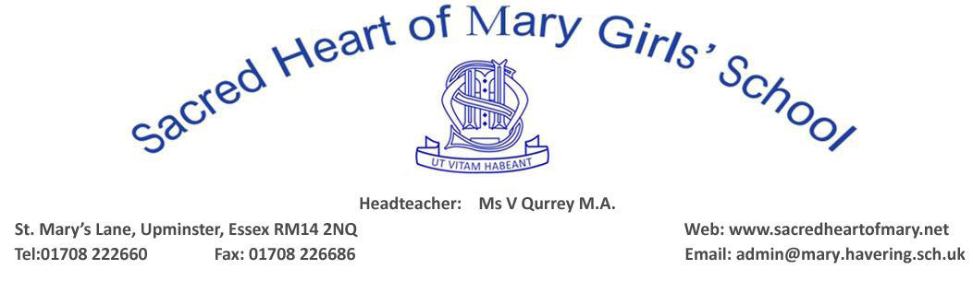

BRENTWOOD DIOCESE CATHOLIC SCHOOLS SUPPLEMENTARY INFORMATION FORM 2023 INTAKE
(PLEASE COMPLETE IN BLOCK CAPITALS)
CHILD’S SURNAME:
FORENAME/CHRISTIAN NAMES:
DATE OF BIRTH:
RELIGION:
IF CATHOLIC, DATE AND PLACE
OF BAPTISM or RECEPTION :
HOME ADDRESS:
POSTCODE:
CURRENT SCHOOL:
FULL NAMES OF PARENTS (CARERS/GUARDIANS): CONTACT DETAILS:
FATHER: Home Tel:
ADDRESS: Mobile Tel:
Work Tel:

E-mail Address ……………………………………………..
MOTHER: Home Tel:
ADDRESS: Mobile Tel:
Work Tel:
E-mail Address ……………………………………………..
NAME OF PERSON TO WHOM CORRESPONDENCE SHOULD BE ADDRESSED:
Mr & Mrs/Mr/Mrs/Ms (Delete as appropriate)
NAME:
RELATIONSHIP TO CHILD:
Cont’d …

PLEASE NAME ANY SIBLINGS WHO ATTEND SACRED HEART OF MARY GIRLS’ SCHOOL IN YEARS 7-13 AT THE TIME OF APPLICATION
NAME: FORM:
NAME: FORM:
NAME: FORM:
RELIGIOUS INFORMATION
NAME & ADDRESS OF PARISH IN WHICH YOU RESIDE:

NAME & ADDRESS OF PARISH WHERE YOU ATTEND MASS, IF DIFFERENT:

NAME & PARISH OF THE PRIEST WHO WILL COMPLETE YOUR REFERENCE:
……………………………………………………………………………………………………………………………………………….
DECLARATION
I/we confirm that the information on this supplementary information form is true to the best of my/our knowledge and belief.
DATE: ………………………… SIGNED: ……………………………………………………PARENT/CARER/GUARDIAN
PRINT NAME: …………………………………………………………………………………………………………………………….
TO ENSURE YOUR DAUGHTER’S APPLICATION CAN BE PROCESSED IMMEDIATELY PLEASE ENSURE THAT:
- the Common Application Form has been fully completed and submitted to the Local Authority
- this Supplementary Information Form has been fully completed, signed and the following documents are attached (originals are not accepted):
- PHOTOCOPY of Certificate of Baptism or Reception into the Catholic Church
- PHOTOCOPY of Birth Certificate
- you have met/arranged an appointment with the priest who will provide your Certificate of Catholic Practice
- If your daughter is not a Catholic you should obtain a letter which states that your daughter is practising her faith, from your Minister/Religious Leader before the closing date for applications
- THIS FORM MUST BE RETURNED DIRECTLY TO:
- SACRED HEART OF MARY GIRLS’ SCHOOL, St Mary’s Lane, Upminster, Essex, RM14 2QR
- (Please do NOT return to London Borough of Havering Education Department.)
- CLOSING DATE FOR SUBMISSION OF THE SIF FORM: MONDAY, 31 OCTOBER 2022. You should be aware that the closing date for submission of the SIF Form falls immediately after the October half-term holiday and the School cannot guarantee that someone will be available to deal with any questions or queries regarding applications during that holiday. Closing date for applications at Havering is also Monday, 31 October, 2022.

