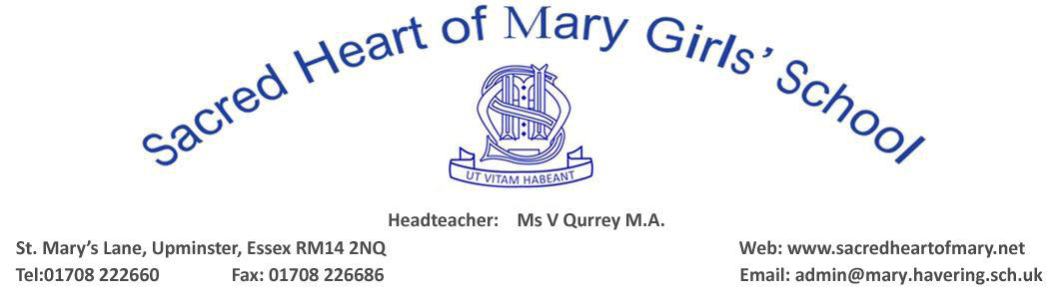

BRENTWOOD DIOCESE CATHOLIC SCHOOLS SUPPLEMENTARY INFORMATION FORM 2022 INTAKE
(PLEASE COMPLETE IN BLOCK CAPITALS)
CHILD’S SURNAME:
FORENAME/CHRISTIAN NAMES:
DATE OF BIRTH:
RELIGION:
IF CATHOLIC, DATE AND PLACE
OF BAPTISM or RECEPTION :
HOME ADDRESS:
POSTCODE:
CURRENT SCHOOL:
FULL NAMES OF PARENTS (CARERS/GUARDIANS): CONTACT DETAILS:
FATHER: Home Tel:
ADDRESS: Mobile Tel:
Work Tel:

E-mail Address ……………………………………………..
MOTHER: Home Tel:
ADDRESS: Mobile Tel:
Work Tel:
E-mail Address ……………………………………………..
NAME OF PERSON TO WHOM CORRESPONDENCE SHOULD BE ADDRESSED:
Mr & Mrs/Mr/Mrs/Ms (Delete as appropriate)
NAME:
RELATIONSHIP TO CHILD:

PLEASE NAME ANY SIBLINGS WHO ATTEND SACRED HEART OF MARY GIRLS’ SCHOOL IN YEARS 7-13 AT THE TIME OF APPLICATION
NAME: FORM:
NAME: FORM:
NAME: FORM:
RELIGIOUS INFORMATION
NAME & ADDRESS OF PARISH IN WHICH YOU RESIDE:

NAME & ADDRESS OF PARISH WHERE YOU ATTEND MASS, IF DIFFERENT:

NAME & PARISH OF THE PRIEST WHO WILL COMPLETE YOUR REFERENCE:
……………………………………………………………………………………………………………………………………………….

DECLARATION
I/we confirm that the information on this supplementary information form is true to the best of my/our knowledge and belief.
DATE: ………………………… SIGNED: ……………………………………………………PARENT/CARER/GUARDIAN
PRINT NAME: …………………………………………………………………………………………………………………………….
TO ENSURE YOUR DAUGHTER’S APPLICATION CAN BE PROCESSED IMMEDIATELY PLEASE ENSURE THAT:
- the Common Application Form has been fully completed and submitted to the Local Authority
- this Supplementary Information Form has been fully completed, signed and the following documents are attached (originals are not accepted):
- PHOTOCOPY of Certificate of Baptism or Reception into the Catholic Church
- PHOTOCOPY of Birth Certificate
- you have met/arranged an appointment with the priest who will provide your Certificate of Catholic Practice
- If your daughter is not a Catholic you should obtain a letter which states that your daughter is practising her faith, from your Minister/Religious Leader before the closing date for applications
THIS FORM MUST BE RETURNED DIRECTLY TO:
SACRED HEART OF MARY GIRLS’ SCHOOL, St Mary’s Lane, Upminster, Essex, RM14 2QR
(Please do NOT return to London Borough of Havering Education Department.)

