

Year 4 Curriculum Plan – Spring Term
Rainforests
English | Our Key Texts  The Great Kapok Tree – Lynne Cherry  The most important animal of all- Penny Worms  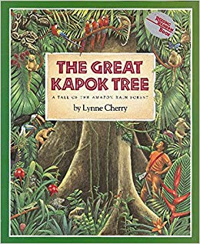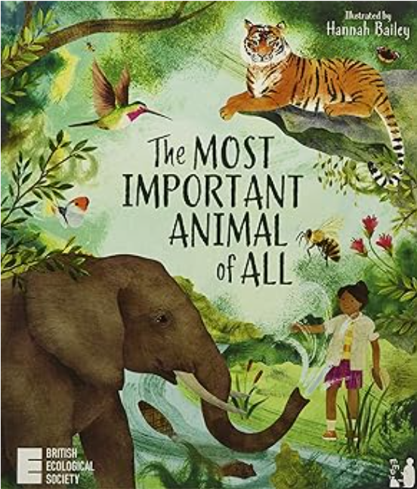 | Maths
This term our focus is on the Amazon Rainforest.  As rainforest rangers the children will:  - Innovate the Great Kapok tree focusing on setting descriptions.  - Write persuasive texts convincing the audience of “The most important animal.”  - Creating non-chronological reports on rainforests animals.  We will focus on using:  Fronted adverbials and expanded noun phrases and we will consolidate our knowledge of punctuating speech and using a range of conjunctions. |  | To multiply and divide  - recall all division facts  - divide 2 and 3 digit numbers by 1 digit  - solve division problems  To use fractions / decimals  - recognise, find and name a wider variety of fractions including equivalent fractions and decimal equivalents  - add and subtract fractions of the same  - round numbers with one decimal place to nearest whole number
Science | Geography | Physical Education
Living Things and their Habitats  As scientists the children will:  - explore and use classification keys.  - recognise that living things can be grouped in a variety of ways.  - recognise that environments can be changed and that this can sometimes pose dangers to specific habitats.  Animals  As scientists the children will:  - describe the simple functions of the basic parts of the digestive system in humans.  - identify the different types of teeth in humans and their simple functions.  - construct and interpret a variety of food chains, identifying producers, prey and predators. | As geographers we will consolidate atlas skills by:  - Locate the world’s countries focusing on South America  - Use maps, atlases, globes, and digital/computer mapping to locate countries and describe features studied  - Identify the position and significance of Equator, the Tropics of Cancer and Capricorn, Northern and Southern Hemispheres  - Describe key aspects of physical geography including climate zones and biomes and human geography including distribution of natural resources, land use and economic activity. | Hockey: Unit focus- Consistently perform basic Hockey skills such as dribbling and push passes. Implement the basic rules of hockey. Develop tactics and apply them in competitive situations. Increase speed and endurance during gameplay.  Dance: Unit 1 Focus- Work to include freeze frames in routines. Practise and perform a variety of different formations in dance.  Gymnastics - Become increasingly competent and confident to perform skills more consistently. Perform in time with a partner and group. Use compositional ideas in sequences.  Hand ball  Develop 3 step rule incorporating bounce. Defend and stop attacks by blocking and intercepting. Pass and move with the ball to set up attacks. Demonstrate and implement the rules of handball.
 | Religious Education | Art and Design
 | This term the children will be learning about Hinduism. This will include learning about:  - What is special to Hindus  - Hindu family life  - Hinduism in Britain and celebrations  This term the children will be learning about why Christians celebrate Easter. This will include learning about:  - the events of holy week and why Jesus is so important  - Different ways Christians celebrate Holy week  - Why Christians call the day Jesus died Good Friday | As Artists the children will be designing and creating their own rainforest scene based on the work of Henri Rouseau. The children will focus on developing their painting skills including:  - Mixing colours to experiment with tone, tint and shade  - Using different brushes to create stippling and dabbing effects  - Choosing colours to alter the mood of a painting.
Computing | Personal, Social and Health Education | Modern Foreign Languages
The children will be learning to use Logo programming to:  - Use key commands and input simple instructions.  - Use a variety of commands to create shapes using multi-line mode, repeat and change the line thickness and colour.  - Write procedural instructions.  Then we move on to Sound stories where the children will:  - explore the features of effective audio books  - work as a team to script, record and edit their own stories. | The children will be learning about their dreams and goals.  This will include:  - Discussing their hopes and dreams.  - Reflecting on positive and happy experiences.  - Setting goals.  - Planning steps to achieve their goals.  - Identifying the contributions made by themselves and others. | As linguists the children will :  - describe how they are feeling in French  - learn French words and phrases for classroom objects  - use numbers in French to go shopping  The children will write basic French words and phrases.
Music | Design and Technology
As musicians children will be :  Creating a song/ rap about bulling called STOP.  Listen and appraise  Perform a song  Compose, perform and share their own song.  Evaluate. | As designers the children will be designing and making a rainforest animal,  The children will be developing their skills of:  - cutting  - measuring  - joining - sewing

