Maths: We have been finding one more and one less than a number.
Practical ideas- Grab your favourite toys or Lego. Make a number and then find 1 less or 1 more than that number.
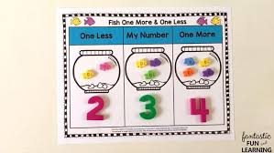
You could play a game online:
www.topmarks.co.uk/learning-to-count/chopper-squad

