Geography: Where do you live?
Can you draw a picture of your house and the rooms you have inside? You could plan/ map of your home. We would love to see them!
What type of home do you have?
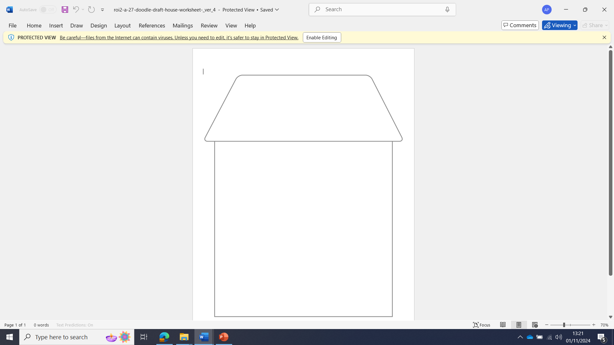
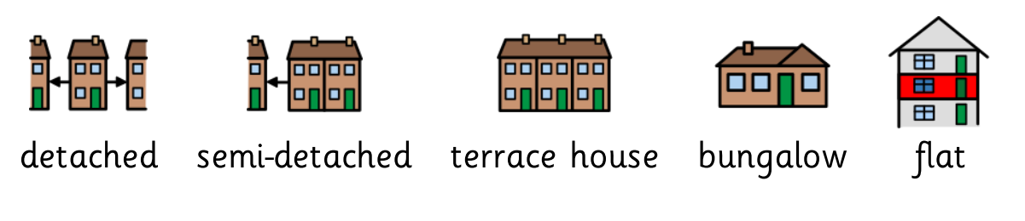

Inside my home I have:

