English- We have started to be penguin experts in Year 1. Please can you read this information text about penguins.
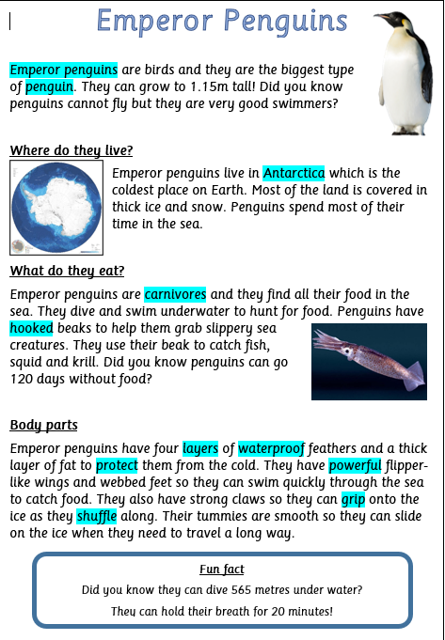

Now you have learnt about the Emperor Penguin- Can you draw a picture of a penguin and label all its body parts? If you can print, you can use this image. If not draw your own and label it.
These are the body parts you can label.
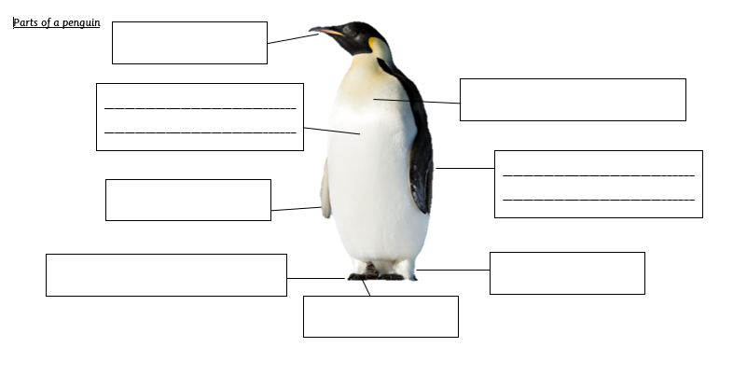
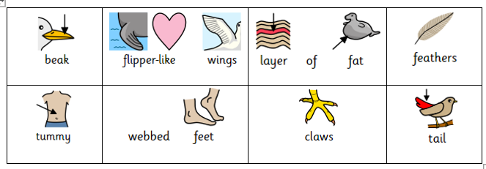

As an extra challenge can you write any facts you have learnt about a penguin?
For example:
Penguins have a sharp beak so they can peck the ice.
_______________________________________________________________________________________________________________________________________________________________________________________________________________________

