
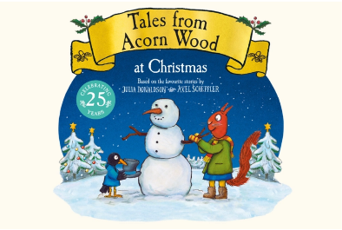

Dear Parents of Bears class

We are delighted to let you know that as part of our Autumn 2 topic of ‘Let’s Celebrate’ and the focus on Christmas, Bears class will be visiting Birmingham MAC Theatre to watch The Tales of Acorn Wood at Christmas on Tuesday 8th December, 12pm–3.20pm.

During the visit, the children will have the opportunity to watch a theatre production of The Tales of Acorn Wood at Christmas.

The children will need to wear school uniform and will need to bring a packed lunch and a drink in a small bag/backpack. If your child is in receipt of Free School Meals, then we can provide a packed lunch. Please contact Mrs Bird in the office to request this.

The cost of the trip is £26.94. If your child receives Pupil Premium, the cost reduction is 50%, and so the cost will be £13.47.

Payment and consent for this trip must be made on ParentPay by Wednesday 2nd December.

We are sure the children will have a fantastic day and benefit hugely from this visit.
Thank you for your continued support.

Mrs Hirons-Reed

