Friday 16th October 2026
School Vision - In our St Luke’s family, we recognise we are all God’s children and through our caring and nurturing environment, we follow His word. We trust and rely on God’s teaching so that we can encourage each other, develop our relationship with one another and the world, and flourish in all that we do.
God’s word is a lamp to my feet and a light to my path.

‘God’s word is a lamp to my feet and a light to my path.’ (Psalm 119: 105)


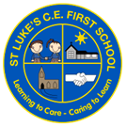
St Luke’s C E First School

Dates for your Diary

October
What a busy week in school! Year 3 have had a wonderful Stone Age visit to Bishops Wood, Year 4 have taken on a range of athletics activities, we’ve enjoyed 2 parental work with me sessions and finished off the week with our fabulous St Luke’s Day celebrations and our very first Grandparents’ Day event!
Thank you to all the wider members of our St Luke’s family for joining us in school this week – we’ve loved spending time with you.

Our final work with me sessions will take place after half term –
Bears – Tuesday 10th November 2:30pm – 3:15pm.
Giraffes – Thursday 12th November 2:15pm – 3:15pm
Please remember, we are unable to accommodate younger siblings at these events. Thank you for your support with this.

A reminder that next week we are holding our Autumn term parents’ evenings on Tuesday and Wednesday. If you are unsure of the time of your appointment, please speak to your child’s class teacher.

20th & 21st October – Parents Evenings

Tuesday 20th – SEND Tenpin Bowling (selected pupils)

Thursday 22nd – Break Up for Half Term

Friday 23rd – School Closed TED

November

Monday 2nd – School Re-opens

Wednesday 11th – Tigers Class Invasion Games

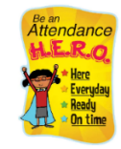

Attendance:
Our year to date attendance is: 97.36%
This week’s attendance:

Bears | Giraffes | Elephants | Tigers | Lions | Whole School
94.35% | 96.55% | 95.86% | 98.71% | 96.79% | 96.57%

Tigers Visit to Bishops Wood
What a fantastic day Tigers had a Bishops Wood this week! The children had so many activities to take part in - weaving, fish net making, grinding wheat to make flour, hunting animals with makeshift spears and using flint to make a fire. They also had a team building activity of making a shelter using willow, ropes, stakes and a covering. The wind had other ideas at times but the children were resilient and kept trying hard and were all successful. Well done Tigers you were all superb!
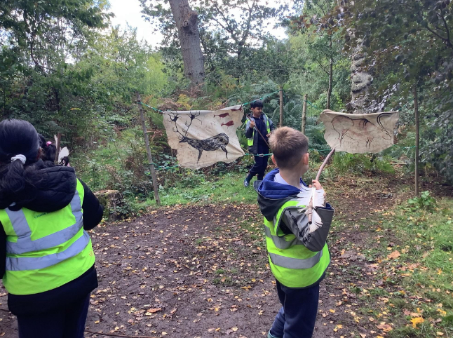
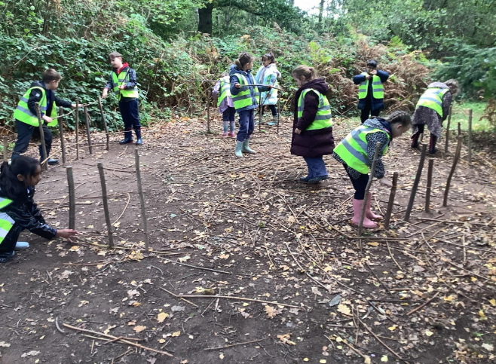

Lions Sporthall Athletics
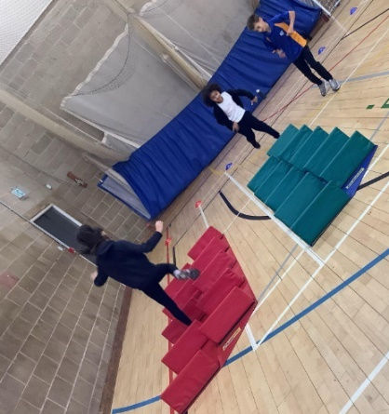
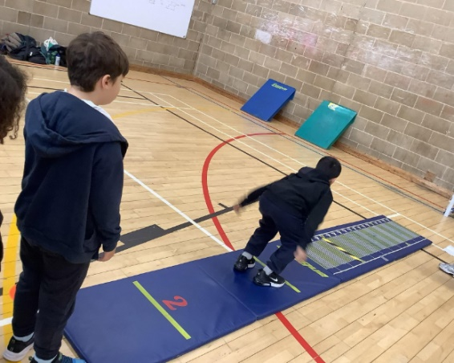
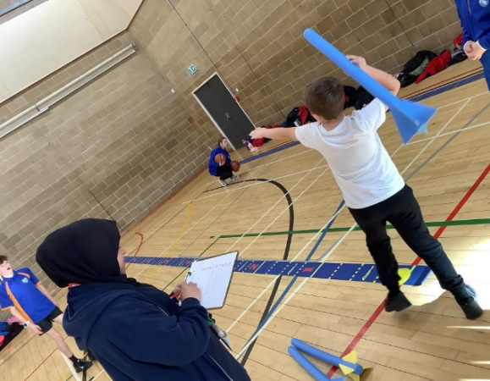
Our Lions had a fantastic morning out at Trinity High school this week, competing in a range of athletic activities – everyone gave it their all!

Grandparents Celebration - Friday 16th October
What a lovely time we have had today for our very first PTA Grandparents’ Day! We really enjoyed inviting wider family members in to school to share time with the children – we hope you enjoyed it and thank you for coming

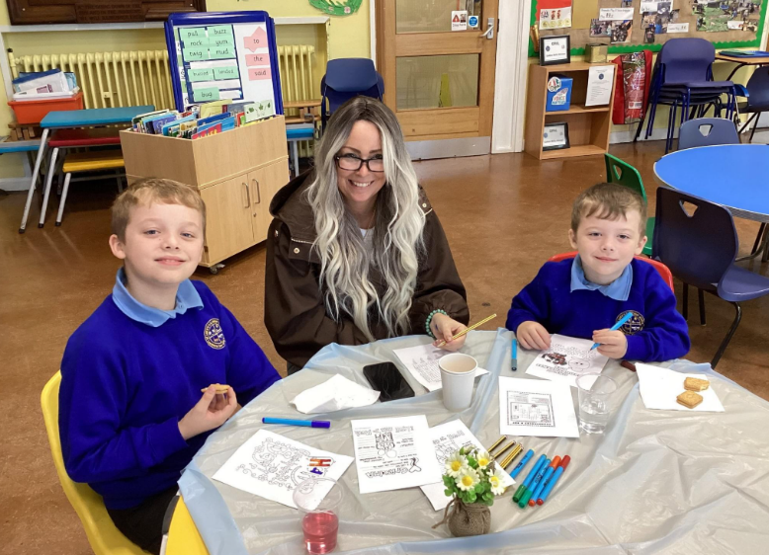
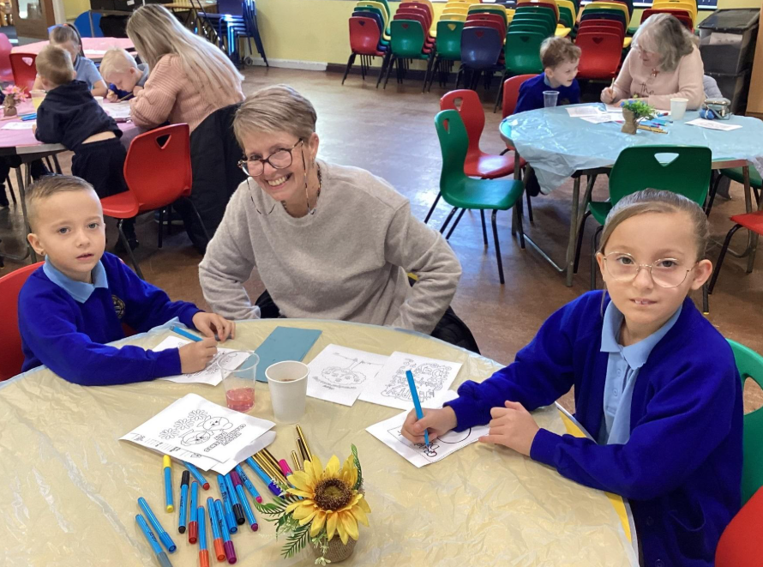

St Luke’s Day
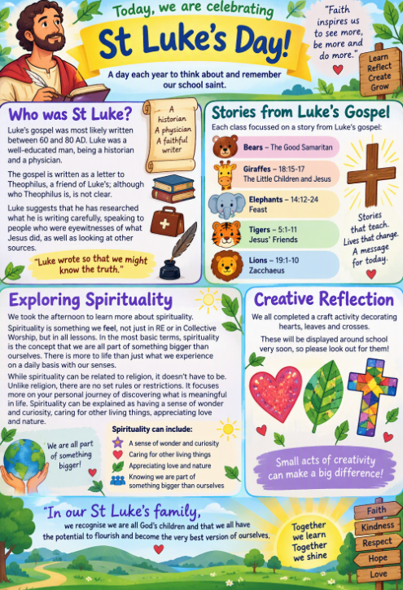
Today, we are celebrating St Luke's Day! A day each year to think about and remember our school saint. We have used today to focus on a story from his gospel and to learn more about spirituality.

Luke’s gospel was most likely written between 60 and 80 AD. Luke was a well-educated man being a historian and a physician. The gospel is written as a letter to Theophilus, a friend of Luke’s; although who Theophilus is, is not clear. Luke suggests that he has researched what he is writing carefully, speaking to people who were eyewitnesses of what Jesus did, as well as looking at other sources.
Each class focussed on a story from Luke’s gospel:
Bears – The Good Samaritan
Giraffes - 18:15-17 – The Little Children and Jesus
Elephants 14:12-24 – Feast
Tigers 5:1-11 – Jesus’ Friends
Lions - 19:1-10 – Zacchaeus
We took the afternoon to learn more about spirituality. Spirituality is something we feel, not just in RE or in Collective Worship, but in all lessons. In the most basic terms, spirituality is the concept that we are all part of something bigger than ourselves. There is more to life than just what we experience on a daily basis with our senses.
While spirituality can be related to religion, it doesn’t have to be. Unlike religion, there are no set rules or restrictions. It focuses more on your personal journey of discovering what is meaningful in life. Spirituality can be explained as having a sense of wonder and curiosity, caring for other living things, appreciating love and nature.
We all completed a craft activity decorating hearts, leaves and crosses. These will be displayed around school very soon, so please look out for them


SAVE THE DATES - Christmas is coming…
It may still be only October, but we know it will come around quickly!
Monday 14th December – KS2 Performances in school. Our Tigers and Lions will be performing at 9:15am and 2:30pm in the school hall.
Tuesday 15th December – Our Bears children will be performing to parents and carers at 9:15am in the school hall.
Wednesday 16th December – KS1 Performances in school. Our Giraffes and Elephants will be performing at 9:15am and 2:30pm in the school hall.

Tuesday 8th December – Children in Years 1-4 have been invited over to the Bridge church in December for a Christmas Experience. This will involve an interactive walk around the church to hear and act out the Christmas story.

After School Clubs
The link for Autumn 2 clubs has been shared on Class Dojo today – don’t forget to sign up as soon as possible.
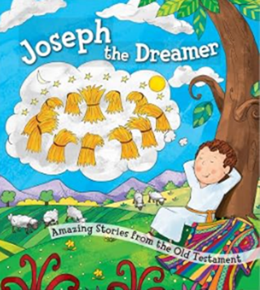
Collective Worship
This week we have continued telling the Bible in a year. We shared the story of Joseph the Dreamer.
Joseph had dreams about his future, but his family did not respond to them in the way he might have hoped.
His story reminds us that life does not always go the way we expect, but we can show courage, persevere through difficult times and trust that God can use us to make a difference.

Key Message: Even when life feels unfair or difficult, we can show courage, persevere and trust that God can help us use our gifts to make a difference to others.
Reflection:​
​How can we make sure everyone feels equally valued and loved in our school family?

What could you say to someone who feels left out, jealous or upset?
How can we keep hope when something does not go the way we planned?

Well done to Giraffes, Elephants, Tigers and Lions classes who have received attendance certificate of the week for attendance over 95%!!

St Luke’s Stars of the Week
Each week in our celebration assembly, the teachers will be choosing a pupil to recognise for their excellent work and attitude to learning. Please see Class Dojo for pictures of our ‘St Luke’s Stars of the Week’. We are very proud of everyone for their hard work and achievements.

There has been no celebration worship today due to our Grandparents Day events – we look forward to seeing who is chosen next time!
Please continue to send in certificates and awards from outside of school achievements so we can share them with the whole school community during our celebration worship.

