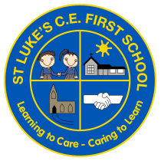 |  | ST LUKE’S CE FIRST SCHOOL  Plymouth Road, Southcrest,  Redditch, Worcestershire B97 4NU  Telephone: 01527 541219  Fax: 01527 543857  Email: admin@stlukesfirst.worcs.sch.uk  Website: www.stlukesfirst.worcs.sch.uk  Thursday 22nd October 2026
Dear Parents/Carers,
Monday 16th – Friday 20th November 2026 is Anti-Bullying week.
The theme is Break the Silence
The week will begin with ‘Odd Sock Day’ so we are asking all children and adults to come to school on Monday 16th November wearing odd socks.
Odd Socks Day is an opportunity to encourage pupils to express themselves and celebrate their individuality and what makes us all unique. It is also an opportunity to help raise awareness of bullying. Most importantly, it is designed to be fun! There is no pressure to wear the latest fashion or to buy expensive costumes. All you have to do to take part is wear odd socks to your school.
On Monday and during the week, the teachers will be planning a range of activities based on anti-bullying in order to support the children’s personal development.
If you would like to find out more information, you can visit the anti-bullying alliance website:
Anti-Bullying Week 2026: Break the Silence
We look forward to seeing everyone in their odd socks!

Mrs H Broughton

Assistant Headteacher



