St Luke’s CE First School
Uniform Policy

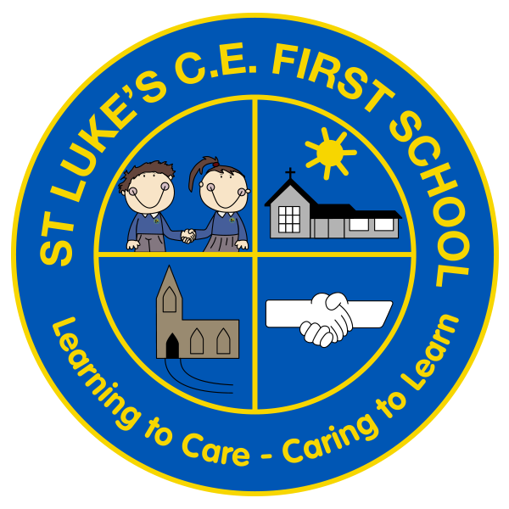

Approved by the Governing Body
Review Date



Introduction
St Luke’s CE First School requires all pupils to wear school uniform throughout their time with us. Our uniform reflects our high expectations for presentation, supports a strong sense of belonging, and promotes equality across our school community. We aim to ensure that our uniform remains affordable, inclusive, and practical for all families.
“Our smart school uniform reflects the school’s focus on high standards of presentation, fosters and embodies a sense of belonging to the school community and promotes equality for all.”

Our School Vision

In our St Luke’s family, we recognise we are all God’s children and through our caring and nurturing environment, we follow His word. We trust and rely on God’s teaching so that we can encourage each other, develop our relationship with one another and the world, and flourish in all that we do. God’s word is a lamp to my feet and a light to my path. (Psalm 119 v.105)

Aims
This policy aims to ensure:
- Reasonable cost — Ensure our uniform is affordable and offers good value for money.
- Equality compliance — Avoid discrimination in line with the Equality Act 2010.
- Clear expectations — Provide clarity for families on what pupils should wear.
- DfE alignment — Meet statutory DfE guidance on cost of school uniform (2024–2026 updates).

Roles and Responsibilities

The Governing Body:
- Establish a practical, smart uniform that reflects our school’s vision and values.
- Ensure equal opportunities and prevent discrimination.
- Listen to parents/carers, pupils and staff when considering changes.
- Ensure uniform remains accessible and affordable.

The Headteacher:
- Enforce uniform expectations daily.
- Ensure staff understand the policy and respond consistently.
- Consider community feedback and make recommendations to governors.
- Provide temporary exemptions where needed (e.g., medical needs).

Teaching and support staff are responsible for:
- Ensure pupils follow the uniform policy.
- Take appropriate action when pupils are not in correct uniform.
- Help pupils understand the purpose of a consistent school uniform.

Parents/carers are responsible for:
- Provide correct uniform as outlined in this policy.
- Inform school if a temporary adjustment is needed.
- Ensure uniform is clean, labelled and fits appropriately.

Pupils:
- Look after their uniform.
- Understand why uniform matters and wear it with pride.

Cost and Availability

- St Luke’s remains committed to DfE guidance on affordability (2024–2026).

- Branded items are optional. “It is not compulsory for any branded items to be worn.”

- Parents may purchase non‑branded items in school colours from any retailer.

- The school does not use exclusive suppliers or cash‑back arrangements.

- Uniform requirements are reviewed infrequently and only with community consultation.

- Support is available for families experiencing financial difficulty. Pupils in receipt of Free School Meals may receive 25% off uniform, including shoes, once per academic year. Parents must provide receipts for reimbursement.

- School maintains a supply of good‑quality second‑hand uniform.

School Uniform Supplier

For our official school uniform items can be purchased from -

Orchard Clothing
Unit 30
Dunlop Road
Redditch
B97 5XP
www.orchardclothing.co.uk

My Clothing
https://myclothing.com/collections/st-lukes-first-school-18105

Our Uniform

The uniform is as follows:

White/blue/yellow shirt or polo shirt (branded or non-branded)
Grey dress/skirt/trousers/shorts/summer dress
St Luke’s logo cardigan / jumper or plain royal blue cardigan/jumper (jumpers and cardigans do not have to be branded)
Grey/white/black socks/tights
Black shoes

All items of clothing and footwear must be labelled with the pupil’s name.

Our PE Kit

Children are asked to come into school on the days of their PE lessons wearing their PE kit. They can wear it for the full school day.

Parents/carers are responsible for ensuring their child is dressed appropriately for PE.

The PE kit is as follows:

- navy blue jogging bottoms and top/sweatshirt (St Luke’s logo or plain sweatshirt)
- plain white T-Shirt / St Luke’s logo t-shirt
- blue/black shorts
- white or black pumps/trainers

Plain jogging bottoms, hoodies/sweatshirts are preferred. However, a small, branded logo is acceptable.

All items of clothing and footwear must be labelled with the pupil’s name.

Forest School Clothing

Children are asked to come into school on the day of their Forest School session wearing their Forest School clothing. Parents/carers will be informed of their children’s Forest School days via Class Dojo reminders.

Forest School clothing is as follows:

- Waterproof coat/jacket.
- Comfortable tracksuit bottoms/leggings (not shorts).
- Long-sleeved top.
- Wellies or old trainers.
- Weather-appropriate hat/scarf/gloves.
- Optional: waterproof trousers, spare socks/underwear.
There is no expectation that Forest School clothing is branded.

Jewellery

The only permitted jewellery that may be worn is:

- One pair of stud earrings (no other piercings are permitted)
- A wristwatch (not a smartwatch)

Jewellery is the responsibility of the pupil and not the school. Lost or damaged items will not be refunded.

All jewellery must be removed during practical lessons, for example, PE lessons / swimming lessons. If children cannot remove their own earrings, then this should be done at home on the day of PE/activity taking place.

School Bag

Pupils must use an appropriately sized waterproof bag to carry their books and equipment. It should hold children’s books and reading diaries comfortably without causing any damage.

Large bags / large rucksacks are discouraged for day-to-day lessons due to space on children’s pegs.

Hair Styles

Hairstyles should be smart and moderate in style.

Long hair should be tied up. This is to avoid health and safety risks and ensure that children’s vision is not impeded.

Large, excessive hair accessories should not be worn; however, small hair clips or plain headbands are acceptable, preferably in school colours.

Adverse Weather

Hot Weather

Everyone working at/attending the school during hot weather conditions is required to wear sun-safe clothing that covers as much of their skin as possible.

This includes wearing:

- Loose fitting tops with collars or covered necklines
- Tops that cover the shoulder area
- Grey or black shorts or pale blue and white summer dresses of an appropriate length (if families wish to)
- Sun-safe hats
- Sunglasses with UV protection
- Sunscreen (applied before school)

During hot weather, lightweight clothing is required to reduce the risk of overheating. Pupils are not required to wear their jumpers/cardigans during heatwaves.

If outside during break and lunch times, pupils not wearing sun-safe clothing/sunscreen are advised to stay in an area protected from the sun.

Cold Weather

During cold weather, pupils are encouraged to wear scarves, gloves, coats and hats when they are outside.

Additional layers underneath the usual school uniform are accepted.

Where possible, pupils not wearing warm clothing are provided with spare clothing if going outside during break and lunch times.

Labelling

School staff encourage good organisation of clothing and footwear, for example, designated spaces for children to keep belongings in and checking of labels. However, all pupils’ clothing and footwear must be clearly labelled with their name.

Clothing and footwear are the responsibility of the pupil and not the school.

If a child goes home in another child’s clothing by accident, for example, their jumper, parents/carers should send the clothing not belonging to them back into school to their child’s class teacher.

Any lost clothing is to be taken to the lost property box. All lost property is retained for a term before being added to the school’s spare uniform supply.

