Friday 25th September 2026
School Vision - In our St Luke’s family, we recognise we are all God’s children and through our caring and nurturing environment, we follow His word. We trust and rely on God’s teaching so that we can encourage each other, develop our relationship with one another and the world, and flourish in all that we do.
God’s word is a lamp to my feet and a light to my path.

‘God’s word is a lamp to my feet and a light to my path.’ (Psalm 119: 105)


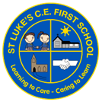
St Luke’s C E First School
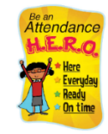
Dates for your Diary

October
Thursday 1st – Harvest Festival @ The Bridge Church
The weeks are flying by, and we have enjoyed another super week in school. As we start to look ahead to October, there is lots coming up, including our Harvest festival next Thursday. Please see further details below.

We will be holding our Autumn term parent/carer meetings on Tuesday 20th and Wednesday 21st October. We will be sending out details for how you can get your appointment booked in very soon. These meetings are a fantastic opportunity for you to meet with your child’s class to teacher to discuss how well they have settled into their new class, as well as finding out about the progress they are making.

Finally, another reminder for our upcoming work with me dates:
Giraffes – Wednesday 7th October
Elephants – Monday 5th October
Tigers – Thursday 15th October – please note, this is a change of date due to the Tiger class trip.
Lions – Wednesday 14th October

Friday 9th – Mental Health Hello Yellow

Tuesday 13th – Tigers Class trip to Bishops Wood

Friday 16th – St Luke’s Day

Thursday 22nd – Break Up for Half Term

Friday 23rd – School Closed TED

November

Monday 2nd – School Re-opens

Attendance:
Our year to date attendance is: 96.91%
This week’s attendance:

Bears | Giraffes | Elephants | Tigers | Lions | Whole School
100% | 98.97% | 100% | 96.77% | 99.26% | 98.92%


Hello Yellow – Mental Health
On Friday 9th October, we will be celebrating World Mental Health Day. We’d love to see everyone dressing in yellow while we spend the day completing activities to focus on our mental health.

Wear yellow and say hello as we celebrate 10 years of standing out, starting conversations and raising funds – so no young person feels alone with their mental health.

There are days when all of us struggle with how we are feeling. Things can get tough, and it can be difficult knowing how to cope. For so many young people, when this happens, they don’t always get the help they need, when they need it. They don’t know where to turn, who to talk to, or even if anyone else feels the same.

But we can change this. By taking part in Hello Yellow you’re starting a conversation about mental health wherever you are. And by funding our support – you’re ensuring we can be there to pick it up where you left off.

Stand out, wear yellow on 9 October and donate what you can. Together we can support young people’s mental health, when they need it – no matter what.

Visit the Young Minds website for more information: https://www.youngminds.org.uk/support-us/fundraising/helloyellow/

Early Years Outdoor Classroom
It has been wonderful to see our new Bears class exploring their new outdoor classroom this week. Lots of fun has been had using the new equipment. The children are becoming more confident with using the loose parts and applying their imagination to create new inventions. The water play has been very popular and we are excited to add more equipment to this now we have our water play overalls ready to go!

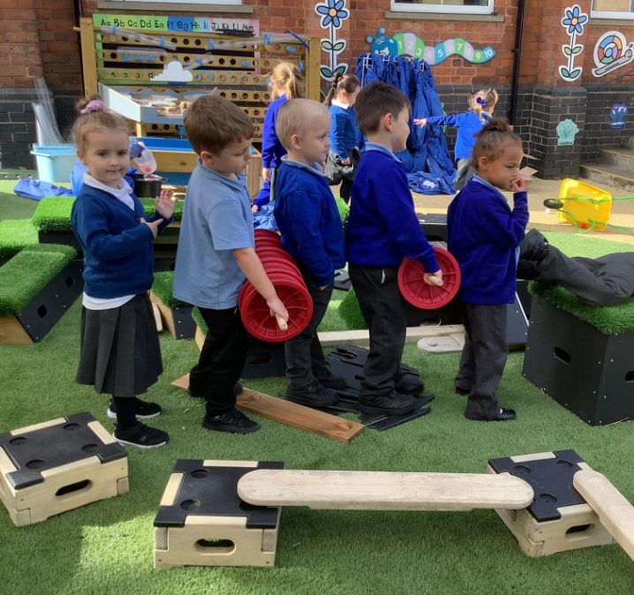
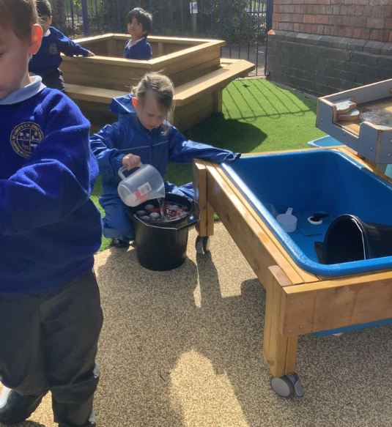

Harvest Festival
Our Harvest Festival will take place at The Bridge Church on Thursday 1st October. All classes will be walking over to the Bridge after morning registration. We aim to start the service at approximately 9:15am. Each class will be singing a harvest song and we hope lots of parents/carers and wider family members will be able to join us for this special event. We also ask that our families make a small donation or non-perishable items if you are able to. These will be collected and taken to the local food bank to support families in the Redditch area.

Languages Day
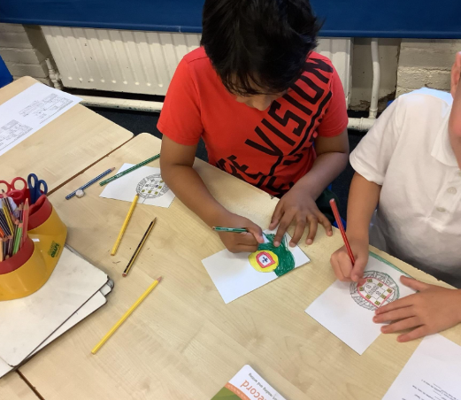
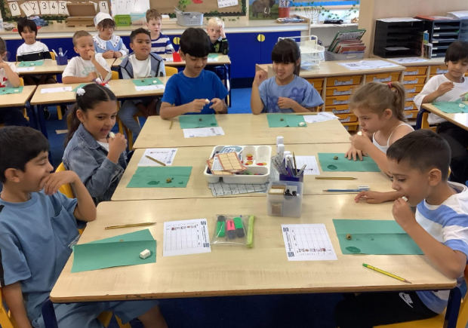
All classes have enjoyed a fabulous languages day today – we’ve loved seeing everyone dressed in their country’s colours and there has been a range of learning and food tasting taking place across the school Thank you to Mrs Smith, our languages lead, for organising this special day. Please see class Dojo pages for more details.
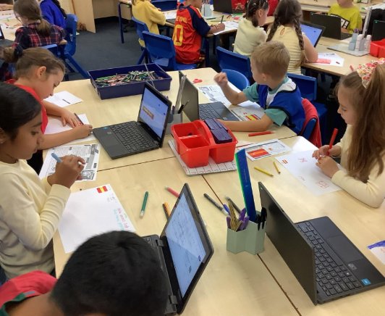
Starting School in September 2027?

We are aware we have some siblings who will be due to start school in September 2027…we can’t wait for you to join us! Don’t forget to submit your applications by the deadline of 15th January 2027.
If you know of anyone who is due to start school next September, please spread the word for our school and encourage prospective parents to attend our open day, which will be held on Thursday 15th October which or to contact the school office to enquire about booking a tour of our school. I have already shown several families around our school in the past couple of weeks which has been a joy!

For parents/carers of our Lions class, don’t forget to submit your applications for middle school by 15th January 2027.


Collective Worship
This week we have gathered together to continue our collective worship cycle for this year. We are going to be ‘telling the Bible’ across the year and this week, we continued with the story of a special promise – Noah and the Ark.

We thought about what a promise is and considered the kinds of promises we make. We considered how sometimes keeping a promise can be much harder that making one.

Reflection:​
Have you ever promised to do something and then forgotten?
Have you ever broken a promise?
How did that make you feel?
How did it make the other person feel?


​ From September 2026, new allergy-safety rules, known as Bendict's Law, will help children with allergies in schools across England. Schools must have a clear allergy plan, train their staff and make sure children can quickly get the help they need. The changes aim to help very child feel safe, understood and included in school.

During Collective Worship we discussed what an allergy is and allergy symptoms. The children then all pledged to be Allery Aware Superheroes and follow 3 rules:

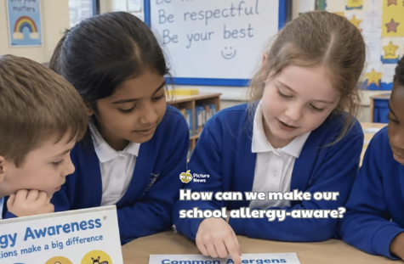
Rule 1 - Never share food
What is a safe treat for you might make your friend very sick

Rule 2 - Leave nuts at home
Our school is a strict Nut-Free Zone to keep our friends safe.​

Rule 3 - Speak up fast
If a friend says they feel itchy, dizzy, or tummy-ache after eating...​ Tell an adult straight away!​

This links directly with our school vision as at St Luke's we ensure we provide a caring and nurturing environment for everyone.

In our Celebration Worship we have said “congratulations” to children impressing their teachers by living out our school vision. I was delighted to hand out vision certificates to Nancy (Bears), Arina (Giraffes), Aliya (Elephants), Ollie (Tigers) and Iyla (Lions).
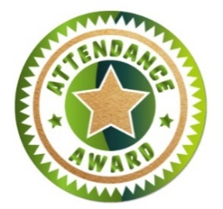
Lunchtime Award Winners: Noah (Lions) & Nevaeh (Elephants)
Golden Welly: Haaniya Tigers

Well done to ALL classes who have received attendance certificate of the week for attendance over 95%...and a huge well done to Bears and Elephants for 100% - WOW!!

St Luke’s Stars of the Week
Each week in our celebration assembly, the teachers will be choosing a pupil to recognise for their excellent work and attitude to learning. Please see Class Dojo for pictures of our ‘St Luke’s Stars of the Week’. We are very proud of everyone for their hard work and achievements.

Bears: Lune- Rae for great pencil control and posture during handwriting sessions.
Giraffes: Nissi for excellent handwriting and correctly forming her letters in the Curly Cat family.
Elephants: Anaya for her dedication and huge improvement with her letter formation when using the lines in our new English books.
Tigers: Tilly for super handwriting and good use of expanded noun phrases to describe.
Lions: Bebe for her beautiful structure and presentation in English, especially her retell of The Lion Inside!
Please continue to send in certificates and awards from outside of school achievements so we can share them with the whole school community during our celebration worship.

