Friday 18th September 2026
School Vision - In our St Luke’s family, we recognise we are all God’s children and through our caring and nurturing environment, we follow His word. We trust and rely on God’s teaching so that we can encourage each other, develop our relationship with one another and the world, and flourish in all that we do.

‘God’s word is a lamp to my feet and a light to my path.’ (Psalm 119: 105)


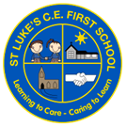
St Luke’s C E First School
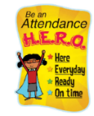
Dates for your Diary

September
This week has brought the completion of our Early Years outdoor area. There may be a few tweaks to make along the way, but we are in the position where staff can now prepare the area for the children to use for their learning. Thank you for your continued support while these works have been ongoing – I can wait to see Bears enjoying all the new learning opportunities available to them!

Work with Me Dates
A reminder of our autumn term ‘work with me’ dates. We invite parents/carers into the classroom from 2.15pm – 3.15pm on the dates below to work alongside your children. Please remember, we are unable to accommodate younger siblings. Bears class, we will be in touch soon about what ‘work with me’ will look like in our Reception class.
Giraffes – Wednesday 7th October
Elephants – Monday 5th October
Tigers – Tuesday 13th October
Lions – Wednesday 14th October

Friday 25th – Languages Day

October
Thursday 1st – Harvest Festival @ The Bridge Church

Friday 16th – St Luke’s Day

Thursday 22nd – Break Up for Half Term

Friday 23rd – School Closed TED

Attendance:
Our year to date attendance is: 96.12%
This week’s attendance:

Bears | Giraffes | Elephants | Tigers | Lions | Whole School
97.33% | 95.52% | 98.62% | 98.06% | 99.26% | 97.76%

National Day of Fitness!
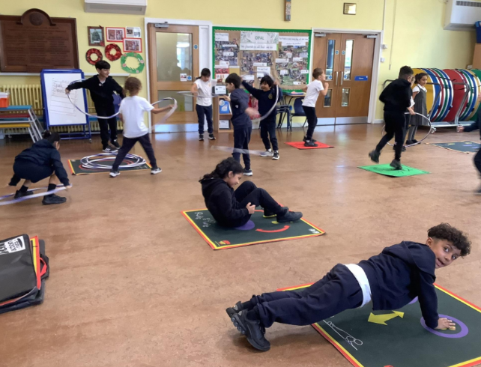
This week we have enjoyed celebrating National Fitness Day! All classes took part in lots of physical activity. From using the active mats to Zumba sessions, and even more opportunities for active play during OPAL, we had a fantastic time!
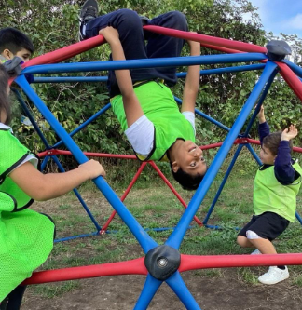
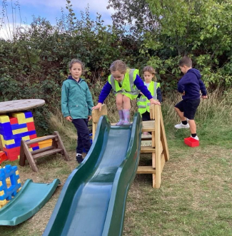
A big thank you to Mrs Larsen for leading our zumba sessions – we loved it!
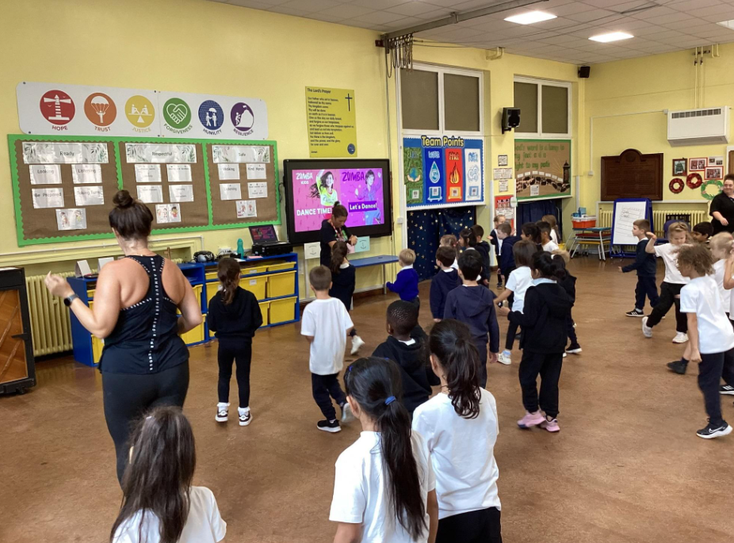
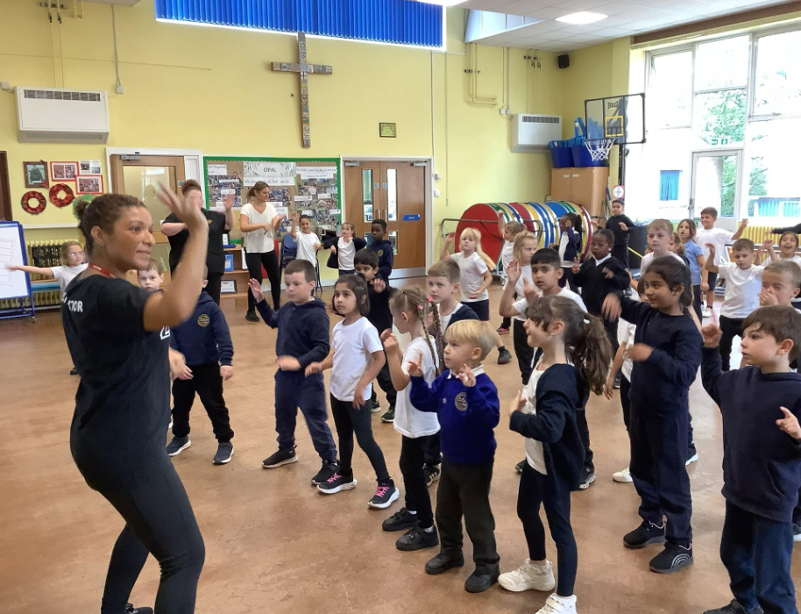

Autumn Term Clubs
Our clubs have started this week! We have enjoyed mindfulness, lego, dodgeball, fitness, times table rockstars and archery, and a great time was had by all. We look forward to the children continuing to enjoy a range of clubs across the next few weeks. Please remember, if your child is dodgeball or fitness, they need to bring trainers with them to change into if Wednesday is not their PE day!

We have also seen children enjoying the start of our wrap around provision with LSC. If you need an earlier start or a later collection for your child, please sign up via the LSC link on Class Dojo.

Harvest Festival
Our Harvest Festival will take place at The Bridge Church on Thursday 1st October. All classes will be walking over to the Bridge after morning registration. We aim to start the service at approximately 9:15am. Each class will be singing a harvest song and we hope lots of parents/carers and wider family members will be able to join us for this special event. We also ask that our families make a small donation or non-perishable items if you are able to. These will be collected and taken to the local food bank to support families in the Redditch area.

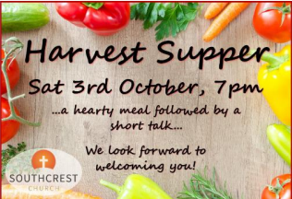
Southcrest Church Harvest Supper
Our St Luke’s family are invited to join members of Southcrest Church for their FREE Harvest Supper on Saturday 3rd October. The evening starts with a meal at 7 pm, then Paul Willmott will be the after dinner speaker, along with one of his puppets. For more details or to book a place, please email info@Southcrestchurch.uk

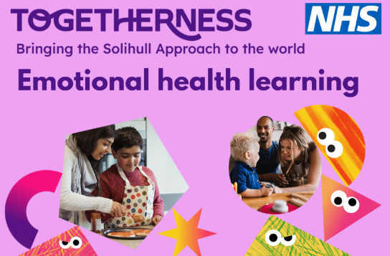
Free Parenting Resource – Togetherness for better emotional health
Togetherness offers free NHS-developed online learning to help families understand child development, strengthen parent-child relationships and support children's emotional wellbeing. A particularly useful resource is Understanding Your Child: From Toddler to Teenager, a flexible online course for parents, carers and grandparents of children aged 6 months to 19+ years.
Read the latest Togetherness newsletter here - https://drive.google.com/file/d/1ZCjujbKzDJIIiAliK4TMl9usxhWOjELG/view

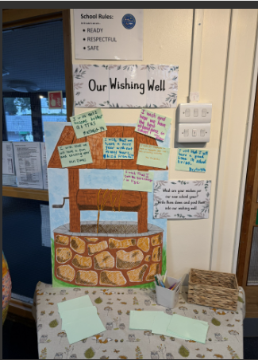
Our wishes for the new school year
We are starting our academic year with our school wishing well, rather than our monthly ‘thunks’. The children have been asked what their wishes are for their new school year. Here are some more of their responses:

I wish that no one will be sick. Zaiba, Elephants
I wish that I can get better at everything in school. Kiswa, Lions
I wish love for everyone. Florence
I wish for everyone to have nice toys. Jonathon Bears

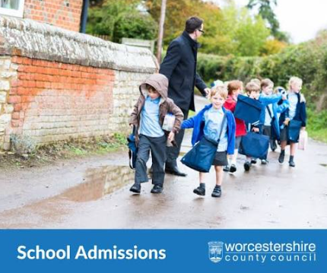
Starting School in September 2027?
We are aware we have some siblings who will be due to start school in September 2027…we can’t wait for you to join us! Don’t forget to submit your applications by the deadline of 15th January 2027.
If you know of anyone who is due to start school next September, please spread the word for our school and encourage prospective parents to attend our open day, which will be held on Thursday 15th October which or to contact the school office to enquire about booking a tour of our school. I have already shown several families around our school in the past couple of week which has been a joy!

For parents/carers of our Lions class, don’t forget to submit your applications for middle school by 15th January 2027.


Collective Worship
This week we have gathered together to continue our collective worship cycle for this year. We are going to be ‘telling the Bible’ across the year and this week, we continued with the story of Adam and Eve, and The Fall.

We talked about the following -
Have you ever done something wrong and then tried to hide it?
How do we sometimes feel when we know we've done something wrong?​

We thought about how making mistakes is part of being human. What matters is what we do next.​

Our Bible story was all about Adam and Eve and the very first time that human beings chose to go against God's instructions.​

Reflection:​
Think of a time when you made a mistake. ​
Perhaps you wanted to hide because you were worried about what someone would think.​
Now imagine God asking you: “Where are you?”​
God isn't asking because He doesn't know where you are.​
He is asking because He wants you to come back to Him.​


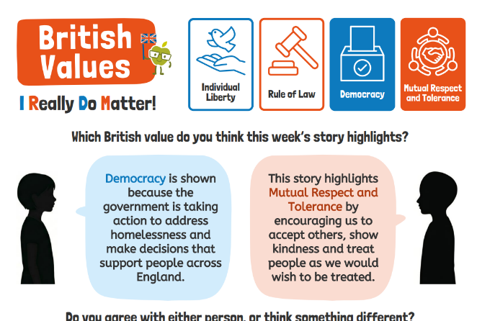
UK Prime Minister Andy Burnham has pledged that, by Christmas, everyone sleeping rough in England will be offered a safe place to stay. Accommodation will be found to end the need for sleeping rough. There will also be practical support for any health needs, as part of a £442m investment.

The children felt this week's story linked to our school vision in the following ways:
- We are all God's children – Everyone is important and deserves to be safe, cared for and treated with kindness.
- Following God's word – Jesus taught us to help people who are struggling and show compassion to others.
- Encouraging each other – Giving people a safe place to stay helps them feel supported and gives them hope.

In our Celebration Worship we have said “congratulations” to children impressing their teachers by living out our school vision. I was delighted to hand out vision certificates to Max (Giraffes), Nicholas (Elephants), Ahad (Tigers) and Aiza (Lions).

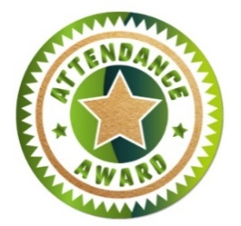
Lunchtime Award Winners:
Golden Welly:

Well done to ALL CLASSES who have received attendance certificate of the week for attendance over 95%!!

St Luke’s Stars of the Week
Each week in our celebration assembly, the teachers will be choosing a pupil to recognise for their excellent work and attitude to learning. Please see Class Dojo for pictures of our ‘St Luke’s Stars of the Week’. We are very proud of everyone for their hard work and achievements.

Bears: Bears will be joining us for their first celebration worship next week.
Giraffes: Umme for brilliant work in maths when representing numbers.
Elephants: Shayan for his magnificent artwork. We were amazed at what Shayan produced with his finger!
Tigers: Salomi for her artwork and attention to detail.
Lions: Hayden for his accuracy when comparing 4-digit numbers in Maths.
Please continue to send in certificates and awards from outside of school achievements so we can share them with the whole school community during our celebration worship.

