Friday 11th September 2026
School Vision - In our St Luke’s family, we recognise we are all God’s children and through our caring and nurturing environment, we follow His word. We trust and rely on God’s teaching so that we can encourage each other, develop our relationship with one another and the world, and flourish in all that we do.

‘God’s word is a lamp to my feet and a light to my path.’ (Psalm 119: 105)


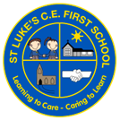
St Luke’s C E First School
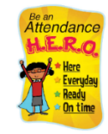
Dates for your Diary

September
Week two in school has flown by – I can’t believe it is Friday already! The children have continued to be amazing super stars and we can’t wait to welcome our new Bears class into school full time from Monday 14th September!
Please remember to keep an eye on Class Dojo for important information/ notices and photographs of the children in school.

I am delighted to see our attendance figures on the rise this week – well done to everyone! We are still having several late arrivals in the morning – please ensure you are here at school before the gate closes at 8:50am. Thank you.

Work with Me Dates
I am pleased to share our autumn term work with me dates. We invite parents/carers into the classroom from 2.15pm – 3.15pm on the dates below to work alongside your children. Bears class, we will be in touch soon about what ‘work with me’ will look like in our Reception class.
Giraffes – Wednesday 7th October
Elephants – Monday 5th October
Tigers – Tuesday 13th October
Lions – Wednesday 14th October

Wk Beginning 14th – After School Clubs start

Friday 25th – Languages Day

October
Thursday 1st – Harvest Festival @ The Bridge Church

Friday 16th – St Luke’s Day

Thursday 22nd – Break Up for Half Term

Friday 23rd – School Closed TED

Attendance:
Our year to date attendance is: 94.64%
This week’s attendance:

Bears | Giraffes | Elephants | Tigers | Lions | Whole School
95.63% | 97.59% | 96.9% | 99.03% | 99.25% | 97.76%

Safeguarding
At St Luke’s we are committed to safeguarding all our pupils. We take safeguarding and child protection very seriously. Our designated safeguarding leads are Mrs Baker and Mrs Broughton. Tabatha Kenny is our Family Support Worker and she can be contacted 01527 541219.

Parental Questionnaire Feedback:
You may remember that back in the summer term, our Academy Trust sent out a parent questionnaire, asking our parents/carers to give their view on St Luke’s. I received the results at the end of last week and wanted to share these with you.
The overall picture stated:
Exceptionally strong parental feedback across all areas, with results significantly above national benchmarks. Overall, satisfaction is outstanding, with 100% of parents agreeing that the school helps their child makes good progress.

The following key strengths were identified:
Leadership & management: 100% positive
Communication from the school: 100% positive
Behaviour management: 100% positive
Pupils feel safe at school: 100% positive
Understanding of pupil progress: 100% positive
Teaching & Learning quality: 100% positive
Extra-curricular opportunities: 100% positive

I would like to thank everyone for taking the time to complete the survey – we are thrilled with the positive results! I have said it before, but we are so lucky to have such wonderful children, dedicated staff and hugely supportive parents here in our St Luke’s family, and we look forward to continue working closely with you all again for the academic year ahead!


Packed Lunches
We know it can be difficult to think of different items for the daily packed lunches now we have returned to the usual school routine. The following link to the BBC website gives some ideas of things to pack:
https://www.bbc.co.uk/food/articles/what_makes_a_great_packed_lunch

Can we please remind parents/carers that we are a nut free school due to pupil allergies.

We are also very mindful about the size of pieces of food that are packed for our younger children. Please ensure grapes are cut in half length ways. Uncut grapes can be a chocking hazard for young children, and for our youngest pupils, it is recommended that gapes are cut into quarters.

Autumn Term Clubs
Our clubs will start next week for Years 1-4 and will run for 5 weeks. All clubs run from 3:20pm – 4:20pm. Please ensure prompt collection. Please ensure you send your child to school with trainers for dodgeball and fitness clubs.
We do still have spaces in our clubs – if your child hasn’t signed up yet, it’s not to late1 Please contact Mrs Bird I our school office and she will add your child to the list.

Harvest Festival
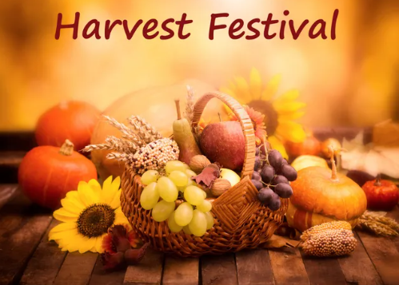
Our Harvest Festival will take place at The Bridge Church on Thursday 1st October. All classes will be walking over to the Bridge after morning registration. We aim to start the service at approximately 9:15am. Each class will be singing a harvest song and we hope lots of parents/carers and wider family members will be able to join us for this special event. We also kindly ask that families donate some non-perishable foods if you can for the local food back. We will take a selection with us for the Harvest service and then all of our donations will be passed on to the food bank to support those who need it. Thank you.

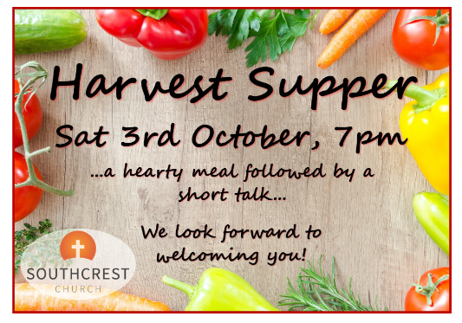
Southcrest Church Harvest Supper
Our St Luke’s family are invited to join members of Southcrest Church for their FREE Harvest Supper on Saturday 3rd October.

The evening starts with a meal at 7 pm, then Paul Willmott will be the after dinner speaker, along with one of his puppets.
For more details or to book a place, please email info@Southcrestchurch.uk

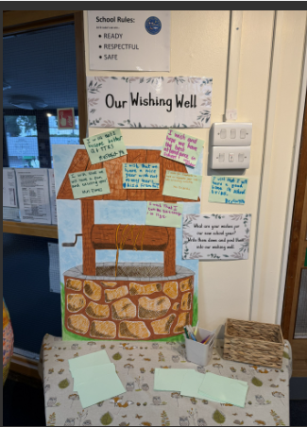
Our wishes for the new school year
We are starting our academic year with our school wishing well, rather than our monthly ‘thunks’. The children have been asked what their wishes are for their new school year. Here are some of their responses:

I wish that we will have a good time on school trips. Bertie, Lions
I wish for Elephants to have an enjoyable year with lots of exciting opportunities. Miss Gibbons
I wish that I will become better at TTRS. Mustafa Lions
I wish that we will have a fun and exciting year! Mrs Elmes
I wish that we will have a nice year with not many tears. Aiza
I wish that I can get better at everything in school. Kizwa Lions
I wish everyone will be fair and let people play with them. Harley, Elephants
I wish for everyone to be happy. Liza, Elephants

Christmas
St Stephen’s Church in Redditch have sent us an invitation to their Carols by Candlelight service on Sunday 20th December at 6pm. All children and their families, as well as the staff are welcome to join them for an evening of traditional carols, followed by mince pies.


Starting School in September 2027?
We are aware we have some siblings who will be due to start school in September 2027…we can’t wait for you to join us! Don’t forget to submit your applications by the deadline of 15th January 2027. If you know of anyone who is due to start school next September, please spread the word for our school and encourage prospective parents to attend our open day, which will be held on Thursday 15th October which or to contact the school office to enquire about booking a tour of our school.

For parents/carers of our Lions class, don’t forget to submit your applications for middle school by 15th January 2027.



LSC Wrap Around Provision
Our wrap around provision starts on Monday 14th September. Staff from LSC will be onsite every morning from 7:30am and every day after school until 6pm leading fun activities for the children. This wrap around care is designed to help out busy families by allowing you to drop children off a little earlier in the morning and collect a little later.
Please see Class Dojo for the links to sign up.

Collective Worship
This week we have gathered together to begin our new collective worship cycle for this year. We are going to be ‘telling the Bible’ across the year and this week, we started at the beginning, with the creation story.

We talked about the following -
God creates a place out of love.​
What God creates is good and has immense value.​
God’s creation forms a relationship between humankind and God.​
This relationship is born out of love as his people are his most prized creation. ​ We talked about the following -

God shares his creation with those he created. ​
We are all called to be ‘good stewards’ of the Earth. ​
God asks each person to look after the land, tend for it, keep it safe and to use it wisely.

We thought about how we can be good stewards of God’s creation –
- Turning off lights when we leave a room ​
- ​Being kind to animals​
- Planting flowers or vegetables ​
- Being thankful for the food we eat ​
- Recycling our rubbish​

In our Celebration Worship we have said “congratulations” to children impressing their teachers by living out our school vision. I was delighted to hand out vision certificates to Faith (Giraffes), Liza (Elephants), Sophia (Tigers) and Ethan (Lions).

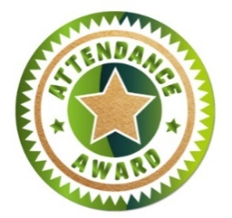
Golden Welly:

Well done to ALL FIVE classes who have received attendance certificate of the week for attendance over 95%!!

St Luke’s Stars of the Week
Each week in our celebration assembly, the teachers will be choosing a pupil to recognise for their excellent work and attitude to learning. Please see Class Dojo for pictures of our ‘St Luke’s Stars of the Week’. We are very proud of everyone for their hard work and achievements.

Bears: Our first Bear will be chosen for next week’s celebration worship, when the class are in school full time.
Giraffes: Ahad for using the working wall and his phonics knowledge to write an independent sentence.
Elephants: Grayson for his super effort and for showing resilience in all of his subjects. I am particularly impressed with his reading, writing and reasoning with numbers to 100.
Tigers: Yaseen working more independently in place value maths sessions.
Lions: Emely for her expanded noun phrases in English.
Please continue to send in certificates and awards from outside of school achievements so we can share them with the whole school community during our celebration worship.

