
Shires Multi Academy Trust
Free School Meals

Since September 2014 every child in Reception and Key Stage 1 (Years 1 and 2) is entitled to a free school meal.

This is a fantastic opportunity for children, and as a catering team we work hard to ensure your child receives a balanced choice of lunches from our kitchen. Remember children who eat more healthily perform better academically!

If you are also eligible for free school meals and in receipt of any of the benefits listed below and you do not complete the application for this; your school will be missing out on vital government funding, as much as £1455 per child!

Income Support
Income-based Jobseekers Allowance
Income-related Employment & Support Allowance
Support under Part VI of the Immigration and Asylum Act 1999
The guaranteed element of pension credit
Child Tax Credit
Working Tax Credit
Universal Credit

Your school uses this money to provide further enrichment to enhance your child’s educational experience.

Therefore, it is important that you still complete your application for free school meals by visiting www.worcestershire.gov.uk/council-services/childrens-services/schools-education-and-learning/free-school-meals or alternatively scan the QR code below.

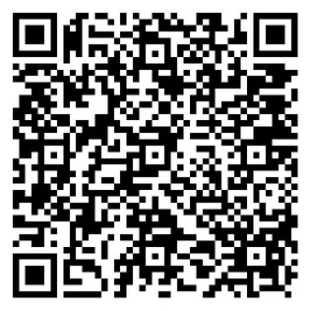
Thank you for supporting your school.

