Common Lane

Shirebrook

Nottinghamshire

NG20 8QF

Tel: 01623 742722 / Fax: 01623 742206

[enquiries@shirebrookacademy.org](mailto:enquiries@shirebrookacademy.org) [www.shirebrookacademy.org](http://www.shirebrookacademy.org)

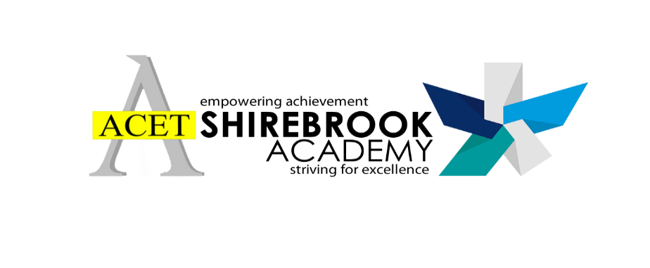

***Executive Principal: Vice Principals:* Lindsay Ward** BA (Hons), PGCE **Rebecca Hibberd** – BEd Hons MA **Damian O’Reilly** BA (Hons), NPQSL

***Associate Principal:***  
**Lindsey Burgin** BA (Hons), PGCE, MA



Ref:

Thursday 15th December 2022

**Information regarding recent Year Group partial closure**

Dear Parents/Carers,

This letter is intended to give some further details and context linked to the recent, necessary, Year Group closures at Shirebrook Academy.

No school ever wants to close. Our mission is clear, to serve our students and local community safely and effectively and ensure that our children learn. Working in partnership, we all have a responsibility to help our young people develop and learn the knowledge, understanding and skills to be successful in later life.

We have recently had to make the difficult, but necessary, decision to close to three Year Groups on different days – Y8-10. The reasons for this decision include a higher level of staff absence due to seasonal illnesses and an inability to secure supply members of staff from agencies due to a range of factors, also including higher levels of seasonal illness.

Our contingency planning has included the recruitment of an additional cover supervisor for after the Christmas break, the retention of longer-term supply staff where needed and the redeployment of staff. Daily, we plan to ensure that all of our children attend the academy safely and, where insufficient staffing means that this may be difficult, we have looked to stagger closure to different Year Groups to minimise the impact on learning.

We are not an academy or trust that would close to any child unless it was absolutely necessary and unless all other management options had been considered. Thank you to parents/carers that have recognised and understood the difficulties involved in making decisions linked to partial closure.

If you have any further questions regarding the recent Year Group closures, please don’t hesitate to contact us at [enquiries@shirebrookacademy.org](mailto:enquiries@shirebrookacademy.org).

Thank you for your ongoing support.

Yours sincerely



**Mrs Lindsey Burgin**

**Associate Principal**