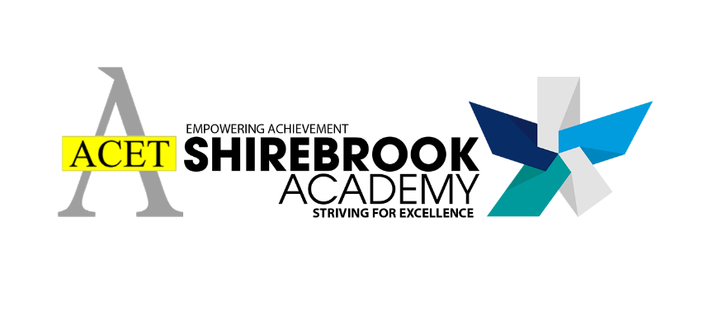

SHIREBROOK ACADEMY

RELATIONSHIPS AND SEX EDUCATION POLICY (RSE)

Date: September 2022
Review cycle: 2 years
Contributors:
Cuan Jacques, Assistant Vice Principal for Personal Development

Contents
- Aims Page 3
- Statutory requirements Page 3
- Policy Development Page 3
- Definition Page 4
- Curriculum Page 4
- Delivery of RSE Page 4
- Use of external organisations and resources Page 6
- Roles and Responsibilities Page 7
- Parents’ right to withdraw Page 8
- Training Page 8
- Monitoring arrangements Page 9
- Appendix 1: Cross Curricular Map of RSE Page 10
- Appendix 2: Curriculum Map Page 27
- Appendix 3: By the end of secondary school pupils should know Page 31
- Appendix 4: Parental form: withdrawal from sex education within RSE Page 34
- Appendix 5: Links to Department for Education advice and guidance Page 36

1. Aims
The aims of relationships and sex education (RSE) at Shirebrook Academy are to:
- Provide a framework in which sensitive discussions can take place
- Prepare pupils for puberty, and give them an understanding of sexual development and the importance of health and hygiene
- Help pupils develop feelings of self-respect, confidence and empathy
- Create a positive culture around issues of sexuality and relationships
- Teach pupils the correct vocabulary to describe themselves and their bodies
- Uphold our academy ethos and values about showing respect towards everyone and keeping everyone safe.
This policy covers the Academy’s whole school approach to Relationships and Sex Education (RSE).

The policy is developed by Cuan Jacques, the Assistant Vice Principal (Personal Development) in consultation with staff, students, parents / carers, governors and relevant outside agencies.
2. Statutory requirements
As a secondary academy, we must provide RSE to all pupils under section 34 of the Children and Social Work Act 2017.
In teaching RSE, we’re required by our funding agreements to have regard to guidance issued by the secretary of state, as outlined in section 403 of the Education Act 1996.
We also have regard to legal duties set out in:
• Sections 406 and 407 of the Education Act 1996
• Part 6, chapter 1 of the Equality Act 2010
• The Public Sector Equality Duty (as set out in section 149 of the Equality Act 2010). This duty requires public bodies to have due regard to the need to eliminate discrimination, advance equality of opportunity and foster good relations between different people when carrying out their activities
At Shirebrook Academy, we teach RSE as set out in this policy.

3. Policy development

This policy has been developed in consultation with staff, pupils and parents. The consultation and policy development process involved the following steps:
- Review – the Assistant Vice Principal for PD and PD Coordinator pulled together all relevant information including relevant national and local guidance

- Staff consultation – Leadership Team and form tutors, who would be delivering the lessons, were given the opportunity to look at the policy and make recommendations

- Parent/stakeholder consultation – parents and any interested parties were invited to attend a meeting about the policy. In addition, Jane O’Byrne, Health and Wellbeing Consultant from the Education Improvement Service at Derbyshire County Council, canvassed KS3 parents and made recommendations that were incorporated into the policy.

- Pupil consultation – throughout the year we have used the student voice to inform the planning of RSE – including student voice on sexual harassment and PD lessons and student reflection on PD days.

- Ratification – once amendments were made, the policy was shared with the link governor for PD (Sally Wheatley) before being shared with the whole governing body and ratified.

4. Definition

RSE is about the emotional, social and cultural development of pupils, and involves learning about relationships, sexual health, sexuality, healthy lifestyles, diversity and personal identity.
RSE involves a combination of sharing information, and exploring issues and values.
RSE is not about the promotion of sexual activity.

5. Curriculum
Our RSE curriculum is set out as per Appendix 1, but it remains dynamic and flexible in order to address topical issues, such as the Sarah Everard case. In this respect, we may need to adapt it as and when necessary.
We have developed the curriculum in consultation with parents, pupils and staff, and taking into account the age, developmental stage, needs and feelings of our pupils. If pupils ask questions outside the scope of this policy, teachers will respond in an appropriate manner so that pupils are fully informed and don’t seek answers online.
For more information about our curriculum, see our curriculum map in Appendix 1.

6. Delivery of RSE

RSE is taught within the Personal Development curriculum. PD is taught once a week for Y7-10 students along with 5 drop down PD Days throughout the year for all year groups. Biological aspects of RSE are taught within the science curriculum, and other aspects are included in Philosophy and Ethics. In Y10 and Y11 students will cover aspects of RSE during their RE input in a weekly scheduled form time. RSE will also be addressed through Assemblies and in the British Values input during form time, focusing on Protected Characteristics, Mutual Respect, Individual Liberty and the Rule of Law.
Small group work also runs throughout the year with SEND and vulnerable students, as identified by the Pastoral Team – this can incorporate input from Harm not Hate, the Elm Foundation and Victim Support.
Following incidents or issues with the academy community, 1-1 work and education sessions will take place according the needs of the students – pre-recorded educational resources have been produced to address racism, sexism, homophobia and transphobia.

RSE focuses on giving young people the information they need to help them develop healthy, nurturing relationships of all kinds including:
- Families
- Respectful relationships, including friendships
- Online and media
- Being safe
- Intimate and sexual relationships, including sexual health
For more information about our RSE curriculum, see Appendices 1 and 2.

These areas of learning are taught within the context of family life, taking care to make sure that there is no stigmatisation of children based on their home circumstances (families can include single parent families, LGBT parents, families headed by grandparents, adoptive parents and foster parents/carers, amongst other structures), along with reflecting sensitively that some children may have a different structure of support around them (for example, looked-after children or young carers).
We will also be mindful of the law and legal requirements, taking care not to condone or encourage illegal political activity, such as violent action against people, criminal damage to property, hate crime, terrorism or the illegal use of drugs.

  - Inclusivity
We will teach about these topics in a manner that:
- Considers how a diverse range of pupils will relate to them
- Is sensitive to all pupils’ experiences
- During lessons, makes pupils feel:
  - Safe and supported
  - Able to engage with the key messages
We will also:
- Make sure that pupils learn about these topics in an environment that’s appropriate for them, for example in:
  - A whole-class setting
  - Small groups or targeted sessions
  - 1-to-1 discussions
  - Digital formats
- Give careful consideration to the level of differentiation needed

  - Use of resources
We will consider whether any resources we plan to use:
  - Are aligned with the teaching requirements set out in the statutory RSE guidance
  - Would support pupils in applying their knowledge in different contexts and settings
  - Are age-appropriate, given the age, developmental stage and background of our pupils
  - Are evidence-based and contain robust facts and statistics
  - Fit into our curriculum plan
  - Are from credible sources
  - Are compatible with effective teaching approaches
  - Are sensitive to pupils’ experiences and won’t provoke distress

7. Use of external organisations and materials

We will make sure that an agency and any materials used are appropriate and in line with our legal duties around political impartiality.
The school remains responsible for what is said to pupils. This includes making sure that any speakers, tools and resources used don’t undermine the fundamental British values of democracy, the rule of law, individual liberty, and mutual respect and tolerance of those with different faiths and beliefs.
We will:
- Make appropriate checks and engage with external agencies to make sure that their approach to teaching about RSE is balanced, and it and the resources they intend to use:
  - Are age-appropriate
  - Are in line with pupils’ developmental stage
  - Comply with:
    - This policy
    - The Teachers’ Standards
    - The Equality Act 2010
    - The Human Rights Act 1998
    - The Education Act 1996
- Only work with external agencies where we have full confidence in the agency, its approach and the resources it uses
- Make sure that any speakers and resources meet the intended outcome of the relevant part of the curriculum
- Review any case study materials and look for feedback from other people the agency has worked with
- Be clear on:
  - What they’re going to say
  - Their position on the issues to be discussed
- Ask to see in advance any materials that the agency may use
- Know the named individuals who will be there, and follow our usual safeguarding procedures for these people
- Conduct a basic online search and address anything that may be of concern to us, or to parents and carers
- Check the agency’s protocol for taking pictures or using any personal data they might get from a session
- Remind teachers that they can say “no” or, in extreme cases, stop a session
- Make sure that the teacher is in the room during any sessions with external speakers

We won’t, under any circumstances:
- Work with external agencies that take or promote extreme political positions
- Use materials produced by such agencies, even if the material itself is not extreme

The agencies we are planning to use for RSE for the next few academic years include:
Kooth, Young Carers, Police Digital PCSO, Action for Children, Got Your back (Victim Support), CAMHS, Elm Foundation, Hope not Hate and School Nurses. We are confident that these external providers will provide age appropriate and invaluable input for our students. All previous sessions run by these organisations have been to the highest standards and all aligned with our academy’s ethos and values.

8. Roles and responsibilities
8.1 The governing board
The governing board will approve the RSE policy, and hold the Associate Principal and the Assistant Vice Principal to account for its implementation. The link governor for Personal Development and therefore the RSE policy is currently Sally Wheatley.
8.2 The Principal
The Associate Principal is responsible for ensuring that RSE is taught consistently across the school, and for managing requests to withdraw pupils from non-science components of RSE (see section 9).
8.3 Staff
Staff are responsible for:
- Delivering RSE in a sensitive way
- Modelling positive attitudes to RSE
- Monitoring progress
- Responding to the needs of individual pupils
- Responding appropriately to pupils whose parents wish them to be withdrawn from the non-science components of RSE
Staff do not have the right to opt out of teaching RSE. Staff who have concerns about teaching RSE are encouraged to discuss this with the Associate Principal or Assistant Vice Principal for Personal Development.
PD and RSE is delivered by all form staff in Y7-10 through their weekly PD lessons. These lessons are planned and overseen by Cuan Jacques, Assistant Vice Principal for Personal Development. The Science components will be delivered by the Science faculty and their teachers.
8.4 Pupils
Pupils are expected to engage fully in RSE and, when discussing issues related to RSE, treat others with respect and sensitivity, with particular reference to our ethos and values in showing respect towards everyone and our academy rules and valuing everybody’s contribution in our academy.

9. Parents’ right to withdraw
Parents have the right to withdraw their children from the non-science components of sex education within RSE up to and until 3 terms before the child turns 16. After this point, if the child wishes to receive sex education rather than being withdrawn, the school will arrange this.
Requests for withdrawal should be put in writing using the form found in Appendix 3 of this policy and addressed to the Associate Principal, Mrs Lindsey Burgin.
A copy of withdrawal requests will be placed in the pupil’s educational record. The Associate Principal or Assistant Vice Principal for Personal Development will discuss the request with parents and take appropriate action.
Alternative school work will be given to pupils who are withdrawn from sex education.
Please note, it is only the non-science components of sex education that parents have the right to withdraw their child from – no other element or aspect of the Personal Development curriculum.

10. Training
Staff are trained on the delivery of RSE as part of their induction and it is included in our continuing professional development calendar.
The Associate Principal and Assistant Vice Principal for Personal Development will also invite visitors from outside the school, such as school nurses or sexual health professionals, to provide support and training to staff teaching RSE. Training so far this year has included PD, safeguarding and specific sessions on KCSIE 2022 and sexual harassment.

11. Monitoring arrangements
The delivery of RSE is monitored by Cuan Jacques, Assistant Vice Principal for Personal Development and the wider Leadership team at Shirebrook Academy through:
- Regular learning walks from the Leadership Team and Heads of faculty – we operate an open door policy with walks taking place each week.
- Book scrutinies – regular samples of books are collected and analysed throughout the year to see the work undertaken by students
- Student voice – termly feedback from samples of students on the quality of education within PD lessons and the delivery of RSE
- Student Voice – feedback on topical issues taken as and when necessary – such as sexual harassment and consent. Year Council also feeds back on PD as a whole.
- Way markers – students will get the chance to feedback what they have enjoyed and what they would like to know more about at the end of each topic. Points for consideration and to inform planning
- Pupils’ development in RSE is monitored by class teachers through the use of climate checks each term with student’s progress monitored in line with whole school data collections.
This policy will be reviewed by Cuan Jacques, Assistant Vice Principal for Personal Development every two years.
At every review, the policy will be approved by the governing body.

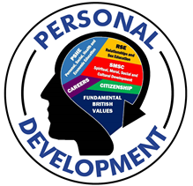
Appendix 1 – Cross Curricular Map – RSE
Personal Development Cross Curricular Map 2022/23
Core Theme 1 – Relationships and Sex Education
Families - Pupils should know:
that there are different types of committed, stable relationships. | Arts - Discussed where opportunities arise when discussing specific artists, musicians and artworks. Examples include John Lennon and Yoko Ono in Music. Texts studied in Drama explore families in all guises from bullying in Y7, to conflicts in Y8 to domestic violence in Listen to Your Parents in Y9.  Humanities - Y10 Philosophy and Ethics Theme A - Relationships and Families. Heterosexual, Homosexual, Pansexual relationships. Y7 Humanities - summer term - Relationships and Families day - comparison of different types of families, and the views of Christians and Muslims.  Maths and Computing - Alan Turing is the Maths character champion  MFL - KS3 and KS4 French and Spanish - topic of family members and relationships with friends.  PE - KS4 HSC students - Unit 1. Students acquire knowledge regarding types of relationships and the characteristics that form a stable relationship in growth and development.  English - Year 8 - Of Mice and Men - Relationships (healthy and unhealthy relationships)  PD – Y7 Term 1, Year 8 Term 2 Healthy Relationships, Year 9 Term 3 Developing relationships, Year 10 Term 2 Relationships, Y11 PD Day 2, Y8 PD Day 1 focuses on relationships,, Y9 PD Day 2 is Life Choices.
how these relationships might contribute to human happiness and their importance for bringing up children. | Arts - Discussed where opportunities arise when discussing specific artists, musicians and artworks. Examples include John Lennon and Yoko Ono in Music. Texts studied in Drama explore families in all guises from bullying in Y7, to conflicts in Y8 to domestic violence in Listen to Your Parents in Y9.  Humanities - Y10 Philosophy and Ethics Theme A - Relationships and Families. Heterosexual, Homosexual, Pansexual relationships. Y7 Humanities - summer term - Relationships and Families day - comparison of different types of families, and the views of Christians and Muslims.  MFL - KS3 and KS4 French and Spanish - expressing opinions on friends/family members and how you get on.  PE - KS4 HSC students - Unit 1. Students acquire knowledge regarding types of relationships and the characteristics that form a stable relationship in growth and development.  English - Year 10/11- A Christmas Carol and An Inspector Calls - family relationships and working relationships. Negative influences and indoctrinations within the family network  PD – Y7 Term 1, Year 8 Term 2 Healthy Relationships, Year 9 Term 3 Developing relationships, Year 10 Term 2 Relationships, Y11 PD Day 2, Y8 PD Day 1 focuses on relationships,, Y9 PD Day 2 is Life Choices.
what marriage is, including their legal status e.g. that marriage carries legal rights and protections not available to couples who are cohabiting or who have married, for example, in an unregistered religious ceremony. | Humanities - Y10 Philosophy and Ethics Theme A - Relationships and Families. Heterosexual, Homosexual, arranged marriages. Y7 Humanities - summer term - Relationships and Families day - comparison of different types of marriages, and the views of Christians and Muslims.  MFL - KS4 French and Spanish - topic of marriage and the pros/cons of marriage/civil partnership  PD – Y7 Term 1, Year 8 Term 2 Healthy Relationships, Year 9 Term 3 Developing relationships, Year 10 Term 2 Relationships, Y11 PD Day 2, Y8 PD Day 1 focuses on relationships,, Y9 PD Day 2 is Life Choices.
why marriage is an important relationship choice for many couples and why it must be freely entered into | Humanities – Y10 Philosophy and Ethics Theme A - Relationships and Families. Heterosexual, Homosexual, arranged marriages. Y7 Humanities - summer term - Relationships and Families day - comparison of different types of marriages, and the views of Christians and Muslims.  MFL - KS4 French and Spanish - topic of marriage and the pros/cons of marriage/civil partnership  PD – Y7 Term 1, Year 8 Term 2 Healthy Relationships, Year 9 Term 3 Developing relationships, Year 10 Term 2 Relationships, Y11 PD Day 2, Y8 PD Day 1 focuses on relationships,, Y9 PD Day 2 is Life Choices.
the characteristics and legal status of other types of long-term relationships. | PE - KS4 HSC students - Unit 1. Students acquire knowledge regarding stable relationships in growth and development and life events and the impact on development
the roles and responsibilities of parents with respect to raising of children, including the characteristics of successful parenting. | PE - KS4 HSC students - Unit 1. Students acquire knowledge regarding stable relationships in growth and development.  Science - GCSE Combined Science B13 Variation and Evolution and GCSE Biology B14 Variation and Evolution (taught to Y11) - the concept of nature vs nurture when learning about inheritance of characteristics.  English - Y8 Romeo and Juliet - Juliet’s relationship with her parents and how their relationship deteriorates, Y9 Jane Eyre - Parental roles in the novel and how these are not always positive (Mrs Reed)  Y10/11 – An Inspector Calls - exploration of the way in which children are raised and influenced in their beliefs and morals by their parents. Y10/11 – A Christmas Carol - The Cratchits and their moral beliefs.  PD – Y7 Term 1, Y8 Term 2 and PD day 1 focuses on relationships, Year 9, Term 2 Developing relationships, PD Day 5 for Y8 explores families in their various guises, Y10 Term 10 deals with all aspects of relationships, and PD day 2 for Y11 includes work on wellbeing in regards to relationships.
how to: determine whether other children, adults or sources of information are trustworthy: judge when a family, friend, intimate or other relationship is unsafe (and to recognise this in others’ relationships); and, how to seek help or advice, including reporting concerns about others, if needed. | Arts - Forming appropriate and productive professional relationships through the completion of group work and ensembles and performances.  Humanities - Y10 Philosophy and Ethics Theme A - Relationships and Families. Y10 History - Crime and Punishment - changes to the law in the 1980s.  MFL - KS4 French and Spanish - topic of dangers of social media and online life.  Science - GCSE Combined Science B6 Preventing and Treating Disease and GCSE Biology B6 Preventing and Treating Disease (taught to Y10) - concept of peer review in relation to testing new drugs and medicines. GCSE Combined Science B17 Biodiversity and Ecosystems and GCSE Biology B18 Biodiversity and Ecosystems, GCSE Combined Science C11 The Earth’s Atmosphere and GCSE Chemistry C13 The Earth’s Atmosphere (taught to Y11) - the concept of peer review in relation to debate about the role humans have played in causing climate change. GCSE Combined Science P7 Radioactivity and GCSE Physics P7 Radioactivity (taught to Y10) - research and the concept of peer review in relation to the negative effects of radiation on humans.  PE - KS4 HSC students - Unit 1. Students acquire knowledge regarding stable relationships in growth and development and life events and the impact on development  English - Y8 - Of Mice and Men - untrustworthy adults - character of Curley and the way he treats his wife, Trustworthy relationship - George and Lennie. Y8 - Romeo and Juliet - Trust between Romeo and Juliet and negative relationship between Juliet and her parents - arranged marriage - against her will. Y9 - Jane Eyre - unsafe relationship for Jane Eyre due to poor treatment by her cousin John Reed and lack of protection from her aunt.  PD – Y7 Term 1, Y8 Term 2 and PD day 1 focuses on relationships, Year 9, Term 2 Developing relationships, PD Day 5 for Y8 explores families in their various guises, Y10 Term 10 deals with all aspects of relationships, and PD day 2 for Y11 includes work on wellbeing in regards to relationships.
Respectful relationships,  Including friendships | PD – focus on term 1 in Y7 about managing change and friendships – with a focus on friendships, peer pressure. This is built upon in Y8 with their relationship PD day and then term 2 topic and healthy relationships – including conflict, diversity and respectful relationships.
the characteristics of positive and healthy friendships (in all contexts, including online) including: trust, respect, honesty, kindness, generosity, boundaries, privacy, consent and the management of conflict, reconciliation and ending relationships. This includes different (non-sexual) types of relationship. | Arts - Character values and human relationships form a core focus for many of our arts activities with creative expression used to process and explore.  Humanities - Y10 Philosophy and Ethics Theme A - Relationships and Families - sexual consent.  MFL - KS3 and KS4 French and Spanish - expressing opinions on friends/family members and how you get on.  PE - KS4 HSC - Unit 1. Students acquire knowledge regarding life events and forms of support. Students also are taught the impact of life events such as being bullied, ending of relationships and positive friendships on growth and development.  English - Y10 & Y11 - Macbeth Relationship between Macbeth and Lady Macbeth (Intensity and decline)  PD – focus on term 1 in Y7 about managing change and friendships – with a focus on friendships, peer pressure. This is built upon in Y8 with their relationship PD day and then term 2 topic and healthy relationships – including conflict, diversity and respectful relationships.
practical steps they can take in a range of different contexts to improve or support respectful relationships. | Arts - Character values and human relationships form a core focus for many of our arts activities with creative expression used to process and explore.  English - Discussed through Y8 – Of Mice and Men, R&J, Jane Eyre.  PD – focus on term 1 in Y7 about managing change and friendships – with a focus on friendships, peer pressure. This is built upon in Y8 with their relationship PD day and then term 2 topic and healthy relationships – including conflict, diversity and respectful relationships.
how stereotypes, in particular stereotypes based on sex, gender, race, religion, sexual orientation or disability, can cause damage  (e.g. how they might normalise non-consensual behaviour or encourage prejudice). | DT - Speak about and use DT news to promote designers/artists/chefs from a range of different backgrounds – from Nadiya Hussain to Kadeena Cox – last winner for Celebrity Masterchef and gold medal winning Paralympian  Humanities - Y10 Philosophy and Ethics Theme A - Relationships and Families - prejudice and discrimination. Y7 Humanities - prejudice and discrimination during relationships and family’s day (summer term). Humanities Week and promotion of Black History Week in Oct each year – through assemblies, displays, form time activities and specific lessons.  MFL - KS3 and KS4 French and Spanish - topics often include case studies/profiles of different religions, genders, sexual orientation etc. to support breaking down stereotypes and highlight differences between ways of life/lifestyles.  PE - KS4 HSC - Unit 1. Students acquire knowledge of social and cultural factor affect growth and development.  Science - All years - examples of female scientists are used where appropriate. Big Idea Genes 2 - Inheritance (taught to Y9), GCSE Combined Science B12 Reproduction and GCSE Biology B13 Reproduction (taught to Y11) - controversy about lack of recognition for Rosalind Franklin in the discovery of the structure of DNA discussed.  English - Y9 - Diverse Voices sequence of lessons explores sexuality, sexual orientation, disability, gender, race and stereotypes through a range of different texts. In Y8 – Of Mice and Men explores race, gender and ageism. Y10/11 GCSE Literature texts are Macbeth, An Inspector Calls and the poetry cluster deals with love and Relationships extensively. All texts explore gender bias, diversity and culture.  PD – focus on term 1 in Y7 about managing change and friendships – with a focus on friendships, peer pressure. This is built upon in Y8 with their relationship PD day and then term 2 topic and healthy relationships – including conflict, diversity and respectful relationships. Term 3 in Y7 there is input on developing relationship online and focusing on consent with a session on Kayleigh’s Love Story.
that in school and in wider society they can expect to be treated with respect by others, and that in turn they should show due respect to others, including people in positions of authority and due tolerance of other people’s beliefs. | Arts - Positive relationships and mutual respect form a major part of all lessons, particularly pertinent when students are performing and providing feedback etc. for others. All students have to work together as a group to produce a piece of work and act respectfully and supportively as an audience when watching a performance in both Music and Drama.  MFL - Routines in MFL are centred around mutual respect - listening to others, expressing opinions and open to share ideas/views  DT - Food Y8 and then GCSE FP&N allergies, intolerances, religions and ethical beliefs and the impact that has on their diets – respect and tolerance then emphasised. Influences of different cultures on ‘British’ food.  Humanities - Y7 Zebra Red enrichment - role of society in discrimination. Y10 Hope not Hate talk on discrimination. Humanities Week and promotion of Black History Week in Oct each year – through assemblies, displays, form time activities and specific lessons.  PE - All PE - All games unit. Sports etiquette and respect in all sports and games.  Science – adheres and applies the whole school ethos across the department.
about different types of bullying (including cyberbullying), the impact of bullying, responsibilities of bystanders to report bullying and how and where to get help. | Arts – 1st topic in Y7 Drama is centred around the issue of bullying – with places for support clearly signposted throughout the sequence of lessons.  DT - Working as a team throughout all of the year groups  Maths and Computing - Y8 - Digital Responsibility and “Cyber Bullying” - HT3  MFL - KS4 French and Spanish - topics on pros/cons of social media touches on negative aspects including cyber bullying, speaking with strangers etc  English - Y9 - Jane Eyre explores the bullying of Jane by John. In Y10/11 – A Christmas Carol and An Inspector Calls both explore bullying in the workplace and abusing positions of power and exploitation in the workplace and the consequences therein.  PD – large push during Anti Bullying Week each year – with additional lessons covered in term 1 with Y7 (input from Derby County), Year 8 term 2 and term 3 in Y9, developing relationships with explores friendships in the context of wider relationships.
that some types of behaviour within relationships are criminal, including violent behaviour and coercive control. | Arts – study of text ‘Listen to your parents’ by Benjamin Zephaniah in Y9.  English - Y8 – Of Mice and Men - Violent and abusive relationship and the coercive control.  PD – Y7 - peer pressure and friendships launches notions of healthy relationships – taught more explicitly within Y9 term 2 developing relationships.
what constitutes sexual harassment and sexual violence and why these are always unacceptable. | PD – Y10 term 2 relationship topics looks at current affairs – including sexual harassment and violence and specific lesson on sexual harassment.
the legal rights and responsibilities regarding equality (particularly with reference to the protected characteristics as defined in the Equality Act 2010) and that everyone is unique and equal. | Humanities - Y10 History - Crime and Punishment. 20th and 21st Century Crime and the changes, particularly since the 1960s e.g. hate crime, 2010 Equalities Act. Humanities Week and promotion of Black History Week in Oct each year – through assemblies, displays, form time activities and specific lessons.  PD – Y10 term 2 relationship topics looks at current affairs – including sexual harassment and violence and specific lesson on sexual harassment.
Online and media
their rights, responsibilities and opportunities online, including that the same expectations of behaviour apply in all contexts, including  online. | Arts - Appropriate conduct through communication in Google Classroom.  Maths and Computing - Y8 - Digital Responsibility, “Malicious Software”, “Social Media”. Y10 GCSE Computer Science - “1.6.1 Impacts of digital technology on wider society & legislation relevant to computer science”. Y11 BTEC DIT “C1: Responsible Use” and “C2: Legal & Ethical”.  MFL - KS4 French and Spanish - topics on pros/cons of social media touches on negative aspects including cyber bullying, speaking with strangers etc.  Science – When setting up google classrooms or setting work online it is explained about appropriate conduct towards each other and members of staff.  PD – Y7 Term 3 – digital literacy covers online safety, use of internet and social media and CSE. Term 5 in Y8 explores mental wellbeing and covers the use of technology
about online risks, including that any material someone provides to another has the potential to be shared online and the difficulty of removing potentially compromising material placed online. | Maths and Computing - Y8 - Digital Responsibility, “Malicious Software”, “Social Media”. Y10 GCSE Computer Science - “1.6.1 Impacts of digital technology on wider society & legislation relevant to computer science”. Y11 BTEC DIT “C1: Responsible Use” and “C2: Legal & Ethical”  MFL - KS4 French and Spanish - topics on pros/cons of social media touches on negative aspects including cyber bullying, speaking with strangers etc.
not to provide material to others that they would not want shared further and not to share personal material which is sent to them. | Maths and Computing - Y8 - Digital Responsibility, “Social Media dangers”. Y10 GCSE Computer Science  “1.6.1 Impacts of digital technology on wider society”. Y11 BTEC DIT “C1: Responsible Use”.
what to do and where to get support to report material or manage issues online | Maths and Computing - Y8 - Digital Responsibility, “phishing”, “Malicious Software” - HT3. Y9 - Digital Responsibility “Legal & ethical issues” - HT1. Y10 GCSE Computer Science - “1.6.1 Impacts of digital technology on wider society & legislation relevant to computer science”. Y11 BTEC DIT - “C1: Responsible Use” and “C2: Legal & Ethical”.
the impact of viewing harmful content. | Maths and Computing - Y8 - Digital Responsibility - “Malicious Software”, “Social Media dangers” - HT3.  Y10 GCSE Computer Science - “1.6.1 Impacts of digital technology on wider society”. Y11 BTEC DIT - “C1: Responsible Use”.
that specifically sexually explicit material e.g. pornography presents a distorted picture of sexual behaviours, can damage the way people see themselves in relation to others and negatively affect how they behave towards sexual partners. | Arts – Drama text for Comp 3 in Y11 – ‘Girls Like That’ exploring sharing explicit material online.  PD units on online safety in Y7 through to 9 – sexting topics covered in Y9 and Y10 and input on PD Day for Y9 – CEOP sexting session
that sharing and viewing indecent images of children (including those created by children) is a criminal offence which carries severe penalties including jail. | Maths and Computing - Y8 - Digital Responsibility - “Social Media dangers” - HT3. Y9 - Digital Responsibility - “legal & ethical issues” - HT1. Y10 GCSE Computer Science - “1.6.1 Impacts of digital technology on wider society & legislation relevant to computer science”. Y11 BTEC DIT - “C1: Responsible Use” and “C2: Legal & Ethical”.  PD - units on online safety in Y7 through to 9 – sexting topics covered in Y9 and Y10 and input on PD Day for Y9 – CEOP sexting session
how information and data is generated, collected, shared and used online. | Maths and Computing - Y8 - Digital Responsibility - “Malicious Software” and “Social Media dangers” - HT3. Y9 – Spreadsheets - “Collecting, presenting and interpreting data” - HT4. Y11 BTEC DIT - “Collecting, presenting and interpreting data” and “B1: Threats to data.  Science - GCSE Combined Science, GCSE Biology, GCSE Chemistry, GCSE Physics Working Scientifically skill WS 1.6 (taught to Y9, Y10 and Y11) - the importance of the process of peer review and how information found online may not have been checked for accuracy.  PD – units on online safety in Y7 through to 9 – sexting topics covered in Y9 and Y10 and input on PD Day for Y9 – CEOP sexting session
Being safe
the concepts of, and laws relating to, sexual consent, sexual exploitation, abuse, grooming, coercion, harassment, rape, domestic abuse, forced marriage, honour-based violence and  FGM, and how these can affect current and future relationships. | Maths and Computing - Y8 - Digital Responsibility - “Social Media dangers” - HT3  PD – issues covered throughout the course – Y7 term 1 is transitions and managing change, term 3 is digital literacy including use of social media, CSE and KLS, Y8 term 2 focuses on healthy relationships, with term 6 looking at mental wellbeing including managing stress and use of technology. Y9 focuses on developing relationships in term 2 with term 5 looking at life skills including local issues. Y7’s 2nd PD day is about health and wellness, Y8’s 1st PD Day focuses on relationships and had input from a wide range of agencies. Y8 Prison Day looked at the law, CEOP’s sexting lesson, Y10 term 2 focuses on local and current issues and sexual harassment, Y11 PD day two covers these issues.
how people can actively communicate and recognise consent from others, including sexual consent, and how and when consent can be withdrawn (in all contexts, including online). | MFL - Communication is at the heart of the MFL curriculum - developing students in to confident/effective communicators in a range of contexts across KS3 and KS4 French and Spanish.  PD – issues covered throughout the course – Y7 term 1 is transitions and managing change, term 3 is digital literacy including use of social media, CSE and KLS, Y8 term 2 focuses on healthy relationships, with term 6 looking at mental wellbeing including managing stress and use of technology. Y9 focuses on developing relationships in term 2 with term 5 looking at life skills including local issues. Y7’s 2nd PD day is about health and wellness, Y8’s 1st PD Day focuses on relationships and had input from a wide range of agencies. Y8 Prison Day looked at the law, CEOP’s sexting lesson, Y10 term 2 focuses on local and current issues and sexual harassment, Y11 PD day two covers these issues.
Intimate and sexual relationships, including
sexual health
how to recognise the characteristics and positive aspects of healthy one-to-one intimate relationships, which include mutual respect, consent, loyalty, trust, shared interests and outlook, sex and friendship. | PD – issues covered throughout the course – Y7 term 1 is transitions and managing change, term 3 is digital literacy including use of social media, CSE and KLS, Y8 term 2 focuses on healthy relationships, with term 6 looking at mental wellbeing including managing stress and use of technology. Y9 focuses on developing relationships in term 2 with term 5 looking at life skills including local issues. Y7’s 2nd PD day is about health and wellness, Y8’s 1st PD Day focuses on relationships and had input from a wide range of agencies. Y8 Prison Day looked at the law, CEOP’s sexting lesson, Y10 term 2 focuses on local and current issues and sexual harassment, Y11 PD day two covers these issues.
that all aspects of health can be affected by choices they make in sex and relationships, positively or negatively, e.g. physical, emotional, mental, sexual and reproductive health and wellbeing. | PE - KS4 HSC - students acquire knowledge on factors affecting growth and development including personal relationships.  Science - Big Idea Genes 1 - Human Reproduction (taught to Y7), GCSE Combined Science B11 Hormonal Coordination , GCSE Biology B11 Hormonal Coordination (taught to Y10) - how choosing the right form of contraception can reduce chances of catching STIs.  PD – issues covered throughout the course – Y7 term 1 is transitions and managing change, term 3 is digital literacy including use of social media, CSE and KLS, Y8 term 2 focuses on healthy relationships, with term 6 looking at mental wellbeing including managing stress and use of technology. Y9 focuses on developing relationships in term 2 with term 5 looking at life skills including local issues. Y7’s 2nd PD day is about health and wellness, Y8’s 1st PD Day focuses on relationships and had input from a wide range of agencies. Y8 Prison Day looked at the law, CEOP’s sexting lesson, Y10 term 2 focuses on local and current issues and sexual harassment, Y11 PD day two covers these issues.
the facts about reproductive health, including fertility and the potential impact of lifestyle on fertility for men and women. | Humanities - Y8 Philosophy and Ethics - “Medical Ethics unit” - the morality of IVF. Also covered in Y10 Philosophy Theme B, Religion and Life.  Science - Big Idea Genes 1 - Human Reproduction (taught to Y7), GCSE Combined Science B11 Hormonal Coordination , GCSE Biology B11 Hormonal Coordination (taught to Y10) - causes of and treatments for infertility and how it affects mental health.  PE - KS4 HSC - students acquire knowledge on factors affecting growth and development including personal relationships.  PD – issues covered throughout the course – Y7 term 1 is transitions and managing change, term 3 is digital literacy including use of social media, CSE and KLS, Y8 term 2 focuses on healthy relationships, with term 6 looking at mental wellbeing including managing stress and use of technology. Y9 focuses on developing relationships in term 2 with term 5 looking at life skills including local issues. Y7’s 2nd PD day is about health and wellness, Y8’s 1st PD Day focuses on relationships and had input from a wide range of agencies. Y8 Prison Day looked at the law, CEOP’s sexting lesson, Y10 term 2 focuses on local and current issues and sexual harassment, Y11 PD day two covers these issues.
that there are a range of strategies for identifying and managing sexual pressure, including understanding peer pressure, resisting pressure and not pressurising others. | PD – issues covered throughout the course – Y7 term 1 is transitions and managing change, term 3 is digital literacy including use of social media, CSE and KLS, Y8 term 2 focuses on healthy relationships, with term 6 looking at mental wellbeing including managing stress and use of technology. Y9 focuses on developing relationships in term 2 with term 5 looking at life skills including local issues. Y7’s 2nd PD day is about health and wellness, Y8’s 1st PD Day focuses on relationships and had input from a wide range of agencies. Y8 Prison Day looked at the law, CEOP’s sexting lesson, Y10 term 2 focuses on local and current issues and sexual harassment, Y11 PD day two covers these issues.
that they have a choice to delay sex or to enjoy intimacy without sex | PE - KS4 HSC - students acquire knowledge on factors affecting growth and development including personal relationships.  PD – issues covered throughout the course – Y7 term 1 is transitions and managing change, term 3 is digital literacy including use of social media, CSE and KLS, Y8 term 2 focuses on healthy relationships, with term 6 looking at mental wellbeing including managing stress and use of technology. Y9 focuses on developing relationships in term 2 with term 5 looking at life skills including local issues. Y7’s 2nd PD day is about health and wellness, Y8’s 1st PD Day focuses on relationships and had input from a wide range of agencies. Y8 Prison Day looked at the law, CEOP’s sexting lesson, Y10 term 2 focuses on local and current issues and sexual harassment, Y11 PD day two covers these issues.
the facts about the full range of contraceptive choices, efficacy and options available | PE - KS4 HSC - students acquire knowledge on factors affecting growth and development including personal relationships.  Science - Big Idea Genes 1 - Human Reproduction (taught to Y7), GCSE Combined Science B11 Hormonal Coordination, GCSE Biology B11 Hormonal Coordination (taught to Y10) - how choosing the right form of contraception can reduce chances of catching STIs. GCSE Combined Science B5 Communicable Diseases and GCSE Biology B5 Communicable Diseases (taught to Y10) - the symptoms of STIs, how they can spread and how this can be prevented.  PD – issues covered throughout the course – Y7 term 1 is transitions and managing change, term 3 is digital literacy including use of social media, CSE and KLS, Y8 term 2 focuses on healthy relationships, with term 6 looking at mental wellbeing including managing stress and use of technology. Y9 focuses on developing relationships in term 2 with term 5 looking at life skills including local issues. Y7’s 2nd PD day is about health and wellness, Y8’s 1st PD Day focuses on relationships and had input from a wide range of agencies. Y8 Prison Day looked at the law, CEOP’s sexting lesson, Y10 term 2 focuses on local and current issues and sexual harassment, Y11 PD day two covers these issues. Pastoral team have been trained on C Scheme.
the facts around pregnancy including miscarriage | DT - FP&N GCSE dietary needs of pregnancy  PE - KS4 HSC - students acquire knowledge on factors affecting growth and development including personal relationships.  Science - Big Idea Genes 1 - Human Reproduction (taught to Y7) - the stages of pregnancy and the development of the foetus.
that there are choices in relation to pregnancy (with medically and legally accurate, impartial information on all options, including keeping the baby, adoption, abortion and where to get further help). | Humanities - Y8 Philosophy and Ethics - “Are some lives worth more than others” unit. - the morality of abortion. Also covered in Y10 Philosophy Theme B, Religion and Life  PE - KS4 HSC - students acquire knowledge on factors affecting growth and development including personal relationships.  Science - GCSE Combined Science B12 Reproduction and GCSE Biology B13 Reproduction - discussion of the economic, social and ethical issues surrounding embryo screening for genetic conditions.  PD – Y8 Relationships topic and Y9 term 2 developing relationships. Term 2 in Year 10.
how the different sexually transmitted infections (STIs), including  HIV/AIDs, are transmitted, how risk can be reduced through safer sex (including through condom use) and the importance of and  facts about testing. | Science - Big Idea Genes 1 - Human Reproduction (taught to Y7), GCSE Combined Science B11 Hormonal Coordination, GCSE Biology B11 Hormonal Coordination (taught to Y10) - how choosing the right form of contraception can reduce chances of catching STIs. GCSE Combined Science B5 Communicable Diseases and GCSE Biology B5 Communicable Diseases (taught to Y10) - the symptoms of STIs (particularly gonorrhoea and HIV), how they can spread and how this can be prevented.  PD – Y8 Relationships topic and Y9 term 2 developing relationships. Term 2 for Y10 Further relationships.
about the prevalence of some STIs, the impact they can have on those who contract them and key facts about treatment. | Science - Big Idea Genes 1 - Human Reproduction (taught to Y7), GCSE Combined Science B11 Hormonal Coordination, GCSE Biology B11 Hormonal Coordination (taught to Y10) - how choosing the right form of contraception can reduce chances of catching STIs. GCSE Combined Science B5 Communicable Diseases and GCSE Biology B5 Communicable Diseases (taught to Y10) - the symptoms of STIs (particularly gonorrhoea and HIV), how they can spread and how this can be prevented.  PD – Y8 Relationships topic and Y9 term 2 developing relationships. Term 2 for Y10 Further relationships.
how the use of alcohol and drugs can lead to risky sexual behaviour. | Science - Big Idea Organisms 2 - Breathing (taught to Y8) - identifying the health risks associated with alcohol and drug use.  PD – Y9 term 2, developing relationships and Y10 term 2 further relationships.
how to get further advice, including how and where to access confidential sexual and reproductive health advice and treatment. | PD – Y9 term 2, developing relationships and Y10 term 2 further relationships – plus C Scheme
The document below maps the provision of Personal Development at Shirebrook Academy – encompassing RSE, Citizenship, SMSC and British Values.
Mapped against Draft Statutory Guidance for Relationships, Sex and Relationships, and Health Education, Feb 2019.
All maintained schools must meet the requirements set out in section 78 of the Education Act 2002 and promote the spiritual, moral, social and cultural (SMSC) development of their pupils. Through ensuring pupils’ SMSC development, schools can also demonstrate they are actively promoting fundamental British values.

Appendix 2 – Curriculum Maps
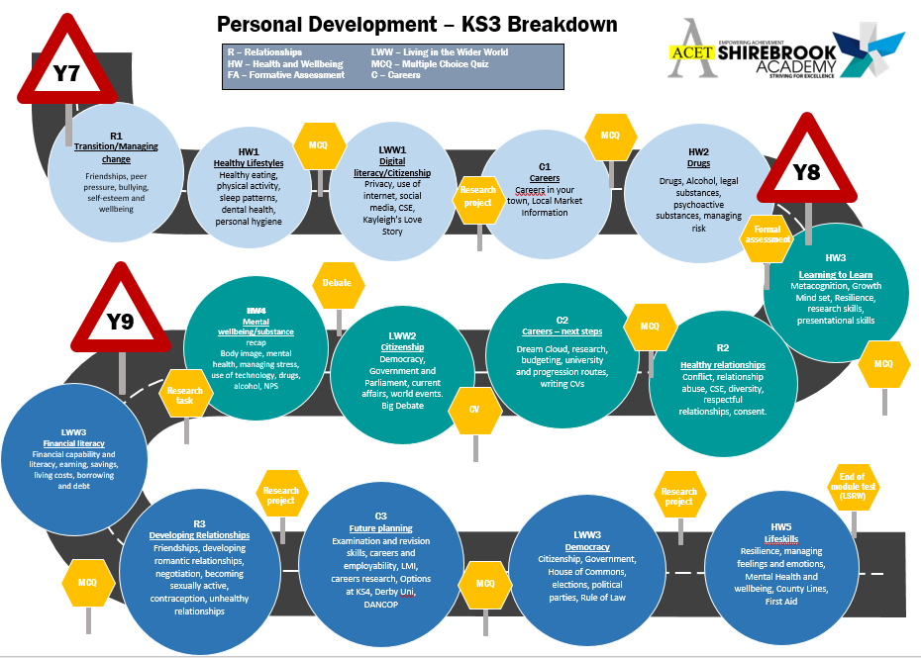
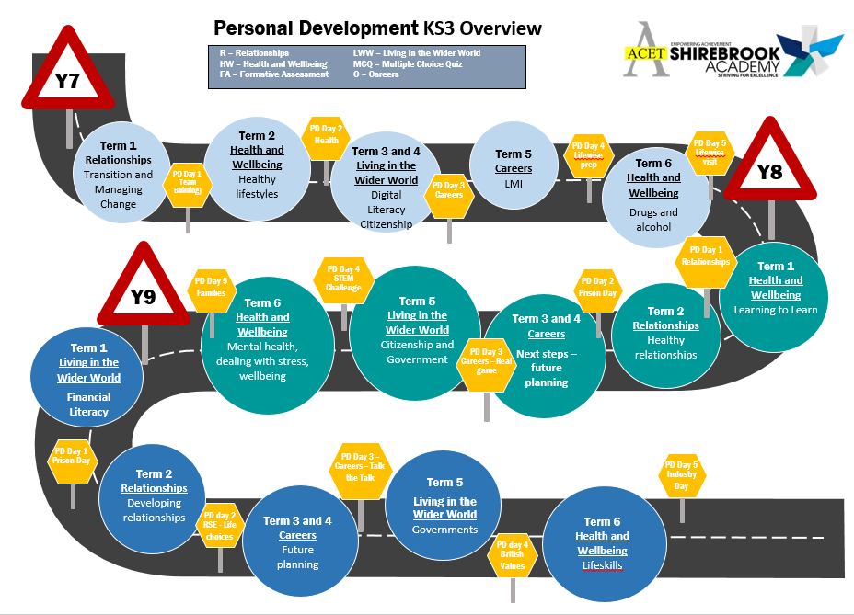
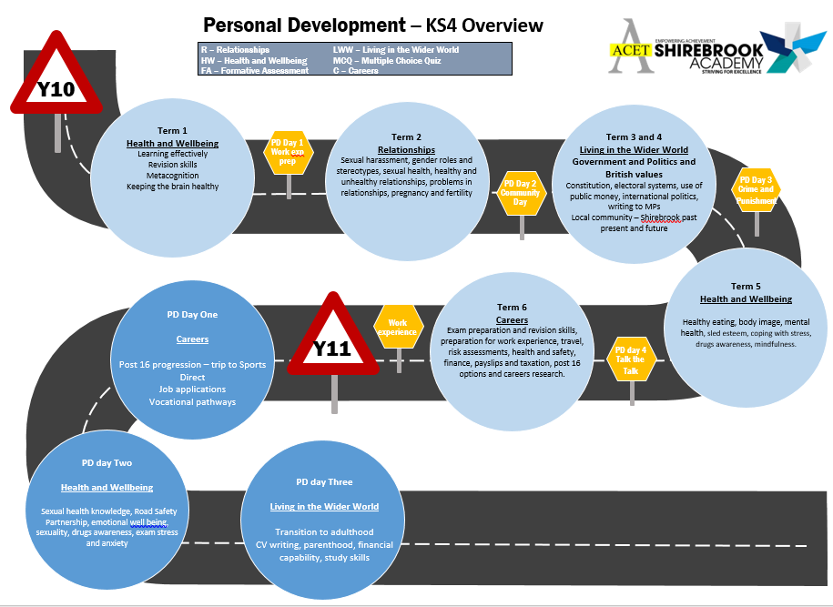
Appendix 3 – By the end of secondary school a student should know

Topics | Pupils should know
Respectful relationships  Online Relationships  Being Safe | • The importance of respecting others, even when they are very different from them (for example, physically, in character, personality or backgrounds), or make different choices or have different preferences or beliefs  • Practical steps they can take in a range of different contexts to improve or support respectful relationships  • The conventions of courtesy and manners  • The importance of self-respect and how this links to their own happiness  • That in school and in wider society they can expect to be treated with respect by others, and that in turn they should show due respect to others, including those in positions of authority  • About different types of bullying (including cyberbullying), the impact of bullying, responsibilities of bystanders (primarily reporting bullying to an adult) and how to get help  • What a stereotype is, and how stereotypes can be unfair, negative or destructive  • The importance of permission-seeking and giving in relationships with friends, peers and adults  • That people sometimes behave differently online, including by pretending to be someone they are not  • That the same principles apply to online relationships as to face-to face relationships, including the importance of respect for others online including when we are anonymous  • The rules and principles for keeping safe online, how to recognise risks, harmful content and contact, and how to report them  • How to critically consider their online friendships and sources of information including awareness of the risks associated with people they have never met  • How information and data is shared and used online  • What sorts of boundaries are appropriate in friendships with peers and others (including in a digital context)  • About the concept of privacy and the implications of it for both children and adults; including that it is not always right to keep secrets if they relate to being safe  • That each person’s body belongs to them, and the differences between appropriate and inappropriate or unsafe physical, and other, contact  • How to respond safely and appropriately to adults they may encounter (in all contexts, including online) whom they do not know  • How to recognise and report feelings of being unsafe or feeling bad about any adult  • How to ask for advice or help for themselves or others, and to keep trying until they are heard  • How to report concerns or abuse, and the vocabulary and confidence needed to do so  • Where to get advice e.g. family, school and/or other sources
Families  Respectful relationships, including friendships | • That there are different types of committed, stable relationships  • How these relationships might contribute to human happiness and their importance for bringing up children  • What marriage is, including their legal status, e.g. that marriage carries legal rights and protections not available to couples who are cohabiting or who have married, for example, in an unregistered religious ceremony  • Why marriage is an important relationship choice for many couples and why it must be freely entered into  • The characteristics and legal status of other types of long-term relationships  • The roles and responsibilities of parents with respect to raising of children, including the characteristics of successful parenting  • How to: determine whether other children, adults or sources of information are trustworthy: judge when a family, friend, intimate or other relationship is unsafe (and to recognise this in others’ relationships); and, how to seek help or advice, including reporting concerns about others, if needed  • The characteristics of positive and healthy friendships (in all contexts, including online) including: trust, respect, honesty, kindness, generosity, boundaries, privacy, consent and the management of conflict, reconciliation and ending relationships. This includes different (non-sexual) types of relationship  • Practical steps they can take in a range of different contexts to improve or support respectful relationships  • How stereotypes, in particular stereotypes based on sex, gender, race, religion, sexual orientation or disability, can cause damage (e.g. how they might normalise non-consensual behaviour or encourage prejudice)  • That in school and in wider society they can expect to be treated with respect by others, and that in turn they should show due respect to others, including people in positions of authority and due tolerance of other people’s beliefs  • About different types of bullying (including cyberbullying), the impact of bullying, responsibilities of bystanders to report bullying and how and where to get help  • That some types of behaviour within relationships are criminal, including violent behaviour and coercive control  • What constitutes sexual harassment and sexual violence and why these are always unacceptable  • The legal rights and responsibilities regarding equality (particularly with reference to the protected characteristics as defined in the Equality Act 2010) and that everyone is unique and equal
Online and media  Being safe | • Their rights, responsibilities and opportunities online, including that the same expectations of behaviour apply in all contexts, including online  • About online risks, including that any material someone provides to another has the potential to be shared online and the difficulty of removing potentially compromising material placed online  • Not to provide material to others that they would not want shared further and not to share personal material which is sent to them  • What to do and where to get support to report material or manage issues online  • The impact of viewing harmful content  • That specifically sexually explicit material e.g. pornography presents a distorted picture of sexual behaviours, can damage the way people see themselves in relation to others and negatively affect how they behave towards sexual partners  • That sharing and viewing indecent images of children (including those created by children) is a criminal offence which carries severe penalties including jail  • How information and data is generated, collected, shared and used online  • The concepts of, and laws relating to, sexual consent, sexual exploitation, abuse, grooming, coercion, harassment, rape, domestic abuse, forced marriage, honour-based violence and FGM, and how these can affect current and future relationships  • How people can actively communicate and recognise consent from others, including sexual consent, and how and when consent can be withdrawn (in all contexts, including online)
Intimate sexual relationships, including sexual health | • How to recognise the characteristics and positive aspects of healthy one-to-one intimate relationships, which include mutual respect, consent, loyalty, trust, shared interests and outlook, sex and friendship  • That all aspects of health can be affected by choices they make in sex and relationships, positively or negatively, e.g. physical, emotional, mental, sexual and reproductive health and wellbeing  • The facts about reproductive health, including fertility and the potential impact of lifestyle on fertility for men and women  • That there are a range of strategies for identifying and managing sexual pressure, including understanding peer pressure, resisting pressure and not pressurising others  • That they have a choice to delay sex or to enjoy intimacy without sex  • The facts about the full range of contraceptive choices, efficacy and options available  • The facts around pregnancy including miscarriage  • That there are choices in relation to pregnancy (with medically and legally accurate, impartial information on all options, including keeping the baby, adoption, abortion and where to get further help)  • How the different sexually transmitted infections (STIs), including HIV/AIDs, are transmitted, how risk can be reduced through safer sex (including through condom use) and the importance of and facts about testing  • About the prevalence of some STIs, the impact they can have on those who contract them and key facts about treatment  • How the use of alcohol and drugs can lead to risky sexual behaviour  • How to get further advice, including how and where to access confidential sexual and reproductive health advice and treatment

Appendix 4: Parent form: withdrawal from sex education within RSE

To be completed by parents
Name of child |  | Class
Name of parent |  | Date
Reason for withdrawing from sex education within relationships and sex education
Any other information you would like the school to consider
Parent signature

To be completed by the school
Agreed actions from discussion with parents

Appendix 5 - Department for Education guidance
Statutory guidance; Relationships education, relationships and sex education (RSE) and health education:
https://www.gov.uk/government/publications/relationships-education-relationships-and-sex-education-rse-and-health-education
Frequently Asked Questions; Relationships education, relationships and sex education (RSE) and health education:
https://www.gov.uk/government/news/relationships-education-relationships-and-sexeducation-rse-and-health-education-faqs
Guides for parents of primary and secondary age pupils that schools can use to communicate with them about teaching relationships and health education.
https://www.gov.uk/government/publications/relationships-sex-and-health-educationguides-for-schools
Statutory guidance: Keeping Children Safe in Education:
https://assets.publishing.service.gov.uk/government/uploads/system/uploads/attachment_data/file/830121/Keeping_children_safe_in_education_060919.pdf
Sexual Violence and Sexual Harassment between children in Schools and Colleges:
https://assets.publishing.service.gov.uk/government/uploads/system/uploads/attachment_data/file/719902/Sexual_violence_and_sexual_harassment_between_children_in_schools_and_colleges.pdf
Statutory guidance; National curriculum in England: science programmes of study:
https://www.gov.uk/government/publications/national-curriculum-in-england-scienceprogrammes-of-study

