Shirebrook Academy

SEN Information Report

Updated: September 2022

Shirebrook Academy supports a wide range of needs, including:

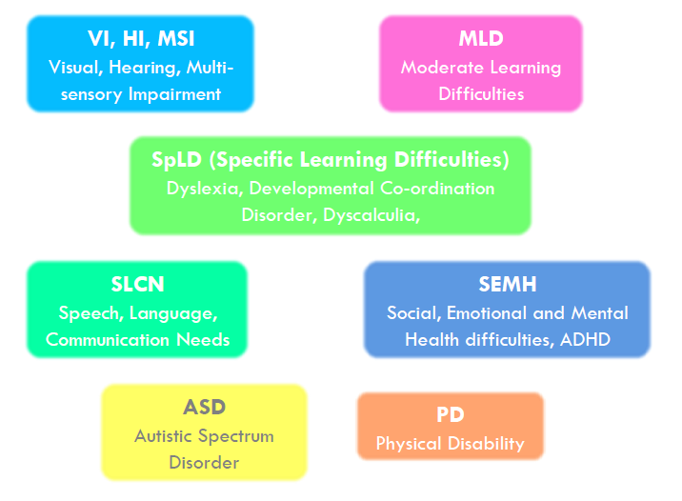

The Academy’s SEN Information Report is part of the Derbyshire Local Offer for learners with Special Educational Needs (SEN). The Local Offer can be found using the following link https://localoffer.derbyshire.gov.uk/#!/directory.

The staff with responsibility for SEN is Dr Mitton - SENDCO). DMitton@shirebookacademy.org and Mrs Cheryl Barquero – Safeguarding and Inclusion Lead, ACET CBarquero@astoncetrust.org

Aims of our provision in regards to students with special educational needs and/or disability: The aims of our policy in relation to special educational need and disability in this school are:
• To make reasonable adjustments for those with a disability by taking action to increase access to the curriculum and the environment.
• To ensure that children and young people with SEN engage in the activities of the school alongside students who do not have SEN.
• To have high expectations of students with SEN and ensure that they receive quality first teaching in all curriculum areas. Where support is necessary – this will be high quality support targeted to meet the individual needs of students. All support / interventions will be closely monitored. We aim for students to be independent in their learning and develop the self-belief and resilience needed to succeed.

- What kinds of special educational needs does the school/setting make provision for? | Shirebrook Academy is able to effectively meet the needs of Students with autistic spectrum conditions; emotional and social needs; specific learning difficulties (dyslexia, dyspraxia, and dyscalculia); and moderate learning difficulties.  The needs of students with physical disabilities, including visual and auditory impairments can also be met in the majority of cases. The school is accessible for wheelchair users.  Shirebrook Academy can also support students whose first language is not English – we have a designated teaching assistant for EAL.
- (For mainstream schools & maintained nurseries only) How does the school/setting know if students need extra help and what should I do if I think that my child may have special educational needs? | Students undertake CAT tests and reading tests on entry to assess starting points. Reading is assessed by subject teachers and any data from testing closely monitored. .  All year 7 follow the Accelerated Reader scheme using a reading book that is appropriate for their ability. Progress is closely monitored by the school’s head of English and literacy and SENDCO.  The school use a dyslexia screener to identify any students who may have dyslexia. (Updated Sept 22)  Teaching and pastoral staff report any concerns as they arise. This is then followed up by the school’s SENDCO  Classroom teachers closely monitor the progress of all students and inform the school’s SENDCO if they have any concerns.  Heads of year and pastoral leaders monitor all students for social, emotional and mental health needs and inform the school’s SENDCO should any concerns be raised.  If you think that your child may have special educational needs or are concerned about your child’s progress then you should contact the academy and ask to speak to the SENDCO - Dr M Mitton.
- a) How does the school/setting evaluate the effectiveness of its provision for students with special educational needs?  b) How will both the school/setting and I know how my child/young person is doing and how will the school/setting help me to support their learning?  c) What is the school’s approach to teaching students with special educational needs?  d) How will the curriculum and learning be matched to my child/young person’s needs?  e) How are decisions made about the type and amount of support my child/young person will receive?  f) How will my child/young person be included in activities outside the classroom, including school trips?  g) What support will there be for my child/young person’s overall well-being? | - The progress of all students is updated and monitored throughout the year by the classroom teacher. In addition, the school’s SENDCO is responsible for monitoring the progress of students on the SEND register and arranging additional support / advising on effective strategies where necessary.  - Students with an EHCP will be invited to attend an annual review meeting to discuss their child’s progress.  All students on the SEND register will be monitored throughout the year and parents/carers contacted if concerns are raised.  - The needs of students with special educational needs are met within the classroom and the classroom teacher is responsible for effectively differentiating tasks and/or making reasonable adjustments to meet the needs of all students. Quality first teaching for all students the best way to support students with a variety of needs and teaches receive regular training, support and advice on how to adapt teaching to ensure students with SEN make progress. Some students will be allocated additional TA support to ensure that they make adequate progress and a small number will receive additional literacy and numeracy lessons.  - All teachers are teachers of SEN and are responsible for adapting the curriculum to meet the needs of students within their classes. Classroom teachers are updated regularly on the needs of students by the school’s SENDCO and supported as necessary.  If students are well below their chronological reading age on entry to the academy, they will be placed in the foundation learning classes where they will receive additional lessons with a focus on reading. All lessons are planned and delivered by subject specialists and closely monitored by the school’s SENDCO.  Students who have significant difficulties with reading or are not making sufficient progress, may have 1:1 Catch-Up Literacy sessions with a trained teaching assistant. (Updated September 2022)  We also have a specialist teaching assistant for social and emotional difficulties (ELSA). (Updated September 2022)  - Decisions about support are usually made by the school’s SENDCO in conjunction with the views / wishes of parents.  Decisions are based on information from the primary school, initial tests to determine academic ability and individual needs. The SENDCO works closely with the feeder primary schools so that the needs of most students are known to the SENDCO before they arrive.  - All out of school activities/school trips will be fully supported by the SEND team. TAs will be allocated according to need to accompany students on such activities as necessary.  - We have a dedicated SEND team enabling the school to provide a ‘safe haven’ during break and lunchtimes; a clear anti-bullying and behaviour policy; an inclusion team to provide mentoring and behaviour support where necessary; a thorough pastoral care system; a robust child protection system and access to outside support as necessary.
- (For mainstream schools and maintained nurseries) Who is the school/setting’s special educational needs co-ordinator (SENDCO) and what are their contact details. | Special educational needs co-ordinator (SENDCO) – Dr M Mitton  Email: MMitton@shirebrookacademy.org
- a) What training have staff supporting special educational needs had and what is planned?  b) What specialist services and expertise are available or accessed by the setting/school? | a. The Academy support department is led by the SENDCO and consists of an experienced inclusion team and qualified teaching assistants. All staff in academy support are trained in all aspects of SEN needs.  2022-23 – ELSA training, Catch-Up Literacy, Mental Health First Aid.  We have a member of staff employed by the school who is qualified to administer and apply for exam access arrangements.  b. There is a small foundation group for students who have below average reading skills on entry which is led by specialist literacy teaching assistant and overseen by the SENDCo.  Where appropriate, we work with the educational psychology service and specialist SEN teams from the local authority for advice on how best to meet the needs of students with more complex SEN needs.
- How is equipment and the facilities to support students with special educational needs secured? How accessible is the school/setting? | There are designated learning areas for students with SEN to access and to complete homework. These areas are equipped with computers.  Equipment for particular or complex needs are considered and catered for on an individual basis.  We have designated disabled parking areas, and most parts of the school are accessible for wheelchair users. There are disabled toilet facilities.
- What are the arrangements for consulting parents of students with special educational needs? How will be I involved in the education of my child/young person? | If your child is identified as not making adequate or expected progress, the school will contact parents to discuss any support that may be necessary.  All students placed on the SEN register have a learning grid/profile of need to inform teachers of their needs and outlines support strategies. All profiles include a section for parent views.  The school’s SENDCO is available to:  - Listen to any concerns you may have.  - Plan any additional support your child may need.  - Discuss with you any referral to outside professionals to support your child’s learning.  Students with an EHCP will have an annual review meeting to enable parents and students to express their views about the nature and level of support given, progress made and to set targets for future progress.
- What are the arrangements for consulting young people with SEN and involving them in their education? | All students on the SEND register will have access to the school SENDCO as required and will be known to the SEN team. The SENDCO will be available at parents’ evening to listen to concerns, offer advice and update individual profiles which outline student needs / strengths and weaknesses. Student and parent views are included on the profiles.  In addition to this, we have a thorough pastoral system to support students with all aspects of their education. All students are allocated a tutor – for some students with SEN needs, a teaching assistant will be attached to the tutor-group.
- What do I do if I have a concern or complaint about the SEN provision made by the school/setting? | The school’s SENDCO, tutors and class teachers are regularly available to discuss any concerns, worries or complaints.  We are committed to working together with parents/carers and students and value parental feedback and/or guidance to help students’ progress and wellbeing.  If necessary, a meeting with the SENDCO can be arranged.  Derbyshire information, support and advice for SEND can be contacted via phone on: 01629 533668 (9.30-3.00 Monday – Friday)  Or via email: ias.service@derbyshire.gov.uk
- How is the governing body involved in the meeting the needs of students with special educational needs and supporting the families of such students? | The SENDCO meets with the named governor for SEN at least annually to discuss policies, procedures and progress of students with SEND needs.
- How does the school/setting seek to signpost organisations, services etc who can provide additional support to parents/carers/young people? | At Shirebrook Academy, we strive to find ways to support parents/carers in and out of school and investigate local organisations and seek support and guidance from outside support where appropriate. The school is supported by a wide range of services, including: an Educational Psychologist; specialist SEN teams and CAMHS.
- How will the school/setting prepare my child/young person to:  - Join the school/setting?  - Transfer between phases of education (e.g. early years to primary, primary to secondary etc)?  - Prepare for adulthood and independent living? | The HoY 7 and Y7 Pastoral Leader are responsible for the successful transition of learners from Year 6 to 7. They regularly visit the feeder primary schools taking the opportunity to speak in detail with the class teacher about every learner who has been allocated a place. This information is collated and then used to help place learners in mixed-prior attainment tutor groups.  All learners take part in a two day early transition programme in July during which they work with their tutor for two days, and experience a full timetable. The aim of the early transition programme is to ensure that learners settle in to school life, get used to their new routines, and develop new friendships to improve their self-esteem and confidence to allow them to be ready to begin learning from the first day in September.  Enhanced Transition  - Specialised transition for vulnerable learners starts in April for Y6. The HoY, SENDCO and safeguarding officer work closely with Primary colleagues throughout the year to ensure smooth transition for vulnerable and SEND learners.  - Students with SEND will be given extra visit(s) to the Academy prior to joining and parents are welcome to visit and discuss any individual needs and concerns in detail with the school’s SENDCO.  - All information from primary school will be passed to the school’s SENDCO in good time so that arrangements are put in place – this information will be shared with teaching staff at the beginning of the school year.  Preparing for adulthood:  The Personal Development curriculum provides learning opportunities for SEND students to prepare for adulthood.  All students undertake work-experience in year 10 and receive career information and guidance to support decision making regarding their next steps. Students with complex or significant needs are supported by the Personal Development Coordinator when finding work experience placements and post 16 destinations. This includes pre-visits and practicing routes.
- Where can I access further information? | Our SEND policy can be found on the school’s website.  Any further information can be obtained by contacting the school to discuss individual circumstances/needs and to arrange a meeting or visit if required.

