ACADEMY

**SHIREBROOK**

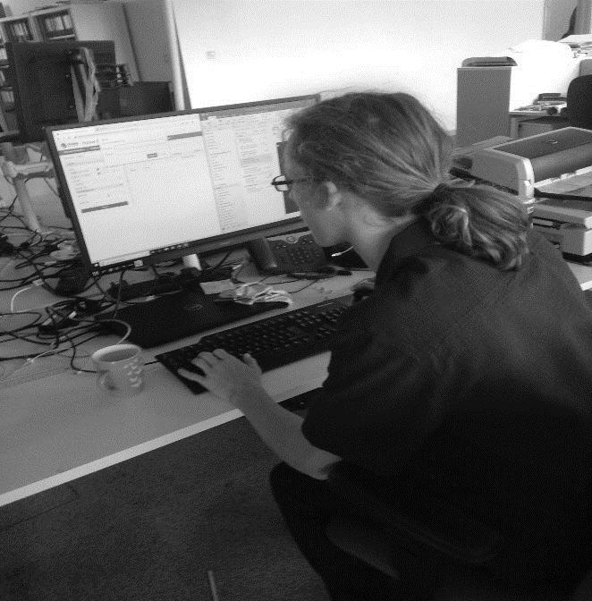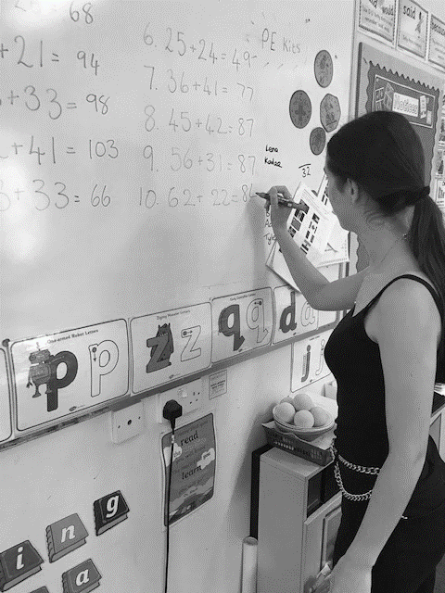

**NAME: ……………………………………………….…………**

**FORM: ……………………………………………….……….…**

**PLANNER**

**EXPERIENCE**

**WORK**



**When?**

11th -22nd July 2022

What is **Work Experience*?***

This is your chance to spend two weeks out of the Academy with an  
employer, finding out  
about the world  
of work.

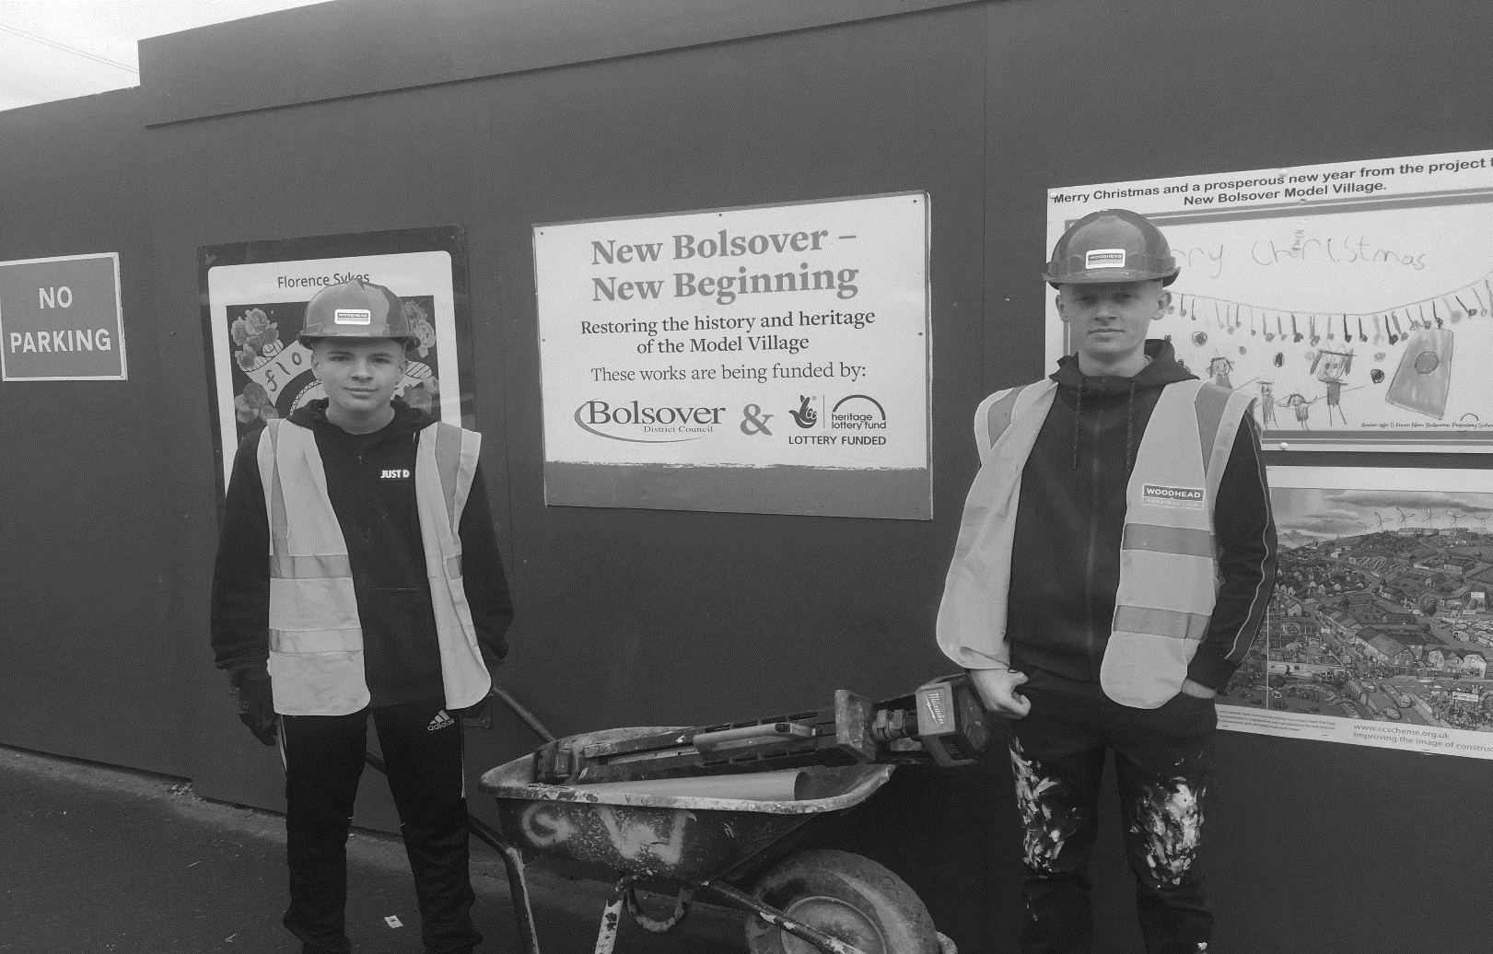

During your placement  
you will be treated as any other employee, and   
you may be expected to work different hours to the Academy.  
Work experience may not be an easy option, but it can be very enjoyable!

Through work experience, you may be able to:

* Try a job you are interested in for the future;
* Spend time with a local employer finding out about a range of jobs;
* Improve your skills such as communication, team work and problem solving;
* Improve your confidence and become more independent;
* Gain skills that will help you with your future job ideas;
* Find out about your own strengths/weaknesses to help you plan for the future after Year 11.

# The Rules

All the placements must be approved by Derbyshire County Council to ensure they meet Health and Safety regulations and have the correct insurance to provide work experience.

***This is to protect you.***



“A very versatile and flexible student. Always willing to learn.

Eager to take responsibility.”

“The student has proved an excellent worker…. developed a professional manner and communicated well with the diverse public”

“A credit to the school”

“One of the best work experience students we have had”

**What employers said last year…**

“An excellent student which we would not hesitate to employ in the future”

Reliable, hardworking and well presented.

Work experience takes place during weekdays. Evening or weekend work can be negotiated between parents/students and employers, the Academy will not be responsible for students at these times. Students cannot work more than eight hours a day or forty hours a week.

Whilst on placement you are representing Shirebrook Academy and your attendance/behaviour will be reported back to us by employers.  
Teachers will also visit you whilst you are on your placement.

It can take some time for placements to be approved, especially those in Nottinghamshire or further afield. This is why you need to let us know about your placement **as soon as possible**.  
early in the year where you would like to go.

“Our student was enjoying the placement so much that he came in an hour earlier to help with a heavy workload.”

All students will be expected to go out of the Academy for work experience - ***staying in school is not an option!***

If you are not able to go on your placement, e.g. due to illness,   
you will need to inform the Academy and your employer.

Most employers in the past have said really good things about

Shirebrook Academy students

***We rely on you to keep this good reputation.***

**Top Tip**

**Be** *ambitious*! **If you want to do something unusual, or different to the things you normally do, go for it! This is a  
great chance to try  
something new.**

Do you have any family contacts that may be able to provide a placement for you?

Have you come across any jobs that appeal to you?

*(Think back to things you enjoyed during lockdown or career ideas from your research today)*

**STEP 1 - Assessing your Skills**

**and Interests**

Fill in the following information to help you plan for finding a placement

Where could you travel to for your work experience?

*(Think about bus routes, family or friends who could take you)*

If you were to gain one thing from going on work experience, what would it be?

**STEP 2: Choosing a Placement**

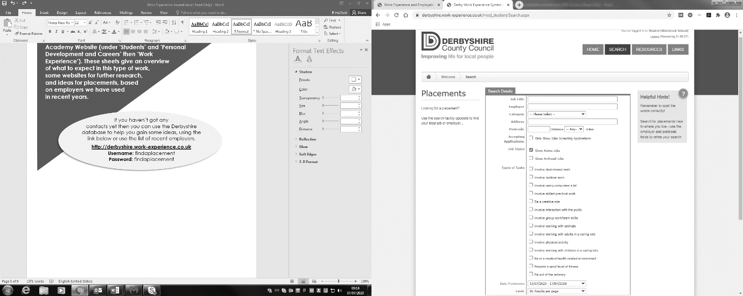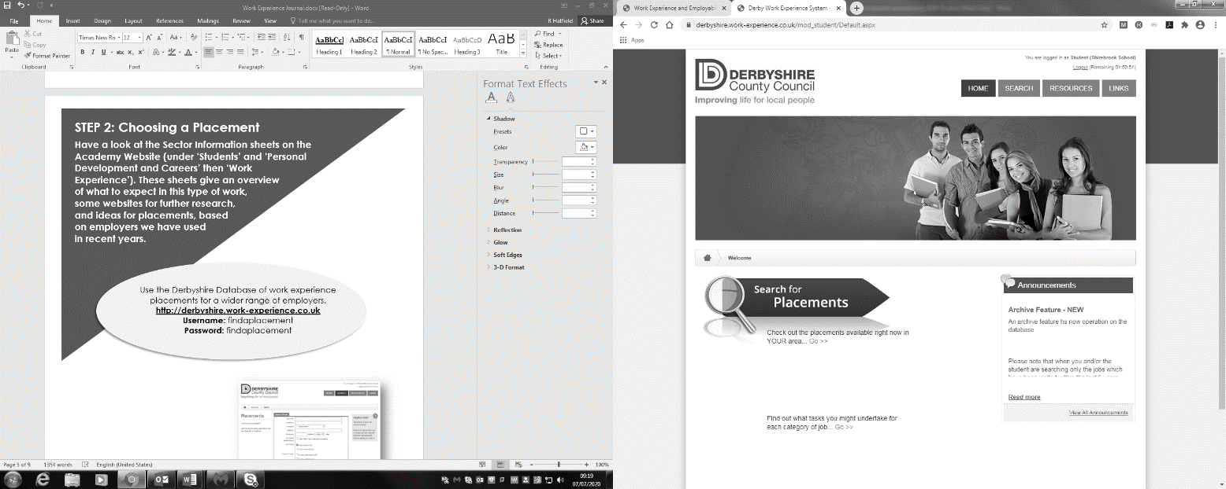

* Have a look at the Sector Information sheets on the Academy Website (under ‘Students’ and ‘Personal Development and Careers’ then ‘Work Experience’). These sheets give an overview of what to expect in this type of work, some websites for further research, and ideas for placements, based on employers we have used in recent years.
* Use the Derbyshire Database of work experience placements for a wider range of employers.

[**http://derbyshire.work-experience.co.uk**](http://derbyshire.work-experience.co.uk)

**Username:** findaplacement

**Password:** findaplacement

* When you search for placements, put your  
  postcode, the distance you are prepared  
  to travel, and the type of work you are  
  interested in. Ignore the other boxes and  
  click on ‘Search’ at the bottom of  
  the page.

For each employer listed you  
can click on a job description  
with contact details, or click  
on the location to check that  
you can get there.

* Complete the Work Experience  
  interest form. This will be used  
  in school to help you find a  
  placement.



**STEP 3: Contacting an Employer**

Students are expected to identify and make contact with employers. We are available for help  
throughout the year but it is important that  
you ask if you are struggling. Many  
employers prefer to have direct  
contact from students.   
This will help you in the  
future when  
applying for  
work.



* **If you already have an offer at a work experience placement:**
  1. Complete a blue ‘confirmed placement’ form which you can get from your form tutor or Student Reception.
* **If you have some ideas but do not have an offer of a placement we will work with you in small groups during this term to identify some possible employers.**

**You will then need to:**

* 1. Contact employers by telephone or email to ask for a placement. **Keep trying.** It may take several attempts to get in touch with an employer before you are successful.
  2. You may be asked to send a letter of application. Please make sure your letter has been saved on the student share so it can be accessed by staff throughout the year.

c) When you have an offer of a placement, complete the blue ‘confirmed placement’ form and give it to your form tutor or Student Reception. **The placement can then be checked out for insurance and health  
and safety**.

**Remember -  
  
Popular placements are limited and  
students from other schools will also be looking for  
placements - you need to do this as soon as possible.**

**Most students should have confirmed placements by *the end of March*.**

If you need  
more help –

We will work with you in PD lessons over the next few weeks. See Natalie on Student Reception or Tracy (Humanities Bridge) Or Email **thorton@shirebrook  
academy.org**

**First  
Impressions Count  
- be professional!**

# How to Contact Employers by Email

Send from your school email address or another account you will check regularly (make sure it’s a sensible name!)

Ideally send to a named person at the organisation, not just a general enquiries email address

Check for grammar and punctuation, try and make it look professional

Under ‘Subject’ write ‘Work Experience request’

Then type the same text as you would use for a letter –  
***see sample letter page***

# How to Contact Employers by Telephone

Call from a quiet room with no distractions if possible.  
Have the following things to hand:

* Company Details: contact name, number and address
* Academy Information: Telephone: 01623 742722
* Date of Work Experience: 11th July – 22nd July 2022
* Information about you:  
  > How many GCSE’s are you taking,   
  > Personal contact information



## **Making the Call**

* Explain clearly what you are asking for

For example: A two week placement from 11th July 2021

A placement in **……** (Type of work or company)

* You may then be asked for further information,  
  e.g.: Why have you contacted this company?

Why do you want this kind of work?

What do you want to be  
doing on the placement?

## **What they may say …**

**No –** The company may have  
good reasons for saying no, thank them  
for their time and try to leave a good  
impression (you are representing the Academy  
when you make the call and it is important to keep  
the contact for future years)

**Maybe –** The company may want more information  
from you in writing or they may want to speak to the  
Academy. Make sure you act on anything you agree to.

**Yes –** Well done! Now complete a blue ‘confirmed  
placement’ form and return it to Student Reception as soon as possible.



# Sample Letter – asking for a work experience placement You can also use this template when writing an email

## 12 Bramble Close

Shirebrook

Derbyshire

NG20 4DX

Mr F Smith

Manns DIY Store

Sawdust Retail Park

Mansfield

N30 6NH

Date

Dear Mr Smith,

I would like to apply for a work experience placement with your company.

I am currently in Y10 at Shirebrook Academy, working towards GCSE’s. I enjoy my IT GCSE and use my computer at home a lot (for homework, using e-mail and the internet). I would really like a work experience placement that will help me look at jobs using IT skills. I found your company details on the work experience database in school.

The work experience dates are Monday 11th  to Friday 22nd July 2022.

I would be happy to visit you before then to meet you and find out more about the work I will be doing.

I hope you are able to offer me a placement. If you need any more information please contact Student Reception at Shirebrook Academy,  
on 01623 742722.

I look forward to hearing from you.

Yours Sincerely,

Joe Bloggs