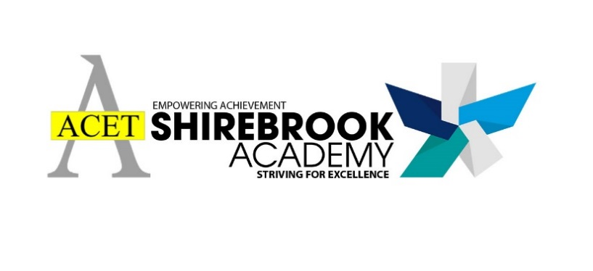

Page 1

|  |  |
| --- | --- |
| **SHIREBROOK ACADEMY WORKSHOPS** | **I would like to attend this session** |
| 1:1 Career guidance support – Jenna/Tracy |  |
| Maintaining English knowledge, understanding and skills to be ready for college |  |
| Maintaining Maths knowledge, understanding and skills to be ready for college |  |
| Getting ready for A Level Maths |  |
| Getting ready for A Level English |  |
| Getting ready for A Level Biology |  |
| Getting ready for A Level Physics |  |
| Getting ready for A Level Chemistry |  |
| Getting ready for A Level Spanish |  |
| Getting ready for A Level French |  |
| Getting ready for A Level Geography |  |
| Getting ready for A Level History |  |
| Getting ready for A Level Philosophy and Ethics |  |
| Getting ready for A Level Art and Photography |  |
| Getting ready for A Level Design and Technology |  |
| Getting ready for A Level Food |  |
| Getting ready for A Level Textiles |  |

|  |  |  |  |  |  |  |
| --- | --- | --- | --- | --- | --- | --- |
| **Name** | | | | | | **Form** |
| **Intended Destination** | | | | | | |
| Course | | | | | | |
| Level | | | | | | |
| Institution | | | | | | |
| **Do you require lunch on the days attending?** | **YES** |  |  | **NO** |  |  |

**Y11 Leavers Programme**

The final day of compulsory attendance for Y11 will be Friday 28th May.

We are excited to offer a series of voluntary sessions that you can sign up for during June to help you prepare for an effective transition to Post 16 study.

These sessions cover:

* Preparation / guidance for post-16 including transition activities provided by West Notts College
* Academic lessons to support you in preparation for L2 or L3 courses at college or sixth form
* English and maths ‘maintaining knowledge and skills’ sessions, particularly but not solely for students who may need to sit GCSEs in November.

**Sessions will take place on Monday 7th June, Tuesday 15th June, Wednesday 23rd June, Thursday 1st July and Friday 9th July.** A full timetable will be produced once student numbers are known.

* You will only attend when you have a specific session.
* You will attend in full school uniform and the normal expectations for behaviour for learning will apply
* You will need to indicate in advance if you require lunch
* You will need to sign in at main reception and attend only sessions applicable

**Please sign up to any sessions that you wish to attend and return to your form tutor no later than Monday 17th May.**

**Y11 PROVISION POST 28TH MAY 2021**

Page 2

|  |  |
| --- | --- |
| **WEST NOTTS COLLEGE WORKSHOPS** | **I would like to attend this session** |
| **PREPARING FOR POST 16 – LEVEL 2**  An introduction to how you can prepare for post 16 level 2 courses. What to expect when you enrol and start a course. |  |
| **PREPARING FOR POST 16 – LEVEL 3**  An introduction to how you can prepare for post 16 level 2 courses. What to expect when you enrol and start a course. |  |
| **INTRODUCTION TO HE**  An insight into different university options, the benefits they carry and a chance to immerse into the action with a virtual tour and quiz. |  |
| **APPLICATION SUCCESS**  Uncover the meaning of transferable skills, their importance and how to develop and discuss them on applications for university and graduate jobs. |  |
| **IS HE FOR ME?**  Get to know current HE students and discover why they chose the HE pathway and begin to learn more about how HE could suit you too. |  |
| **STUDYING AT HE**  An introduction to university style study. Helps students get to grips with university lingo and gives an insight into what HE study might look like for them. |  |
| **RAISING ASPIRATIONS WITH GROWTH MINDSET**  Stories of individual journeys to study at Higher Education detailing the obstacles they faced and discover how Growth Mind-set allows these to be overcome. |  |
| **BTEC PROGRESSION**  Showcase how BTECs can open doors to opportunities in a wide range of industries and support a successful transition into Higher Education. |  |
| **STEM AT UNIVERSITY**  Dive into the world of science, technology, engineering and maths and discover the demand whilst inspiring new career ideas. |  |
| **WHERE COULD A DEGREE TAKE ME?**  This assembly joins the dots between HE and careers, showing how degree level qualifications are transferrable to the workplace. |  |
| **ARTS AND HUMANITIES AT UNI**  What are the Arts and Humanities and why are they important? This assembly gives a brief intro to AAH at University as well as dispelling some common misconceptions. |  |

**West Notts College are offering the following workshops. Workshops will take place at Shirebrook Academy.  
Please indicate which sessions you would like to attend.**

|  |  |
| --- | --- |
| **SHIREBROOK ACADEMY WORKSHOPS** | **I would like to attend this session** |
| Getting ready for A Level Business Studies |  |
| Getting ready for A Level Drama |  |
| Getting ready for A Level PE |  |
| Getting ready for A Level Media |  |
| Getting ready for Level 3 BTEC Sport |  |
| Getting ready for Level 3 Health and Social Care |  |
| Getting ready for Level 3 Computing/Digital Information Technologies |  |
| Getting ready for Level 3 Music |  |
| Getting ready for Level 2 BTEC Sport |  |
| Getting ready for Level 2 BTEC Health and Social Care |  |
| Getting ready for Level 2 Computing/Digital Information Technologies |  |
| Getting ready for Level 2 Music |  |
| Is there anything else you would like support with? | |