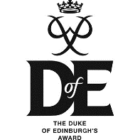
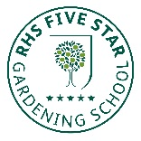
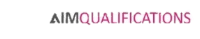
MC/BN
Tel: 01623 742722 Fax: 01623 742206
enquiries@shirebrookacademy.org www.shirebrookacademy.org
Common Lane Shirebrook Nottinghamshire NG20 8QF
15 March 2021

Dear Parents and Carers
As you will already be aware, the exam series for this summer has been cancelled due to Covid-19 and instead schools have been asked to provide the exam boards with internally assessed grades to enable students to receive their qualifications.
Please find below an outline of the process that we will be taking at Shirebrook Academy to provide exam boards with these grades.
The basic principle of this process is to ensure that all students are given a fair opportunity to demonstrate what they know, understand and can do in each subject. In this way we hope to be able to award a grade that is as close as possible to the grade they would have achieved had they been able to follow the full course of study and sit external exams.
In many subjects, the periods of lockdown since March 2020 have meant that not all of the course content could be covered. Students will only be assessed on content that has been covered so that they are not disadvantaged compared to previous year groups who completed the whole course.
All students will sit formal exams in the Sports Hall for all of their qualification subjects in the two weeks after the Easter Holiday 19th to 30th April. These will be exam papers adapted from previous exams and material provided by exam boards to take account of the content covered. In some exams, supporting materials may be allowed in the exam hall.
Between May 4th and May 28th, students will be given other formal assessments during lessons to give them further opportunities to show what they can do.
For both formal exams and formal in-class assessments, students with entitlement to access arrangements i.e. a reader, scribe or additional time, will receive their entitlement.
Grades will be submitted to the exam boards on 18th June and students can collect their final grades in school on the morning of August 12th. There will be a process of appeal to the exam board for any student who believes their grade has been unfairly awarded which I will explain in a separate communication nearer the time.

Teachers are not allowed to reveal or discuss the grades submitted with students or parents before August 12th.
To arrive at their final grade teachers will take the following evidence into account:
- The forecast grade from December 2020
- Performance in the Formal Exams taken between 19th and 30th of April
- Performance in other formal assessments held in class between 4th and 28th of May
- Performance in Non-Exam Assessments (NEAs) in those subjects that have them
- Any externally assessed components already completed in BTEC qualifications
- Other BTEC assessed tasks
I know you will work with us to ensure that our students continue to work hard and put their all into the formal assessments in order to achieve the best possible outcome and prepare them for further learning beyond Year 11.
It is particularly important that they maintain full attendance, work hard and concentrate fully in class and on tasks set for homework. They must treat the formal exams and in class assessments in the same way that they would treat the external exams that would normally take place.
Do get in touch if you have any questions regarding this process.
Many thanks for your support as ever.
Yours faithfully
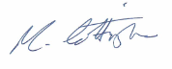
Mr M Cottingham
Principal

