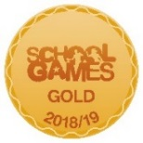
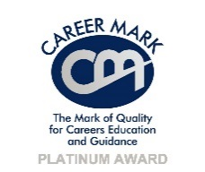
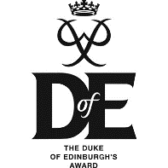
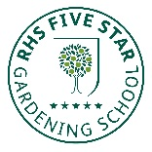
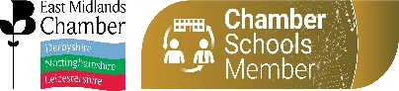
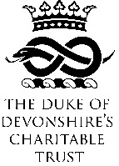
MC/bn
Tel: 01623 742722 Fax: 01623 742206
enquiries@shirebrookacademy.org www.shirebrookacademy.org
Common Lane Shirebrook Nottinghamshire NG20 8QF
25th November 2020

Dear Parent / Carer
During the summer we were one of a small number of schools around the country who made a successful bid to Magic Breakfast - a national charity supplying free breakfast food for any students who needed it. We felt it was a way that we could help our families at this challenging time.
The charity is very generous in supplying this food to anyone without the need to prove you need it. The system is built on trust and integrity - that students will be sensible and only take food if they are actually going to eat it. We made this clear to students in September.
I am therefore extremely disappointed that a small number of students in our community have not shown the integrity and honesty that this scheme calls for. Some students are taking the food and then throwing it around the field, the bus and the local community. Not only is this a terrible waste of food that is badly needed by some families but it causes litter, attracts vermin and tarnishes the reputation of every Shirebrook Student.
As result of this abuse of the generosity of this charity by a small number of students we are now limiting access to the food. In future, the breakfast food will be limited to those who place an order and it will be collected from a specific, controlled point.
I hope that those who are responsible for spoiling this scheme for everyone will quickly learn the values of honesty, integrity and compassion; I trust that in future students will show more respect for the needs of others and show more pride in their school and local community.
Yours faithfully
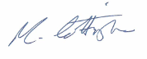
Mr Cottingham
Principal

