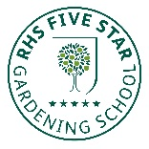
Ref:/MC
April 2020
Tel: 01623 742722 Fax: 01623 742206
enquiries@shirebrookacademy.org www.shirebrookacademy.org
Common Lane Shirebrook Nottinghamshire NG20 8QF

Dear Parents, Carers and Students
As we start the most unusual summer term of my thirty years as a teacher, I hope you are all coping as well as possible in these strange times.
It does not look like we will be allowed to open school for you all in the near future, so I wanted to make sure you have all the help you need to keep learning during the lockdown.
Where you have access to the internet, students should be accessing learning via SAM Learning and/or GCSE Pod. Go to our website www.shirebrookacademy.org and click on ‘work for closure’ to access work set by our teachers. The web site is also the place to go for updates and news as well as our twitter feed @shireacademy
In addition, teachers are sending work and messages via the school email and students are able to email their teachers directly on that address. Please use the school email rather than private ones to keep the communication secure. If you have any problems accessing your school email or SAM Learning / GCSE Pod please call school reception, email your form teacher or email NMehrotraHughes@shirebrookacademy.org for help.
This week the DfE have set up a new platform for lessons, Oak National Academy – you can follow this link to access lessons - 180 new lessons are uploaded each week. https://www.thenational.academy/
There are also lots of great ideas for activities being produced by the BBC and various other organisations.
If you do not have access to the internet we can provide printed materials for you to work from, just let us know by calling reception or by emailing your form tutor. The government have just announced a scheme to provide laptops and routers to a limited number of students in Y10 if you do not have access already and are eligible for Pupil Premium, plus any children who are supported by local authority social care. If you are eligible for this scheme we will be in touch with details of how it will work once we have further guidance from government.
The most important thing is to make sure you have a routine and follow it as much as you possibly can. It is easy to find the day drifting by without getting much done and for each day to seem much like another.
My advice would be to draw a timetable that:
- runs Monday to Friday
- includes at least four hours of school work each day
- include at least one physical activity during the day
- includes some time reading for pleasure each day
- if working on a computer remember to take regular breaks away from the screen
- keep regular bed time, getting up time and meal times as you would if still at school
In addition, this is a great time to learn new skills or perfect an old one and to try something creative. You could try playing a musical instrument, drawing, painting or photography, dancing, creative writing, cooking, making something – wherever your imagination takes you really.
Above all, stay safe, be kind to each other and get in touch if you have any concerns.
I hope to see you all soon,
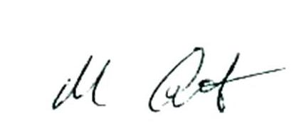
Mr Cottingham
Principal, Shirebrook Academy

