Year 9 Homework Tasks- Autumn Term 2

Complete at least one task per week ensuring that they are completed by the deadlines listed below.

Task 1: Using some of the following vocabulary describe a dark and gloomy setting. Write at least 2 well-crafted paragraphs.  Bleak, unlit, shadowy, indistinct, dreary, obscure, grimy, dismal.  Challenge: Have you used at least 3 different types of sentence structure in your paragraphs – redraft to improve. | Due in Friday 8th November
Task 2: Write some sentences using the following conjuctions and fronted adverbials:  However, although, since, recently, frantically, in the blink of an eye. (Try to put the conjuctions in different places in sentences)  Challenge: Use the conjunctions and fronted adverbials to add another paragraph to your description for last week’s homework. | Due in Friday 15th November
Task 3: Write 10 lines of dialogue for a story. Ensure it is laid out correctly, you use the right punctuation and interesting speech tags. (A new line for each new speaker, speech marks around the words spoken)  Challenge: Try using speech tags which describe the actions of your characters as well as how they sound. E.g he uttered quietly whilst unconsciously twisting the ring on his finger. | Due in Friday 22nd November
Task 4: Correct the errors in the sentences below. Explain why the words/punctuation you’ve corrected were wrong.  For there homework’s they had too do a series of task’s that showed there understanding of writing skills. There where supposed to show that they could use apostrophe’s and comma’s and full stop’s correctly. Some of the pupils where not able to sea were there errors where.  Challenge: Research which other homophones in the English language are commonly mixed up. | Due in Friday 29th November
Task 5: Change the following descriptive starter into third person narrative. Add another paragraph to it. (Change from ‘I’ to ‘he,’ ‘she’ or ‘they’)  I couldn’t see the end of the tunnel. I was cold. It was dark. I was alone. I felt the damp walls; they were smooth and in places I sensed that water had saturated the brick recently. All around me, the darkness closed in. My voice echoed horribly as I cried out for help. | Due in Friday 6th December
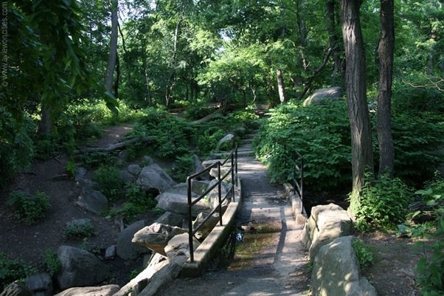  Task 6: Using the picture as a starting point, describe a park. Write at least 3 paragraphs.  Challenge: Redraft your work, showing improvements in sentence structure, use of a full range of punctuation and sophisticated vocabulary. | Due in Friday 13th December
Task 7: Write a paragraph in which you successfully use a semi-colon, a colon, question mark and dashes to describe a family member or a friend. | Due in Friday 20th December

Christmas Challenge.

Re-read ‘The Sign of Four.’ What do you notice that you didn’t notice during your first read through the novel. Make some flash cards or mind maps to help with your revision later in the year.

