Task 1 – READING – DUE Thursday 30th April  To read for a minimum of 45 minutes – you MUST record your reading in your yellow reading record.  This reading can be chunked into small sessions.  Challenge: To complete (and pass 80% or more) an Accelerated Reader quiz. (Print the result sheet off and show your teacher) | Task 2 – WRITING – DUE Thursday 7th May  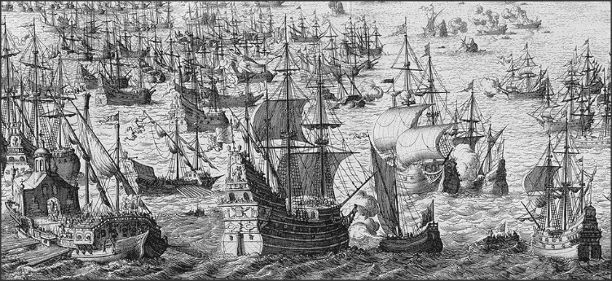  - Create a vocabulary list – 5 words inspired by this image.  - Write the opening paragraph to a story using the words inspired by the image. | Task 3 – Summary –DUE Thursday 14th May  Write a summary of the play so far. You must include:  Key events  Key characters  Key quotes  This needs to be detailed enough for someone new joining your class to be able to catch up on the story so far.  Challenge: Use some relevant quotes from the text.
Task 4 – REVISION – DUE Thursday 21st May  Revise the skills from lesson:  - Finding information in a text  - What language and language techniques are used – what effect do these have on the reader.  - What is to summarise and synthesise.  - Collect a vocabulary bank – learn the words | Task 5 – HALF TERM READING – DUE Thursday 5th June.  To read for a minimum of 45 minutes – you MUST record your reading in your yellow reading record.  This reading can be chunked into small sessions.  Challenge: To complete (and pass 80% or more) an Accelerated Reader quiz. (Print the result sheet off and show your teacher) | Collect your vocabulary here from revision task 4:

