Video games may improve children's intellectual and social skills, study finds
Scientists found associations between high video game use and better social skills and school performance
Independent Online |Doug Bolton | Wednesday 9 March 2016
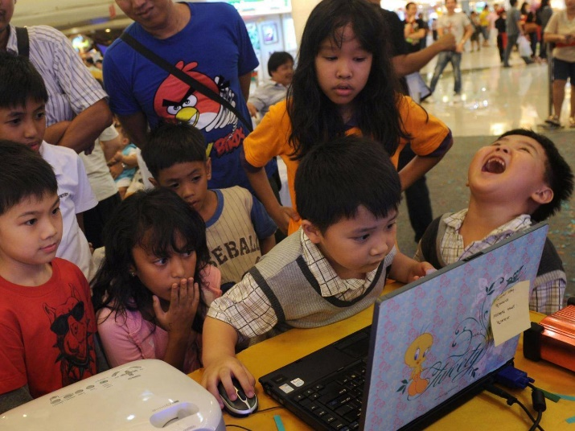
Young children who play a lot of video games may be more likely to have better intellectual and social skills than their non-gaming peers, a new scientific study has suggested.
The study, conducted by an international team of researchers at Columbia University's Mailman School of Public Health in New York, involved the analysis of mental health data relating to thousands of children between the ages of six and 11 from across Europe.
The data was collected through questionnaires filled out by parents and teachers, and the children responded to the questions through an interactive tool.
Accounting for variations in development explained by the children's ages and genders, the team found that high video game usage was associated with a 1.75 times increase in the odds of high intellectual functioning.
Children play Angry Birds on a laptop in an Indonesian shopping centre

Children who played a lot of video games were also found to be 1.88 times more likely to have "high overall school competence."
The affect of video games on children's social skills is often a cause for concern, but the team found links between high game usage and better peer relationships and good social skills.
During their analysis, the researchers found no significant associations between gaming and child mental health problems, regardless of whether they were reported by parents, teachers, or the children themselves.
Katherine M. Keyes, PhD, an assistant epidemiology professor at the Mailman School who worked on the study, said: "Video game playing is often a collaborative leisure time activity for school-aged children, and these results indicate that children who frequently play video games may be socially cohesive with peers and integrated into the school community."
However, Keyes urged against over-interpretation of their findings, saying that "setting limits on screen usage remains an important components of parental responsibility as an overall strategy for student success."
A paper detailing the findings, published earlier this month in the journal Social Psychiatry and Psychiatric Epidemiology, concludes by saying that mechanisms through which games stimulate children should be investigated further.

Task 1 – TAP – Due Tues 14th January 2020

Using the text type titled ‘Video games may improve children's intellectual and social skills, study finds’ complete a TAP analysis.
- TEXT TYPE –
- AUDIENCE –
- PURPOSE –
Challenge: Write a summary of your own opinion on the effect of video games on children.
TEACHER ASSESSED
TASK 2 – READING AND SUMMARISING – Due Tuesday 21st January 2020

- Read an article on a topic you are interested in (newspaper, magazine or online).
- Write a summary of this article – make sure you include the key facts/information.

Challenge: Write a glossary of 5 new words that you have found whilst reading your article and their meanings.
PEER ASSESSED
TASK 3 – WRITING – Due Tuesday 28th January 2020

Write the opening of a speech about your own opinion on gaming. This speech is to be delivered to teachers.
You must make sure you craft your writing and include AFORREST techniques.

Write 3-4 effective paragraphs.
Challenge: Does your speech include a full range of sentence structures and punctuation?
TEACHER ASSESSED
TASK 4 – SPELLING TEST - Due Tues 4th February 2020

Alliteration | Rhetorical question
Facts | Repetition
Opinion | Statistics
Emotive language | Triple
Direct address | Text type
Audience | Purpose
SELF ASSESSED
TASK 5 – RESEARCH/REVIEW – Due Tues 11th February 2020
- Have a look at how a review is written – what key features can you identify?
- Write a short review for your favourite film.
Challenge: Compare your film review to one that you have found online. PEER ASSESSED
TASK 6 – REVISION POSTER – Due Tues 18th February 2020
Create an engaging revision poster. This needs to be something you can come back to and revise from.
EVERYTHING I HAVE LEARNT ABOUT NON-FICTION

Include: techniques, text types, audiences, purposes and language you need to use. SELF ASSESSED

