Year 10 MEDIA Homework - Autumn 1

|  |  |  |
| --- | --- | --- |
| Homework 1 – What is NEWS?  Research news.   1. What does an audience/consumer want to know? 2. How do people access news? 3. List different types of news? | Homework 2 – NEWSPAPERS  Speak to relatives/friends about what NEWS means to them.  Questions you might ask:   1. Do you read NEWSPAPERS? 2. What NEWSPAPER do you read? Why? 3. What do you like to read about? 4. Do you read the NEWS online? 5. Do you read national NEWS or regional NEWS? | Homework 3 - NEWSVALUES  Create a news values poster.  The poster must have different news values with examples to support.  The examples could be:   * Images from a news website * Headlines from newspapers * Quotes from articles (online or print news) |
| Homework 4 – Codes and Conventions  Annotate the front page of a newspaper on the rear of this sheet.  CHALLENGE: Can you associate news values to the main story. | Homework 5 – Spelling test   * Pun * Masthead * Image * Caption * Headline * Narrative * Audience * Broadsheet * Tabloid * Alliteration | Homework 6 – Revise Codes and Conventions  Revise what you expect to see on a front cover of a newspaper ready for the assessment in week 7 and week 8.  CHALLENGE: Can you use your own images for your newspaper front page |

1. Annotate the codes and conventions
2. What is the effect on the reader?
3. Challenge: NEWS VALUES

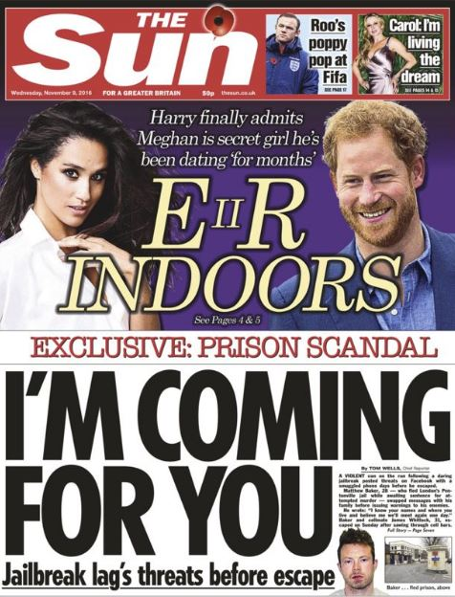

|  |
| --- |
| What news values are being used here? Why? |