Students are assessed in Key Stage 3 using Skills and Knowledge that are closely linked to the Head Hearts and Hands model. Each strand focuses on a different set of knowledge and skills designed to develop the whole performer in line with the schools’ ethos of ‘developing the whole person’ in Ridgeway 360.

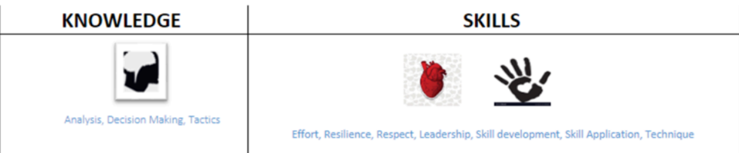

**Skills and knowledge assessment**

