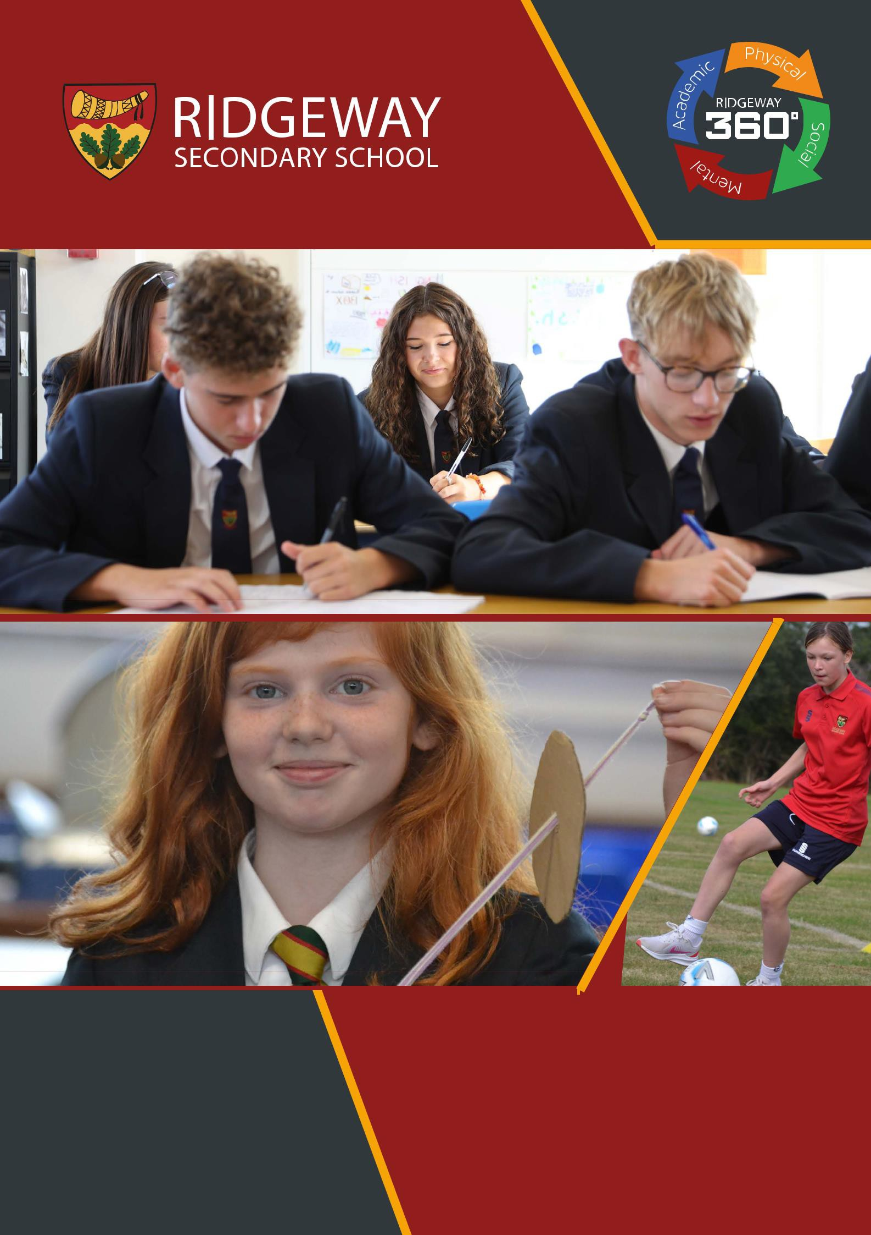

Computing Teacher Application Pack

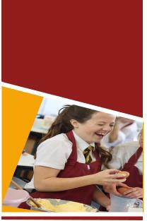
Welcome

Thank you for considering Ridgeway Secondary School. We appreciate it is a big decision to make a career move, so we want to ensure that Ridgeway is the right school for you by asking you to answer the following questions: Do you want to work in a school where behaviour is exceptional and you are able to teach as the expert in the room? Do you want to teach in a school where all staff are valued, supported and developed? Will you be an excellent teacher and a member of staff that colleagues can rely on? Will you put our students and their futures first? If you have answered yes to the questions above then we would love to receive an application from you and would encourage you to visit us, meet with key staff and see our fantastic school in action.

Small School
Big Vision

We are a small school of 300 students with high expectations and an ambitious vision for the future. We converted to a secondary school in 2015 and after a period of success the school has struggled to maintain the high level of offer it had become known for. Outcomes have not been where we would expect them, and the 2021 OFSTED inspection confirmed that things needed to change. Ridgeway Secondary School is a completely different school from the one that gained that inspection judgement and has undergone rapid, significant improvements. There is a new leadership structure in place, excellent staff have been recruited into key positions and the school joined the Shires MAT in September 2022.
Students at Ridgeway are happy, polite and exceptionally well behaved, supported by their peers and a pastoral system. We nurture and guide students to make good decisions and gain experiences that prepare them for the world of work and later life.
It is our vision that Ridgeway Secondary becomes the school of choice in our local area. The school is growing with every new Year 7 intake and we are immensely proud of the school we have become and are determined to be the very best. There is still much to do in our exciting journey to give all of our community the very best all-round educational experience and this is an exciting time to join our committed and dedicated team.
We hope that by reading this information and visiting the school you will gain a sense of what it means to be at Ridgeway.

We look forward to welcoming you.

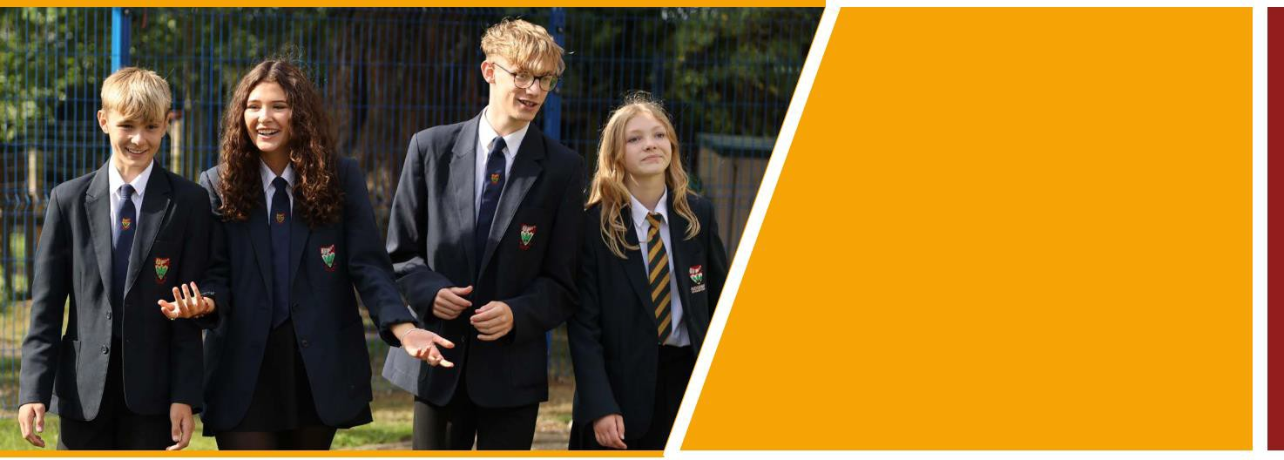
Small School
Big Ambition

What do we stand for?
Our mission is to develop the whole person and we are committed to Ridgeway 360° for all our students and staff. Ridgeway 360° underpins everything we do both inside and outside the classroom, developing young people and staff academically, mentally, physically and socially, so that they leave our school a fully rounded person, equipped to meet the challenges of the next steps they take.

Small School
Big Results

Academic Excellence

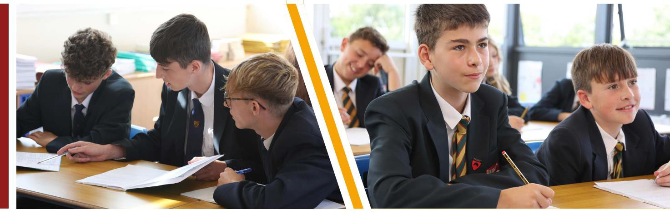
Creating an ethos of personal development and high standards enables our students to achieve academic success. We are continually developing to ensure that students leave our school with the necessary qualifications and experiences to succeed in life. Students and staff work hard and teachers use the latest evidence-based research to ensure knowledge and skills are embedded in the long-term memory. The curriculum and the lessons within it are carefully planned
in a sequence that is most conducive to retaining and applying information. As a result, our students will achieve the highest possible grades at GCSE and make excellent progress, significantly above national expectations from their starting points. They currently go on to study a wide range of courses at the very best 6th Form providers and colleges.

Small School
Big Opportunities

Curriculum
The curriculum at Ridgeway is central to our aim to develop the whole person. It has been completely restructured in the past year so that it is broad and varied, offering students the opportunity to learn and develop key learning skills and a depth of knowledge across a range of subjects as they journey through the school.

By coherently planning and sequencing each stage in the learning journey students benefit from a knowledge and skills rich curriculum that aims to develop all students regardless of their starting point or disposition.

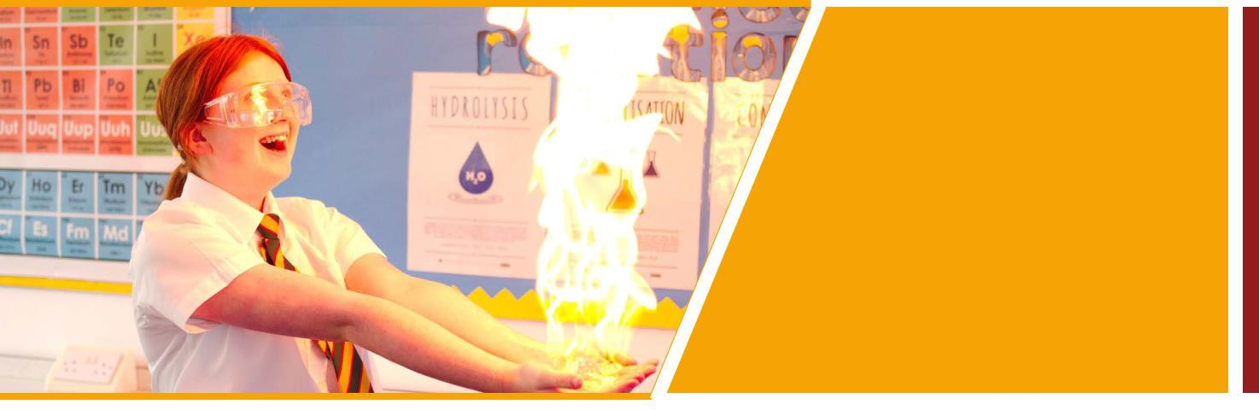

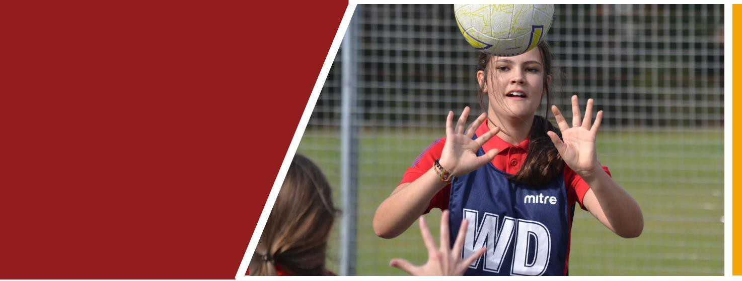
In Key Stage 3, students develop new skills and refine those that they have already learned. The Key Stage 3 curriculum lasts for 3 years, giving students the opportunity to study subjects in greater depth and develop the skills, knowledge and understanding required to be successful at GCSE in Key Stage 4. The Key stage 4 curriculum has

been broadened and offers a rich blend of subjects tailored to the strengths, interests and needs of the cohort. At the end of Year 9 students are selected to study the separate Sciences of Biology, Chemistry and Physics. We believe in offering subjects that allow a wide range of pathways and progression for our students in the future.

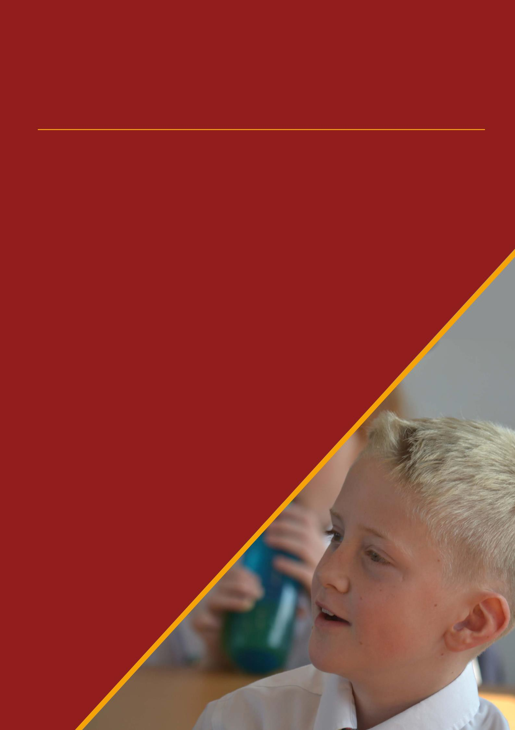
Small School
Big Futures

Careers
At Ridgeway, careers education is not an ‘add on’ to education, it is a key component of everything that we do. Within subject areas, careers education is embedded into the curriculum allowing students to see different career options within the context of their lessons.

All students receive at least one 1 to 1 careers guidance appointment from a level 6 qualified careers adviser. This helps everyone to explore a range of different pathways for success after Ridgeway. This is also done through PSHCE, as each year group have dedicated lessons to develop skills to prepare them for their future careers.
We care about every individual being successful,
not only while they are at Ridgeway but also long after they have left.

Small School
Big Heart

Pastoral
At Ridgeway, we offer a bespoke and specialist level of pastoral care to meet the different needs of each student. Our well-equipped and highly trained Student Services Team work tirelessly to ensure our students can be safe, happy and engaged with all that school life has to offer.
The team consists of leaders responsible for each key stage in the school: their role is to monitor, challenge and support everything from welfare and attendance to behaviour and mental health. Alongside this we have a dedicated student and family support worker who forms a support system around the child by engaging with parents and carers, the student, the school and appropriate external agencies to reduce or break down any barriers to learning that may arise.
Ready, Respectful, Safe
The three words that every Ridgeway student knows are ready, respectful and safe. Quite simply these are the words that underpin every desirable behaviour that the school expects. With these rules it is easy to reinforce the high expectations we have as a school.

Ready: this refers to anything from attention, uniform, equipment or punctuality.
Respectful: relates to communication and interaction with the school environment and all of those in it.
Safe: ensures we have an emphasis on maintaining a calm and safe environment for all to flourish.

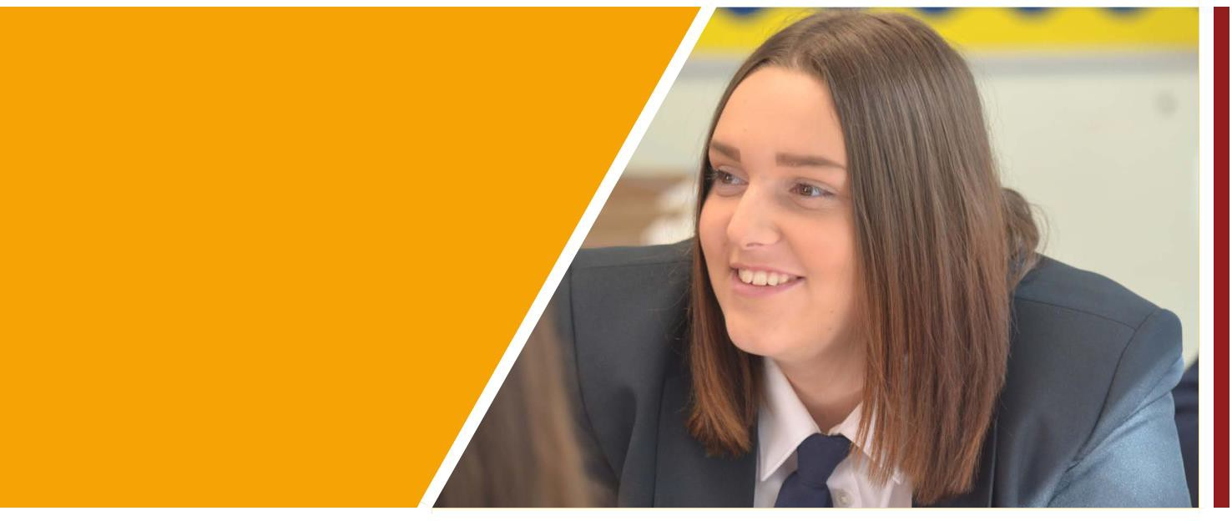

Small School
Big Experiences

Personal Development

At Ridgeway we deliver a broad and extensive Personal Development curriculum within Tutor time. This time is spent developing each student in our four pillars of development: Academically, Socially, Physically and Mentally. In this time students will cover topics ranging from how to stay safe online and making healthy friendships to leading an active life and how to reduce stress and study effectively.
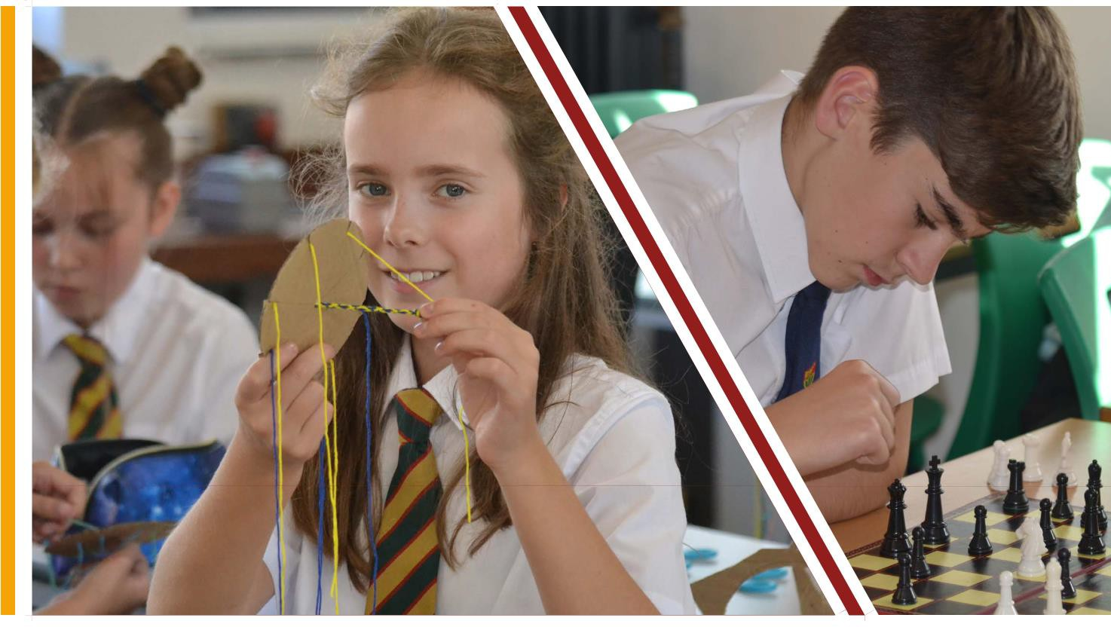
In addition to the Personal Development curriculum, we also offer an extensive enrichment programme to all students every Thursday afternoon after school. These sessions have a link to one

of the schools’ pillars and activities include everything from learning an ancient language to self-defence.
Alongside this, students have access to extra-curricular clubs in other areas across the week from competitive sport and activities to music and the arts.
At Ridgeway we understand that learning about who we are and developing as a person does not just happen in the classroom. There are those priceless experiences that we all remember from our time at school. The residential trips, visits and sports fixtures that build character and forge memories that stay with us until today.
Our ‘Ridgeway Promise’ means that as students’ progress through the school, they have opportunities to take advantage of trips and experiences outside of the classroom. Ski trips, residentials for outdoor activities, foreign exchange visits, sports tours, museum visits and theatre performances all feature in the programme. The school also offers the Duke of Edinburgh Award to its students from Year 9 onwards with students achieving both bronze and silver levels of the award.

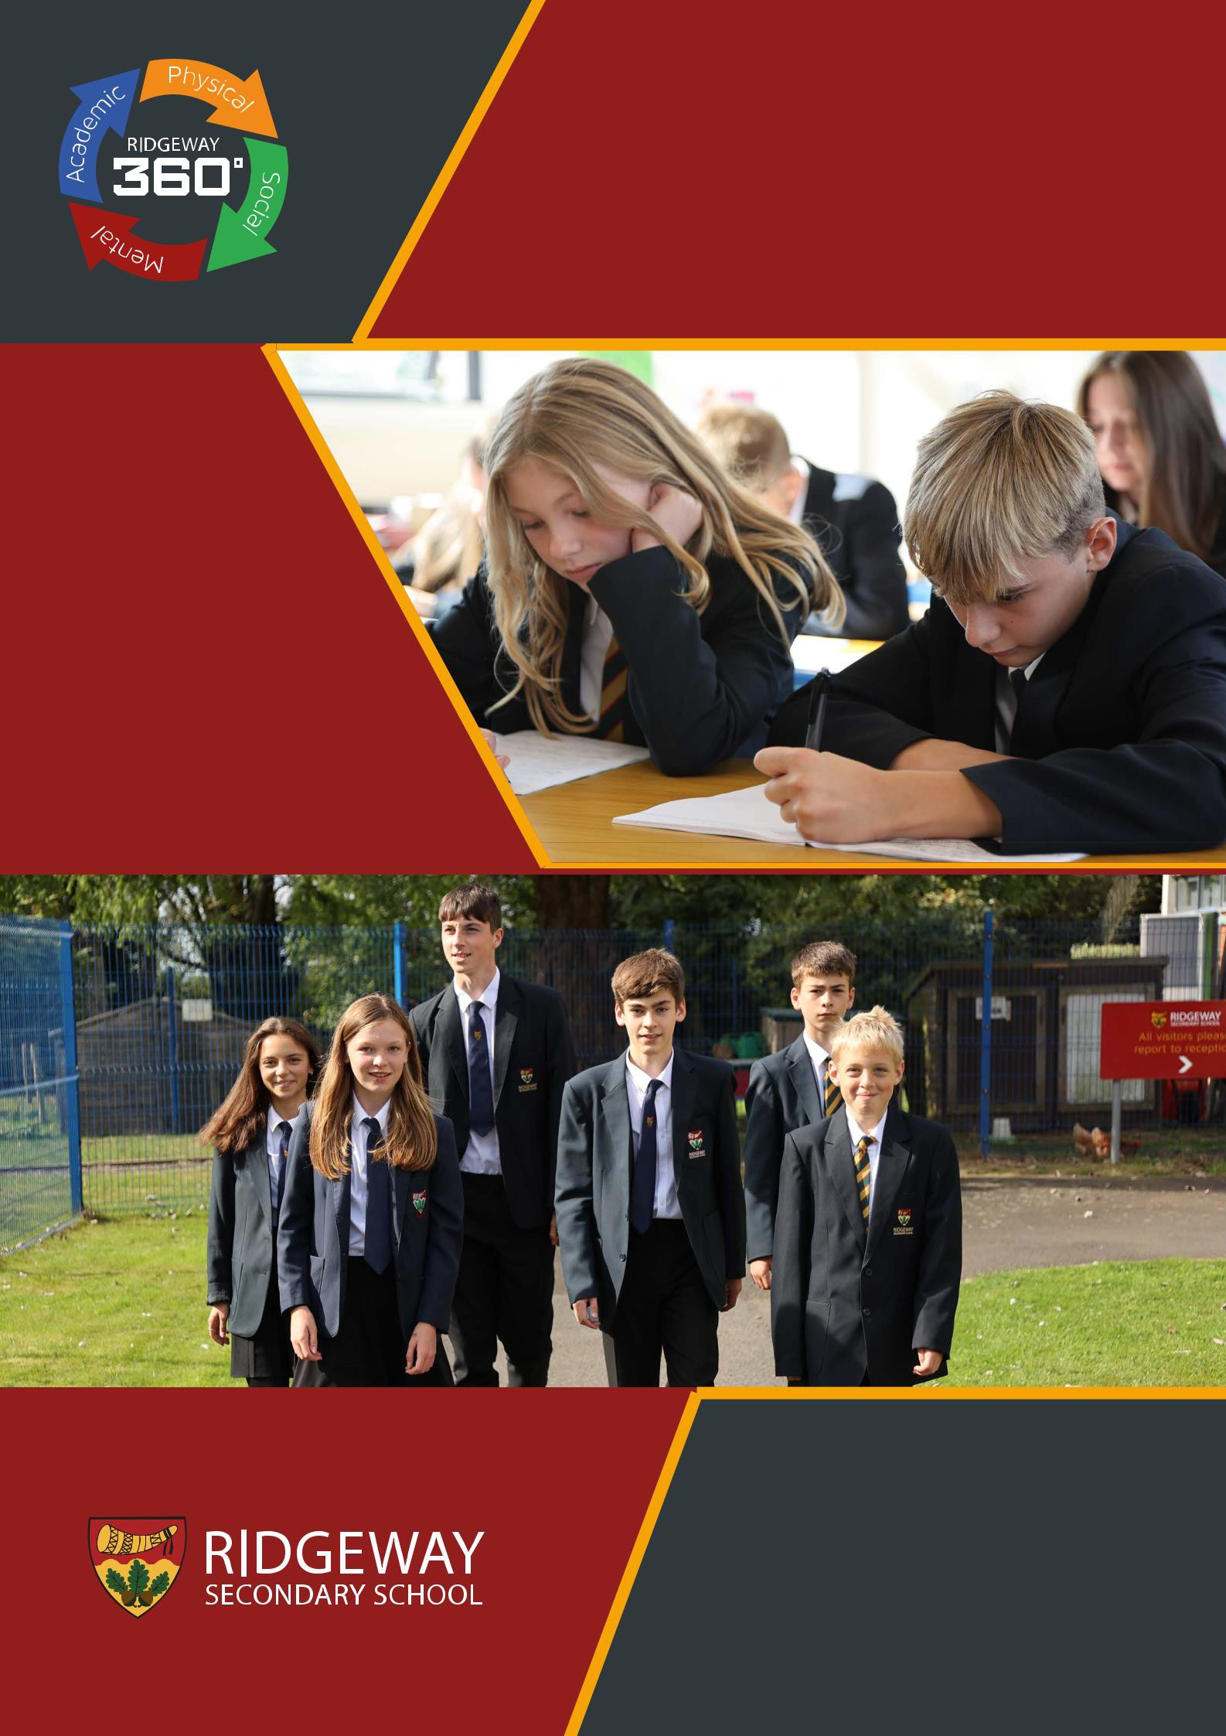

Ridgeway Secondary School, Evesham Road, Astwood Bank, Redditch, Worcestershire B96 6BD
Tel 01527 892867
Web ridgewaysecondary.org.uk

