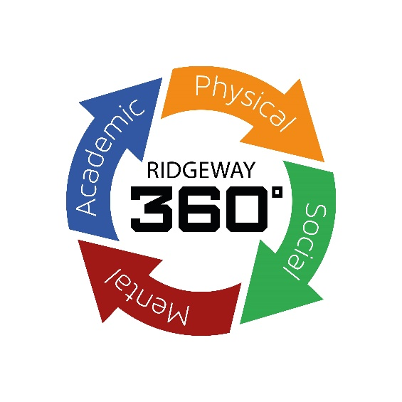
Vacancy Details
Teaching Assistant
Full time

Band 2, SCP 3 – 4, £22737.00 - £23114.00 (Actual salary is calculated at £17,254).
Monday to Friday, 08:00 to 15:00, 32.5 hours per week.
Term time only plus 5 Inset days.

Required from September 2024

Closing Date: 3rd May 2024

Do you want to work in a school where behaviour is exceptional and teachers can teach as the expert in the room? Do you want to work in a school where staff are valued, supported and developed? Will you be an excellent teaching assistant and a member of staff that colleagues can rely on? Will you put our students and their futures first?

Ridgeway Secondary School is rapidly becoming a great school, a place where the very best staff want to work with amazing students in a supportive environment. Read our 2021 Ofsted report and then come and visit us. You will see for yourself, the incredible progress that we have made in such a short space of time and the amazing learning and working environment that we have created.

You will have the highest expectations, knowledge, skills and commitment to supporting our students and colleagues. You will strive to make a positive difference to our students in every aspect of their development. You will have integrity, be ambitious, tenacious, caring, driven and a team player. The role will be challenging and exciting, and you will be supported by a SENDCo and a collaborative team of committed teaching assistants and the wider trust with opportunities for progression as both the school and trust grow.

Interested candidates who wish to have an informal conversation about this role are welcome to contact Matthew Ball, Headteacher. Further information, including job description, person specification and application form, are available from the school website www.ridgewaysecondary.org.uk, alternatively please email slt@rss.shiresmat.org.uk

Ridgeway is an equal opportunities employer, and all appointments are subject to appropriate checks for child protection and safety. Applications should be made via the Ridgeway application form addressed to the Mrs M Evans – PA to SLT.

Appointment will be subject to references and an Enhanced DBS check in line with school safeguarding policy.

Shires Multi Academy Trust is committed to safeguarding and promoting the welfare of children and expects all
staff and volunteers to share this commitment. All offers of employment are subject to an Enhanced DBS
check, and where applicable, a prohibition from teaching check will be completed for all applicants.
In accordance with our statutory obligations under Keeping Children Safe in Education, Shires Multi Academy
Trust is required to conduct an online search as part of our due diligence on appointed candidates. This may
help identify any incidents or issues that have happened, and are publicly available online, which the Shires
Multi Academy Trust might want to explore with you. The Trust is committed to the promotion of
equal opportunities and diversity. Ridgeway Secondary School is a company limited by guarantee - Registered in England No. 7610791.

Job Description

JOB DESCRIPTION – Teaching Assistant
Title of Post: Teaching Assistant
Salary Scale: Band 2, SCP 3 – 4, £22737.00 (Actual salary is calculated at £17,254)

Responsible to: SENDCo
Main Responsibilities and Tasks
- Implement planned learning activities / teaching programmes as agreed with the teacher, adjusting activities according to students’ responses and resolving related problems as appropriate;
- Participate in planning and evaluation of learning activities with the teacher for the session, day or week and providing feedback to the teacher on pupil progress and behaviour;
- Support the teacher in monitoring, assessing and recording pupil progress / activities;
- Provide feedback to students in relation to attainment and progress under the guidance of the teacher;
- Communicates with students to promote learning, including assessing the impact of the communication on recipients and adjusting approach as necessary;
- Support learning by arranging/providing resources for lessons / activities under the direction of the teacher;
- Responsible for the careful and safe use equipment, such as play and standard ICT equipment;
- Support students in social, health and emotional well-being, drawing any problems which cannot be resolved to the attention of the teacher;
- Share information about students with other staff, parents / carers, as appropriate;
- Understand and support independent learning and inclusion of all students as required;
- Maintain confidentiality and adhere to safeguarding procedures;
- Demonstrate and adhere to the schools health and safety policies and procedures.
- Undertake any other tasks as reasonably required by the SLT.

Teaching Assistants in this role may also:
- Assist in the development of individual development plans for students (such as Individual Educational Plans);
- Support the work of other teaching assistants in the classroom;
- Support the use of ICT in the curriculum;
- Assist with break-time supervision;
- Invigilate exams and tests;
- Support with staff absence of covering lessons in teachers absence;
- Assist in escorting and supervising students on educational visits and out of school activities;
- Select, prepare and clear away classroom materials and learning areas ensuring they are available for use, including developing and presenting displays;
- Support students in developing and implementing their own personal and social development;
- Assist students by encouraging independence;
- Demonstrate own duties to new or less experienced staff.

Other Duties
- To carry out the professional duties as reasonably requested by the Headteacher.
- To act as a role-model for students and other members of staff and represent the school in a manner consistent with its ethos and values.

- To ensure that all work with students underpins and promotes the school’s ethos and values as reflected in the School’s Aims & Values.
- To promote and safeguard the welfare of all students at Ridgeway Secondary School.
- To maintain personal and professional development to meet the changing demands of the job and participate in appropriate training activities.
- To undertake such other duties/training and/or hours of work as may be reasonably required and which are consistent with the general level of responsibility of this job.
- To undertake health and safety duties commensurate with the post and/or as detailed in the Academy’s Health & Safety Policy.
- To attend school training days as required.

Commitment to Safeguarding Children:
- Promote and safeguard the welfare of children and young persons you are responsible for or come into contact with by:
- Having excellent knowledge of the school safeguarding policy and procedures regarding child protection.
- Becoming aware of the signs and symptoms of abuse by attending relevant safeguarding training.
- Understanding and support the school by attending training relevant to current national safeguarding issues such as The Prevent Duty, Child Exploitation, Female Genital Mutilation.
- Reporting all causes for concern to the Safeguarding team using detailed and accurate information.
- Ensuring the safety of all students in the school learning environment both indoor and outdoor.
- It is a requirement of all staff to report any actual or potential risks to the safety or welfare of students to the Designated Safeguarding Lead (or in the case of staff to report to the Headteacher).

School Ethos:
- To play a full part in the life of the school community, to support its values and ethos and to encourage staff and students to follow this example.
- To promote actively the school’s corporate policies.
- To comply with the school’s Health & Safety policy and undertake risk assessments as appropriate.
- To comply with the school’s GDPR policy.
- To comply with the school’s Code of Conduct for employees.

Equalities:
- To understand and comply with the Equality Information and Objectives Policy.
- The Trust is committed to the promotion of equal opportunities and diversity.

Whilst every effect has been made to explain the main duties and responsibilities of
the post, each individual task undertaken may not be identified.

Notes:
- The School reserves the right to alter the content of this Job Description, after consultation, to reflect changes to the job or services provided, without altering the general character or level of responsibility.
- The duties described in this Job Description must be carried out in a manner which promotes equality of opportunity, dignity and due respect for all employees and service users and is consistent with the School’s Equal Opportunities Policy.

Signatures:
The school will endeavour to make any necessary reasonable adjustments to the job and
working environment to enable access to employment opportunities for disabled job
applicants or continued employment for any employee who develops a disabling condition.

This job description is current at the date below but will be reviewed on an annual basis
and following consultation with you, may be changed to reflect or anticipate changes in the
job requirements which are commensurate with the job title and grade. The job description
should be seen as enabling rather than restrictive and will be subject to regular review.

Special Requirements:
An enhanced Disclosure and Barring Service (DBS) check and references will be
requested in the event of a successful applicant. Where applicable, a prohibition from
teaching check will also be completed.

Signed ………………………………….. Signed …………………………………….
(Issued by - Headteacher) (Received by – staff member)

Dated …………………………………… Dated ………………………………………

Teaching Assistant: Person Specification

Education and Qualifications | Essential | Desirable
Demonstrate levels of numeracy and literacy equivalent to GCSE (9 – 4 / A-C). | ✓
Relevant experiencing of working with children, either paid or in a voluntary capacity. | ✓
Hold a recognised qualification (NVQ level 2 or equivalent or higher). |  | ✓
Commitment to personal/professional development | ✓
Knowledge and Experience | Essential | Desirable
Knowledge of Safeguarding and other child-related legislation | ✓
An understanding of the needs of children. | ✓
Knowledge of the roles played by various adults in a child’s education. | ✓
Awareness of and commitment to inclusion, SEN and the support of all children, whatever their needs. | ✓
Interest in, and experience of how ICT contributes as a powerful tool for both teaching and learning. |  | ✓
Skills and Attributes | Essential | Desirable
Ability to establish good working relationships and effective teamwork | ✓
Willingness and ability to embrace change | ✓
Good communication skills | ✓
Excellent role model for staff and students | ✓
Ability to generate ideas | ✓
Assured communication skills | ✓
Able to listen and empathise | ✓
Ability to use own initiative | ✓
The ability to scaffold knowledge and skills to meet the individual  needs of the child. | ✓
Attention to detail | ✓
Excellent ICT skills | ✓
Personal Qualities | Essential | Desirable
Ability to motivate and inspire students | ✓
Highly motivated and organised | ✓
Enthusiastic and committed to support others beyond the school day | ✓
A forward-thinking approach | ✓
A passion for learning | ✓
Ability to be reflective and self‐critical | ✓
Display calmness under pressure and have a sense of humour | ✓
Ability to meet deadlines | ✓
Drive, adaptability and resilience | ✓
Ability to be discrete and understand professional boundaries | ✓
Other Requirements | Essential | Desirable
Enhanced DBS Disclosure | ✓
Ability to understand and demonstrate a commitment to equality and diversity | ✓
Appropriate level of safeguarding training | ✓

