Ridgeway Secondary School
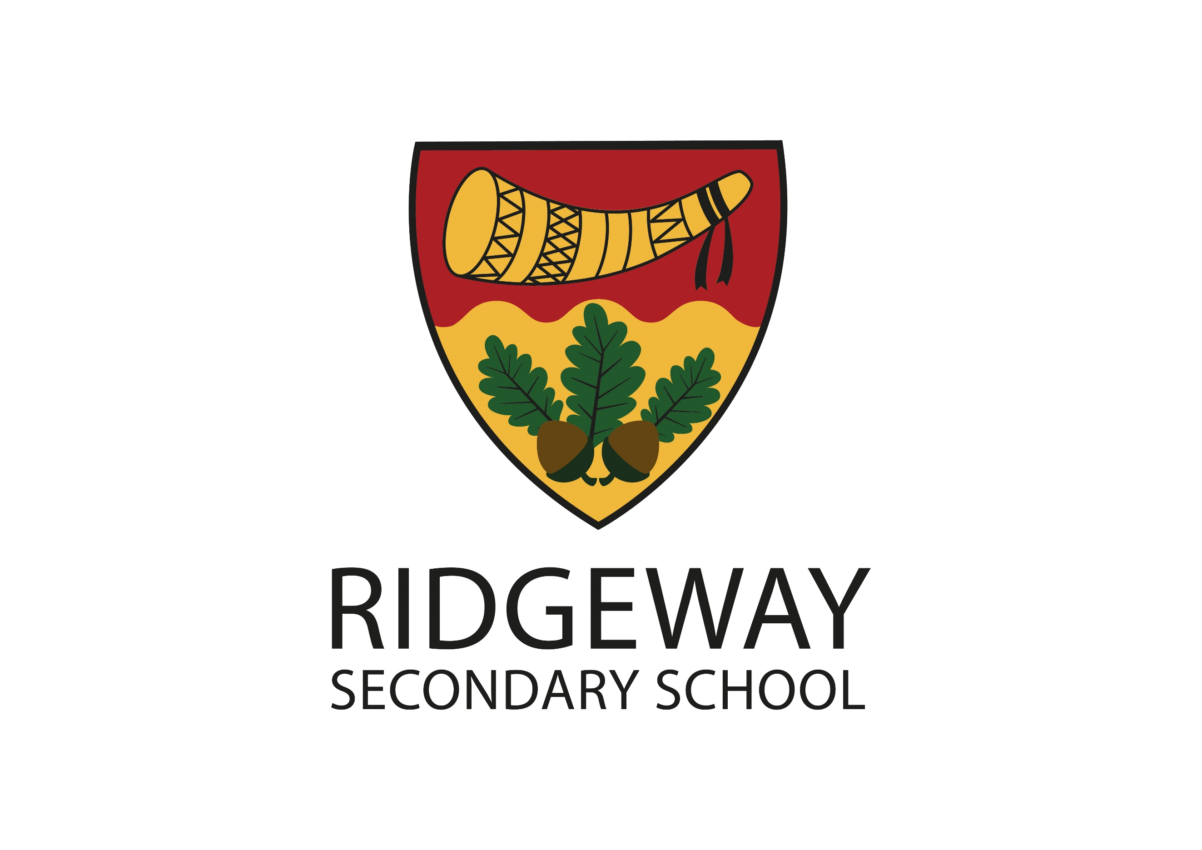
Evesham Road, Astwood Bank, Redditch, Worcestershire, B96 6BD

Tel: 01527 892867
E-mail: slt@ridgewaysecondary.org.uk
Web Site: www.ridgewaysecondary.org.uk
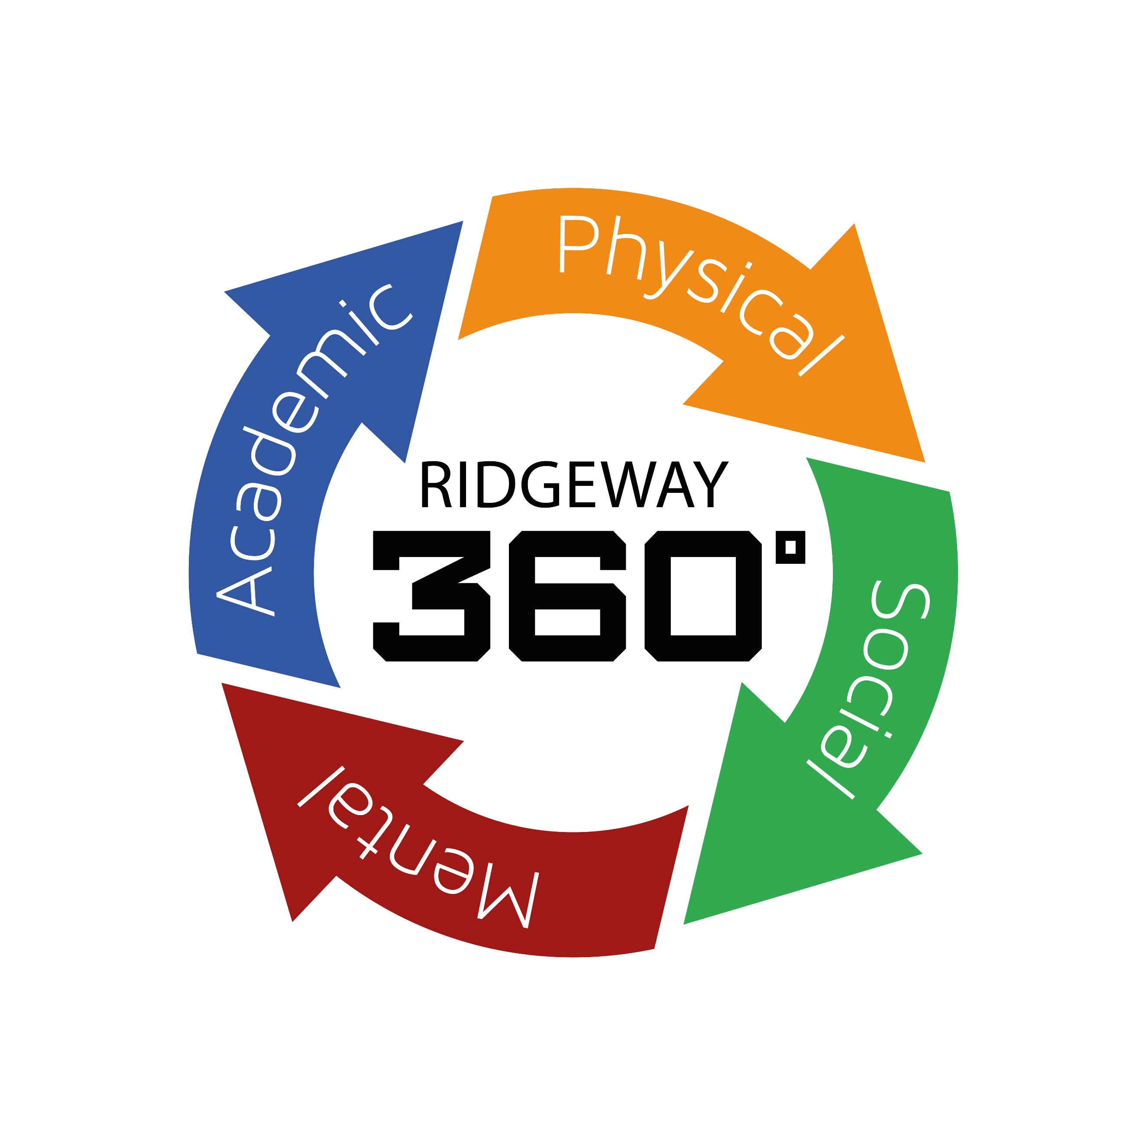
Headteacher: Mr M Ball

Exam Invigilators
£11.67 per hour (£12.82 from April 2024)
Casual Contract

Closing Date: ongoing

We are seeking to recruit Exam Invigilators to work under the direction of the Exams Officer/Deputy Head Teacher in the running of internal and external examinations at the school.
We require a person who is enthusiastic and passionate about attention to detail, teaching & learning and the impact this has on a child’s academic progress and development as a young adult.
Duties include supervising students taking examinations, preparing exam rooms and distributing and collecting exam papers. The ideal applicant will be highly organised, vigilant and reliable, have excellent attention to detail and have the ability to remain calm under pressure.
We are particularly interested in applicants who are available any day of the week (Monday - Friday).
Full training will be provided and working hours will be negotiated for each exam period.

If you would like an informal discussion or to visit the school please contact Mrs M Evans, PA to SLT to arrange this.
Ridgeway is an equal opportunities employer and all appointments are subject to appropriate checks for child protection and safety. Applications should be made on a Ridgeway application form addressed to the PA to SLT.

Appointment will be subject to references and an Enhanced DBS check in line with school safeguarding policy

