10-11-2023

To whom it may concern

Consultation on Admission Arrangements – Ridgeway Secondary School (Astwood Bank Worcestershire), Year 2025/2026

The Trustees of Shires MAT (Multi Academy Trust), along with the Local Governing Body of Ridgeway Secondary School, are currently determining proposed admission arrangements for admissions to the school in September 2025.

As determined by the School Admissions Code, we are required to consult on these arrangements, and are inviting comments on the proposed changes. A copy of the proposed admissions policy is attached to this communication. It is also available on the school’s website at Admissions 2025 entry.pdf . If you require a hard copy of the policy, please contact the Trust directly. The consultation period will start on 07th November 2023.

The only change the Trust is proposing is to amend the PAN from 120 to 108 for entry into year 7 2025 onwards. The reason for this is to ensure the school site can accommodate all pupils linked to a 4-form entry comprehensive school and provide them with an excellent learning experience.

If you wish to comment on the proposed change to the admissions arrangements, please send your response in writing for the attention of Mrs M Evans, either by post (Ridgeway Secondary School, Evesham Road, Astwood Bank, Redditch, Worcestershire, B96 6BD) or email to mevans@rss.shiresmat.org.uk Comments should be received by no later than 9.00am on Monday 8th January 2024.

Yours sincerely

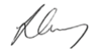
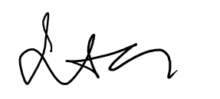
L Gray (CEO/Principal) C Torrington (Chair of Governors)

